**ASSIGNMENT 11.2**

1. Created a dataset employee.txt

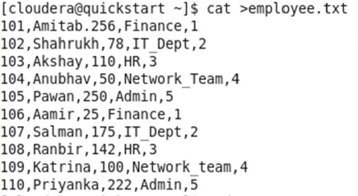

Loading data into table

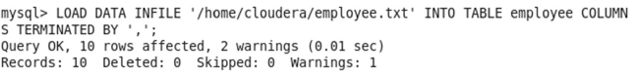

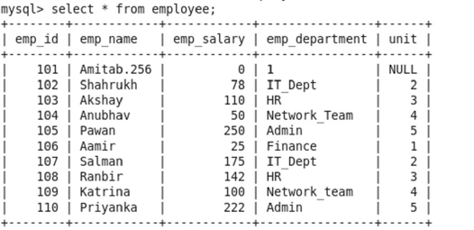

sqoop import --connect jdbc:mysql://localhost/db2 --username root --password cloudera --

table employee -m1 --target-dir /sqoopouthive --hive-import;

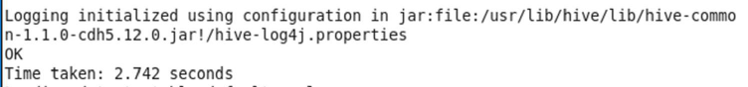

Hive table after import

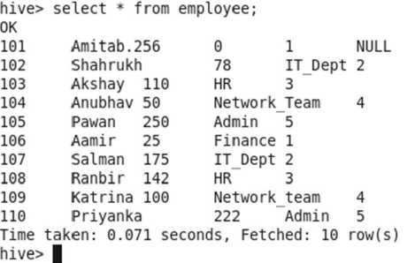

Inserted new values to the table employee.



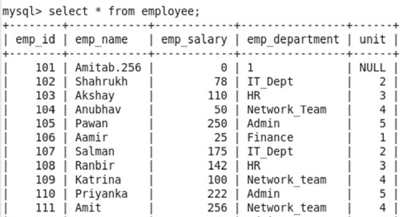

Incremental LOAD

sqoop import --connect jdbc:mysql://localhost/db2 --username root -password cloudera --

table employee --check-column emp_id --incremental append --last-value 110 -m1 --target-dir

/sqoopouthive –hive-import;

updating the new values by comparing the existing values of the table

with the column emp_id.

