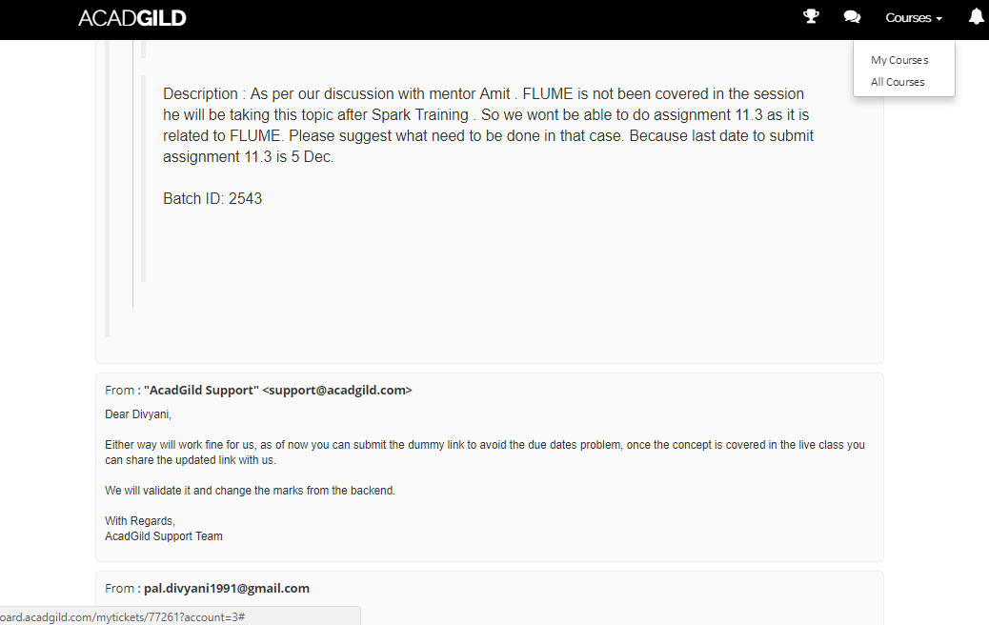

I will be submitting this assignment by 19 Dec ‘2017

Thank