**Assignment 12.3**

Created a List of Tuples

**var asgnmnt1 = List ((1, ‘alpha’), (2, ‘beta’), (3, ‘gamma’), (4, ‘zeta’), (5, ‘omega’))**



1. print the numbers where the corresponding string length is 4

**asgnmnt1.filter(a=> a._2.length ==4).map(_._1).foreach(println)**

The out will give the index number of those tuples whose string has a length of 4.

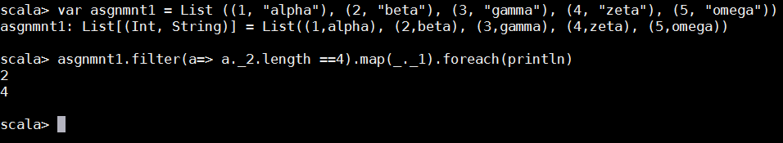

1. find the average of all numbers, where the corresponding string contains alphabet ‘m’ or alphabet ‘z’

**var asgnmnt1_tup = asgnmnt1.filter(a =>( a._2.count(_ == 'm') != 0 || a._2.count(_ == 'z') != 0))**

**asgnmnt1_tup.map(_._1).sum/asgnmnt1_tup.size**

this will give you the average of all the numbers whose corresponding string contains M or Z.

