**Assignment 13.1**

Create a Scala application to find the GCD of two numbers.

In the following command, we are defining the function of GCD to return the GCD of 2 numbers.

In the following we are getting an output of GCD if b is not equal to 0

**def** gcd(a: Int, b: Int): Int = {  
 **if** (b == 0) a  
 **else** gcd(b, a % b)  
}  
  
gcd(18, 36)

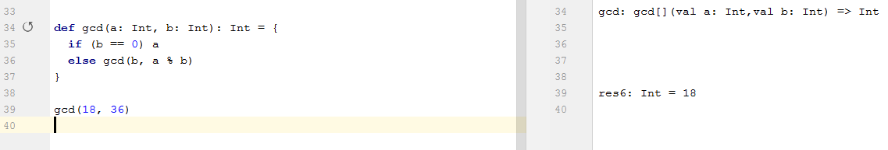

**def** gcd(a: Int, b: Int): Int = {  
 **if** (b == 0) a  
 **else** gcd(b, a % b)  
}  
  
gcd(25, 0)

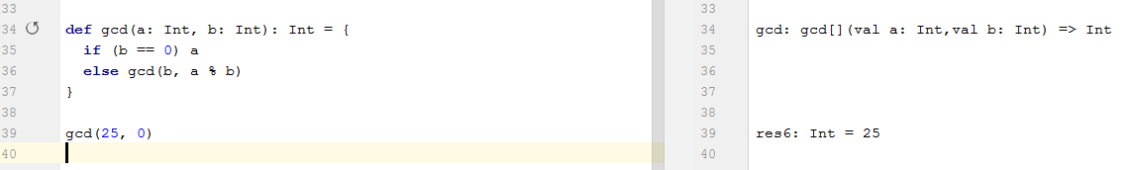

The above command we get the output of GCD of 2 numbers if any one values is 0