**Assignment 13.3**

Find square root of number using Babylonian method.

1. Start with an arbitrary positive start value x (the closer to the

root, the better).

1. Initialize y = 1.
2. Do following until desired approximation is achieved.

a) Get the next approximation for root using average of x and y

b) Set y = n/x

**Code:**

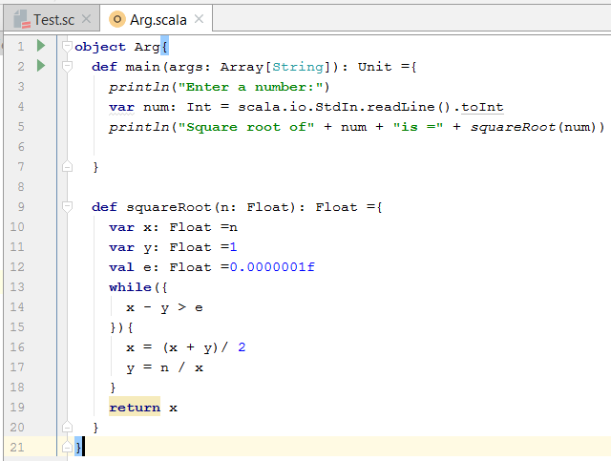

**Output:**

Square of a proper number

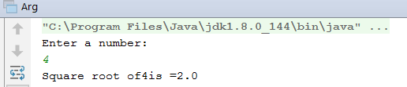

Square of an improper number

