There are 3 main components of Hadoop 2

1: HDFS

2: MapRedude

3: YARN

1 .HDFS :

HDFS stands for Hadoop Distributed File System. It is also known as HDFS V2 as it is part of Hadoop 2.x with some enhanced features. It is used as a Distributed Storage System in Hadoop Architecture.HDFS is a Java-based file system that provides scalable and reliable data storage, and it was designed to span large clusters of commodity servers. HDFS has demonstrated production scalability of up to 200 PB of storage and a single cluster of 4500 servers, supporting close to a billion files and blocks. HDFS is a scalable, fault-tolerant, distributed storage system that works closely with a wide variety of concurrent data access applications, coordinated by YARN. HDFS work under a variety of physical and systemic circumstances. By distributing storage and computation across many servers, the combined storage resource can grow linearly with demand while remaining economical at every amount of storage.

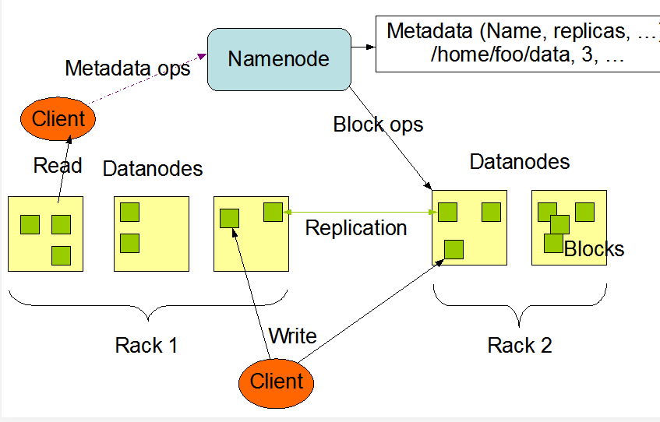

2.YARN :

YARN stands for Yet Another Resource Negotiator. It is new Component in Hadoop 2.x Architecture. It is also known as “MR V2”.

YARN’s original purpose was to split up the two major responsibilities of the JobTracker/TaskTracker into separate entities:

a global ResourceManager

* a per-application ApplicationMaster
* a per-node slave NodeManager
* a per-application Container running on a NodeManager

3. MapReduce :

MapReduce is a Batch Processing or Distributed Data Processing Module. Hadoop MapReduce is a software framework for easily writing applications which process vast amounts of data (multi-terabyte data-sets) in-parallel on large clusters (thousands of nodes) of commodity hardware in a reliable, fault-tolerant manner.

A MapReduce *job* usually splits the input data-set into independent chunks which are processed by the *map tasks* in a completely parallel manner. The framework sorts the outputs of the maps, which are then input to the *reduce tasks*. Typically both the input and the output of the job are stored in a file-system. The framework takes care of scheduling tasks, monitoring them and re-executes the failed tasks.

Typically the compute nodes and the storage nodes are the same, that is, the MapReduce framework and the Hadoop Distributed File System are running on the same set of nodes. This configuration allows the framework to effectively schedule tasks on the nodes where data is already present, resulting in very high aggregate bandwidth across the cluster.

The MapReduce framework consists of a single master JobTracker and one slave TaskTracker per cluster-node. The master is responsible for scheduling the jobs' component tasks on the slaves, monitoring them and re-executing the failed tasks. The slaves execute the tasks as directed by the master.

Minimally, applications specify the input/output locations and supply *map* and *reduce* functions via implementations of appropriate interfaces and/or abstract-classes. These, and other job parameters, comprise the *job configuration*. The Hadoop *job client* then submits the job (jar/executable etc.) and configuration to the JobTracker which then assumes the responsibility of distributing the software/configuration to the slaves, scheduling tasks and monitoring them, providing status and diagnostic information to the job-client.