1 )AVG

The Pig-Latin AVG() function is used to compute the average of the numerical values within a bag. While calculating the average value, the AVG() function ignores the NULL values..

grunt> AVG(expression)

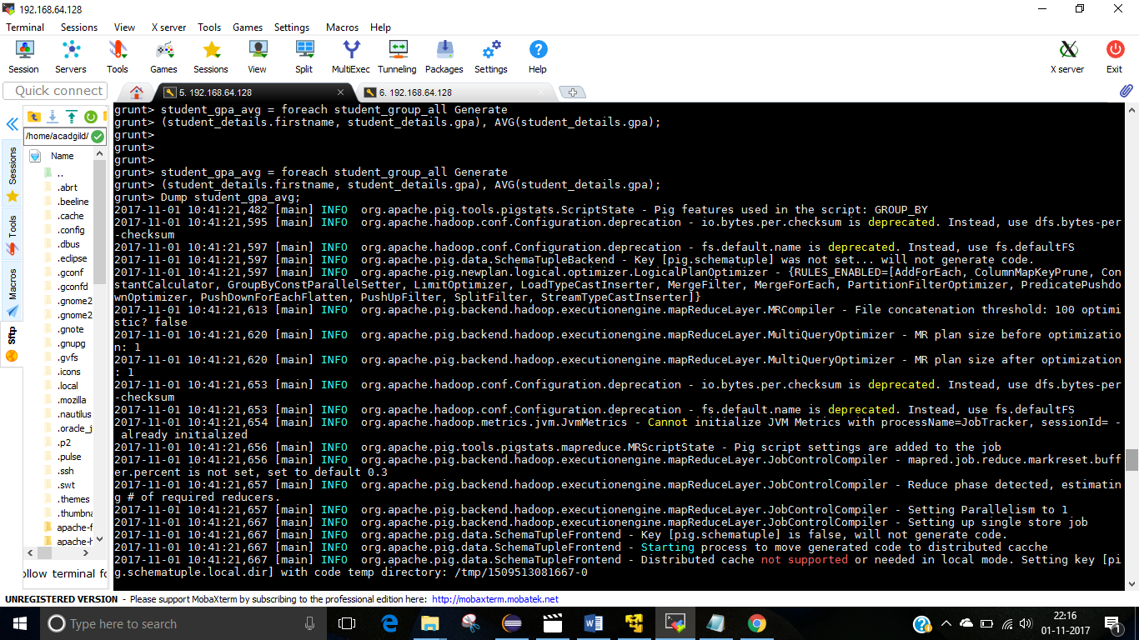

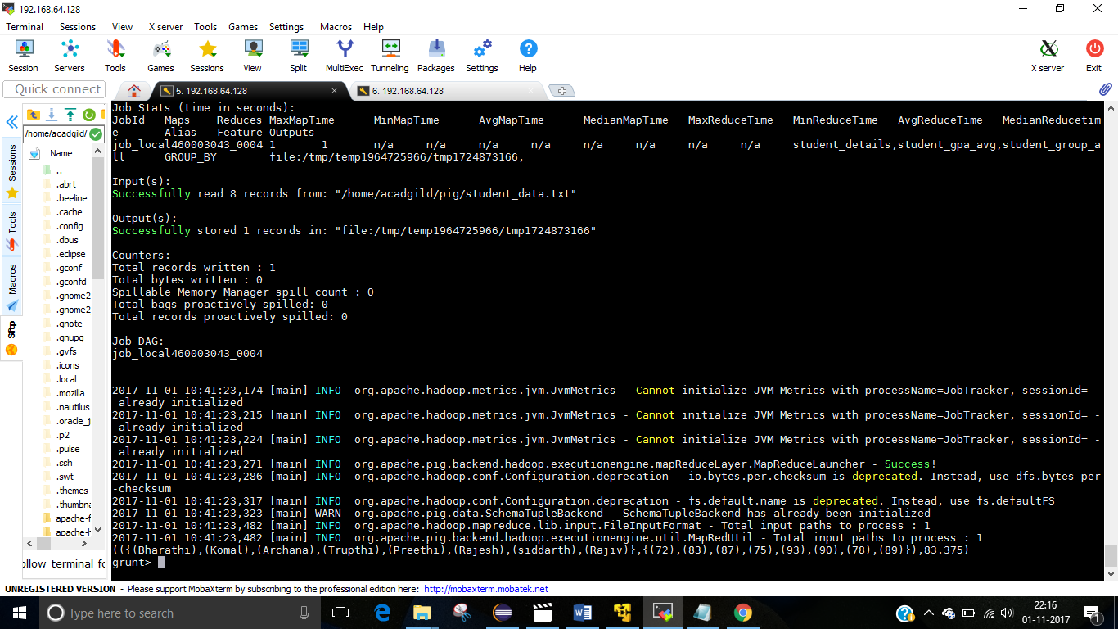

2 ) Max

The Pig Latin Max() function is used to calculate the highest value for a column (numeric values or chararrays) in a single-column bag. While calculating the maximum value, the Max() function ignores the NULL values.

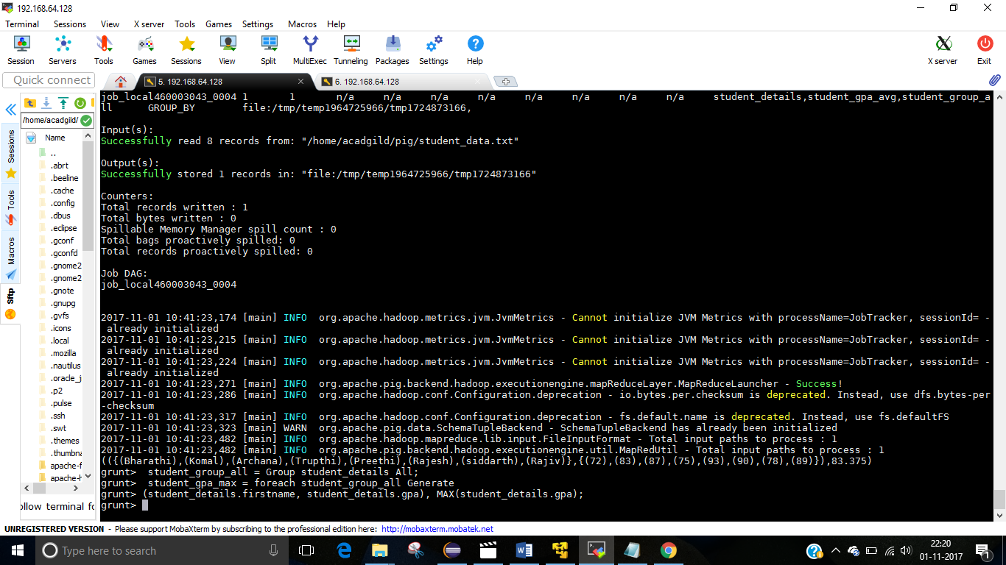

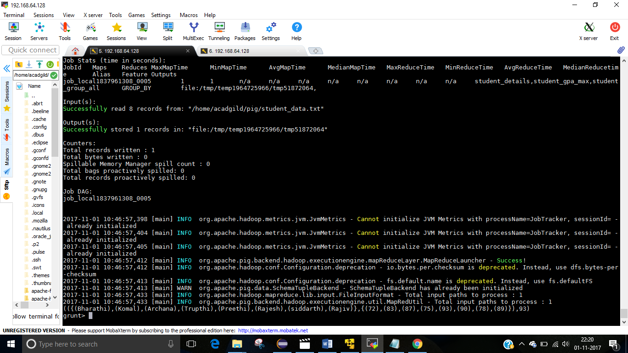

3 ) Min

The Min() function of Pig Latin is used to get the minimum (lowest) value (numeric or chararray) for a certain column in a single-column bag. While calculating the minimum value, the Min() function ignores the NULL values.

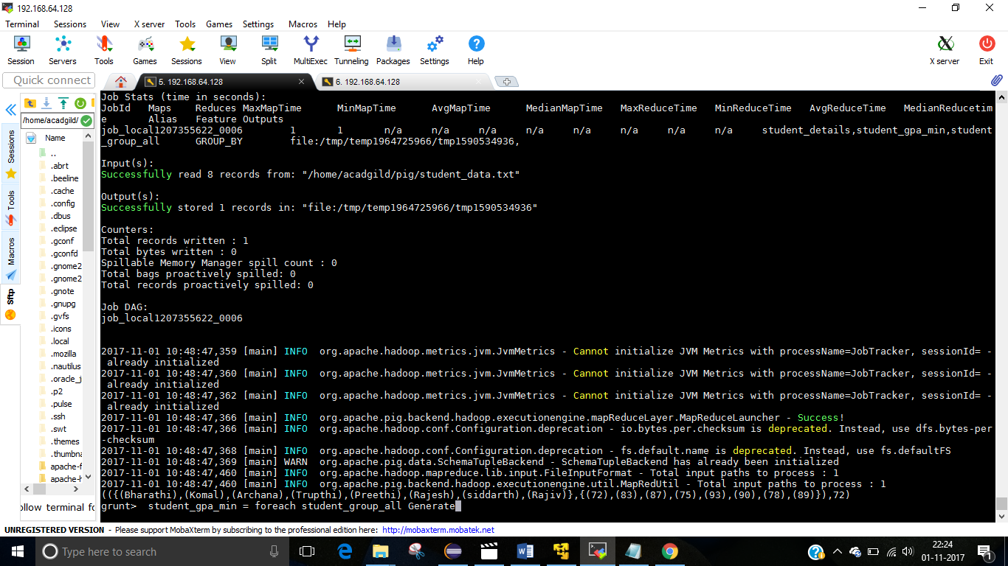

5 )Count

The count() function of Pig Latin is used to get the number of elements in a bag. While counting the number of tuples in a bag, the count() function ignores (will not count) the tuples having a NULL value in the FIRST FIELD.

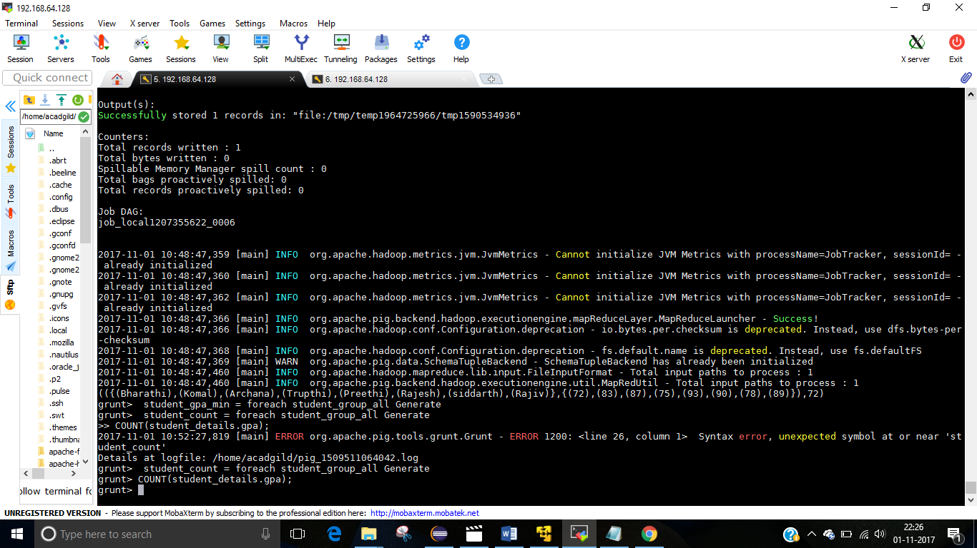

Dump student_count;

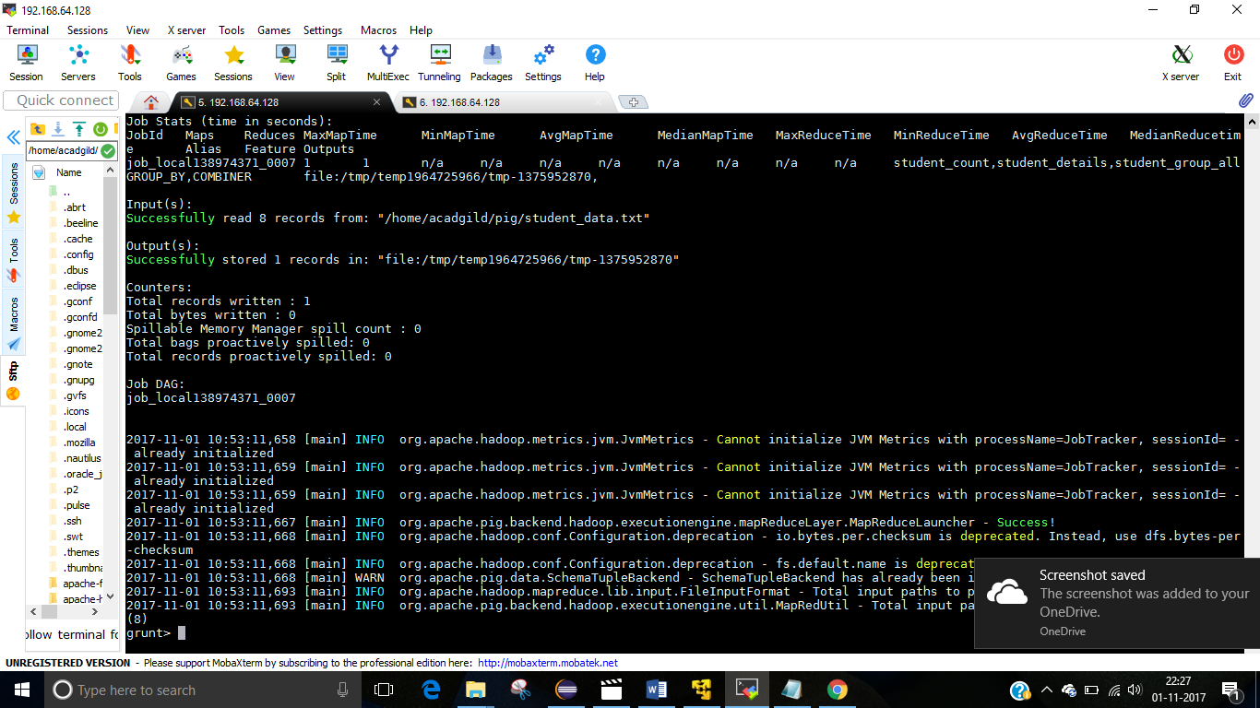

6)Sum

You can use the Sum() function of Pig Latin to get the total of the numeric values of a column in a single-column bag. While computing the total, the sum() function ignores the NULL values.

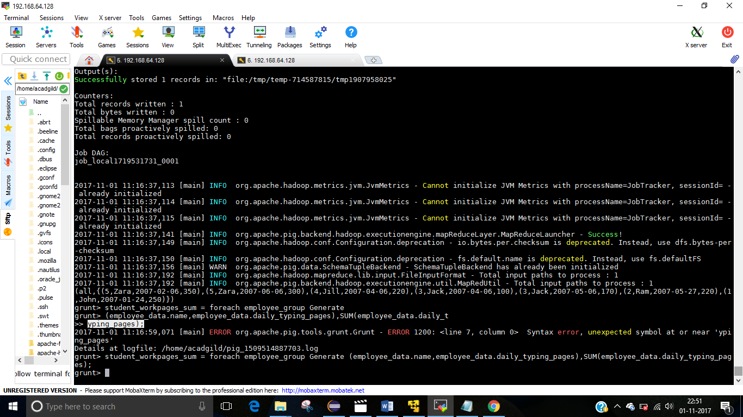

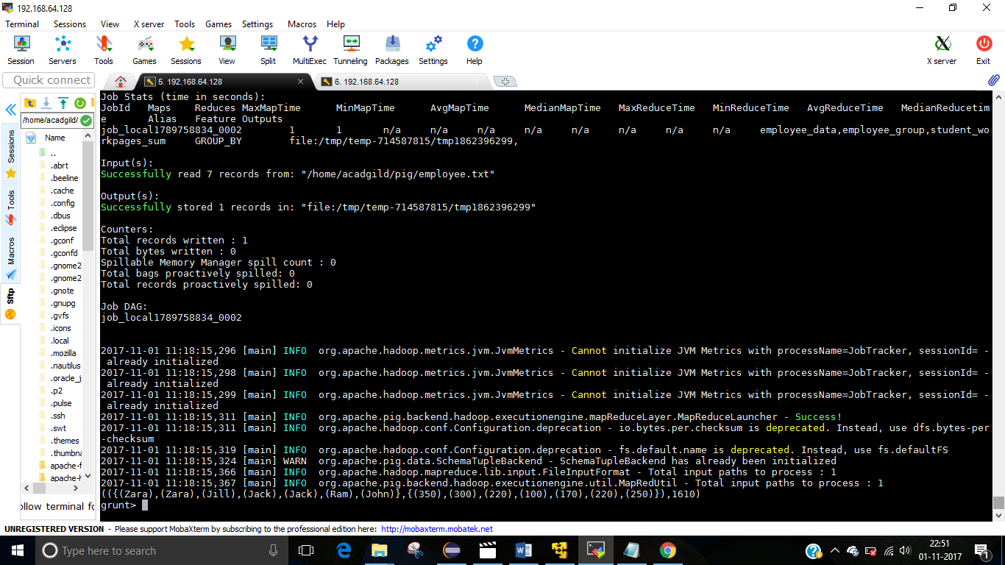

7)Concat( )

The CONCAT() function of Pig Latin is used to concatenate two or more expressions of the same type.

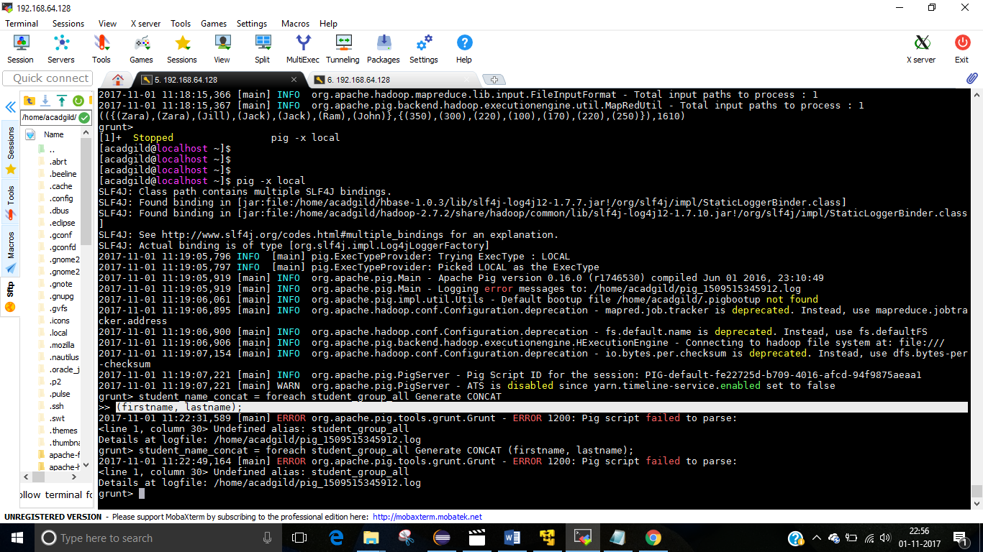

grunt> student_group_all = Group student_details All;

grunt> student_name_concat = foreach student_group_all Generate CONCAT (firstname, lastname);

output :

(RajivReddy) (siddarthBattacharya) (RajeshKhanna) (PreethiAgarwal) (TrupthiMohanthy) (ArchanaMishra) (KomalNayak) (BharathiNambiayar)

8 )Tokenizing a String

We can use the Tokenize() function to split a string. First of all, verify the contents of the student_details schema using the Dump operator as shown below.