(a) Top 5 employees (employee id and employee name) with highest rating. (In case two

employees have same rating, employee with name coming first in dictionary should get

preference)

Solution:

emp = LOAD '/home/acadgild/pig/employee_details.txt' USING PigStorage(',') AS (emp_id:int, emp_name:chararray, emp_salary:int, emp_rating:int);

DUMP emp;

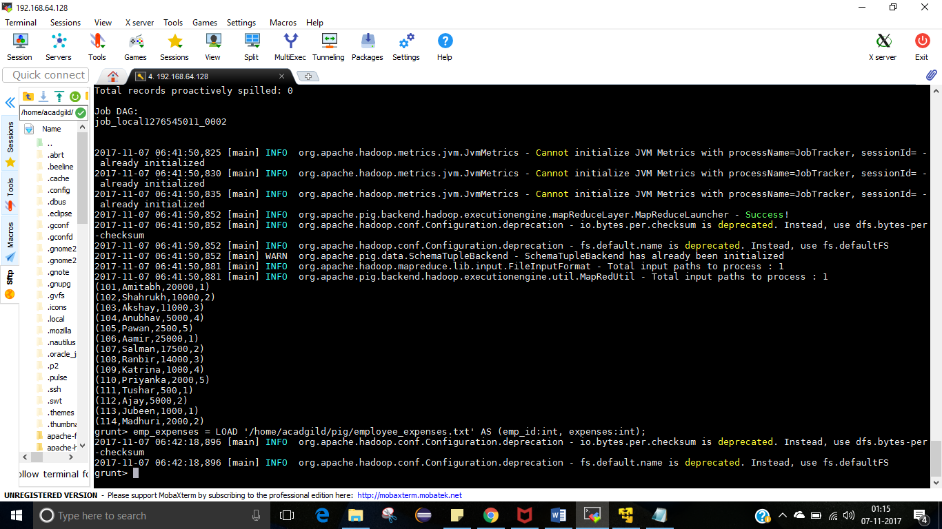

emp_expenses = LOAD '/home/acadgild/pig/employee_expenses.txt' AS (emp_id:int, expenses:int);

DUMP emp_expenses;

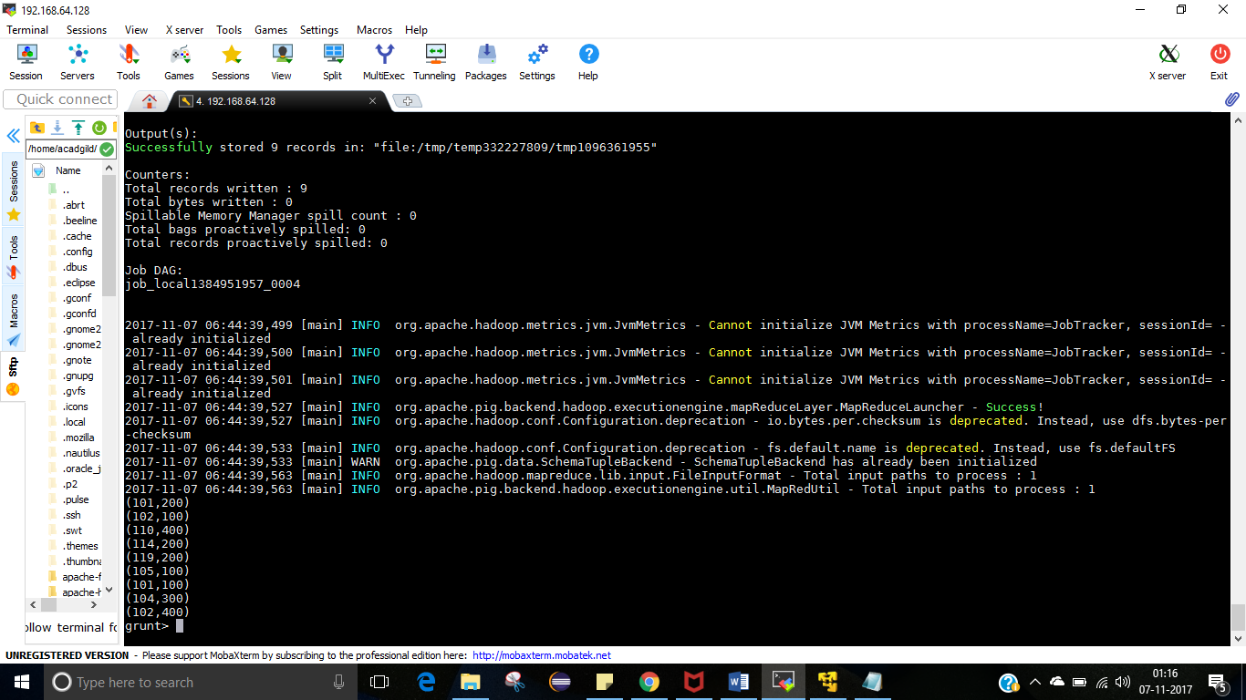

emp_high_rating = ORDER emp BY emp_rating ASC , emp_name ASC;

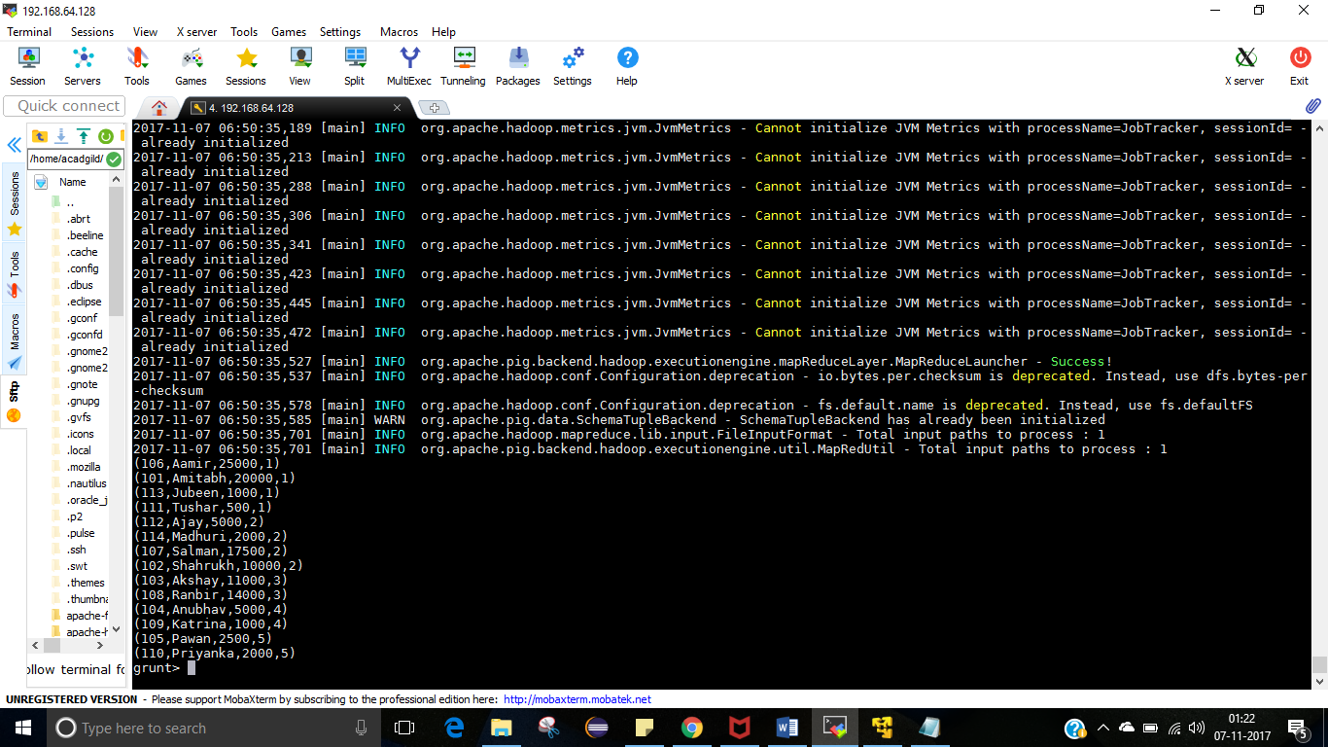

five_emp = limit emp_high_rating 5;

(b) Top 3 employees (employee id and employee name) with highest salary, whose employee id

is an odd number. (In case two employees have same salary, employee with name coming first

in dictionary should get preference)

Solution :

filter_odd_emp_id = FILTER emp BY emp_id%2!=0;

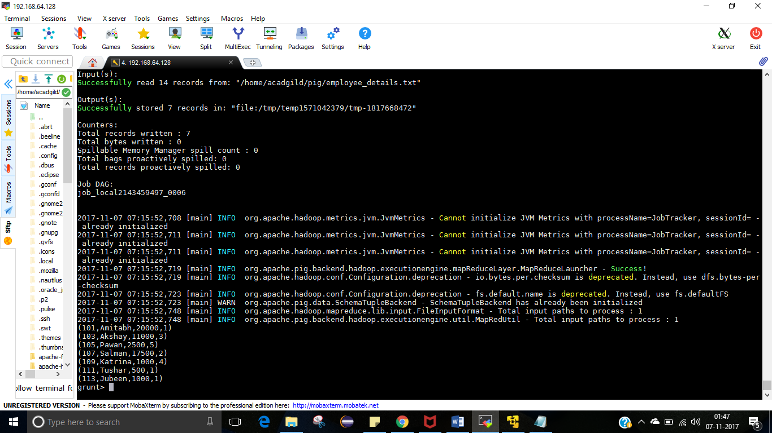

order_odd_id_employee = ORDER filter_odd_emp_id BY emp_salary DESC ,emp_name ASC;

DUMP order_odd_id_employee;

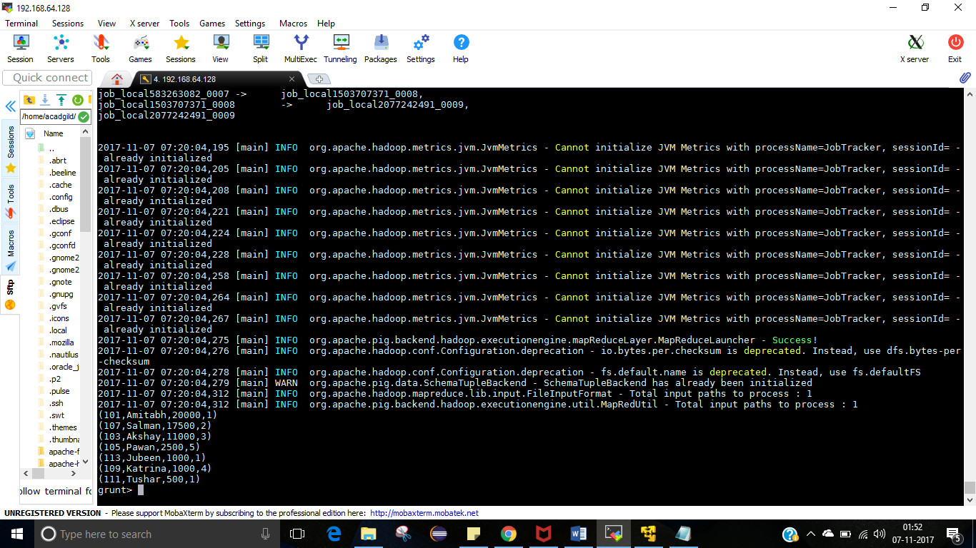

three_emp = limit order_odd_id_employee 3;

DUMP three_emp;

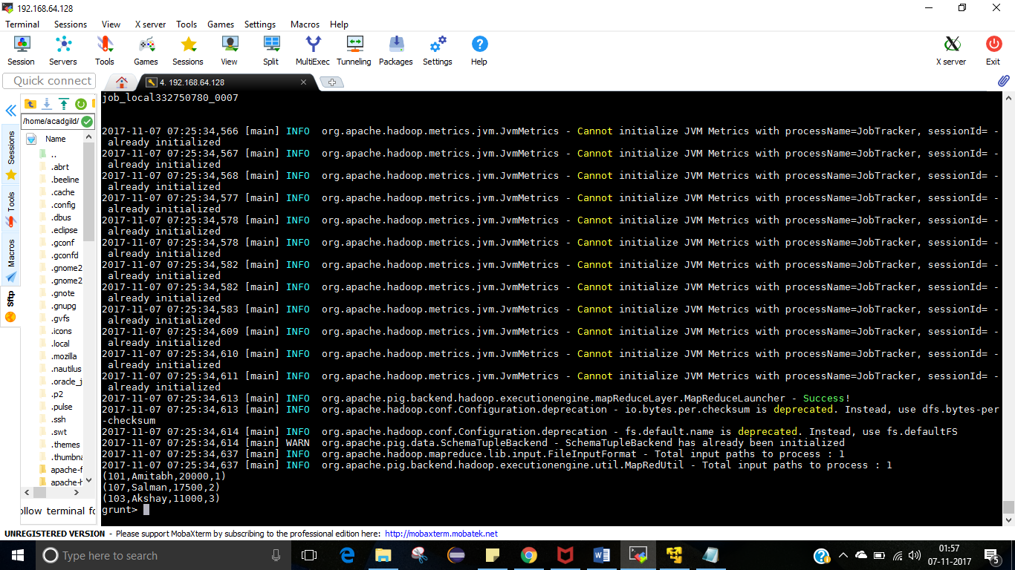

(c) Employee (employee id and employee name) with maximum expense (In case two

employees have same expense, employee with name coming first in dictionary should get

preference)

joined_data = join emp by emp_id , emp_expenses by emp_id;

dump joined_data;

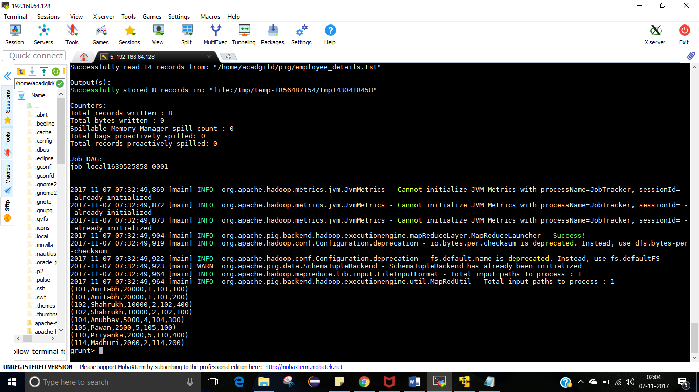

order_by_name_expense = ORDER joined_data BY expenses DESC;

DUMP order_by_name_expense;

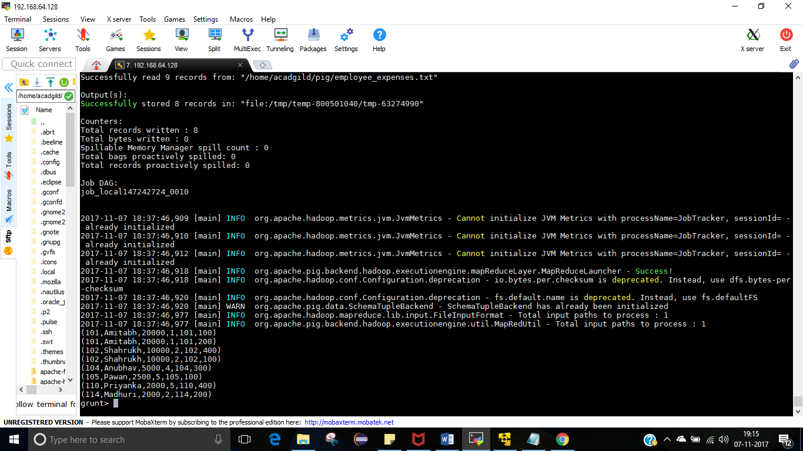

(e) List of employees (employee id and employee name) having no entry in employee_expenses

file.

filter_emp_id = FILTER left_outer_joined_data BY emp_expenses::emp_id is NULL;

DUMP filter_emp_id;

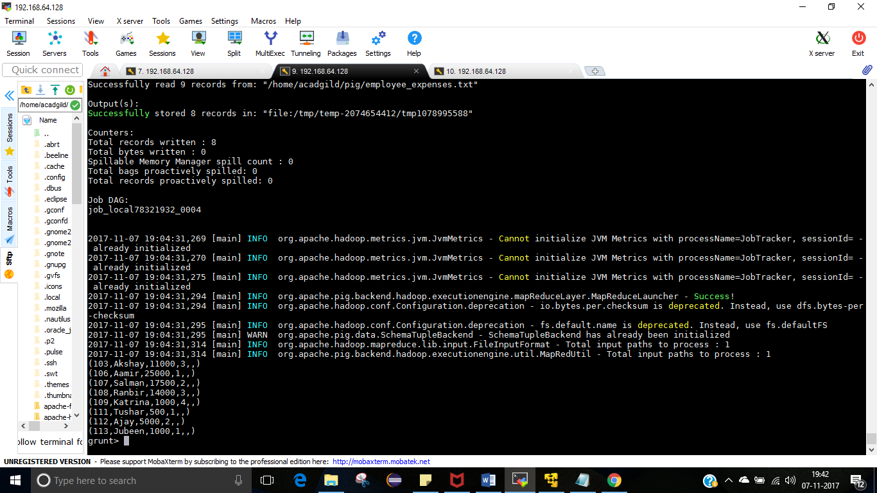

(d) List of employees (employee id and employee name) having entries in employee_expenses

file.

filter_emp_id = FILTER left_outer_joined_data BY emp_expenses::emp_id is not NULL;

DUMP filter_emp_id ;

