load_data = LOAD '/home/acadgild/pig/Pokemon.csv' USING PigStorage(',') AS (Sno:int,Name:chararray,Type1:chararray,Type2:chararray,Total:int,HP:int,Attack:int,Defense:int ,SpAtk:int , SpDef:int , Speed:int);

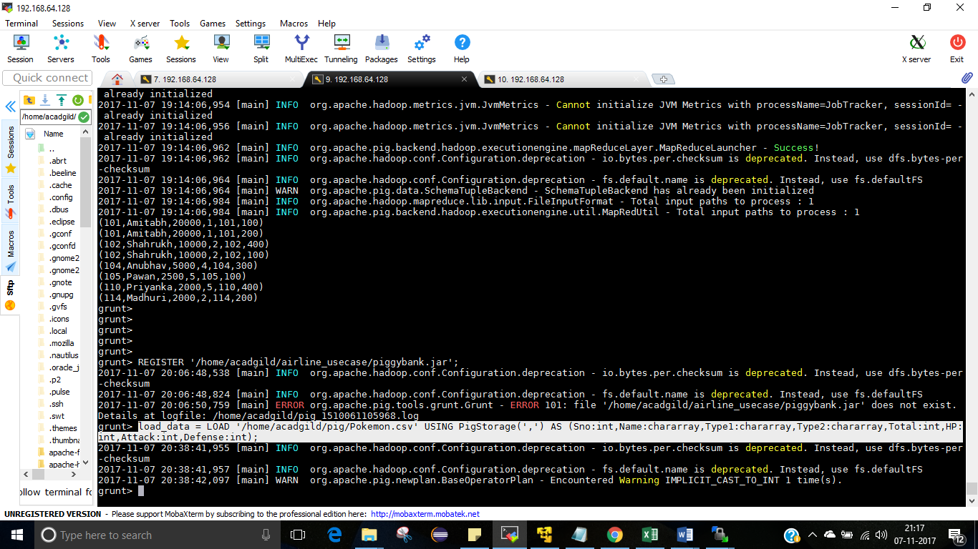

DUMP load_data;

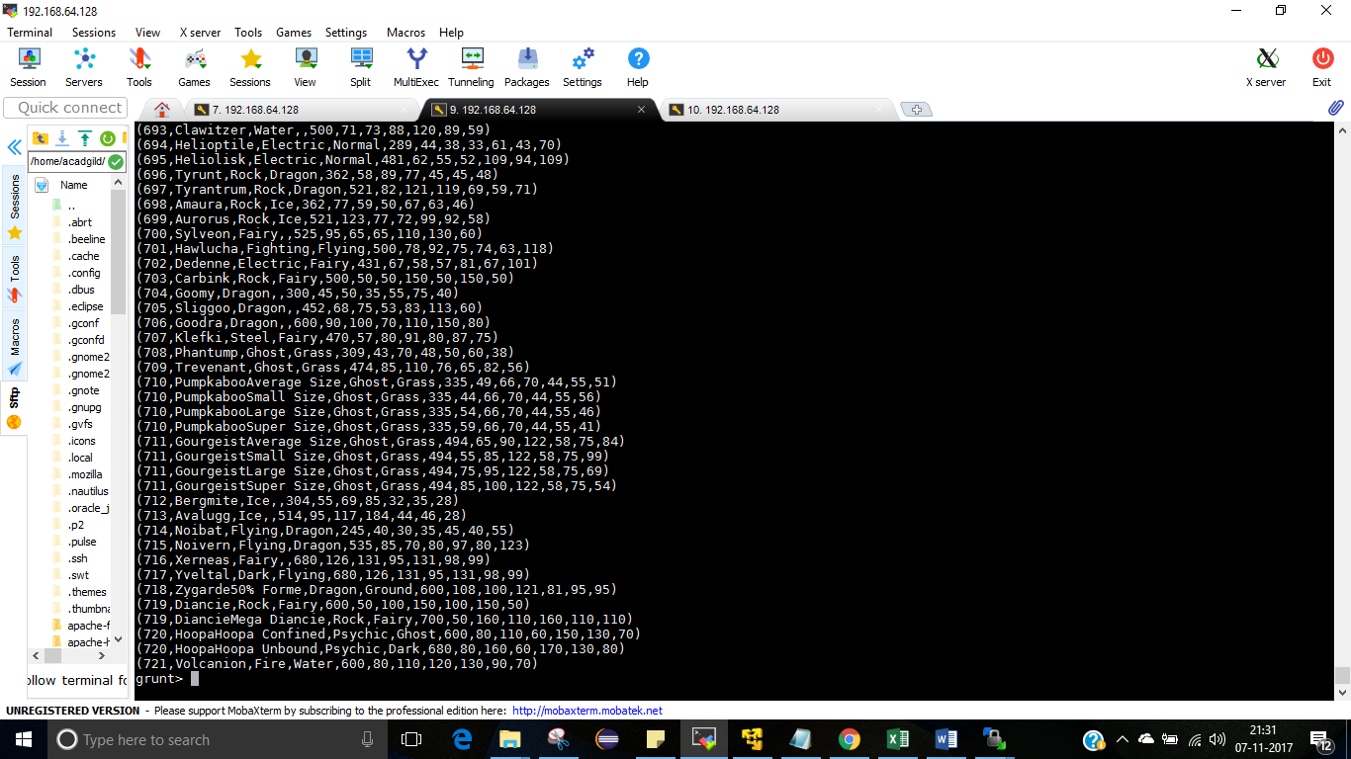

**Ques 1: Find the list of players that have been selected in the qualifying round (DEFENCE>55).**

selected_list = FILTER load_data BY Defense>55;

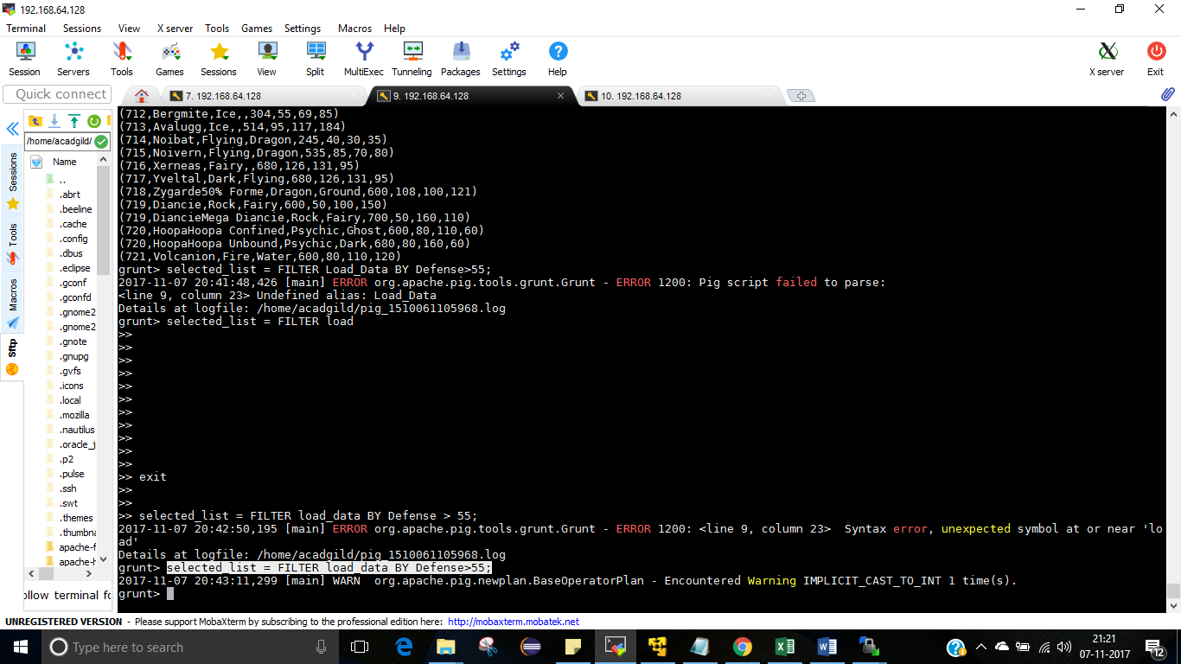

DUMP selected_list;

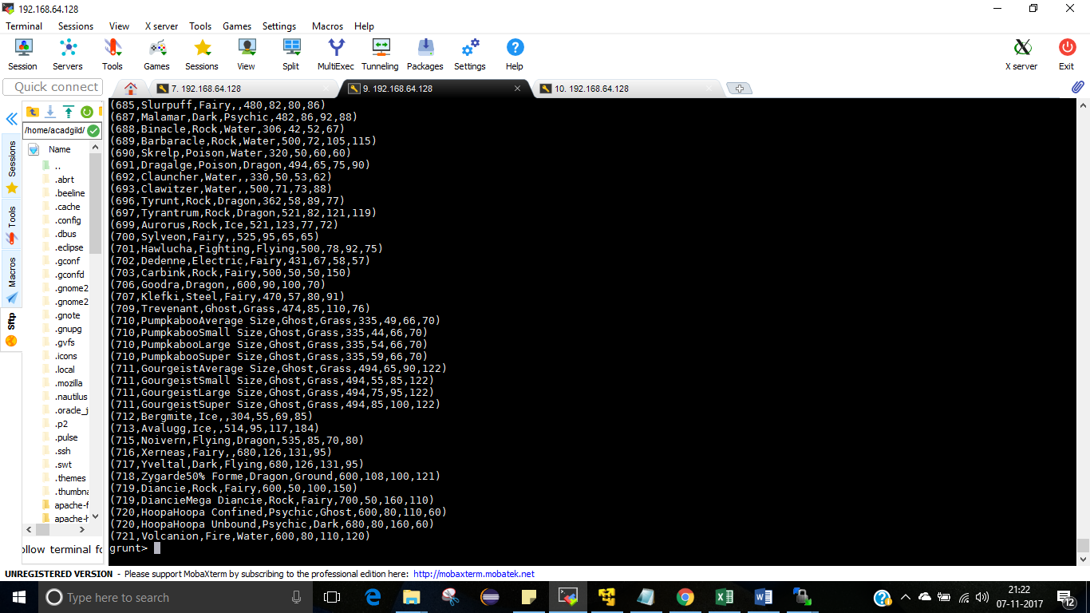

#### Ques 2: State the number of players taking part in the competition after getting selected in the qualifying round.

gourp_selcted_list = Group selected_list All;

count_selcted_list = foreach gourp_selcted_list GENERATE COUNT(selected_list);



Dump;

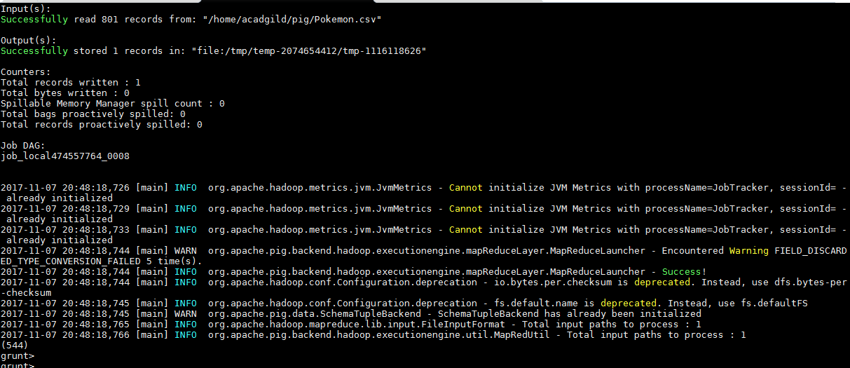

#### Ques 3: Using random() generate random numbers for each Pokémon on the selected list.

random_include1 = foreach selected_list GENERATE RANDOM(),Name,Type1,Type2,Total,HP,Attack,Defense,SpAtk,SpDef,Speed;



DUMP random_include1;

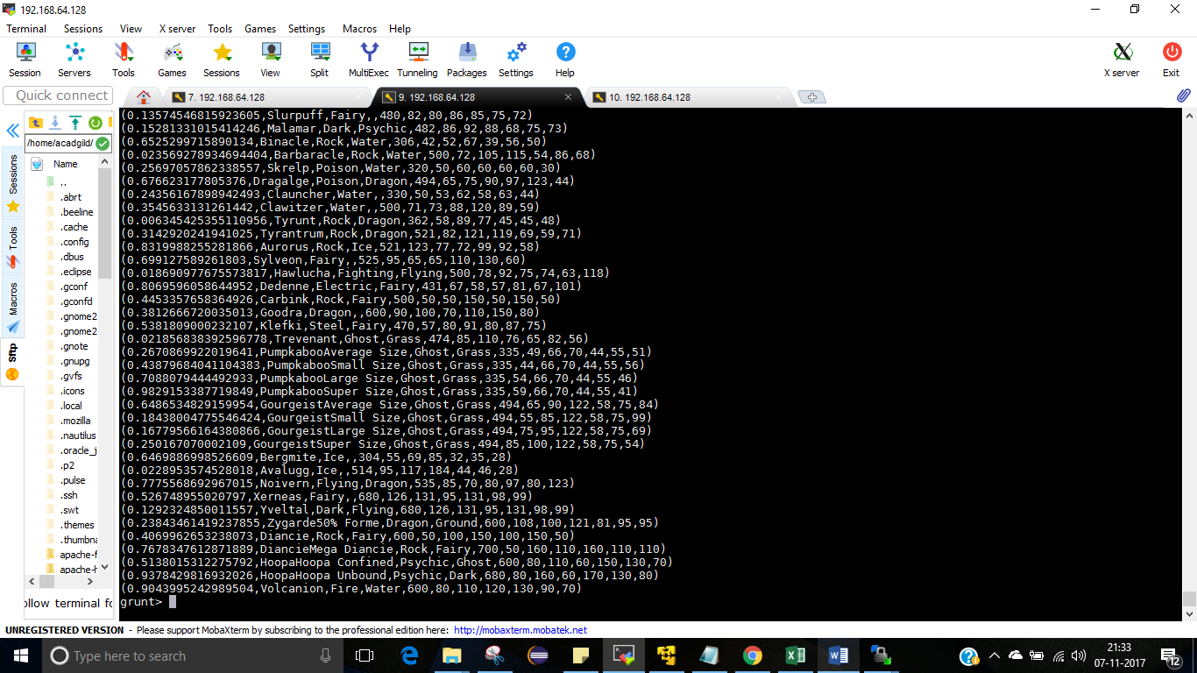

#### Ques 4: Arrange the new list in a descending order according to a column randomly.



DUMP random1_desending;

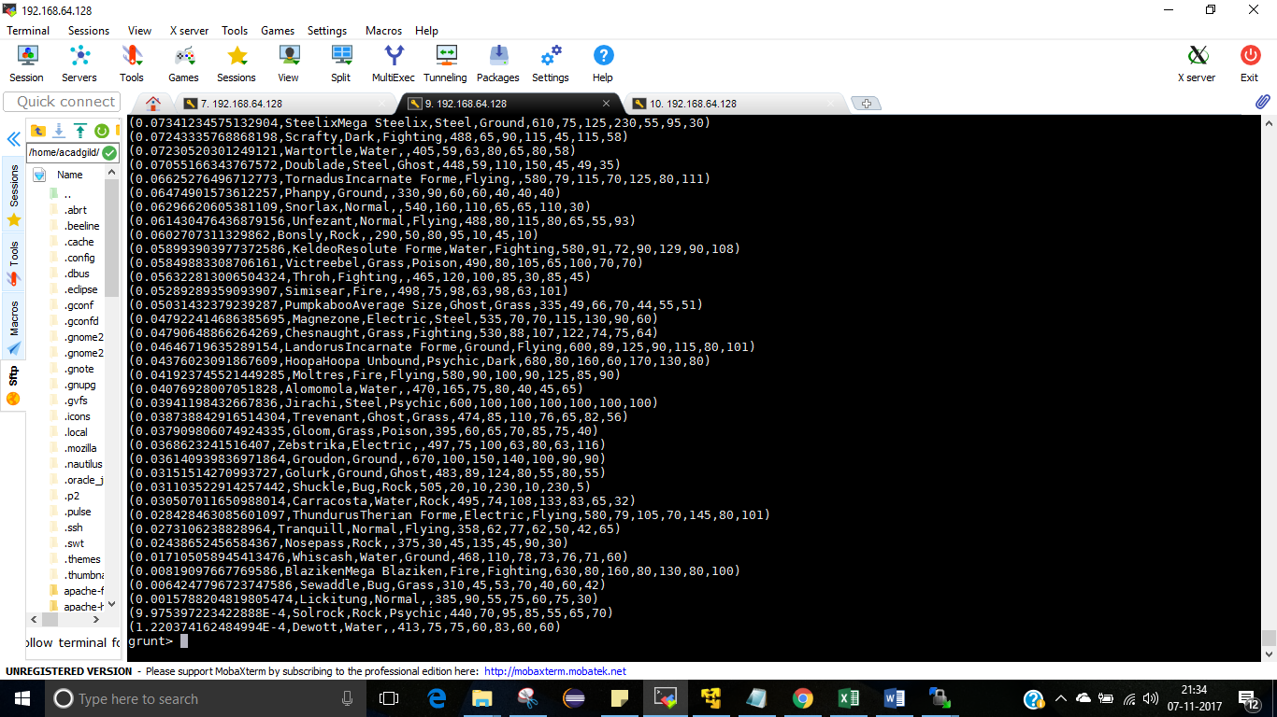

#### Ques 5: Now on a new relation again associate random numbers for each Pokémon and arrange in descending order according to column random.

random_include2 = foreach selected_list GENERATE RANDOM(),Name,Type1,Type2,Total,HP,Attack,Defense,SpAtk,SpDef,Speed;

random2_desending = ORDER random_include2 BY $0 DESC;



DUMP random_include2;

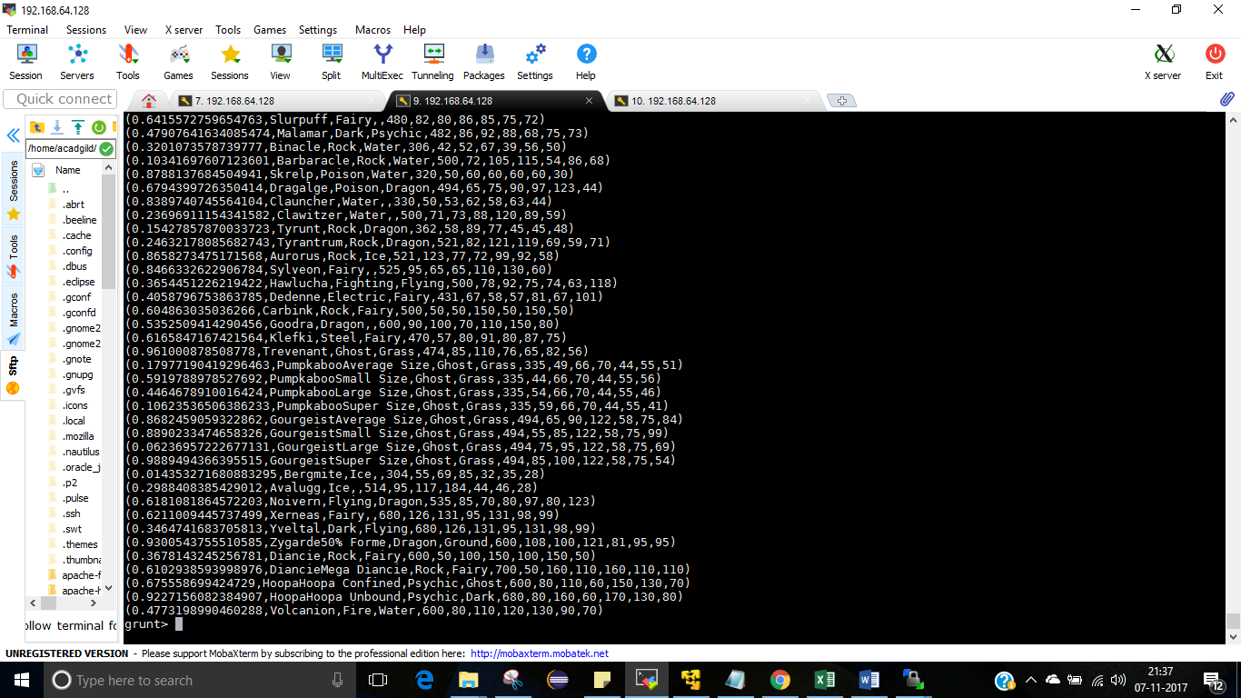

DUMP random2_desending;

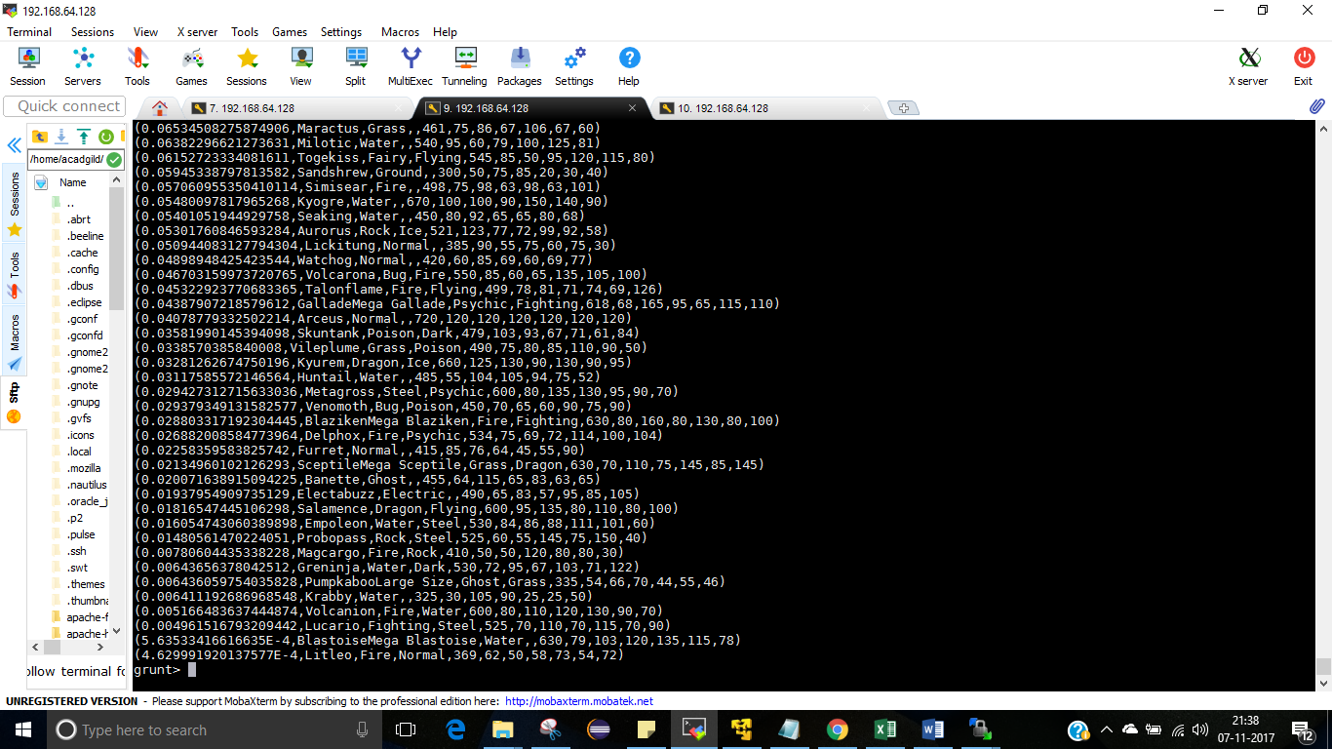

#### Ques: From the two different descending lists of random Pokémons, select the top 5 Pokémons for 2 different players.

limit_data_random1_desending = LIMIT random1_desending 5 ;

DUMP limit_data_random1_desending;

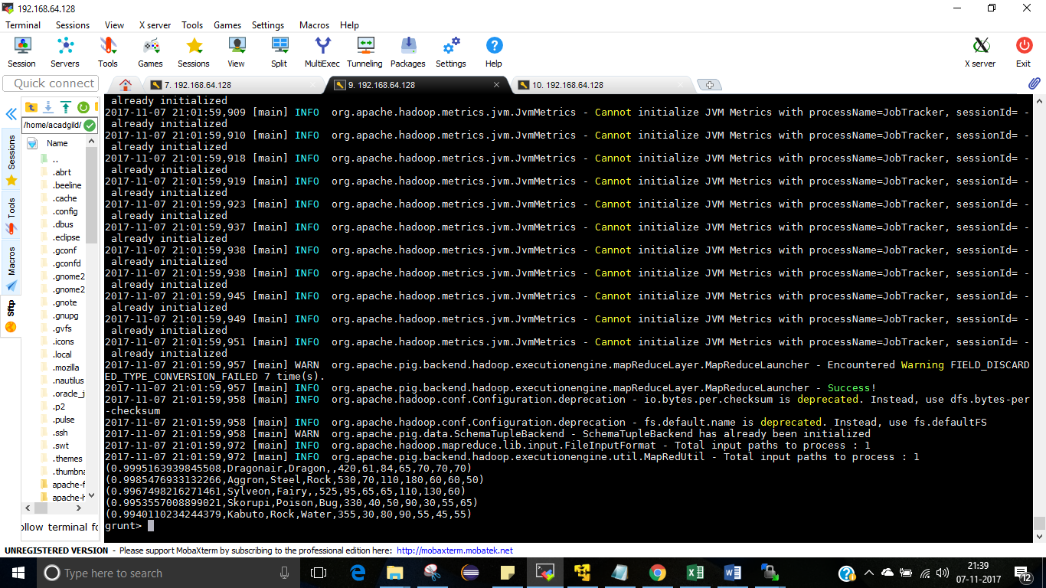

limit_data_random2_desending = LIMIT random2_desending 5 ;

DUMP limit_data_random2_desending;

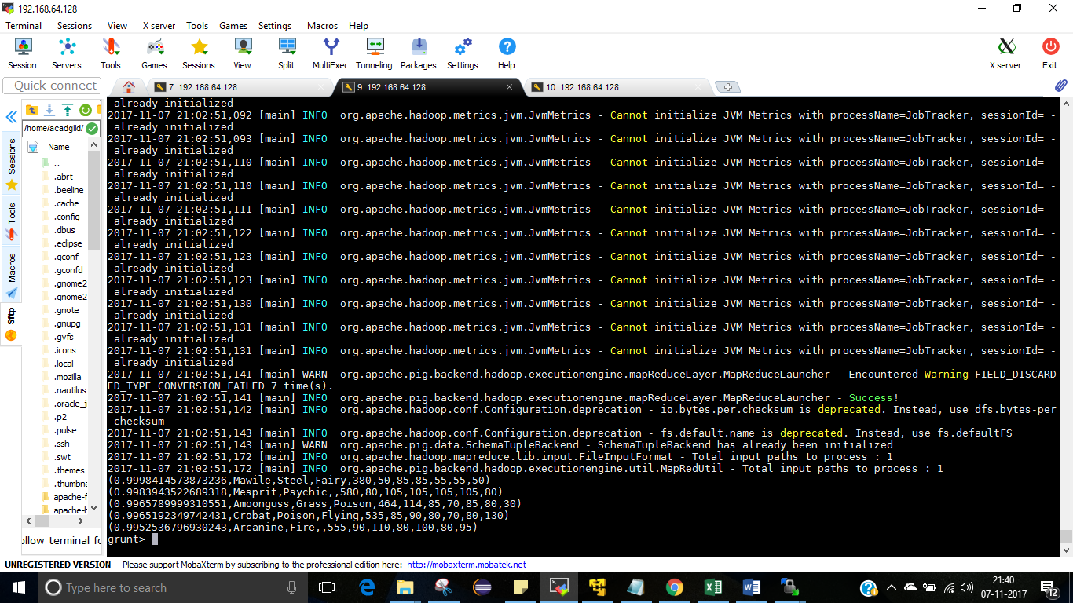

#### Ques: Store the data on a local drive to announce for the final match. By the name player1 and player2 (only show the NAME and HP).

filter_only_name1 = foreach limit_data_random1_desending Generate ($1,HP);

DUMP filter_only_name1;

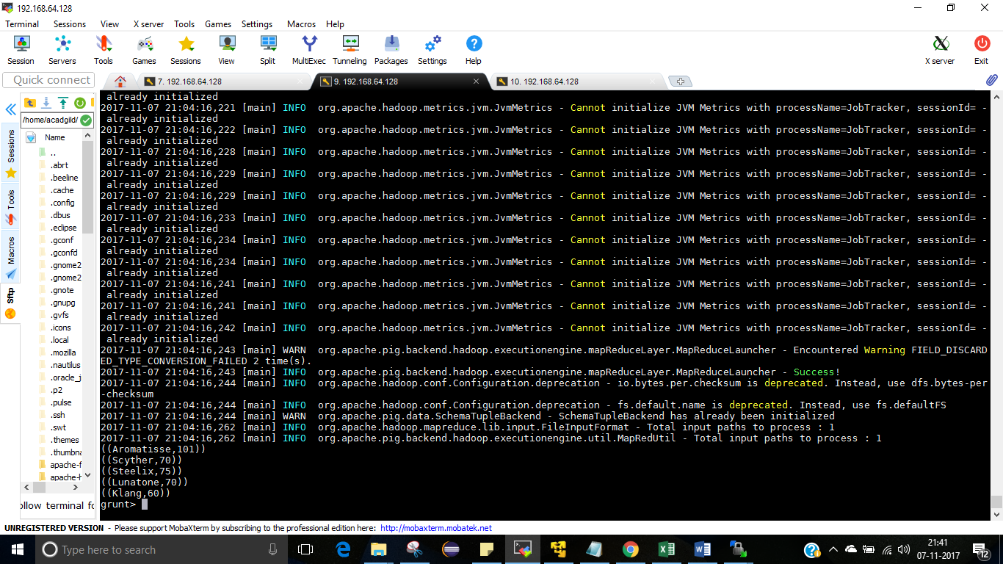

filter_only_name2 = foreach limit_data_random2_desending Generate ($1,HP);

DUMP filter_only_name2;

