## Problem Statement 1

A = load '/home/acadgild/pig/DelayedFlights.csv' USING org.apache.pig.piggybank.storage.CSVExcelStorage(',','NO_MULTILINE','UNIX','SKIP_INPUT_HEADER');

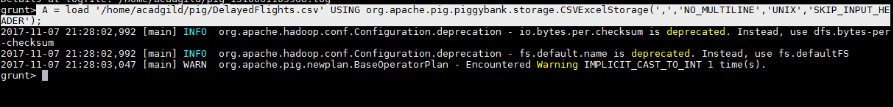

B1 = foreach A generate (int)$16 as dep_delay, (chararray)$17 as origin;

C1 = filter B1 by (dep_delay is not null) AND (origin is not null);

D1 = group C1 by origin;

E1 = foreach D1 generate group, AVG(C1.dep_delay);

Result = order E1 by $1 DESC;

Top_ten = limit Result 10;

Lookup = load '/home/acadgild/airline_usecase/airports.csv' USING org.apache.pig.piggybank.storage.CSVExcelStorage(',','NO_MULTILINE','UNIX','SKIP_INPUT_HEADER');

Lookup1 = foreach Lookup generate (chararray)$0 as origin, (chararray)$2 as city, (chararray)$4 as country;

Joined = join Lookup1 by origin, Top_ten by $0;

Final = foreach Joined generate $0,$1,$2,$4;

Final_Result = ORDER Final by $3 DESC;

dump Final_Result;

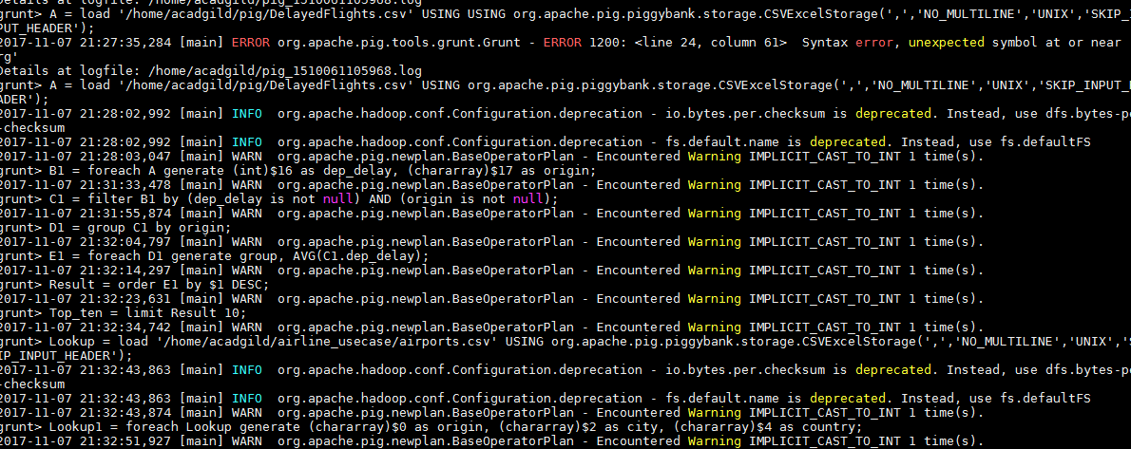

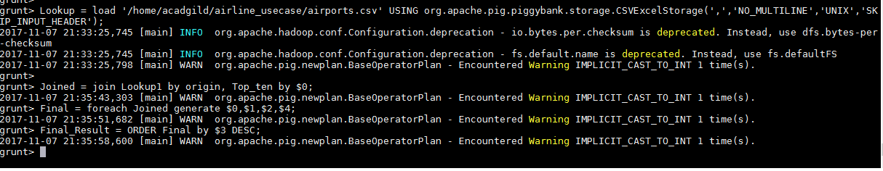

dump Final_Result;

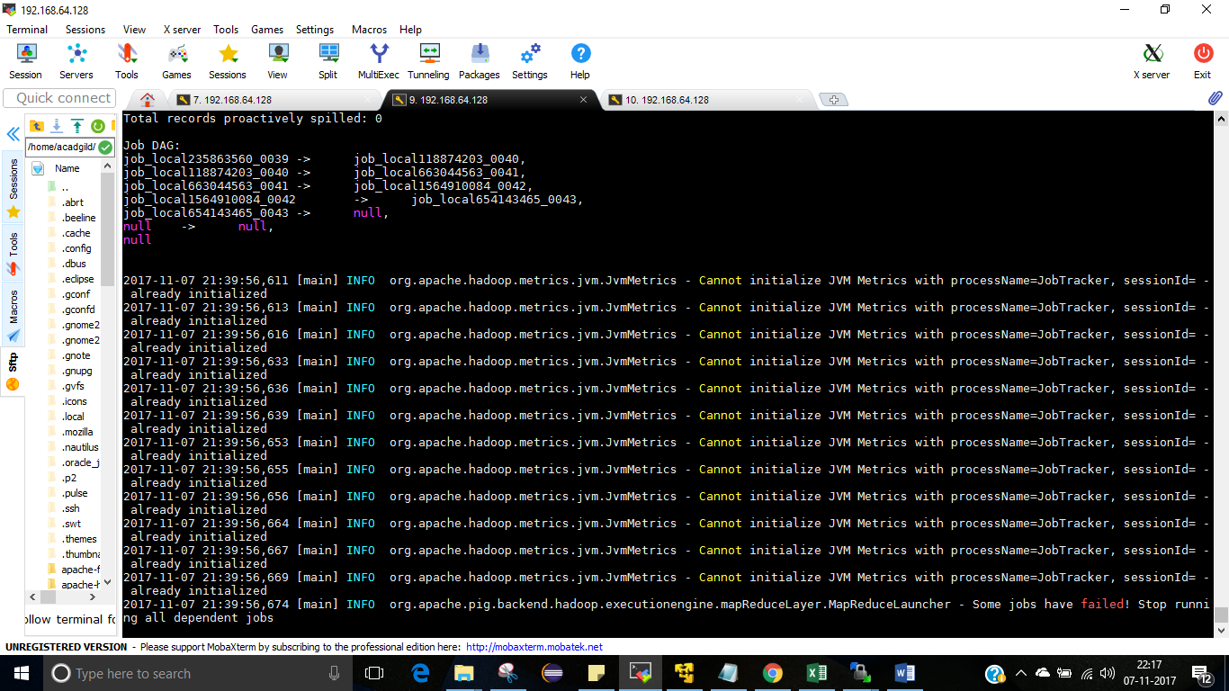

## Problem Statement 4

A = load '/home/acadgild/airline_usecase/DelayedFlights.csv' USING org.apache.pig.piggybank.storage.CSVExcelStorage(',','NO_MULTILINE','UNIX','SKIP_INPUT_HEADER');

B = FOREACH A GENERATE (chararray)$17 as origin, (chararray)$18 as dest, (int)$24 as diversion;

C = FILTER B BY (origin is not null) AND (dest is not null) AND (diversion == 1);

D = GROUP C by (origin,dest);

E = FOREACH D generate group, COUNT(C.diversion);

F = ORDER E BY $1 DESC;

Result = limit F 10;

dump Result;

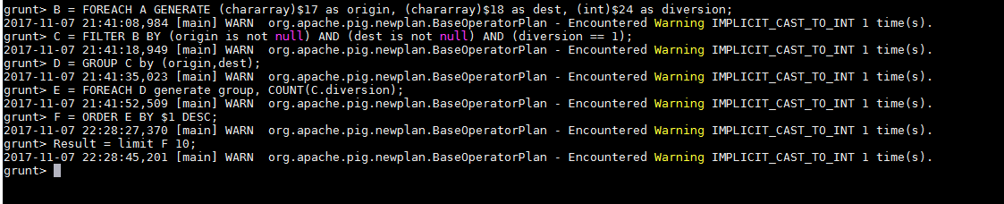

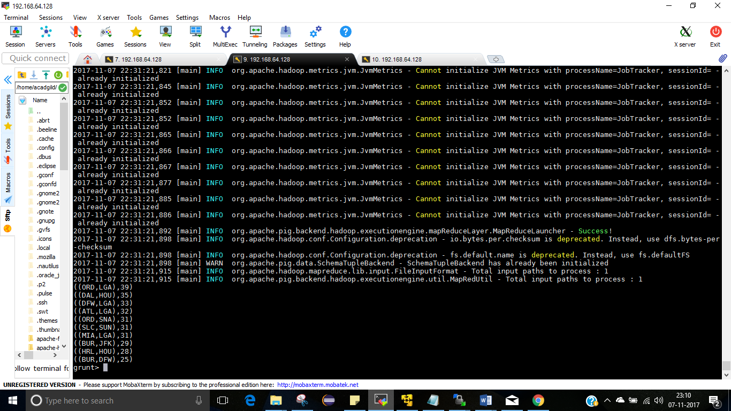

**Problem Statement 2**

A = load '/home/acadgild/airline_usecase/DelayedFlights.csv' USING org.apache.pig.piggybank.storage.CSVExcelStorage(',','NO_MULTILINE','UNIX','SKIP_INPUT_HEADER');

B = foreach A generate (int)$2 as month,(int)$10 as flight_num,(int)$22 as cancelled,(chararray)$23 as cancel_code;

C = filter B by cancelled == 1 AND cancel_code =='B';

D = group C by month;

E = foreach D generate group, COUNT(C.cancelled);

F= order E by $1 DESC;

Result = limit F 1;

dump Result;

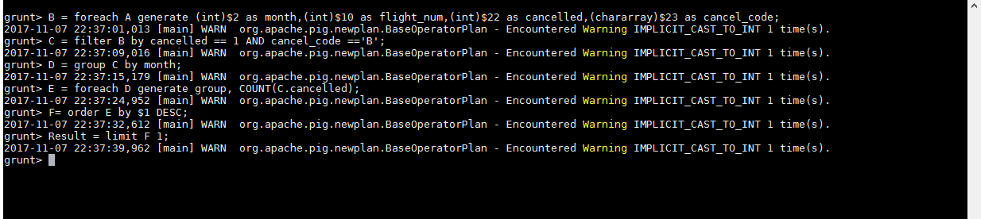

dump Result;

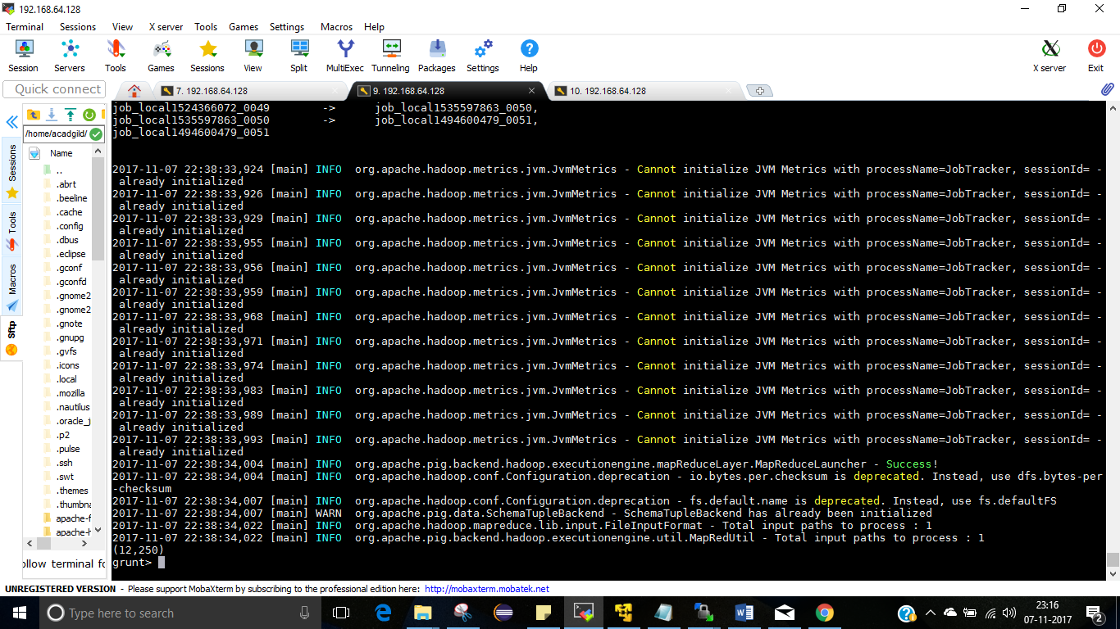

## Problem Statement 3

A = load '/home/acadgild/airline_usecase/DelayedFlights.csv' USING org.apache.pig.piggybank.storage.CSVExcelStorage(',','NO_MULTILINE','UNIX','SKIP_INPUT_HEADER');

B1 = foreach A generate (int)$16 as dep_delay, (chararray)$17 as origin;

C1 = filter B1 by (dep_delay is not null) AND (origin is not null);

D1 = group C1 by origin;

E1 = foreach D1 generate group, AVG(C1.dep_delay);

Result = order E1 by $1 DESC;

Top_ten = limit Result 10;

Lookup = load '/home/acadgild/airline_usecase/airports.csv' USING org.apache.pig.piggybank.storage.CSVExcelStorage(',','NO_MULTILINE','UNIX','SKIP_INPUT_HEADER');

Lookup1 = foreach Lookup generate (chararray)$0 as origin, (chararray)$2 as city, (chararray)$4 as country;

Joined = join Lookup1 by origin, Top_ten by $0;

Final = foreach Joined generate $0,$1,$2,$4;

Final_Result = ORDER Final by $3 DESC;

dump Final_Result;

