Created table name **emp_detail**s and loaded data from emp_detail.txt

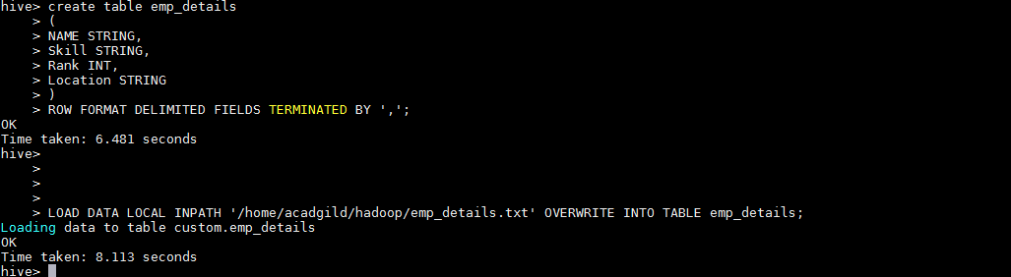

Calculate the number of employees corresponding to each skill from the table 'employee' which is

loaded in the Demo.



**OUTPUT**:-

