1. **create table olympic (athelete STRING,age INT,country STRING,year STRING,closing STRING,sport STRING,gold INT,silver INT,bronze INT,total INT) row format delimited fields terminated by ‘,’;**



1. **Load DATA in table OLYMPIC**

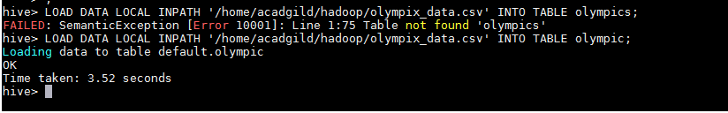

**3 select * from Olympic;**

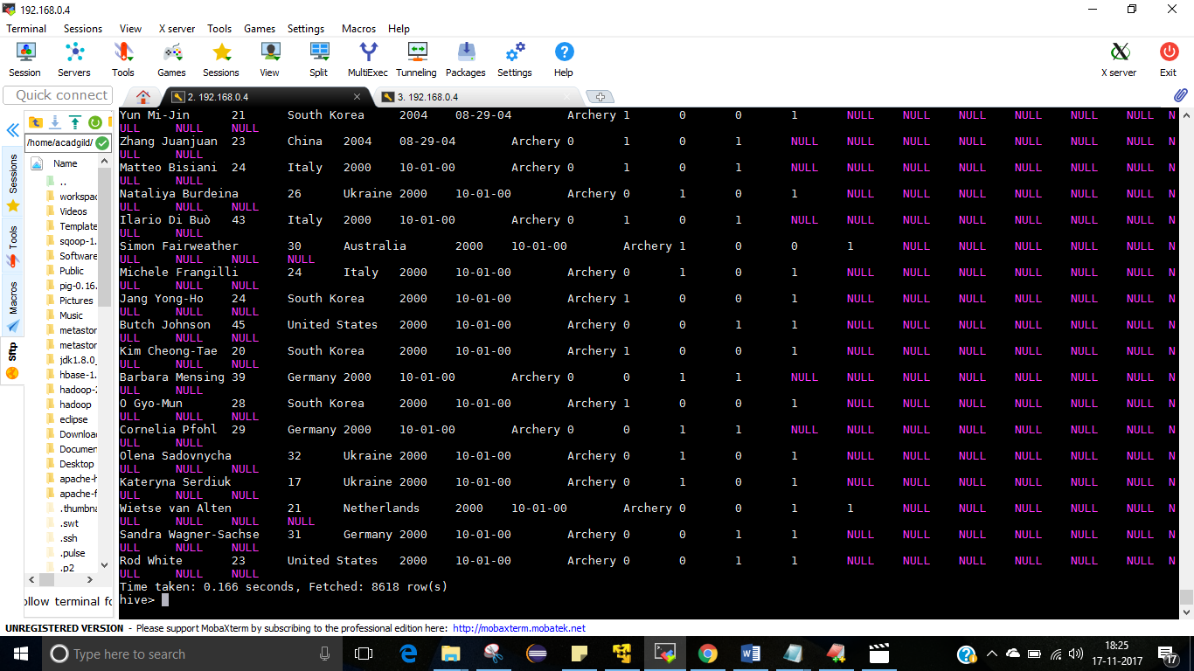

**QUERIES FOR DATASET**

1. **Write a Hive program to find the number of medals won by each country in swimming.**

**select country,SUM(total) from olympic where sport = "Swimming" GROUP BY country;**

**OUTPUT:**

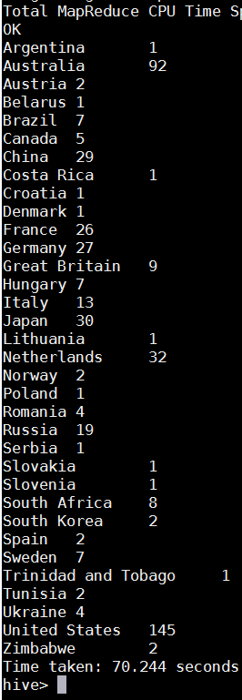

1. **Write a Hive program to find the number of medals that India won year wise.**

**select year,SUM(total) from olympic where country = "India" GROUP BY year;**

**OUTPUT:**

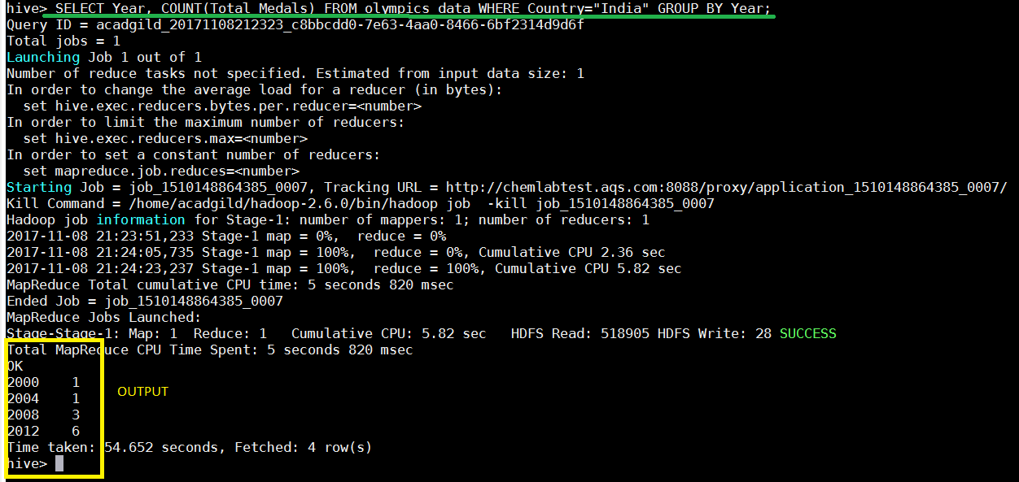

1. **Write a Hive Program to find the total number of medals each country won.**

**select country,SUM(total) from olympic GROUP BY country;**

**OUTPUT:**

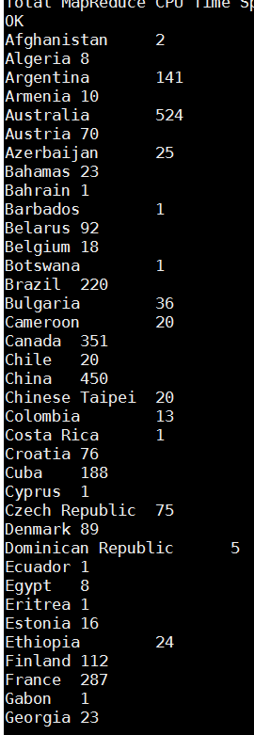

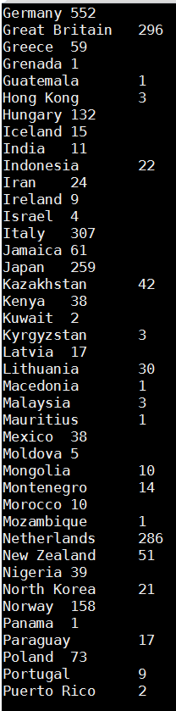

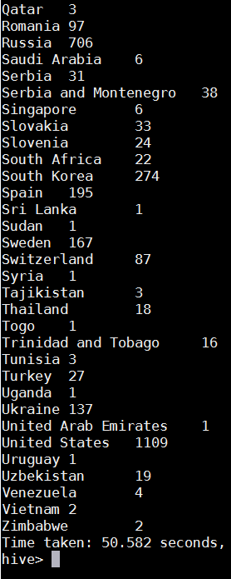

1. **Write a Hive program to find the number of gold medals each country won.**

**select country,SUM(gold) from olympic GROUP BY country;**

**OUTPUT:**

