**ASSIGNMENT 8.3**

**Transactions in Hive**

Transactions in Hive are introduced in Hive 0.13, but they only partially fulfill the ACID properties like atomicity, consistency, durability, at the partition level. Here, Isolation can be provided by turning on one of the locking mechanisms available with zookeeper or in memory.

But in Hive 0.14, new API’s have been added to completely fulfill the ACID properties while performing any transaction.

Transactions are provided at the row-level in Hive 0.14. The different row-level transactions available in Hive 0.14 are as follows:

1. Insert
2. Delete
3. Update

There are numerous limitations with the present transactions available in Hive 0.14. ORC is the file format supported by Hive transaction. It is now essential to have ORC file format for performing transactions in Hive. The table needs to be bucketed in order to support transactions.

### **Row-level Transactions Available in Hive 0.14**

The below properties needs to be set appropriately in ***hive shell***, order-wise to work with transactions in Hive:

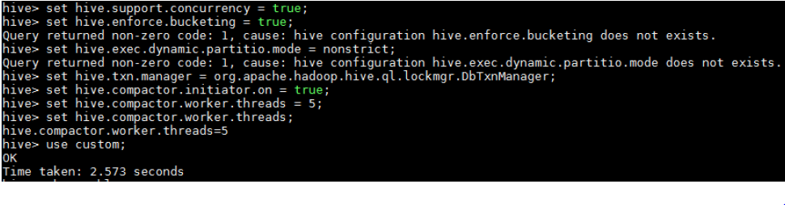

Table Creation for HIVE TRANSACTION:

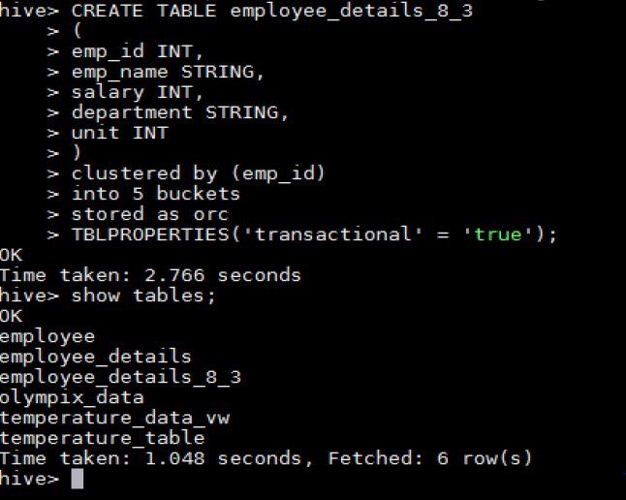 insert data into table

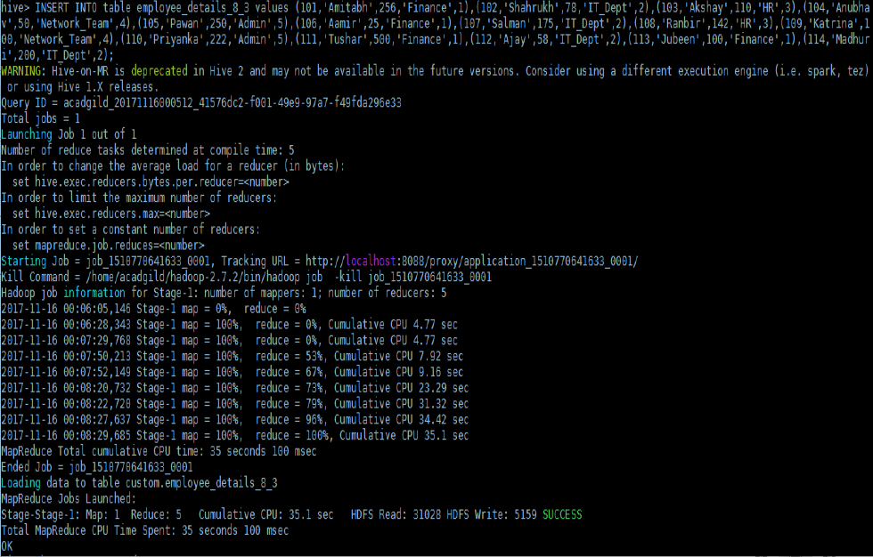

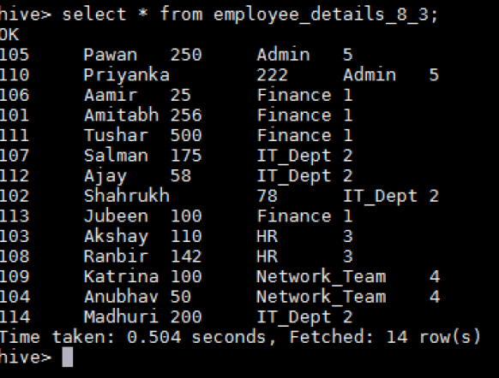

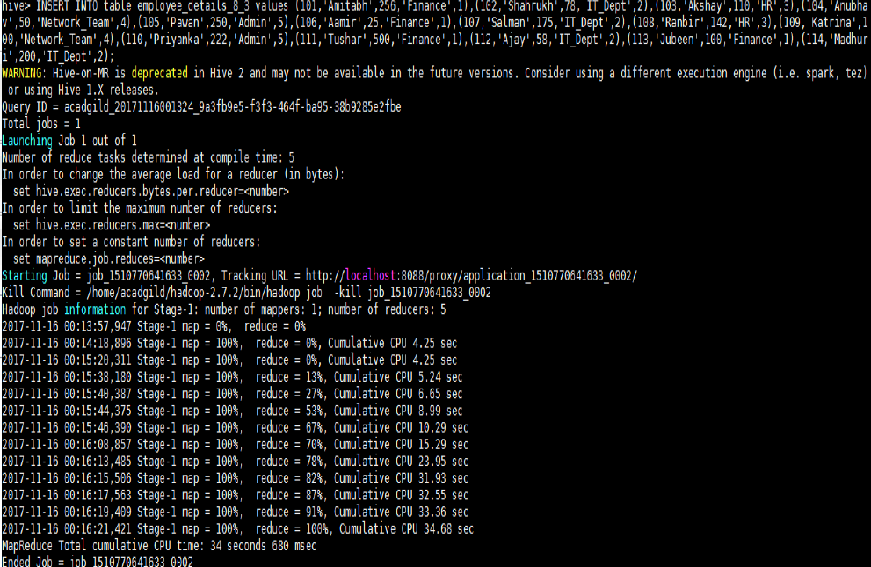



UPDATE DATA

QUERY :



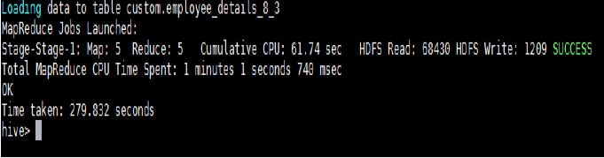

OUTPUT



Delete command



OUTPUT:

