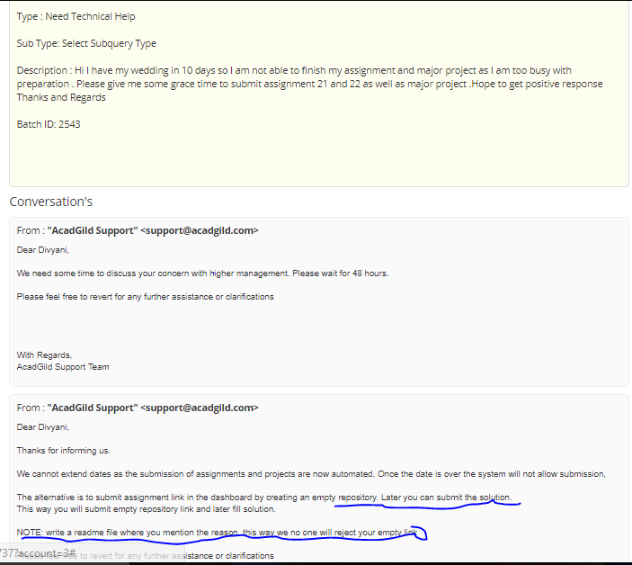

I will be updating assignment and project soon . please do not reject the assignment.