**Name: Varun Menon**

**Reg No: 19BCE1438**

**Course Code: CSE4001**

**Faculty: Dr. Harini S**

**Lab Experiment 1**

1. Write a parallel program to print “Hello World” with 1 thread

Code:

#include <stdio.h>

#include <pthread.h>

#include <stdlib.h>

#include <omp.h>

int main() {

    omp_set_num_threads(1);

    #pragma omp parallel {

        int thNum = omp_get_thread_num();

        printf("Hello World %d\n", thNum);

 }

}

Output:

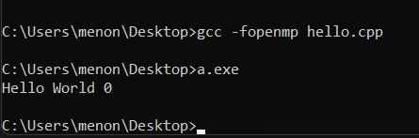

1. Write a parallel program to print “Hello World” with 2 Threads

Code:

#include <stdio.h>

#include <pthread.h>

#include <stdlib.h>

#include <omp.h>

int main()

{

    omp_set_num_threads(2);

    #pragma omp parallel

    {

        int thNum = omp_get_thread_num();

        printf("Hello World %d\n", thNum);

    }

}

Output:

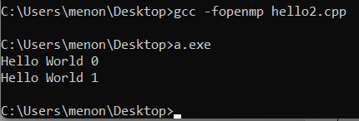

1. Write a parallel program to print “Hello World” with 4 Threads

Code:

#include <stdio.h>

#include <pthread.h>

#include <stdlib.h>

#include <omp.h>

int main()

{

    omp_set_num_threads(4);

    #pragma omp parallel

    {

        int thNum = omp_get_thread_num();

        printf("Hello World %d\n", thNum);

    }

}

Output:

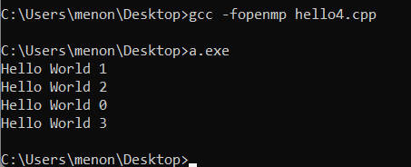

1. Write a parallel program to add 2 arrays

Code:

#define _GNU_SOURCE

#include <stdio.h>

#include <pthread.h>

#include <stdlib.h>

#include <omp.h>

#include <sched.h>

int main()

{

    int a[10], b[10], c[10];

    int i;

    printf("Enter values of first array and second array:\n");

    for(i = 0; i < 10; i++)

    {

        scanf("%d %d", &a[i], &b[i]);

    }

    printf("\n\n");

    printf("Info on Threads:\n");

    #pragma omp parallel

    {

        for (i = 0; i < 10; i++)

        {

            c[i] = a[i] + b[i];

            printf("Thread %d\tValue %d\n", omp_get_thread_num(), c[i]);

        }

    }

    printf("\n\n");

    printf("Sum of Arrays:\n");

    for(i = 0; i < 10; i++)

    {

        printf("%d\n", c[i]);

    }

    return 0;

}

Output:

