1. Python was created by **Guido van Rossum**, and first released on February 20, 1991.
2. Python is a multi-paradigm programming language. **Object-oriented programming and structured programming** are fully supported.
3. **Yes, Python is a case-sensitive language.**
4. The extensions for Python files are -  .**py .**
5. Python is an interpreted language.
6. if else elif for while
7. HASH Character.
8. **python_version()** function.
9. **Lambda**
10. preferred installer program
11. print() , type() , input() , max()
12. 79 characters
13. Python is commonly used for **developing websites and software, task automation, data analysis, and data visualization.**
14. Memory management in Python **involves a private heap containing all Python objects and data structures**.

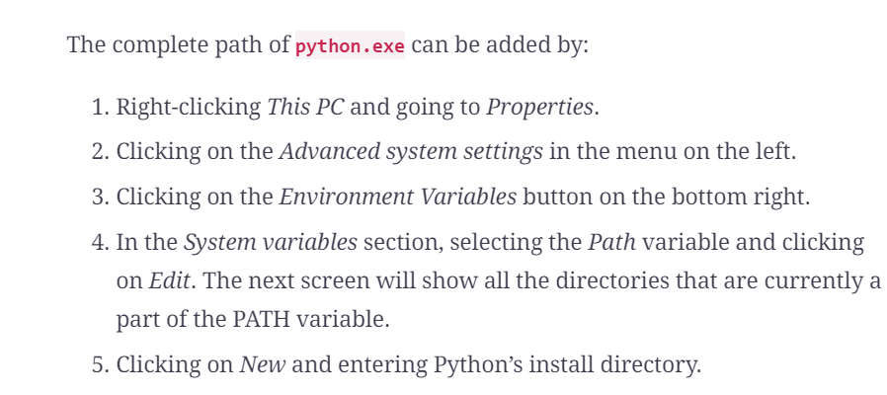

1. Yes required