
A project report on
ECLIPSIS
AI-Based Cyber Security Threat Detection and Intrusion Prevention System
Summer Internship
in
Cyber Security
by
Divyanka Dutta
under the guidance of
AARIVYA LABS INTERNSHIP PROGRAM
July 2026


CERTIFICATE
This is to certify that the project report entitled ECLIPSIS – AI-Based Cyber Security Threat Detection and Intrusion Prevention System submitted by
Divyanka Dutta
in partial fulfillment of the requirements for the award of the Aarivya Labs Internship Program is a bonafide record of the work carried out under my(our) guidance and supervision at Aarivya Labs and H&P Projects

Signature of Supervisor 2  NAME OF THE SUPERVISOR 2  Academic affiliation  Organization | Signature of Supervisor 1  NAME OF THE SUPERVISOR 1  Academic affiliation  Organization
................................................................................................................................................
The Project was evaluated by us on DD/MM/YYYY
EXAMINER 1 |  | EXAMINER 2
EXAMINER 3 |  | EXAMINER 4

ACKNOWLEDGEMENTS

I would like to express my sincere gratitude and heartfelt thanks to Aarivya Labs for their continuous guidance, valuable suggestions, and constant encouragement throughout the course of this project. Their expertise, insightful feedback, and supportive approach helped me gain a deeper understanding of the subject and successfully complete this project.
I am especially thankful to the mentors and technical team at Aarivya Labs for their expert guidance, motivation, and technical support. Their industry knowledge, practical insights, and constructive suggestions played a significant role in shaping this project and enhancing its overall quality.

Finally, I extend my sincere thanks to H&P Projects for providing me with the opportunity to undertake this project and gain valuable academic and practical learning experience. I also express my appreciation to Aarivya Labs for offering industry exposure and mentorship that greatly enriched my understanding and professional growth.

Divyanka Dutta

ABSTRACT

Network intrusions such as brute-force login attempts, port scanning, and denial-of-service attacks continue to pose a serious threat to organizational and personal networks. Traditional signature-based intrusion detection systems struggle to keep pace with the volume and variety of modern attacks, motivating the use of machine learning to detect malicious traffic patterns in real time. This project presents ECLIPSIS, a Real-Time Network Threat Intelligence System that combines AI-based threat detection with automated intrusion prevention and a live monitoring dashboard. The system was built using the CICIDS2017 dataset, from which the top 20 most important traffic features were identified using Random Forest feature importance, after cleaning nearly 2.83 million network flow records and correcting a class-imbalance pipeline using SMOTE applied strictly after the train/test split. Three machine learning models (Decision Tree, Random Forest, and K-Nearest Neighbors) were trained and evaluated, with the final 15-class Random Forest model achieving 98.96% accuracy across BENIGN traffic and 14 attack categories including DDoS, FTP-Patator, SSH-Patator, PortScan, Web Attacks, Heartbleed, and Infiltration. The trained model was then connected to a live packet-capture pipeline built with Scapy, which extracts CICIDS-style flow features from real network traffic and classifies each flow in real time. Detected threats trigger an automated intrusion-prevention layer that blocks malicious IP addresses via the Windows Firewall, combined with a rule-based system covering SSH and FTP brute-force attempts, port scanning, and SYN floods, with a graduated response so that low-confidence detections are only logged or alerted rather than blocked outright. Finally, a Streamlit-based dashboard named ECLIPSIS was developed to present all of this information live: network health scoring, an attack timeline, a threat predictor, geographic IP lookup, attack severity ratings, and a port-activity heatmap. Additional AI upgrades — confidence-based decision thresholding and SHAP-based explainability — were implemented to make the system's decisions more reliable and interpretable. The result is an end-to-end AI-powered intrusion detection and prevention system that moves from raw network packets to an actionable, explainable, and visual security operations interface.

TABLE OF CONTENTS
TOPICS | : | PAGE NO
Abstract | : | 4
Table of Contents | : | 6
List of Figures | : | 7
List of Tables | : | 8
List of symbols/ abbreviations | : | 9
CHAPTER I: INTRODUCTION | : | 12
  - Background and Motivation
1.2 Problem Statement
1.3 Objectives of the project
1.4 Scope of the project
CHAPTER II: BACKGROUND | : | 14
2.1 Intrusion Detection and Prevention Systems
2.2 The CICIDS2017 Dataset and Machine Learning Approach
CHAPTER III: IMPLEMENTATION | : | 16
3.1 System Architecture
3.2 Data Collection and Preprocessing
3.3 Feature Engineering
3.4 Model Training
3.5 Real-Time Network Monitoring
3.6 Intrusion Prevention
CHAPTER IV: RESULTS AND DISCUSSION | : | 23
4.1 Model Performance
4.2 Real-Time Detection and Prevention Results
4.3 Dashboard and Visualisation
4.4 Limitations
CHAPTER V: CONCLUSION & SCOPE FOR FURTHER WORK | : | 27
5.1 Conclusion
5.2 Scope for further work
REFERENCES |  | 11

LIST OF FIGURES

Figure ID | Figure Title | Page
3.1 | Class distribution in the combined dataset prior to SMOTE balancing, showing the severe imbalance between BENIGN traffic and attack classes (FTP-Patator, SSH-Patator). | 18
3.2 | ECLIPSIS dashboard main interface, showing the Network Health Score, live metric panels, and control sidebar in its idle state. | 21
3.3 | Confidence-based decision thresholding zones — predictions below 60% are logged only, 60–80% trigger an alert, and above 80% trigger an alert plus automatic IP block. | 22
3.4 | SHAP feature-contribution chart explaining a detected SSH-Patator flow, confirming Destination Port as the dominant signal (SHAP value 0.4751). | 22
4.1 | Live monitoring log showing captured network flows classified in real time, each correctly identified as BENIGN with high confidence. | 25
4.2 | ECLIPSIS dashboard after a completed monitoring cycle (947 packets, 76 flows), showing the Attack Timeline, Traffic Distribution chart, and Port Activity Heatmap | 26

LIST OF TABLES

Table ID | Table Title | Page
3.1 | Dataset loading, cleaning, and preprocessing summary. | 16
3.2 | Top features ranked by Random Forest importance score. | 17
3.3 | Class distribution before and after SMOTE balancing. | 18
3.4 | Rule-based intrusion prevention logic. | 20
3.5 | Confidence-based decision thresholding logic. | 22
4.1 | Model accuracy and training time comparison (3-class) | 23
4.2 | Comparison between the 3-class and 15-class models. | 23
4.3 | 15-class model precision and recall by attack type | 23
4.4 | Live intrusion-prevention system test results. | 24
4.5 | Confidence-threshold test cases and outcomes. | 25

LIST OF SYMBOLS / ABBREVIATIONS

Symbol / abbreviations | Description
IDS | Intrusion Detection System
IPS | Intrusion Prevention System
NIDS | Network Intrusion Detection System
HIDS | Host Intrusion Detection System
SIEM | Security Information and Event Management
DDoS | Distributed Denial of Service
DoS | Denial of Service
TCP | Transmission Control Protocol
IP | Internet Protocol
SSH | Secure Shell (also SSH-Patator brute-force attack)
FTP | File Transfer Protocol (also FTP-Patator brute-force attack)
SYN | Synchronize — TCP connection flag
PSH | Push — TCP connection flag
SMOTE | Synthetic Minority Oversampling Technique
KNN | K-Nearest Neighbors
ROC-AUC | Receiver Operating Characteristic — Area Under Curve
SHAP | SHapley Additive exPlanations
API | Application Programming Interface
UI | User Interface
IDE | Integrated Development Environment
SOC | Security Operations Center
CSV | Comma-Separated Values
AI | Artificial Intelligence
ML | Machine Learning

References
- I. Sharafaldin, A. Habibi Lashkari, and A. A. Ghorbani, "Toward Generating a New Intrusion Detection Dataset and Intrusion Traffic Characterization," 4th International Conference on Information Systems Security and Privacy (ICISSP), 2018 (CICIDS2017 Dataset).
- S. M. Lundberg and S.-I. Lee, "A Unified Approach to Interpreting Model Predictions," Advances in Neural Information Processing Systems (NeurIPS), 2017 (SHAP).
- Scapy Documentation, https://scapy.net/.
6. Streamlit Documentation, https://docs.streamlit.io/.
7. Plotly Python Open Source Graphing Library, https://plotly.com/python/.
8. Wireshark Documentation, https://www.wireshark.org/docs/.
9. Microsoft Docs, "netsh advfirewall firewall Command-Line Utility," https://learn.microsoft.com/.
10. ip-api.com, "IP Geolocation API," https://ip-api.com/.

CHAPTER I: INTRODUCTION
1.1 Background and Motivation
Network intrusions such as brute-force login attempts, port scanning, denial-of-service floods, and web-application attacks continue to threaten organizational and personal networks. Traditional signature-based Intrusion Detection Systems (IDS) rely on known attack patterns and struggle to keep pace with the volume, speed, and variety of modern network traffic. Machine learning offers an alternative: rather than matching traffic against a fixed list of signatures, a trained model can learn the statistical patterns that separate normal traffic from malicious traffic, and generalize that knowledge to detect attacks it has not seen labeled examples of before.
This project was undertaken as part of the Aarivya Labs Internship Program, in the Cyber Security domain, with the goal of designing and building a working AI-based cyber security threat detection and intrusion prevention system, from raw network data through to a live, usable monitoring interface.
1.2 Problem Statement
Given a stream of live network traffic, the problem addressed by this project is threefold: (1) accurately classify network flows as either normal (BENIGN) traffic or one of several known attack categories using a machine learning model trained on labeled network flow data; (2) automatically respond to detected threats by blocking malicious IP addresses at the firewall level, while minimizing false positives that could block legitimate traffic; and (3) present all of this information through a live, human-readable dashboard so that a security analyst can monitor network health, review alerts, and understand why the system made a given decision.
1.3 Objectives of the Project
The specific objectives defined for this internship project were:
– To study core cyber security concepts, attack types, and Intrusion Detection/Prevention System architectures.
– To obtain, clean, and analyze a realistic labeled network traffic dataset (CICIDS2017).
– To engineer relevant traffic features and train machine learning models capable of classifying both a small (3-class) and a broad (15-class) set of attack types.
– To build a real-time packet capture and feature extraction pipeline capable of feeding live network traffic into the trained model.
– To implement automated intrusion prevention that blocks malicious IP addresses using the Windows Firewall, combined with a rule-based safety layer.
– To build a live, branded monitoring dashboard (named ECLIPSIS) that visualizes network health, alerts, and threat analytics.
– To improve the reliability and interpretability of the AI model's decisions using confidence thresholding and SHAP-based explainability.
1.4 Scope of the Project
The scope of this project covers the full pipeline from dataset acquisition to a live demonstrable system: data preprocessing, feature engineering, model training and evaluation (3-class and 15-class Random Forest/Decision Tree/KNN models), real-time packet capture using Scapy, automated intrusion prevention via the Windows Firewall, and a Streamlit-based real-time dashboard. The project is scoped to a single-host Windows environment for live monitoring and does not include distributed or multi-node network monitoring.
CHAPTER II: BACKGROUND
2.1 Intrusion Detection and Prevention Systems
An Intrusion Detection System (IDS) monitors network or host activity for malicious behavior or policy violations, while an Intrusion Prevention System (IPS) goes a step further and actively blocks or mitigates detected threats. IDS/IPS architectures are commonly classified as Network-based (NIDS/NIPS), which monitor traffic across a network segment, Host-based (HIDS/HIPS), which monitor activity on a single machine, or Hybrid systems that combine both. This project's background research also covered broader cyber defense strategies that informed the system's design philosophy, including Defense in Depth, Least Privilege, Zero Trust, Network Segmentation, Threat Intelligence, Incident Response, and Security Information and Event Management (SIEM). Common attack categories studied include Distributed Denial of Service (DDoS), brute-force credential attacks, port scanning, man-in-the-middle (MITM) attacks, SQL injection, botnets, and infiltration, alongside underlying network vulnerabilities such as unpatched software, weak passwords, open ports, misconfigured firewalls, unencrypted data, poor access control, social engineering, and zero-day vulnerabilities.
2.2 The CICIDS2017 Dataset and Machine Learning Approach
The CICIDS2017 dataset (Canadian Institute for Cybersecurity, 2017) provides realistic, labeled network flow data captured over five days, containing both benign traffic and a wide range of modern attack types including brute-force FTP/SSH attacks, DoS/DDoS variants, web attacks, infiltration, botnet activity, and port scanning. Each flow record contains around 78 statistical features describing packet timing, size, and protocol-level behavior, making it well suited to supervised machine learning.
This project uses supervised classification, in which a model is trained on flows already labeled as BENIGN or a specific attack type, and learns to predict the correct label for unseen flows. Three algorithms were evaluated: Decision Tree, Random Forest, and K-Nearest Neighbors (KNN), all implemented using scikit-learn. Because attack traffic is naturally rare compared to normal traffic, the Synthetic Minority Oversampling Technique (SMOTE) was used to balance the training data, and SHAP (SHapley Additive exPlanations) was used to interpret individual model predictions by quantifying each feature's contribution to a given decision.
CHAPTER III: IMPLEMENTATION
3.1 System Architecture
The completed system, named ECLIPSIS (Real-Time Network Threat Intelligence System), follows a pipeline architecture: live network packets are captured and grouped into flows; CICIDS-style statistical features are extracted from each flow; a trained Random Forest model classifies the flow as BENIGN or one of several attack types; a confidence-thresholding and rule-based decision layer determines whether to log, alert, or block; the Windows Firewall is used to block malicious IP addresses; and a Streamlit dashboard presents all of this information live, including a Geo IP lookup, severity ratings, and a network health score.
3.2 Data Collection and Preprocessing
The CICIDS2017 MachineLearningCSV dataset was downloaded and initially loaded using the Monday (529,918 BENIGN rows) and Tuesday (432,074 BENIGN, 7,938 FTP-Patator, and 5,897 SSH-Patator rows) files, combined into a single dataset of 975,827 rows across 79 columns. Cleaning steps included removing 32 rows with negative Flow Duration values and replacing or dropping 1,402 infinity values (701 rows dropped). Labels were encoded numerically (BENIGN→0, FTP-Patator→1, SSH-Patator→2), features were separated from labels and scaled using StandardScaler, and the data was split 80/20 into training and test sets. Visual analysis of the traffic showed that attack traffic tends to be uniform and repetitive, whereas normal user traffic is comparatively random — an early insight that motivated the choice of statistical flow features for classification. The pipeline was later extended to all five days of the dataset (Monday–Friday, 2,830,743 rows, cleaned to 2,827,761), covering 15 total classes (BENIGN plus 14 attack types), after fixing a label-encoding issue in the Web Attack category.
Table 3.1: Dataset loading, cleaning, and preprocessing summary.
Step | Action | Result
Load dataset | Loaded Monday + Tuesday CICIDS2017 CSVs with Pandas | 975,827 rows loaded
Remove negative durations | Removed rows where Flow Duration < 0 | 32 rows removed
Handle infinity values | Replaced infinity values with NaN, then dropped | 701 rows removed
Label encoding | Converted text labels to numbers | BENIGN=0, FTP-Patator=1, SSH-Patator=2
Final clean shape | Dataset ready for feature engineering | 975,094 rows, 79 columns
Extension to 5 days | Combined Monday–Friday for the 15-class model | 2,827,761 rows, 15 classes

3.3 Feature Engineering
Random Forest feature importance (10 trees, 50,000-row sample) was used to reduce the original 78 features down to the top 20 most informative features. On the 3-class dataset, Destination Port was by far the strongest feature (importance score 0.3049), reflecting that FTP-Patator targets port 21 and SSH-Patator targets port 22. Class imbalance was corrected using SMOTE — critically, applied only after the train/test split to avoid data leakage. Before balancing, the training data contained 961,262 BENIGN, 7,935 FTP-Patator, and 5,897 SSH-Patator rows; after SMOTE, all three classes were balanced to 961,262 rows each, for a total of 2,307,027 training rows. Attack pattern analysis showed that FTP-Patator traffic moves at roughly twice the packet rate of normal traffic, while SSH-Patator traffic shows slower, more persistent connections. When the pipeline was extended to the full 15-class dataset, Destination Port's importance dropped from rank 1 to rank 10 as attack diversity increased, with Total Length of Bwd Packets emerging as the new top feature (importance 0.072).
Table 3.2: Top features ranked by Random Forest importance score.
Rank | Feature | Importance Score
1 | Destination Port | 0.3049
2 | Bwd Header Length | 0.0697
3 | Total Fwd Packets | 0.0585
4 | Fwd Packet Length Mean | 0.0557
5 | Total Length of Fwd Packets | 0.0508
6 | Init_Win_bytes_backward | 0.0481
7 | Fwd Packet Length Max | 0.0360
8 | Init_Win_bytes_forward | 0.0310
9 | Fwd Header Length.1 | 0.0260
10 | Max Packet Length | 0.0239

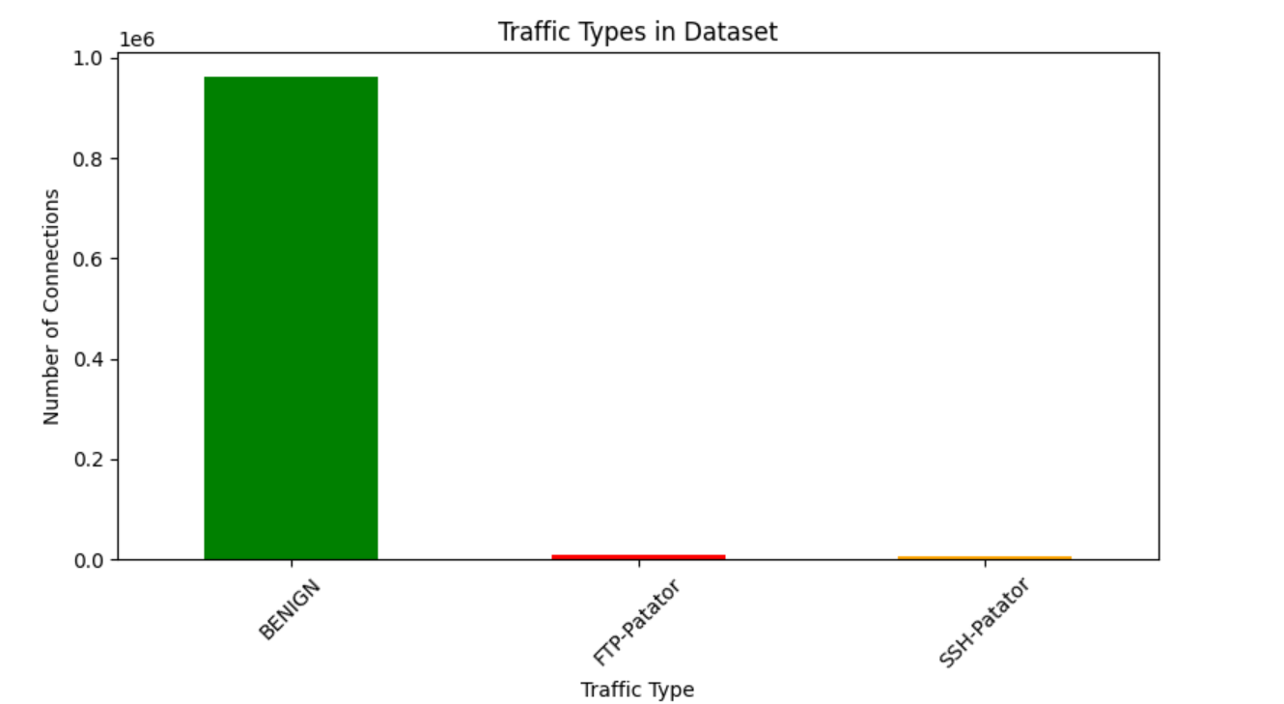
Fig 3.1: Class distribution in the combined dataset prior to SMOTE balancing, showing the severe imbalance between BENIGN traffic and attack classes (FTP-Patator, SSH-Patator).
Table 3.3: Class distribution before and after SMOTE balancing.
Class | Label | Before SMOTE | After SMOTE
BENIGN | 0 | 961,262 | 961,262
FTP-Patator | 1 | 7,935 | 961,262
SSH-Patator | 2 | 5,897 | 961,262
Total | – | 975,094 | 2,883,786

3.4 Model Development
An initial pipeline bug was discovered and corrected during this phase: SMOTE had originally been applied before the train/test split, which caused synthetic samples derived from test data to leak into training. The corrected pipeline splits the data first and applies SMOTE only to the training portion. On the corrected 3-class dataset, three models were trained and compared: Decision Tree (100% accuracy, 11.62 seconds), Random Forest (100% accuracy, 28.34 seconds), and KNN (99.84% accuracy). Five-fold cross-validation confirmed accuracy consistently between 99.9% and 100%, with only 2 misclassifications across 195,019 test samples and a ROC-AUC of 1.0000 for all three classes. This very high accuracy is explained by Destination Port acting as a near-perfect indicator for FTP/SSH brute-force attacks in this dataset.
The pipeline was then extended to a full 15-class model covering all five days of the CICIDS2017 dataset. After applying SMOTE to the training data only (27,254,445 balanced training rows), a Random Forest with 30 trees and a maximum depth of 20 was trained in 7.46 minutes, achieving 98.96% overall accuracy. The weighted average F1-score was 0.99, but the macro-average dropped to 0.74, revealing weaker performance on rare classes such as Web Attack categories (9–17 real samples), Heartbleed (9 samples), and Infiltration (29 samples) — an expected limitation given how few real examples of these attacks exist in the dataset. The trained artifacts (3-class and 15-class Random Forest models, their scalers, and the 15-class label encoder) were saved for reuse in the real-time pipeline and dashboard.
3.5 Real-Time Network Monitoring
To move from a static, dataset-trained model to a live system, Scapy and Npcap were installed to capture live packets directly from the network interface (run under an Administrator terminal, as required for packet capture on Windows). Captured packets are grouped into flows — conversations between two endpoints — from which 20 CICIDS-style features are calculated, some exactly (Destination Port, packet counts and lengths, SYN/PSH flag counts) and some approximated (backward header length, initial window bytes, subflow statistics) since raw packets do not directly expose every CICIDS flow statistic. The live feature columns were carefully aligned in name and order with the columns used during training — a detail that matters because the CICIDS dataset's column names contain leading spaces (e.g. " Destination Port"), and because live data must always be transformed with scaler.transform() rather than re-fit. In initial testing, all live traffic on the development laptop was correctly classified as BENIGN, and a real SSH-Patator sample taken from the dataset was correctly detected with 100% confidence when replayed through the pipeline.
3.6 Intrusion Prevention
Automated prevention was implemented using Windows' netsh advfirewall firewall command, invoked via Python's subprocess module, with a companion unblock function and duplicate-IP protection to avoid creating redundant firewall rules. All blocking actions are logged with timestamp, IP address, reason, action, and status. During testing, a false-positive bug was discovered in an early DDoS detection rule, which used total backward packet bytes rather than actual packet rate and ended up blocking the development machine's own IP address; the rule was corrected to use forward packet count and connection duration instead. The final rule-based safety layer combines four rules — SSH brute-force (port 22, more than 20 forward packets, under 60 seconds → block, HIGH severity), FTP brute-force (port 21, same thresholds → block, HIGH), port scanning (a single forward packet in under 1 second → alert only, MEDIUM), and SYN flood (over 1,000 forward packets in under 10 seconds → block, CRITICAL) — together with the AI model's own predictions, so that if the AI model says a flow is BENIGN but a rule still triggers, the system raises an alert rather than automatically blocking, giving a graduated response instead of a single binary decision.
Table 3.4: Rule-based intrusion prevention logic.
Rule Name | Condition | Action | Severity
SSH Brute Force | Port 22 AND forward packets > 20 AND duration < 60s | BLOCK | HIGH
FTP Brute Force | Port 21 AND forward packets > 20 AND duration < 60s | BLOCK | HIGH
Port Scanning | Forward packets = 1 AND duration < 1s | ALERT | MEDIUM
SYN Flood | Forward packets > 1000 AND duration < 10s | BLOCK | CRITICAL

3.7 Dashboard Development (ECLIPSIS)
The project was formally branded as ECLIPSIS — Real-Time Network Threat Intelligence System — and its live front end was built using Streamlit and Plotly. Unlike the earlier Jupyter Notebook-based development, Streamlit dashboards are standalone Python scripts launched from the terminal and rendered live in the browser. An initial functional dashboard (v1) displayed live metrics, a monitoring log, an alert feed, a traffic-distribution pie chart, and a sidebar of blocked IP addresses. Dashboard v2 added a 0–100 Network Health Score with color-coded status, a live Attack Timeline with pulsing indicators for threat events, a Threat Predictor that estimates the most likely next attack type from recent alert history, a Geo IP Lookup panel using the ip-api.com REST API to identify the country and city of attacking IP addresses, Attack Severity Ratings (CRITICAL/HIGH/MEDIUM/LOW) for all 15 attack types, a Port Activity Heatmap highlighting which ports are targeted most often, and session statistics such as uptime and scan count.
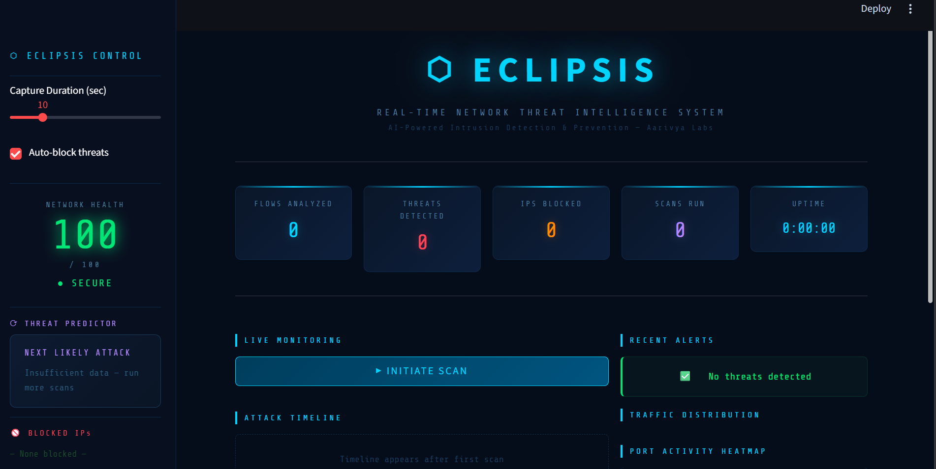
Fig 3.2: ECLIPSIS dashboard main interface, showing the Network Health Score, live metric panels, and control sidebar in its idle state.
As additional enhancements beyond the core dashboard requirements, two AI upgrades were implemented in a dedicated notebook. Confidence Thresholding maps the model's prediction confidence to a graduated response: predictions below 60% confidence are logged silently, predictions between 60% and 80% generate an alert without blocking, and predictions above 80% generate an alert and automatically block the source IP; all six manual test cases for this logic produced the expected result. SHAP Explainability was integrated using a SHAP TreeExplainer built for the 15-class Random Forest model, producing per-feature contribution scores for individual predictions; for a tested SSH-Patator sample, Destination Port was confirmed as by far the strongest signal (SHAP impact 0.4751, more than four times the second-most-important feature), reinforcing the earlier feature importance findings. Extending this explanation function across all 15 attack classes, along with further planned upgrades — anomaly detection and ensemble voting — remained in progress at the time of writing.
Table 3.5: Confidence-based decision thresholding logic.
Threshold | Confidence Range | Action Taken
LOG | Below 60% | Silently log — no alert, no block
ALERT | 60% to 80% | Generate alert — do not block
BLOCK | Above 80% | Generate alert AND block IP
SAFE | Any (BENIGN) | No action

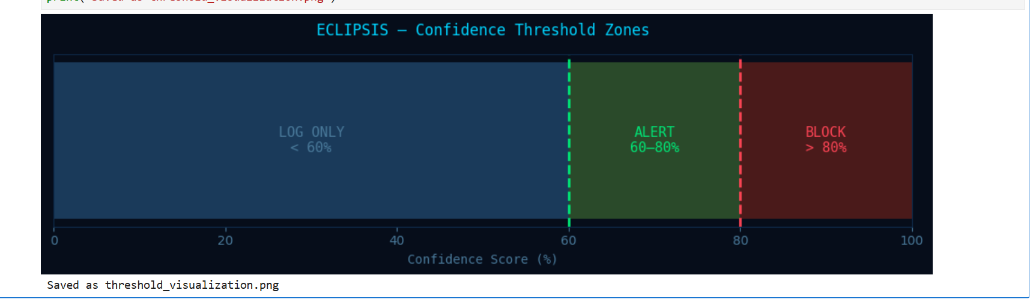
Fig 3.3: Confidence-based decision thresholding zones — predictions below 60% are logged only, 60–80% trigger an alert, and above 80% trigger an alert plus automatic IP block.
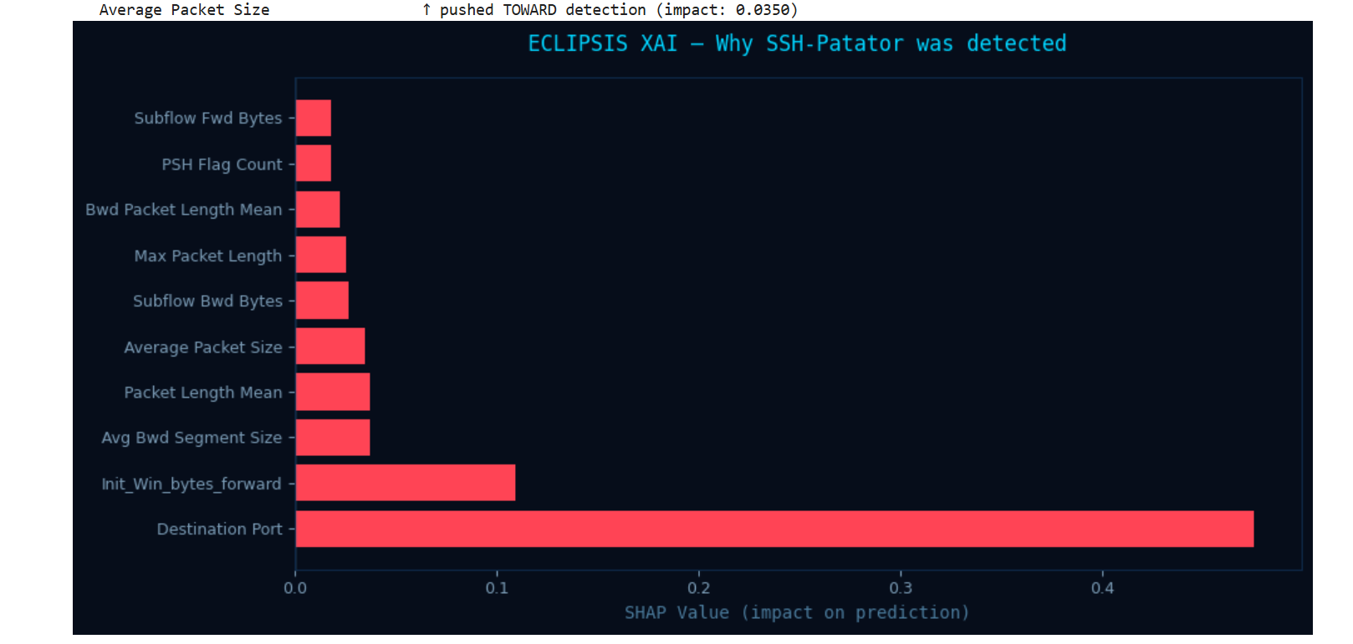
Fig 3.4: SHAP feature-contribution chart explaining a detected SSH-Patator flow, confirming Destination Port as the dominant signal (SHAP value 0.4751).
CHAPTER IV: RESULTS AND DISCUSSION
4.1 Model Performance
The 3-class model (BENIGN, FTP-Patator, SSH-Patator) achieved effectively perfect performance, with the Random Forest and Decision Tree models both reaching 100% test accuracy and only 2 misclassifications out of 195,019 test samples, confirmed by 5-fold cross-validation and a ROC-AUC of 1.0000 for every class. The 15-class model, covering the full range of CICIDS2017 attack types, achieved 98.96% overall accuracy with a weighted-average F1-score of 0.99. However, its macro-average F1-score of 0.74 shows that performance on the rarest attack classes — Web Attack categories, Heartbleed, and Infiltration, each with fewer than 30 real training examples — is considerably weaker than on well-represented classes. This is a known and expected limitation of training on a fixed, imbalanced real-world dataset rather than a data-quality flaw in the pipeline itself, and it is an important caveat when interpreting the system's overall accuracy figure.
Table 4.1: Model accuracy and training time comparison (3-class).
Model | Accuracy | Training Time
Decision Tree | 100.00% | 11.62 sec
Random Forest | 100.00% | 28.34 sec
K-Nearest Neighbors (KNN) | 99.84% | Slower prediction

Table 4.2: Comparison between the 3-class and 15-class models.
Property | 3-Class Model | 15-Class Model
Source data | Monday + Tuesday only | All 5 days (Monday–Friday)
Total rows (cleaned) | 975,094 | 2,827,761
Number of classes | 3 | 15
Rows after SMOTE (training) | 2,307,027 | 27,254,445
Model used | Random Forest | Random Forest (30 trees, max_depth=20)
Training time | 28.34 sec | 447.64 sec (7.46 min)
Overall accuracy | 100.00% | 98.96%

Table 4.3: 15-class model precision and recall by attack type.
Attack Type | Precision | Recall | Performance
BENIGN | 1.00 | 0.99 | Excellent
DDoS | 1.00 | 1.00 | Excellent
DoS Hulk | 0.99 | 1.00 | Excellent
PortScan | 0.99 | 1.00 | Excellent
SSH-Patator / FTP-Patator | 0.97–1.00 | 1.00 | Excellent
Bot | 0.34 | 1.00 | Poor precision — many false alarms
Web Attack (Brute Force/XSS/SQLi) | 0.00–0.08 | 0.20–0.96 | Poor — insufficient real samples
Heartbleed | 0.67 | 1.00 | Unreliable — only 9 real samples
Infiltration | 1.00 | 0.57 | Unreliable — only 36 real samples

4.2 Real-Time Detection and Prevention Results
Across multiple live monitoring test runs, the system consistently and correctly classified all live traffic on the development machine as BENIGN, since ordinary browsing traffic on a personal laptop does not itself contain real attacks. In one representative real-time monitoring session, 2,944 packets were captured, forming 40 flows, with zero threats detected and correctly logged. When the intrusion-prevention rule-based layer was tested alongside the AI model on a separate run of 1,244 packets (19 flows), the AI model again reported zero threats, while the rule-based layer correctly raised one port-scan alert without blocking it — demonstrating the value of the graduated, alert-vs-block response for lower-confidence signals. To validate true-positive detection, a real SSH-Patator sample drawn from the CICIDS2017 dataset was replayed through the live pipeline and correctly classified with 100% confidence, confirming that the trained model, feature-extraction pipeline, and firewall-blocking logic all function correctly together, even though genuine attacks did not occur naturally during testing.
Table 4.4: Live intrusion-prevention system test results.
Test Run | Packets | Flows | AI Threats | Rules Triggered | IPs Blocked
Run 1 (basic IPS) | 392 | 10 | 0 | 0 | 0 — all BENIGN
Run 2 (buggy rule) | 227 | 11 | 0 | 1 | 1 — false positive (own IP)
Run 3 (fixed rules) | 1,244 | 19 | 0 | 1 | 0 — alert only, no block

Table 4.5: Confidence-threshold test cases and outcomes.
Prediction | Confidence | Expected Action | Result
SSH-Patator | 95.0% | BLOCK | BLOCK — auto-blocked (95.0%)
DDoS | 72.0% | ALERT | ALERT — alert only (72.0%)
PortScan | 45.0% | LOG | LOG — logged silently (45.0%)
BENIGN | 99.0% | SAFE | SAFE — normal traffic
FTP-Patator | 81.0% | BLOCK | BLOCK — auto-blocked (81.0%)
Web Attack - XSS | 59.0% | LOG | LOG — logged silently (59.0%)

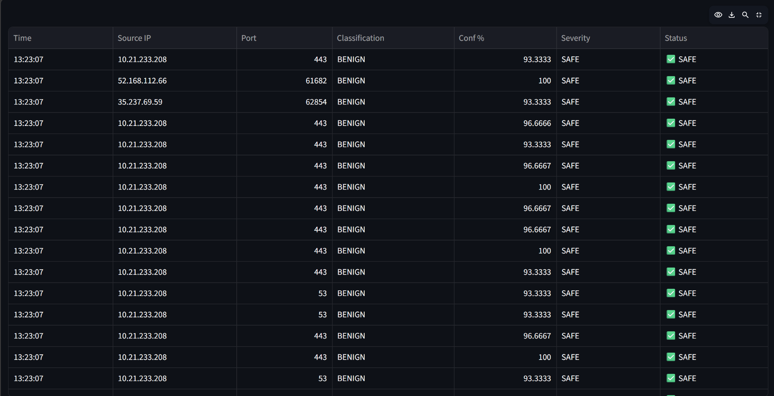
Fig 4.1: Live monitoring log showing captured network flows classified in real time, each correctly identified as BENIGN with high confidence.
4.3 Dashboard and Visualization
The ECLIPSIS dashboard successfully brought together every stage of the pipeline into a single, live operational view. The Network Health Score gave an at-a-glance summary of overall network condition; the Attack Timeline and monitoring log gave a chronological record of every flow analyzed; the Geo IP Lookup and Attack Severity Ratings added investigative context to individual alerts rather than a flat threat/no-threat signal; and the Port Activity Heatmap gave a visual sense of which services were being probed most. Because all live test traffic was benign, the dashboard's attack-handling features (alert cards, blocking notifications, the timeline's pulsing threat indicators) could only be confirmed using replayed dataset samples rather than organically during testing — which is why a controlled Demo Mode, capable of injecting simulated attack flows for presentation purposes, was identified as a priority for the final stage of the project.
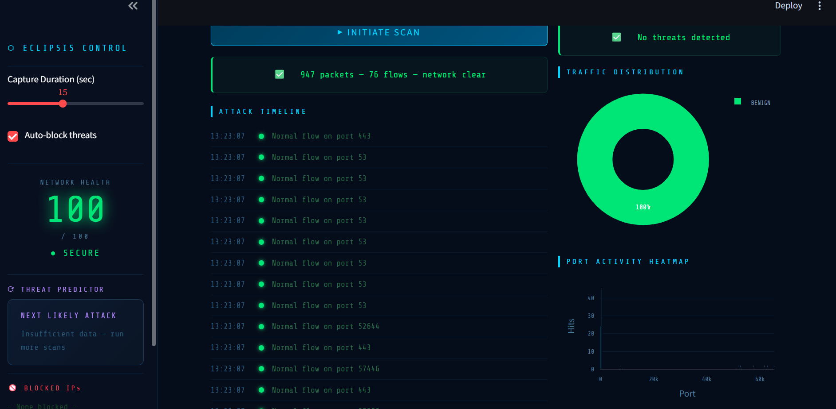
Fig 4.2: ECLIPSIS dashboard after a completed monitoring cycle (947 packets, 76 flows), showing the Attack Timeline, Traffic Distribution chart, and Port Activity Heatmap.
4.4 Limitations
– Reduced accuracy on rare attack classes (Web Attacks, Heartbleed, Infiltration) due to very few real training examples, rather than any flaw in the modeling approach.
– Live traffic on an ordinary development machine rarely contains genuine attacks, making organic true-positive demonstrations difficult without a dedicated Demo Mode.
– Approximated (rather than exactly measured) flow features in the live pipeline, since not every CICIDS statistic can be derived directly from raw captured packets.
– The system currently requires an Administrator terminal for packet capture and a single-host Windows environment, rather than distributed, multi-node deployment.
CHAPTER V: CONCLUSION & SCOPE FOR FURTHER WORK
5.1 Conclusion
This project successfully designed and implemented ECLIPSIS, an end-to-end AI-based cyber security threat detection and intrusion prevention system, covering the complete pipeline from raw labeled network data to a live, branded monitoring dashboard. Working with the CICIDS2017 dataset, statistically important traffic features were identified and used to train Decision Tree, Random Forest, and KNN classifiers, culminating in a 15-class Random Forest model achieving 98.96% overall accuracy across BENIGN traffic and 14 distinct attack categories. This model was connected to a live packet-capture and feature-extraction pipeline built with Scapy, enabling real-time classification of network flows, and paired with an automated intrusion-prevention layer that blocks malicious IP addresses through the Windows Firewall while using a graduated, rule-assisted response to reduce false positives. All of this was made visible and usable through the ECLIPSIS Streamlit dashboard, which adds network health scoring, geographic threat context, severity ratings, and, through confidence thresholding and SHAP explainability, a more reliable and interpretable decision-making process. Along the way, a data-leakage bug (SMOTE applied before the train/test split) and a false-positive firewall rule were identified and corrected, reflecting the kind of iterative debugging that real-world machine learning security systems require.
5.2 Scope for Further Work
Several extensions were identified during the project and are planned for its final stage:.
– Adding Anomaly Detection (e.g. Isolation Forest) to catch novel, zero-day attack patterns that do not resemble any labeled training class.
– Adding Ensemble Voting across the Random Forest, Decision Tree, and KNN models to improve robustness on rare attack classes.
– Implementing a controlled Demo Mode that injects simulated attack traffic, to reliably showcase detection and blocking behavior during live presentations.
– Packaging the system with Docker for portable, reproducible deployment beyond a single development machine.

