AWS Project Architecture Summary

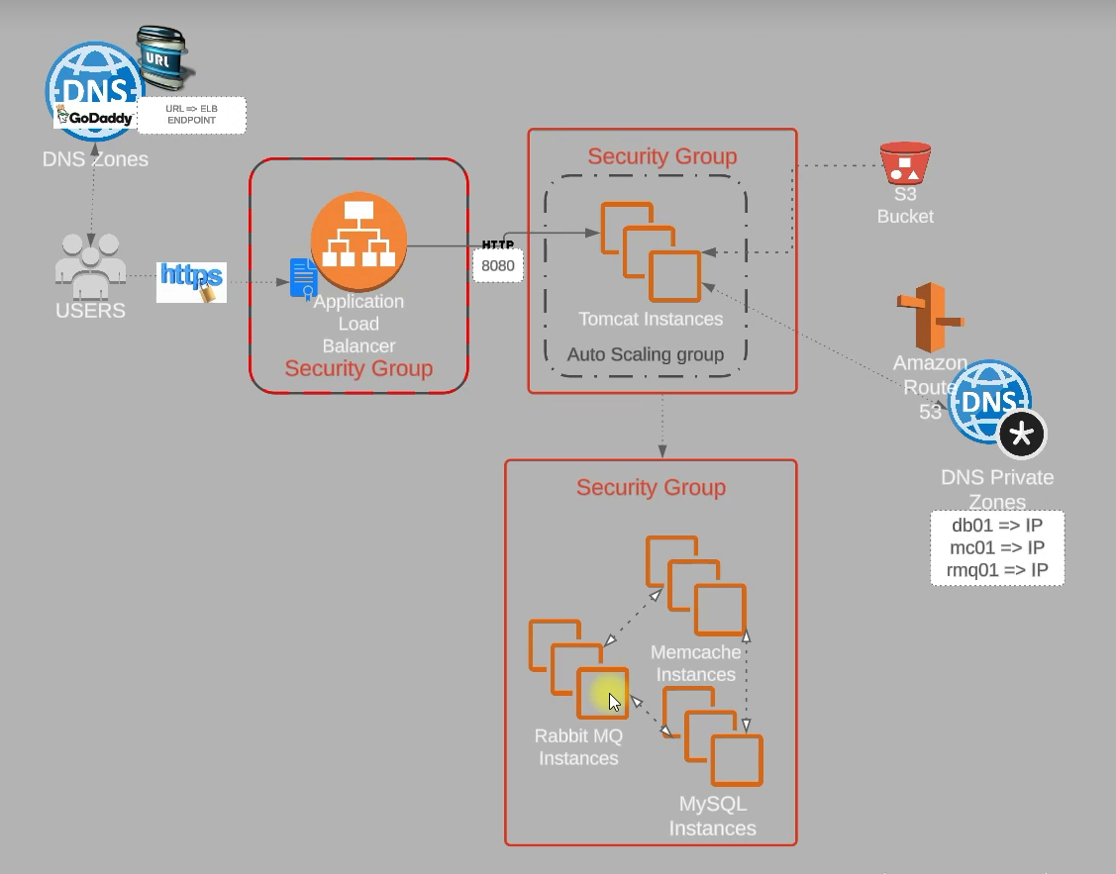

Figure 1: Architecture Diagram of the Deployed Project

✅ Project Architecture Summary  
  
🧑‍💻 User + Domain Layer  
- Users access the app via your custom domain vprofileapp.dhop.xyz bought from GoDaddy.  
- GoDaddy DNS routes traffic to your AWS ALB endpoint via a CNAME.  
  
🔐 HTTPS via ACM  
- Secured using HTTPS.  
- ACM certificate (likely created in the N. Virginia (us-east-1) region).  
- Certificate attached to the Application Load Balancer (ALB).  
  
🌐 Application Load Balancer (ALB)  
- Handles HTTPS (443) and forwards requests to Tomcat servers on HTTP (8080).  
- Security group allows only ports 443 and 80.  
- Targets an Auto Scaling Group via a Target Group.  
  
📦 Tomcat App Layer  
- Part of an Auto Scaling Group (ASG) using preconfigured AMI (app01).  
- Scaling policy: CPU usage > 70% marks instance unhealthy and replaces it.  
- Private subnet instances, traffic allowed only from ALB.  
- Fetches .war file from S3 using an IAM role with full S3 access (IAM role: S3 admin).  
  
🪣 S3 Bucket  
- Stores your application .war file.  
- Bucket: vprofile-las-artifacts-12.  
- Accessed via IAM role with full S3 access.  
  
🧠 Amazon Route 53 Private Hosted Zone  
- Internal DNS setup:  
 - db01.vprofile.in → MySQL  
 - mc01.vprofile.in → Memcached  
 - rmq01.vprofile.in → RabbitMQ  
  
🧱 Backend Service Layer (Private Only)  
- RabbitMQ: Message queue for async processing.  
- Memcached: In-memory cache.  
- MySQL: Primary data store (port 3306).  
  
🛡️ Security Groups Overview  
| Layer | Security Group Allows |  
|---------------|--------------------------------------------|  
| ALB | 80/443 from anywhere (0.0.0.0/0) |  
| App Instances | 8080 from ALB security group |  
| DB/Queue/Cache| Respective ports from App security group |