DAY 1 — Intro to DVC
Data Management, Reproducibility & Dataset Versioning
MLOps → LLMOps Series
The big picture
DVC is not the starting point. First understand the ML lifecycle, then MLOps, then reproducibility and versioning. DVC appears when we need to version the data that Git cannot practically manage.

1. What Does a Machine Learning Project Actually Do?
A machine learning project is more than training a model once. It moves through a lifecycle: define the problem, obtain data, prepare it, build and train a model, evaluate it, and deploy it. The Week 1 material presents these as the structured phases of the machine learning lifecycle.
- Problem Definition — decide what the model must solve.
- Data Collection — gather the data required for training and testing.
- Data Preprocessing — clean, transform, and prepare the data.
- Model Building — choose an algorithm, architecture, and hyperparameters.
- Model Training — learn model parameters from the prepared data.
- Model Evaluation — measure performance on unseen data.
- Model Deployment — move the model into a real-world system and monitor it.

Why this matters for MLOps
A model is only one component of the lifecycle. In a real system, data, code, experiments, models, deployment, and monitoring all have to work together.

2. From DevOps to MLOps
The Week 1 material introduces DevOps before MLOps. It then describes MLOps as applying the methodology of DevOps used in software engineering to the machine learning model lifecycle.
MLOps — source-based definition
MLOps is a methodology of operation that facilitates bringing an experimental machine learning model into production and maintaining it efficiently.
So the relationship can be viewed as:
Software development → DevOps
Machine learning lifecycle → MLOps

3. What Does MLOps Add?
The Week 1 material identifies five main features of an MLOps project:
MLOps feature | What it addresses
Data and Model Versioning | Keep track of which data and model state belongs to which project state.
Feature Management and Storing | Manage reusable features used by ML systems.
Automation of Pipelines and Processes | Reduce repeated manual work across the ML workflow.
CI/CD for Machine Learning | Bring software-style continuous integration and delivery practices into ML.
Continuous Monitoring of Models | Observe deployed models and detect changes in behavior or performance.

4. Why Do We Need Reproducibility?
Once an ML project becomes operational, it is not enough to say, 'this model was trained last week.' We need to know what produced that model: the code, the dataset, the preprocessing, the configuration, and the resulting artifacts.
Reproducibility — operational meaning
For this series, reproducibility means being able to recreate a previous ML project state using the same tracked inputs and configuration, rather than depending on files that may have changed.

Consider two training runs:
Run A: code v1 + dataset v1 + configuration v1 → model A
Run B: code v2 + dataset v2 + configuration v2 → model B

If we only keep the latest files, it becomes difficult to determine exactly which data and code produced model A. Versioning turns those changing inputs into identifiable project states.
Project state | Inputs | Result
Version 1 | training.csv v1 + code v1 + preprocessing v1 | Model A — accuracy 91%
Version 2 | training.csv v2 + code v1 + preprocessing v1 | Model B — accuracy 94%

Concrete example — why reproducibility matters
Imagine that six months ago a fraud-detection model achieved 91% accuracy. A new engineer needs to reproduce that exact result. The code is still available, but the training dataset has since been updated: some records were added, removed, or changed. Running the same code now produces a different model.
The problem is not necessarily the training algorithm. The inputs are no longer the same. If the project recorded the exact dataset version, code version, preprocessing configuration, and model artifact, the engineer can reconstruct the earlier project state instead of guessing which files were used.
Reproducibility means being able to answer: “What exact inputs and configuration produced this model?”
This is the connection to DVC: when the dataset is one of the inputs that must be reproduced, the dataset itself needs to have a versioned identity.

5. The Problem: Git Can Version Code, But ML Has More Than Code
Git is designed to track changes in a project repository. The Week 1 material explains that version control records changes, supports reversion, branching, collaboration, and project history.
Git
├── source code
├── configuration
├── DVC metadata
└── project history
But ML datasets can be large. Putting every dataset version directly into Git can make the repository heavy and inefficient. We therefore need a system that can version large data while allowing Git to remain the system that records the project state.
The machine learning lifecycle moves from problem definition and data through training and evaluation to deployment. MLOps adds operational practices across that lifecycle: versioning, management, automation, delivery, and monitoring. DVC is introduced specifically where the lifecycle needs reliable versioning of ML data and artifacts.

6. Where DVC Enters the MLOps Picture
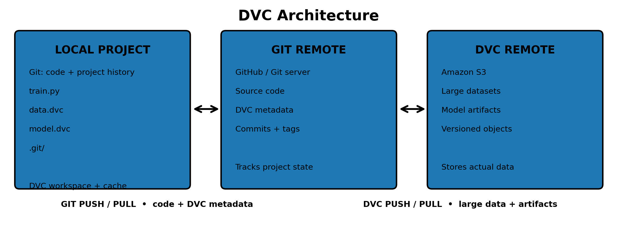

The role of DVC
DVC provides a data-versioning layer for ML projects. Git records the lightweight project metadata and history, while DVC tracks dataset and model artifacts and can connect them to remote storage.

7. DVC Versioning: The Basic Idea
Suppose the project begins with dataset version 1. DVC tracks that dataset and creates metadata. Git commits the metadata with the rest of the project. Later the dataset changes, producing version 2. A new Git checkpoint records that new DVC state.
Dataset v1
↓
dvc add data
↓
data.dvc
↓
git commit + tag v1.0
↓
Dataset changes
↓
dvc add data
↓
git commit + tag v2.0

8. Remote Storage: Where the Large Data Can Live
DVC can work with remote storage so that large datasets do not need to be stored directly inside the Git repository. For this series, the remote is mapped to Amazon S3.
Git → project history + DVC metadata
DVC → dataset/artifact versions
S3 → remote storage for large data

9. Reproducing an Earlier Dataset State
Versioning becomes useful when we need to return to an earlier experiment. First, Git moves the project back to the corresponding checkpoint. Then DVC restores the data associated with that checkpoint.
git checkout v1.0
↓
project returns to v1.0 metadata
↓
dvc checkout
↓
dataset v1 is restored

10. The Complete Git + DVC Workflow

DATASET
↓
dvc add data
↓
data.dvc
↓
git add + git commit + git tag
↓
DVC remote / Amazon S3
↓
DATASET CHANGES
↓
dvc add data
↓
git commit + git tag v2.0
↓
git checkout v1.0
↓
dvc checkout
↓
ORIGINAL DATASET STATE RESTORED

11. Commands Used in the DVC Example
git init
git clone https://github.com/iterative/example-versioning
cd example-versioning
python3 -m venv .env
source .env/bin/activate
pip install -r requirements.txt
pip install dvc
dvc get https://github.com/iterative/dataset-registry tutorials/versioning/data.zip
unzip -q data.zip
rm -f data.zip
dvc add data
python train.py
dvc add model.weights.h5
git add data.dvc model.weights.h5.dvc metrics.csv .gitignore
git commit -m "first iteration done with 1000 images"
git tag -a "v1.0" -m "model v1.0, 1000 images"
# later: new dataset state
dvc add data
python train.py
dvc add model.weights.h5
git add data.dvc model.weights.h5.dvc metrics.csv .gitignore
git commit -m "second iteration done with 200 images"
git tag -a "v2.0" -m "model v2.0, 2000 images"
# reproduce the first state
git checkout v1.0
dvc checkout
Note on the supplied example
The provided command sequence contains different image counts in the second commit message and the v2.0 tag: the commit says 200 images while the tag message says 2000 images. The sequence is preserved here as supplied rather than silently changing it.

12. Key Takeaways
- The ML lifecycle describes how an ML project moves from a problem to a deployed model.
- MLOps applies operational and DevOps-style practices to that ML lifecycle.
- Versioning, automation, CI/CD, feature management, and monitoring are identified as major MLOps features.
- Reproducibility requires knowing which tracked inputs and configuration produced a project state.
- Git is excellent for project/code history, but large ML datasets need a dedicated data-versioning workflow.
- DVC adds that data-versioning layer and can connect ML artifacts to remote storage such as Amazon S3.
- Git + DVC together allow an ML project to move back to a known project-and-data state.

