**CYBER SECURITY CAPSTONE PROJECT**

**Screenshots**

1. **EDA on dataset**

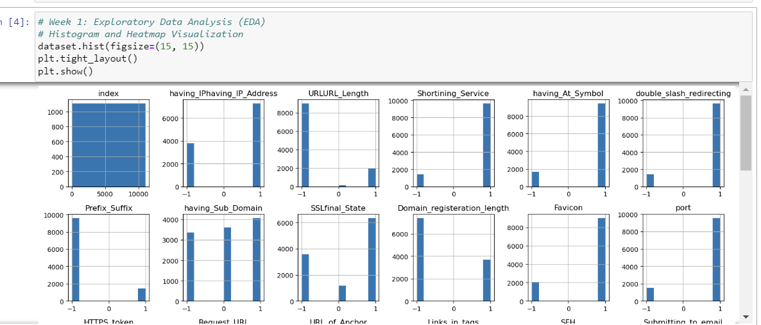

1. **Heatmap**

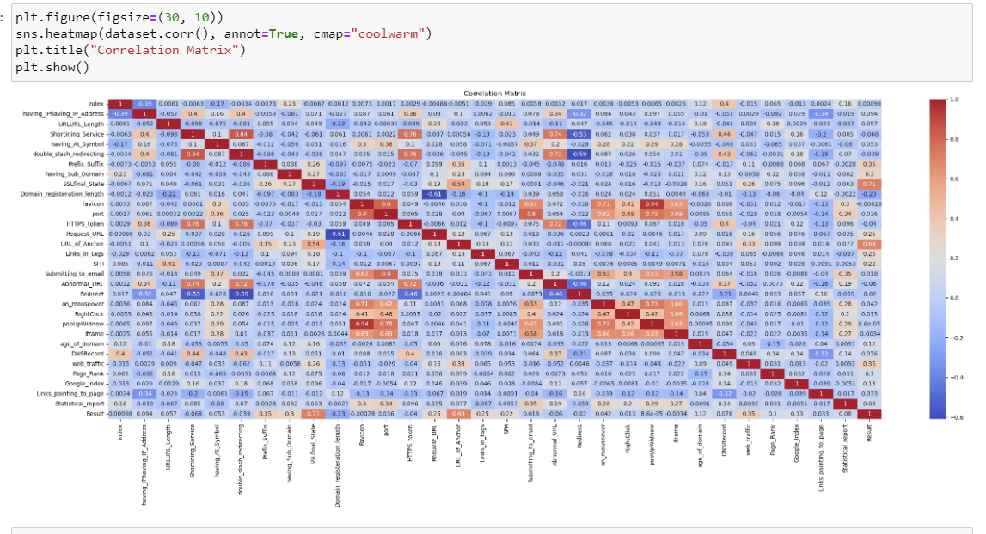

1. **Correlation Analysis and feature selection**

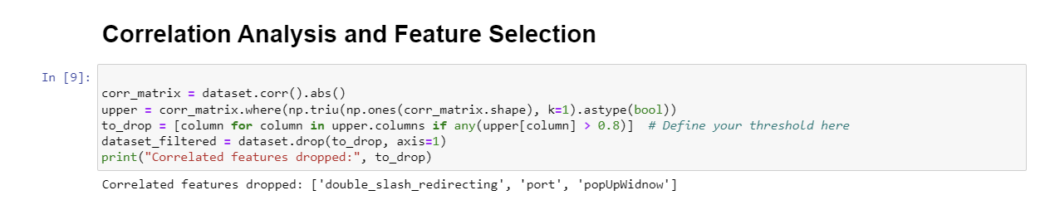

1. **Training the data using RandomForestClassifier Model**

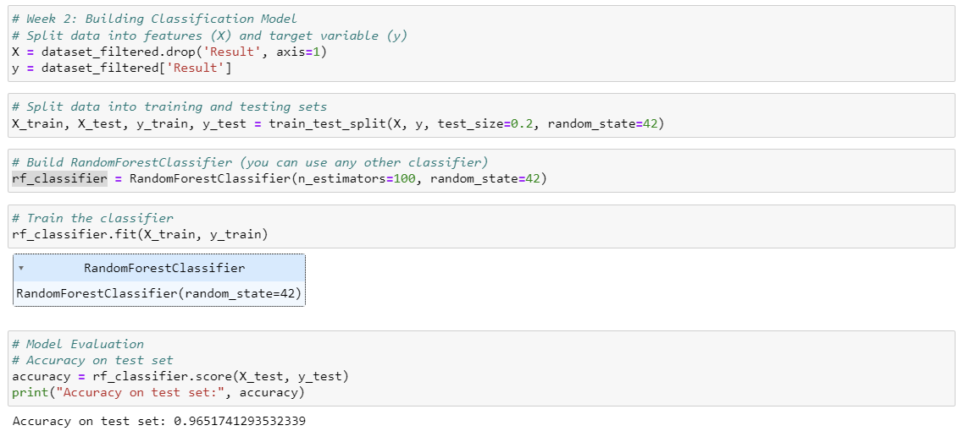

1. **ROC curve**

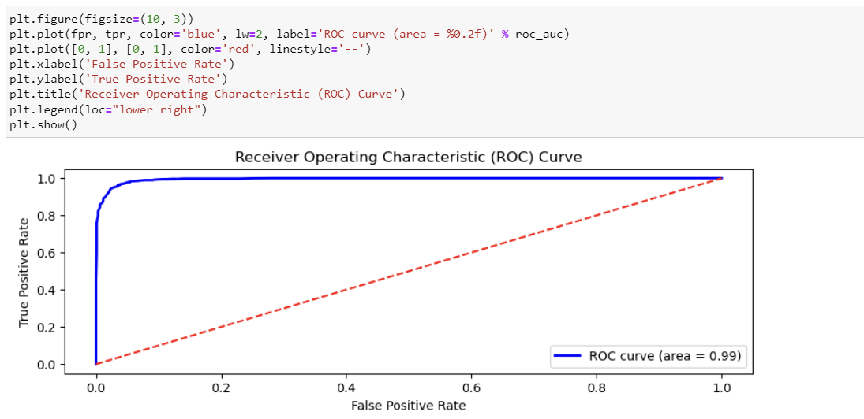

1. **K-Fold validation on data**

