Power BI Assignment
Question/Answer
Question 1 : Define Power BI and What are the key components of the Power BI ecosystem? Briefly explain:
● Power BI Desktop ● Power BI Service ● Power BI Mobile ● Power BI Gateway
Answer: Power BI is a business intelligence (BI) and data visualization tool developed by Microsoft that helps users connect to multiple data sources, transform data, create interactive reports and dashboards, and share insights for better decision-making.

Key Components of the Power BI Ecosystem
1. Power BI Desktop
- A Windows-based application used to connect, clean, and transform data using Power Query.
- Allows users to create data models and interactive reports using visuals.
- Reports created in Desktop can be published to Power BI Service.

2. Power BI Service
- A cloud-based (online) platform used to publish, share, and collaborate on reports and dashboards.
- Enables real-time data refresh, sharing with users, and access control.
- Used mainly for report consumption and collaboration.

3. Power BI Mobile
- A mobile application available on Android, iOS, and Windows.
- Allows users to view and interact with reports and dashboards on the go.
- Supports alerts, notifications, and touch-friendly visuals.

4. Power BI Gateway
- Acts as a bridge between on-premises data sources and Power BI Service.
- Enables secure data refresh without moving data to the cloud.
- Commonly used for databases like SQL Server, Oracle, and local files

Question 2 : Compare the following Power BI visuals:
● Pie Chart vs Donut Chart
● Bar Chart vs Column Chart
When would you prefer one over the other? Give one example for each pair.
Answer: 1. Pie Chart vs Donut Chart
Aspect | Pie Chart | Donut Chart
Shape | Solid circular chart | Circular chart with a hole in the center
Data display | Shows parts of a whole | Shows parts of a whole with extra space
Readability | Good for few categories | Better readability with labels in center
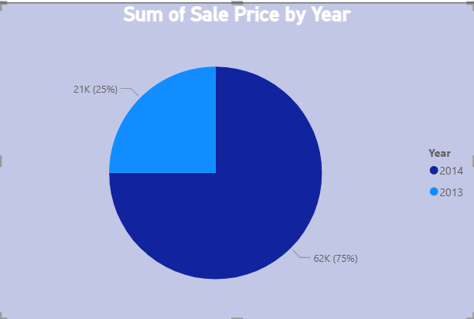
When to prefer which?
- Use a Pie Chart when you have 2–4 categories and want a simple view of proportions.
- Use a Donut Chart when you want to display total values or KPIs in the center.
Example:
- Pie Chart: Market share of mobile brands (Apple, Samsung, Others).
- Donut Chart: Percentage contribution of sales by product category with total sales shown in the center.
2. Bar Chart vs Column Chart
Aspect | Bar Chart | Column Chart
Orientation | Horizontal | Vertical
Best for | Long category names | Time-based or numeric comparisons
Space usage | Efficient for many categories | Better for trend comparison
Axis focus | Category on Y-axis | Category on X-axis
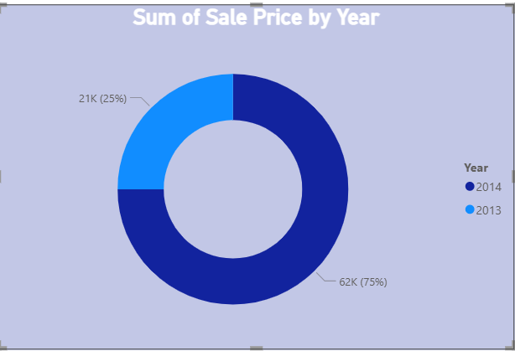
When to prefer which?
- Use a Bar Chart when you have many categories or long labels.
- Use a Column Chart when analyzing trends over time or comparing values across periods.
Example:
- Bar Chart: Employee count by department (Human Resources, Administration, Customer Support).
- Column Chart: Monthly sales comparison from January to December.
Question 3 : Explain the significance of:
● Star schema vs Snowflake schema
● Primary key vs Foreign key in relationships (Power BI) Why is cardinality important?
Answer: 1. Star Schema vs Snowflake Schema
⭐ Star Schema
- Consists of a central fact table connected directly to dimension tables.
- Simple design with fewer joins, improving performance in Power BI.
- Easier to understand, maintain, and write DAX.
Significance:
Star schema is preferred in Power BI because it delivers faster query performance and simpler relationships.
Example:
Fact_Sales connected to Dim_Date, Dim_Product, Dim_Customer.

❄ Snowflake Schema
- Dimension tables are normalized into multiple related tables.
- Reduces data redundancy but increases complexity.
- Requires more joins, which may impact performance.
Significance:
Snowflake schema is used when dimensions are large or highly normalized, but it is less efficient for reporting in Power BI.
Example:
Dim_Product → Dim_Product_Category → Dim_Product_Subcategory.

2. Primary Key vs Foreign Key in Power BI Relationships
🔑 Primary Key
- A column with unique values in a table.
- Used to uniquely identify each record in a dimension table.
- Example: CustomerID in Dim_Customer.
🔗 Foreign Key
- A column that references the primary key of another table.
- Found in fact tables to create relationships.
- Example: CustomerID in Fact_Sales.
Significance:
Primary and foreign keys ensure accurate filtering and data integrity between tables in Power BI.
3. Why Cardinality Is Important
Cardinality defines how tables are related in Power BI:
- One-to-Many (1:*) – Most common and recommended
- Many-to-One (*:1) – Reverse of 1:*
- One-to-One (1:1)
- Many-to-Many (:)
Importance of Cardinality:
- Controls filter direction and data flow between tables.
- Prevents incorrect aggregations and duplicate results.
- Improves model performance and accuracy.
- Helps Power BI correctly interpret relationships for calculations.
Example:
One customer can have many sales records, so relationship should be 1 (Customer) to * (Sales).

Question 4 : Differentiate between:
● Calculated column vs Measure Also, define Row context and Filter context with simple examples.
Answer: 1. Calculated Column vs Measure
Aspect | Calculated Column | Measure
Calculation time | Calculated at data refresh | Calculated on the fly
Storage | Stored in the table (uses memory) | Not stored, only result is shown
Context | Uses row context | Uses filter context
Usage | Used for row-level logic, categorization | Used for aggregations and KPIs
Performance | Increases model size | More efficient for calculations
Example | Sales[Profit] = Sales[Revenue] - Sales[Cost] | Total Sales = SUM(Sales[Revenue])

When to use which?
- Use Calculated Columns when you need row-by-row values (e.g., profit per transaction).
- Use Measures when you need dynamic calculations (e.g., total sales by region).

2. Row Context
Definition:
Row context means Power BI evaluates a calculation one row at a time.
Example:
If a Sales table has Revenue and Cost, a calculated column
Profit = Sales[Revenue] - Sales[Cost]
3. Filter Context
Definition:
Filter context refers to filters applied to data (by visuals, slicers, or filters).
Example:
A measure:
Total Sales = SUM(Sales[Revenue])
- If a report is filtered to Region = North,
the measure returns total sales only for the North region.
- Changing slicers or visuals changes the result dynamically.
Question:5 What is the difference between a report and a dashboard in Power BI?
Answer: Report
- A report is a detailed, multi-page collection of visuals created in Power BI Desktop.
- Built from one dataset.
- Allows deep data analysis with filters, slicers, and drill-through.
- Can contain multiple pages.
Example:
A sales performance report with pages for monthly trends, region-wise analysis, and product-wise sales.
Dashboard
- A dashboard is a single-page canvas created in the Power BI Service.
- Can combine visuals from multiple reports and datasets.
- Designed for high-level monitoring and KPIs.
- Visuals are static tiles but can link back to reports for details.
Example:
An executive dashboard showing total sales, profit margin, top region, and key alerts.

Question 6 : Using the Sample Superstore dataset:
● Create a Clustered Bar Chart to display Total Sales by Sub-Category
● Create a Donut Chart for Sales % by Region

Answer:
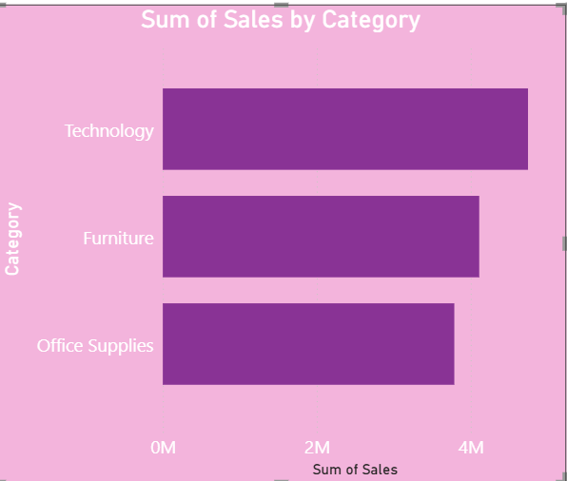
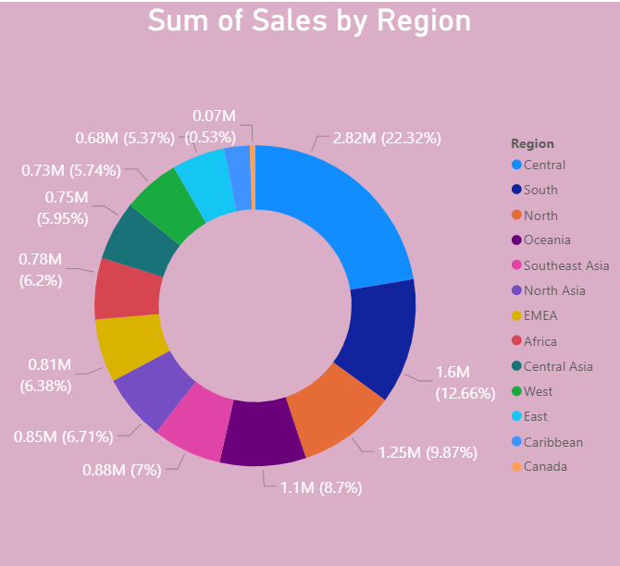

Question 7 : Write and apply the following measures:
● Total Profit = SUM([Profit])
● Average Discount = AVERAGE([Discount])
Display both in a KPI Card, and use a Line Chart to show profit trend over months. Add visuals and DAX formulas.

Answer:
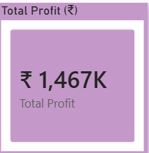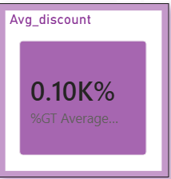

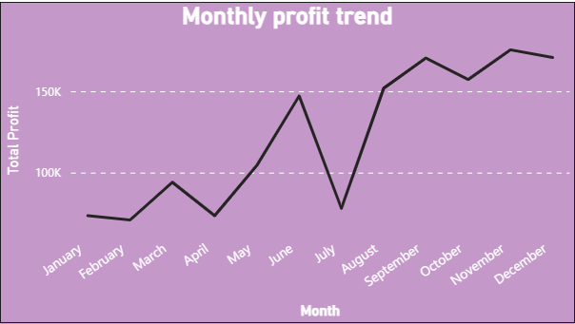

Question 8 : Implement a DAX measure that calculates the percentage of total sales by product category.
Answer:

Product_category | Sales_Amount
Electronics | 5000
Clothing | 3000
Home Appliance | 7000
Books | 2000
Table and chair | 8000
Toy | 1500
Sports Equipment | 1200
Office Supplies | 1000
Beauty Product | 4400
Garden Supplies | 1000
Jewelry | 1800
Automative | 2600

Answer:
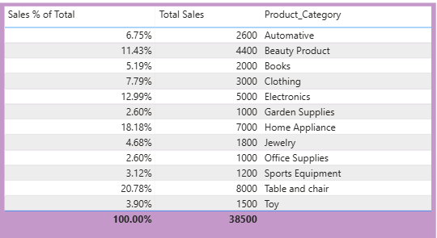
This DAX measure calculates the percentage contribution of each product category to total sales.
The ALL function removes the product category filter to calculate overall sales, and DIVIDE safely computes the ratio.

Sales % of Total =DIVIDE([Total Sales],CALCULATE( [Total Sales],ALL ( Table[Product_Category] )))

Question 9 :
● Create a DAX Measure for Total Profit
● Use it in a Waterfall Chart to analyze how different Sub-Categories contribute to overall profit
● Add a Slicer for Region to filter the visual
● Write brief business insights (4–5 lines) from the chart and provide 2–3 data-driven recommendations to improve profit.
Provide a steps, screenshot of the Waterfall chart and the DAX formula

Answer:
A Total Profit measure was created and visualized using a Waterfall chart to analyze Sub-Category contributions. A Region slicer was added to enable dynamic filtering. Insights and recommendations were derived to improve overall profitability.
Business Insights (4–5 Lines)
- Technology sub-categories such as Copiers and Phones contribute the highest positive profit.
- Certain Furniture sub-categories like Tables and Bookcases show negative profit impact.
- Profit distribution varies significantly across regions when filtered using the slicer.
- The Waterfall chart clearly highlights loss-making sub-categories dragging overall profitability.

Data-Driven Recommendations (2–3 Points)
- Reduce discounts or optimize pricing for loss-making sub-categories such as Tables.
- Increase marketing and inventory focus on high-profit sub-categories like Copiers.
- Apply region-specific strategies, focusing on profitable categories in high-performing regions.

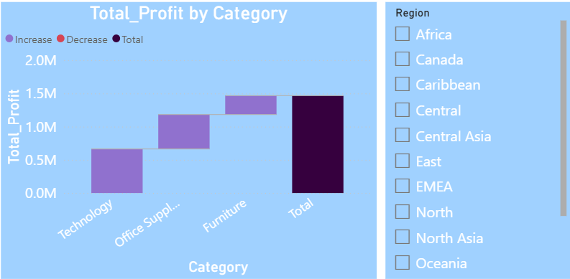

Question 10 :
Scenario:
VitaTrack Wellness, a digital health company in FitZone, has collected data on users’ daily habits and health vitals. The analytics team is tasked with drawing actionable insights from this data to improve lifestyle suggestions and prevent heart-related risks.
Your Task: Using the provided dataset (includes Age, Gender, BMI, Steps, Calories, Sleep, Heart Rate, Blood Pressure, Smoking, Alcohol, Exercise, Diabetic & Heart Disease status):

Build a one-page Power BI dashboard that answers:
1. Are users maintaining a balanced lifestyle (Steps, Sleep, Calories)
2. What lifestyle patterns (Smoking, Alcohol, BMI, etc.) indicate heart disease risk?
3. Is there any visible relationship between Sleep and Physical Activity?
4. How does BMI vary across Age Groups and Genders?
5. What is the impact of smoking and alcohol on heart rate and blood pressure?
6. Segment people based on their health activity to suggest lifestyle changes.
Answer:
1.
Steps (Physical Activity)
- Most age groups are meeting or exceeding the steps benchmark.
- Younger and middle-age groups (Under 30, 30–45) show strong activity levels.
- The 60+ group is slightly closer to the minimum benchmark, indicating reduced physical activity.
Sleep
- Average sleep hours for all age groups are close to the recommended benchmark (~7 hours).
- Minor shortfalls are visible in some groups, but no severe sleep deprivation trend is observed.
- Overall, sleep habits appear fairly balanced.
Calories (Energy Intake)
- Average calorie intake across age groups is very close to the benchmark.
- This indicates controlled and consistent dietary patterns.
- No age group shows extreme over- or under-consumption.
While users generally demonstrate healthy calorie intake and adequate sleep, physical activity varies by age.
This suggests that users are not perfectly balanced, but are largely on a healthy path, with older age groups needing more focus on movement.
2. Higher heart disease prevalence is observed among smokers and alcohol consumers. Users with elevated BMI show greater risk, indicating obesity as a major contributing factor.
3. A positive relationship is visible between sleep duration and physical activity, where users with adequate sleep tend to take more daily steps.
4. BMI increases with age, especially among middle-aged groups. Male users generally show slightly higher BMI compared to females across age groups.
5. Smokers show slightly higher average systolic and diastolic blood pressure compared to non-smokers.
Additionally, average heart rate is elevated among smokers, indicating increased cardiovascular strain.
6. Health Activity Segments
Segment | Criteria
🟢 Active & Healthy | Steps ≥ 8,000 AND Sleep ≥ 7 hrs
🟡 Moderately Active | Steps 5,000–7,999 OR Sleep 6–6.9 hrs
🔴 Sedentary / At Risk | Steps < 5,000 OR Sleep < 6 hrs

