Systems Design

Multi-Modal Audio Processing with Domain-Specific Retrieval-Augmented Generation (RAG)
Divyansh Gupta
Prof. Dinesh Sthapit
2/2/2025

Table of Contents

Multi-Modal Audio Processing with Domain-Specific Retrieval-Augmented Generation (RAG) 1
Background 3
Problem Statement 3
Technology Solution 4
Process Maps 5
User Interface 9
Wireframe 1: Login Screen 9
Wireframe 2: Dashboard 10
Infrastructure Architecture 11
Network Topology 11
Information Architecture 13
Entity Relationship Diagram 13
Security and Privacy Architecture 17
Programming 18
References 20

Background
Multimodal translation has evolved significantly with the advent of Large Language Models (LLMs) and Retrieval-Augmented Generation (RAG). These technologies allow for more accurate and contextually relevant translations by incorporating external knowledge bases into the translation process. Traditional machine translation methods often fail to capture domain-specific terminology and nuanced contextual meanings, leading to inaccuracies and a lack of precision in generated translations.
This project aims to develop an AI-driven multi-modal audio processing system that leverages RAG-enhanced LLMs for improved translation quality. Unlike conventional translation models that rely only on pre-trained knowledge, this system integrates a vector database to dynamically retrieve relevant context and terminology, ensuring factual consistency and domain relevance in generated outputs. The primary goal is to enable seamless, accurate, and adaptive translation workflows, catering to various industries that require high contextual fidelity in translations.

Problem Statement
Despite significant advancements in AI-driven translation models, existing solutions suffer from several limitations:
- Loss of domain relevance when translating industry-specific content.
- Inconsistencies in factual accuracy, as most models lack real-time knowledge retrieval mechanisms.
- Inefficient adaptation to evolving datasets, leading to outdated or incorrect translations over time.
This project enhances LLM-powered translation by integrating a retrieval-augmented generation pipeline that dynamically fetches relevant domain-specific terminology and contextual references from a vector database. This approach ensures:
- Precision in generated translations by incorporating real-world knowledge.
- Factually accurate responses, eliminating outdated or incorrect information.
- Context-aware and adaptive outputs, adjusting dynamically based on user inputs and retrievals.

Technology Solution
The proposed system integrates multiple components to deliver contextually accurate and adaptive translations:
- LLM (GPT-4o) with Retrieval-Augmented Generation (RAG) to enhance translation accuracy.
- Vector Database (e.g., FAISS, Pinecone, or We aviate) for contextual information retrieval.
- Flask/Django Web Framework to manage user interactions and API endpoints.
- Role-Based Access Control (RBAC) for security and authentication.
- Base64-encoded audio processing for standardizing audio file inputs.
- OpenAI’s GPT-4o API for multimodal text and audio generation.
- User Dashboard for uploading files, managing settings, and reviewing processed translations.
- Authentication System to restrict access and ensure data privacy.

Process Maps
Function: Multi-Modal Translation Workflow
Process Map:
- User Logs In → Users enter credentials for authentication. If unsuccessful, access is denied.
- User Uploads Audio/Text → Users provide audio files or textual input via the web interface.
- Transcription (if needed) → The system converts audio to text using GPT-4o.
- Contextual Data Retrieval → The system queries the vector database for domain-specific terms and related knowledge.
- LLM Processing → The input undergoes processing using GPT-4o, enhanced by retrieved knowledge for contextual accuracy.
- Final Output Generation → The system produces translated text and/or synthesized audio, incorporating contextual enhancements.
- User Reviews & Downloads Output → Users review the processed content and download the generated results if required.

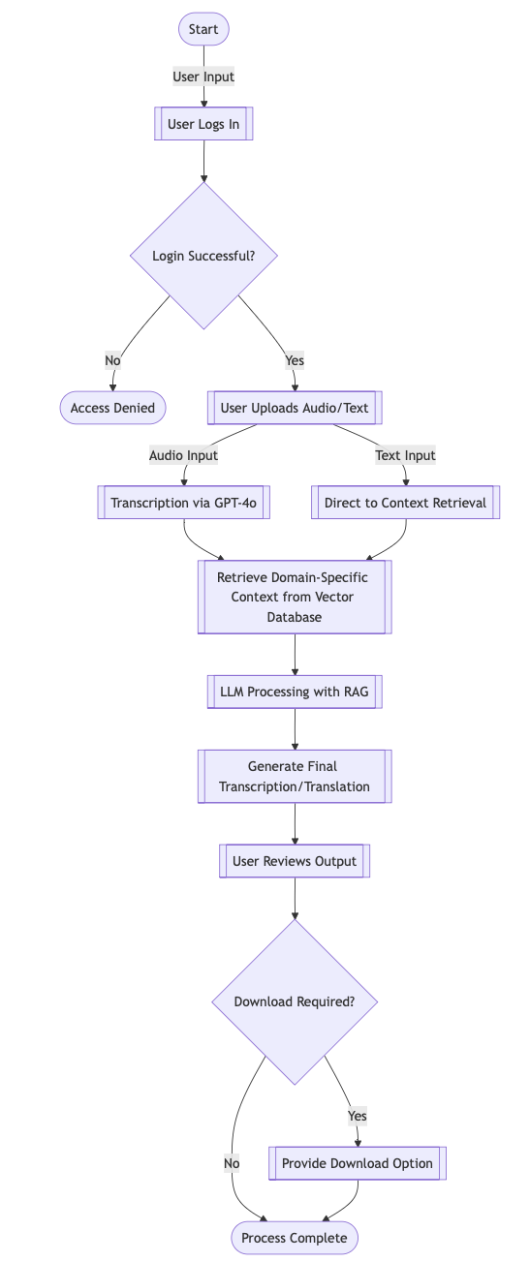
Figure 1: RAG engine process map
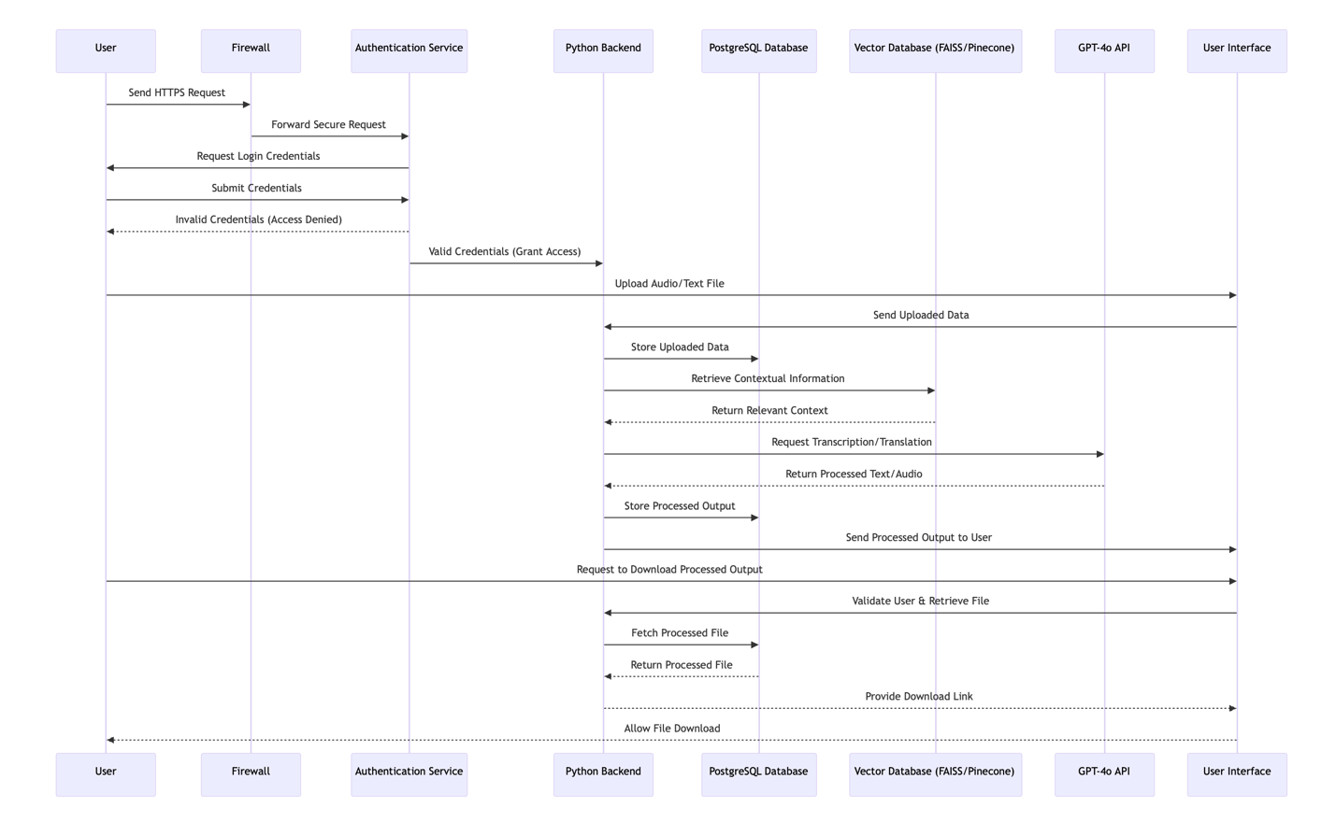
Figure 2 Sequence Diagram
The sequence diagram represents the interaction flow between the various components of the Multi-Modal Audio Processing System. It illustrates the secure client-server communication, authentication process, data retrieval, and processing pipeline. Below is a step-by-step breakdown:
- User Authentication:
  - The user initiates interaction by sending an HTTPS request to the system via the web interface.
  - The request passes through a firewall, ensuring it meets the system's security standards.
  - The authentication service prompts the user to provide valid login credentials.
  - If the credentials are invalid, the user is denied access. Valid credentials allow the user to proceed to the backend.
- File Upload:
  - The authenticated user uploads an audio or text file via the user interface.
  - The backend receives the uploaded file and stores the metadata in the PostgreSQL database.
- Contextual Data Retrieval:
  - The backend queries the vector database (e.g., FAISS or Pinecone) to retrieve relevant domain-specific contextual information.
  - The database responds with the retrieved context, which is used to enrich the input data.
- Processing and Translation:
  - The backend forwards the enriched input data to the GPT-4o API for transcription, translation, or audio synthesis.
  - The API processes the input and returns the translated or synthesized output.
  - The processed output is stored in the PostgreSQL database for future retrieval.
- Output Delivery:
  - The backend sends the processed output back to the user interface for review.
  - The user can review the content and request a download if needed.
- Download Process:
  - Upon the user's request, the backend validates the user's session and retrieves the processed file from the database.
  - The file is securely transmitted to the user, who is provided with a download link.
This diagram highlights the modular and secure architecture of the system, ensuring data integrity, contextual accuracy, and user authentication at every stage of interaction.

User Interface

Wireframe 1: Login Screen
Description:
- Allows users to authenticate using their credentials.
- Redirects users to the dashboard upon successful login.
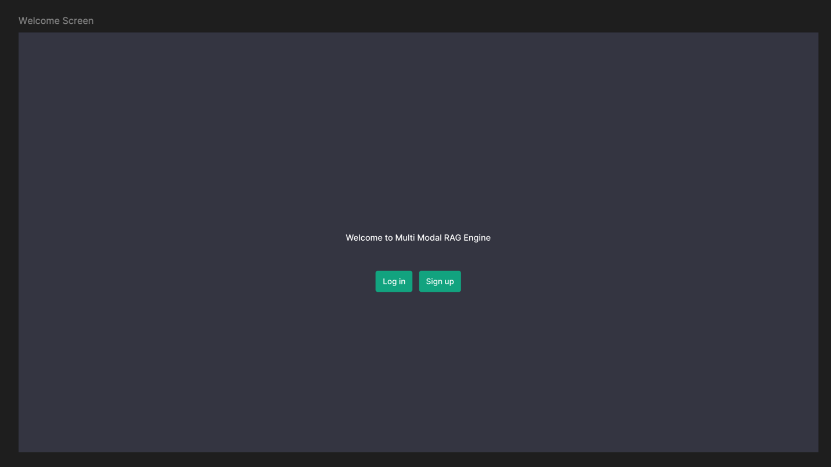
Figure 3 Login Screen

Wireframe 2: Dashboard
Description:
- Allows users to upload audio or text files.
- Provides options for domain-specific retrieval configuration.
- Displays real-time processing status.
- Presents transcribed and translated text.
- Enables context tracing (highlighting retrieved knowledge contributions).
- Allows users to download outputs.
Figure 4 Dashboard

Infrastructure Architecture
The system comprises:
- Frontend: ReactJS (UI/UX for user interaction)
- Backend: Python (API and logic handling)
- Database: PostgreSQL (user data storage)
- Vector Database: FAISS/Pinecone for retrieval-augmented generation
- LLM Integration: GPT-4o API for transcription, translation, and synthesis
- Authentication System: Secure login for role-based access control

Network Topology
The system follows a secure client-server architecture with structured data flow:
- Users interact via a secure web interface that communicates with the backend.
- Requests pass through a firewall, ensuring security against unauthorized access.
- Authentication Layer verifies credentials, determining access rights.
- Backend processes valid requests and interacts with data storage and external APIs.
- PostgreSQL Database stores structured content, ensuring persistence and security.
- Vector Database enhances translations through retrieval-augmented generation (RAG).
- GPT-4o API handles complex processing, including transcription, translation, and audio synthesis.
- Final outputs are displayed to users via the UI dashboard
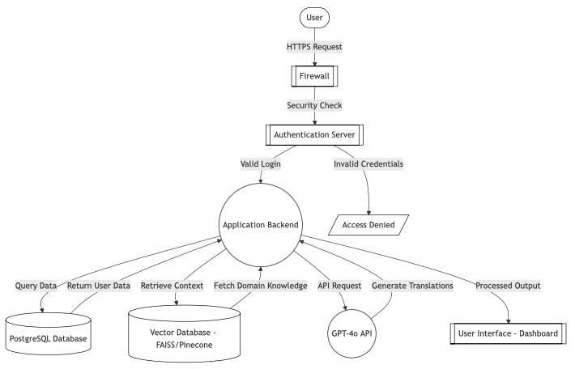
Figure 5 Network Topology Diagram

Information Architecture

Entity Relationship Diagram

Entities
- USERS
  - Attributes:
    - UserID (Primary Key): Unique identifier for each user.
    - Name: The name of the user.
    - Email: User’s email address for communication and authentication.
    - Password: Encrypted password for secure access.
    - Role: The role assigned to the user (e.g., admin, regular user).
  - Description: Represents individuals using the system.
- UPLOADED_FILES
  - Attributes:
    - FileID (Primary Key): Unique identifier for each uploaded file.
    - UserID (Foreign Key): Links the file to the user who uploaded it.
    - Filename: The name of the file uploaded by the user.
    - UploadDate: The date the file was uploaded.
    - FileType: The type of the file (e.g., audio, text).
  - Description: Stores metadata about the files uploaded by users.
- PROCESSED_OUTPUTS
  - Attributes:
    - OutputID (Primary Key): Unique identifier for each processed output.
    - FileID (Foreign Key): Links the processed output to the uploaded file.
    - ProcessedText: The text generated after processing the uploaded file.
    - TranslatedText: The translated version of the processed text.
  - Description: Contains results generated after processing and translation of uploaded files.
- KNOWLEDGE_BASE
  - Attributes:
    - TermID (Primary Key): Unique identifier for each knowledge base entry.
    - SourceTerm: The original term in the source language.
    - TargetTerm: The corresponding term in the target language.
    - Domain: The domain or context of the terms (e.g., medical, legal).
    - VectorEmbedding: Encoded representation for retrieval and contextual matching.
  - Description: Stores domain-specific terminology for retrieval-augmented generation.
- AUTHENTICATION
  - Attributes:
    - AuthID (Primary Key): Unique identifier for each authentication record.
    - UserID (Foreign Key): Links the record to a specific user.
    - HashedPassword: Securely stored password.
    - LastLogin: The timestamp of the user’s last login.
    - Role: Specifies the access level of the user.
  - Description: Tracks user authentication and role information.
- LOGS
  - Attributes:
    - LogID (Primary Key): Unique identifier for each log entry.
    - UserID (Foreign Key): Links the log entry to a specific user.
    - ActionTimestamp: The timestamp when the action occurred.
    - Action: Description of the action performed by the user (e.g., upload, download).
  - Description: Records actions performed by users for auditing and monitoring purposes.

Relationships
- USERS Owns UPLOADED_FILES:
  - Type: One-to-Many
  - Description: A user can upload multiple files, but each file is linked to a single user.
- USERS Has AUTHENTICATION:
  - Type: One-to-One
  - Description: Each user has one authentication record for secure access.
- USERS Generates LOGS:
  - Type: One-to-Many
  - Description: A user can generate multiple logs detailing actions performed within the system.
- UPLOADED_FILES Produces PROCESSED_OUTPUTS:
  - Type: One-to-One
  - Description: Each uploaded file results in one processed output.
- KNOWLEDGE_BASE Enriches PROCESSED_OUTPUTS:
  - Type: Many-to-Many
  - Description: Multiple knowledge base entries can enrich a single processed output, and each processed output may be linked to multiple terms from the knowledge base.

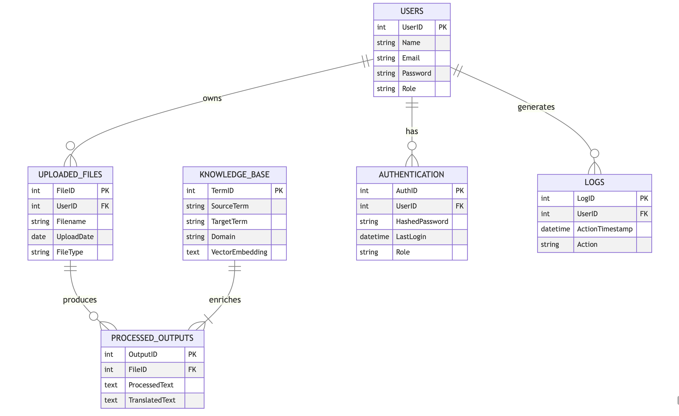
Figure 6 Entity Relationship Diagram

Security and Privacy Architecture
Security measures include:
- User Authentication (RBAC with username/password authentication).
- Access Control (Restricted access to generated content).
- Data Encryption (Secure transmission and storage of sensitive data).
- API Rate Limiting (Prevents excessive requests to GPT-4o and vector database).

Programming

Development Tools
- Python: Chosen for its simplicity, extensive libraries, and suitability for handling backend tasks such as data processing, database interaction, and API integrations.
- PostgreSQL: Selected as the database for storing user data, uploaded files, and processed outputs due to its reliability and support for complex queries.
- FAISS/Pinecone: Used as the vector database for retrieval-augmented generation, enabling fast and accurate context retrieval.
- Pytest: A testing framework for ensuring the correctness and robustness of the codebase.
- VS Code: Used as the Integrated Development Environment (IDE) for efficient coding and debugging.
- Git/GitHub: For version control, collaboration, and deployment tracking.

Programming Languages
- Python: The sole programming language for backend development due to its:
  - Rich ecosystem of libraries like NumPy, Pandas, SQLAlchemy, and Pydantic.
  - Strong support for machine learning and AI-related tasks.
  - Ease of integration with APIs like OpenAI’s GPT-4o.

Backend Development
The backend will be implemented entirely in Python without any additional web frameworks like Flask or Django. Python will directly handle:
- Parsing user requests (audio/text inputs).
- Interacting with PostgreSQL and the vector database.
- Calling the GPT-4o API for transcription, translation, and synthesis.
- Managing authentication and role-based access control.
Core Functions:
- User Authentication: authenticate_user(username, password)
- Audio/Text Processing: process_audio_with_gpt_4o(base64_encoded_audio, output_modalities, system_prompt)
- Context Retrieval: retrieve_context_from_vector_db(query, domain)
- Translation & Formatting: format_translation_output(response)
- Knowledge Injection: enhance_response_with_retrieval(raw_output, context_data)
- Optimization: optimize_prompt_with_feedback(scores, parameters)

References
- OpenAI. (n.d.). OpenAI platform documentation. OpenAI. https://platform.openai.com/docs/concepts
- OpenAI. (n.d.). Backward compatibility: API reference. OpenAI. https://platform.openai.com/docs/api-reference/backward-compatibility
- OpenAI. (n.d.). OpenAI cookbook. OpenAI. https://cookbook.openai.com
- PostgreSQL: documentation. (n.d.). The PostgreSQL Global Development Group. https://www.postgresql.org/docs/

