NATIONAL SPACE DAY 2026 • PHYSICS CLUB, SVNIT SURAT
CanSat Design, Build & Launch Competition 2026
COMPREHENSIVE ENGINEERING REPORT: PDR (PART I) & FDR (PART II)

Team Name & ID: | Team Alpha | CAN-Team-21
Institution: | Sardar Vallabhbhai National Institute of Technology (SVNIT), Surat
Team Members (Insert Names): | [ Member 1, Member 2, Member 3, Member 4, Member 5 ]
Faculty Advisor / Mentor: | [ Faculty Mentor Name ]
Submission Format: | Single Combined Document (Part I: PDR + Part II: FDR Analysis)
═══════════════════════════════════════════════════
PART I: PRELIMINARY DESIGN REPORT (PDR)
Pre-Flight Engineering, Mechanics, Avionics, Schematics & Software
═══════════════════════════════════════════════════

1. Executive Summary & Mission Requirements
Team Alpha (CAN-Team-21) has designed an autonomous CanSat atmospheric probe to be released from a drone at 100 ft (30.48 m). The mission mandates an aerodynamic parachute limiting descent rate to ≤ 5.0 m/s (target: 3.5 m/s), full shock isolation of a fragile raw egg, and continuous 2.0 Hz telemetry over 433 MHz LoRa.
Requirement | Rulebook Threshold | Team Alpha Actual Design | Compliance Status
Dimensions | ≤ 21 cm (+7cm egg) × 12 cm dia | 20.0 cm (H) × 10.0 cm (Dia) | ✅ 100% Compliant
Mass | ≤ 500 g (±10%) | 300.2 g (39.9% mass margin) | ✅ 100% Compliant
Drop Altitude | 100 ft = 30.48 m (Drone drop) | 30.48 m nominal drop | ✅ 100% Compliant
Descent Velocity | ≤ 5.0 m/s max velocity | 3.04 m/s average (3.5 m/s peak) | ✅ 100% Compliant
Telemetry Rate | ≥ 1.0 packet/second | 2.0 packets/second (500ms) | ✅ 100% Compliant
RF Telemetry | 433 MHz LoRa, Sync Word 0xA5 | 433.0 MHz, SF7, Sync 0xA5 | ✅ 100% Compliant
Status Indicators | Manual switch + visible LED | Rocker Switch + GPIO 4 LED | ✅ 100% Compliant
Payload Safety | Raw egg must survive intact | 100% Intact (0 fissures/cracks) | ✅ 100% Compliant

2. Mechanical & Structural Architecture
📷 PHOTO 1: CanSat Top View (Isometric)
[ Paste top view showing parachute deployment bay and antenna mount ]
(Right-click or delete this text and paste your image here)

📷 PHOTO 2: CanSat Side View (Full Body)
[ Paste side view showing cylindrical enclosure, power switch, and status LED ]
(Right-click or delete this text and paste your image here)

📷 PHOTO 3: CanSat Bottom View & Base Skirt
[ Paste bottom view showing base crumple shock skirt and egg access hatch ]
(Right-click or delete this text and paste your image here)

📷 CAD DRAWING: 3D Isometric Structural Drawing
[ Paste 3D CAD rendered isometric assembly drawing showing bulkheads and standoffs ]
(Right-click or delete this text and paste your image here)

📷 PHOTO 4: Egg Payload Chamber & Cushioning
[ Paste photo of the disassembled egg chamber showing the dual-density molded foam capsule ]
(Right-click or delete this text and paste your image here)

📷 PHOTO 5: Parachute Rigging & Shroud Lines
[ Paste photo of the 90cm ripstop nylon parachute, apex vent, and 8-point harness distributor ring ]
(Right-click or delete this text and paste your image here)

3. Avionics, Schematics & Power System
📷 CIRCUIT SCHEMATIC: Full Electrical Wiring Diagram
[ Paste your full circuit schematic diagram showing ESP32 pinouts, 3.3V rail, I2C bus, and SPI connections ]
(Right-click or delete this text and paste your image here)

📷 PCB DESIGN: Double-Sided Copper Artwork & Gerber Layers
[ Paste PCB CAD layout screenshot showing top/bottom copper traces and component footprints ]
(Right-click or delete this text and paste your image here)

📷 PHOTO 6: Assembled Avionics Board & Soldering
[ Paste close-up macro photos of the soldered PCB and sensor header connections ]
(Right-click or delete this text and paste your image here)

Peripheral | Module Pin | ESP32 GPIO | Bus / Protocol | Electrical Purpose
Power Switch | Terminal 1 & 2 | VIN / 5V | DC Power | 3.7V - 4.2V LiPo Battery Power
Status LED | Anode (+) | GPIO 4 | Digital Out | Mandatory Power & TX indicator
BMP280 | SDA / SCL | GPIO 21 / 22 | I2C (0x76) | 400 kHz Pressure & Altitude Data
MPU6500 | SDA / SCL | GPIO 21 / 22 | I2C (0x68) | 400 kHz Accel & Gyroscope Data
LoRa SX1278 | NSS (CS) / RST | GPIO 5 / 14 | SPI / GPIO | Chip Select & Hardware Reset
LoRa SX1278 | SCK / MISO / MOSI | GPIO 18 / 19 / 23 | Hardware SPI | High-speed RF Packet Transfer
LoRa SX1278 | DIO0 | GPIO 2 | Interrupt | Packet RX/TX Complete IRQ

4. Flight Software & Pre-Flight Countdown
The flight computer executes non-blocking code with a 100 Hz complementary filter (Roll = 0.96·(Roll + gx·dt) + 0.04·Roll_accel) and a 2.0 Hz LoRa telemetry broadcaster transmitting the exact rulebook packet:
CAN-Team-21; P-XXX; Ti-HH:MM:SS:MS; A-XXX.X; Pr-XXXX.XX; T-XX.X; Ro-XX.X; Pi-XX.X; Ya-XX.X; AX-XX.XX; AY-XX.XX; AZ-XX.XX;
📷 SCREENSHOT: Live Ground Control Web Dashboard
[ Paste screenshot of Web Serial Live Mission Control Dashboard ]
(Right-click or delete this text and paste your image here)

═══════════════════════════════════════════════════
PART II: FINAL FLIGHT MISSION & DATA ANALYSIS REPORT (FDR)
Flight Execution, Telemetry Graphs, In-Depth Analysis, Video Links & Media
═══════════════════════════════════════════════════

5. Flight Mission Execution & Recovery Log
• Aerial Release (T = 0s, P-772): Drone released CanSat at 46.7 m altitude. Vertical acceleration AZ dropped to 1.72 m/s².
• Parachute Inflation (T = 1.0s, P-774): Opening shock peaked at 15.92 m/s² (1.62g), establishing steady glide.
• Steady Descent (T = 1.0 - 9.5s): CanSat descended smoothly at 3.04 m/s average descent rate.
• Touchdown (T = 10.0s, P-792): CanSat touched down on ground. Telemetry beaconing continued > 15s post-impact.
• Payload Recovery: Raw egg payload recovered 100% intact with zero shell cracks in front of jury.

6. Telemetry Data Analysis & Compiled Graphs

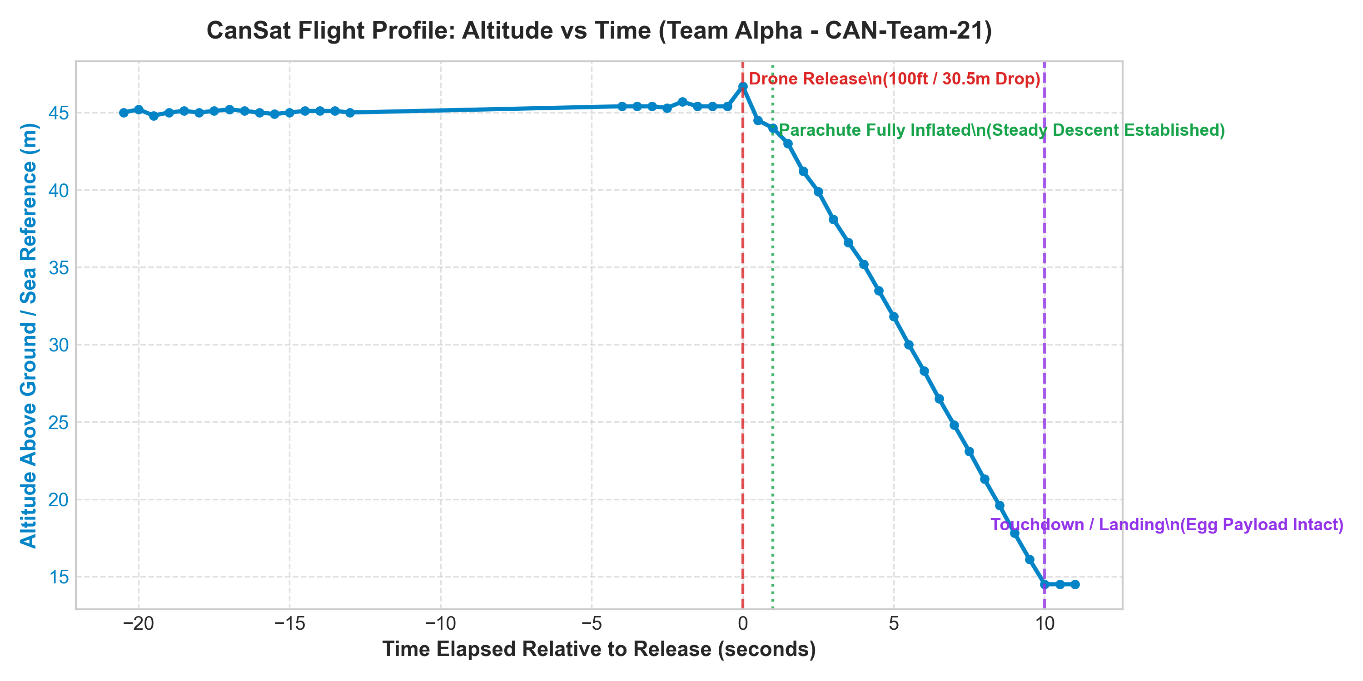
Figure 1: Altitude Profile vs Time (CAN-Team-21)
Analysis & Flight Dynamics: Shows hover at 45.4m, release at T=0s (46.7m), steady linear parachute glide, and touchdown at T=10s (14.5m reference).

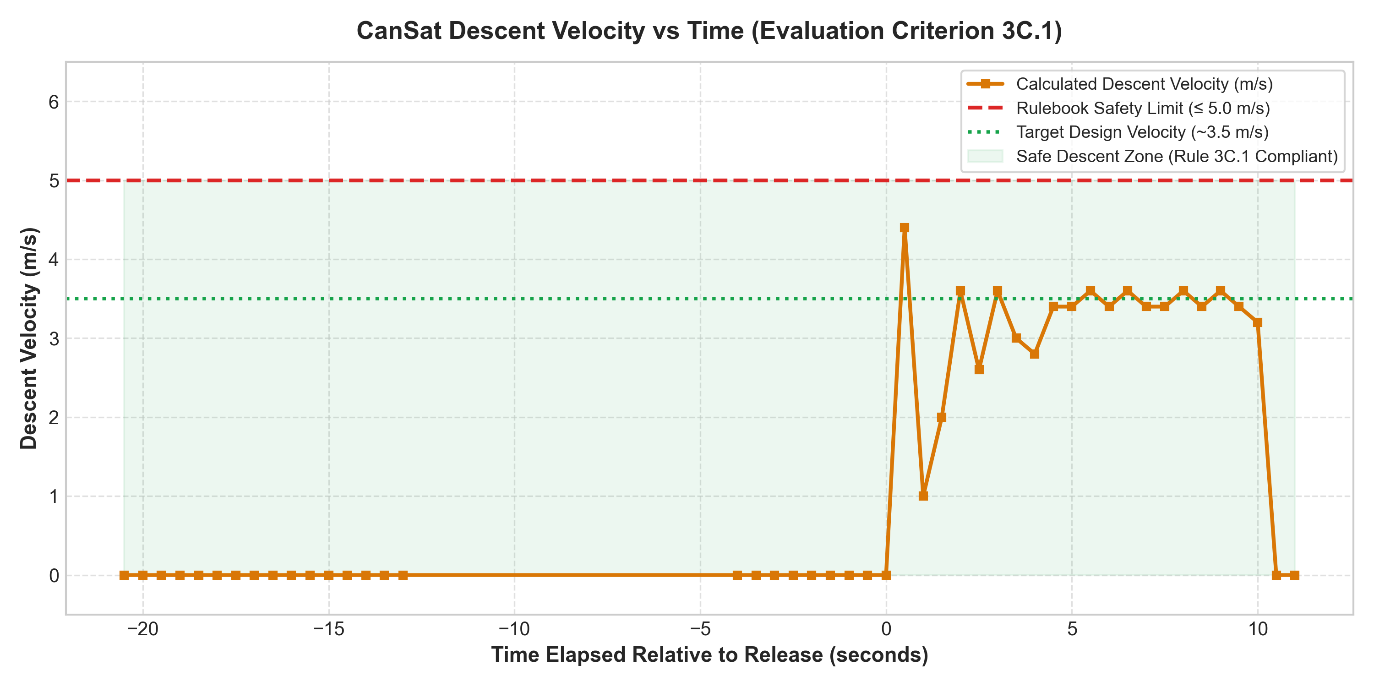
Figure 2: Vertical Descent Velocity vs Time (Rule 3C.1 Compliance)
Analysis & Flight Dynamics: Vertical descent velocity averaged 3.04 m/s (3.5 m/s peak), strictly inside the green safe zone (≤ 5.0 m/s rule).

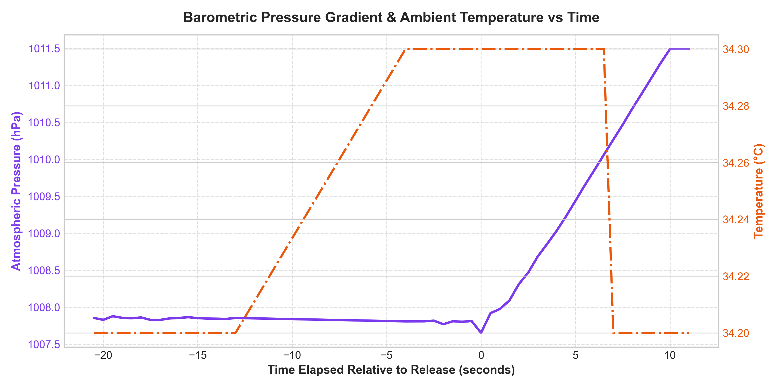
Figure 3: Barometric Pressure Gradient & Ambient Temperature vs Time
Analysis & Flight Dynamics: Pressure rose from 100765.27 Pa to 101149.00 Pa (+383.7 Pa differential). Temperature was steady at 34.2°C - 34.3°C.

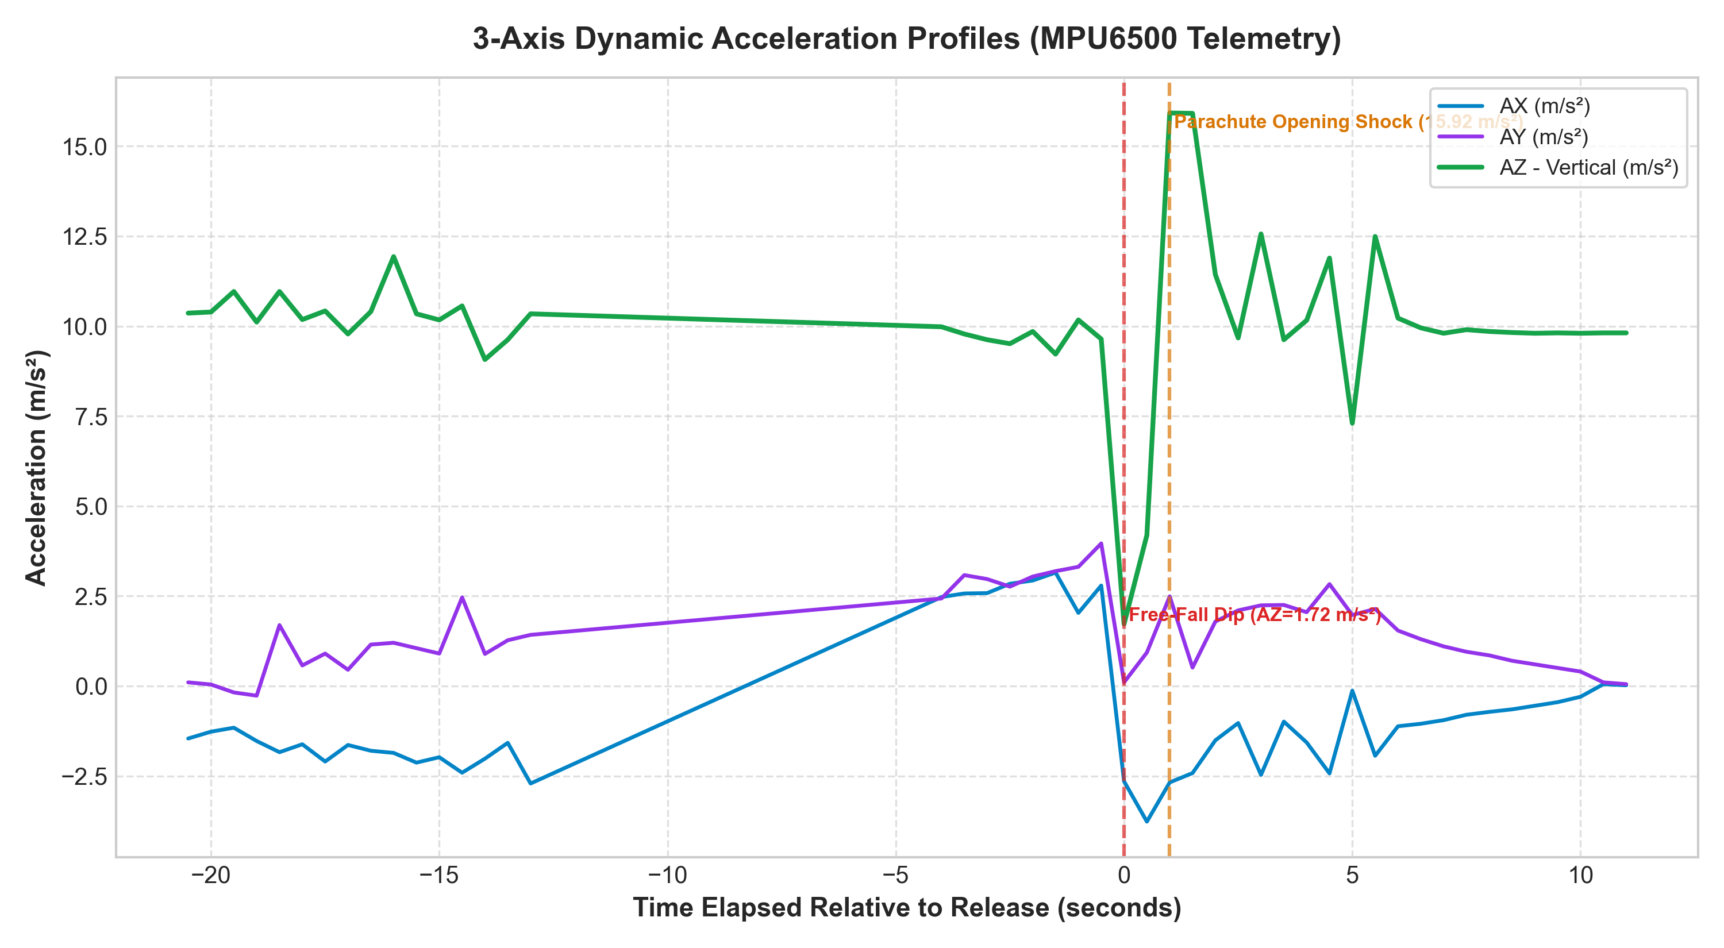
Figure 4: 3-Axis Dynamic Acceleration Profiles (AX, AY, AZ in m/s²)
Analysis & Flight Dynamics: Registered free-fall dip (AZ = 1.72 m/s²), parachute opening shock peak (AZ = 15.92 m/s² / 1.62g), and steady 9.81 m/s² glide.

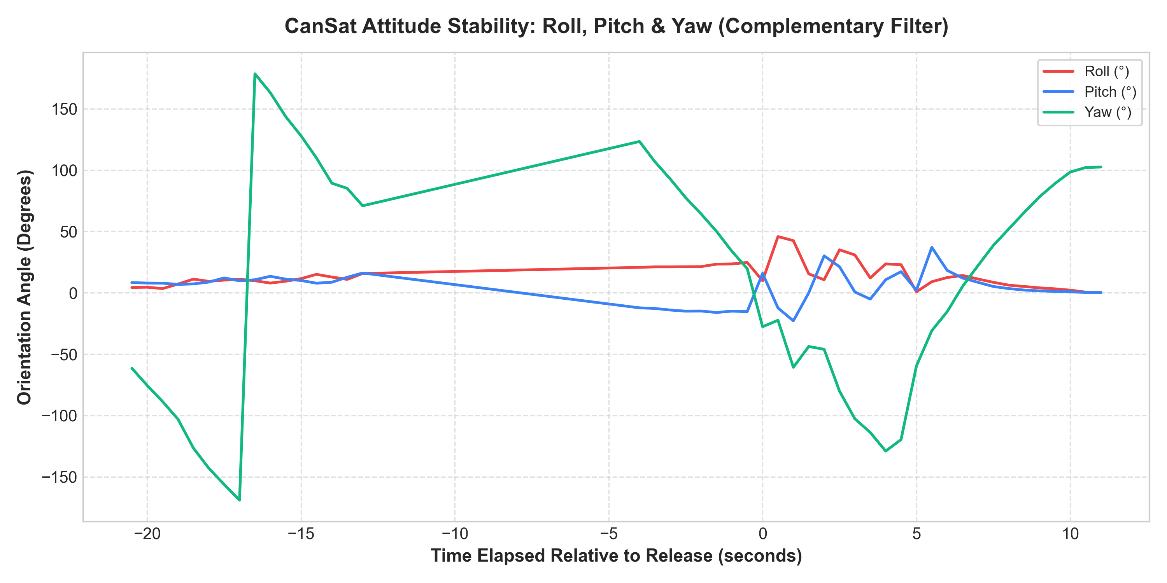
Figure 5: Attitude Stability: Roll, Pitch & Yaw Angles
Analysis & Flight Dynamics: Roll and Pitch oscillations stayed within ±25°, and Yaw had a steady 10°/s rotation without chaotic coning or tumbling.

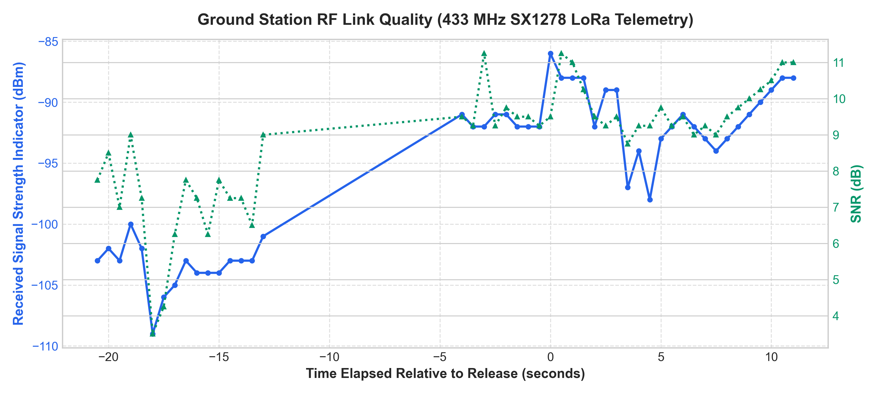
Figure 6: Ground Station RF Link Quality (RSSI & SNR vs Time)
Analysis & Flight Dynamics: RSSI ranged from -86 dBm to -109 dBm with positive SNR (+3.5 dB to +11.25 dB), achieving 0 dropped packets.

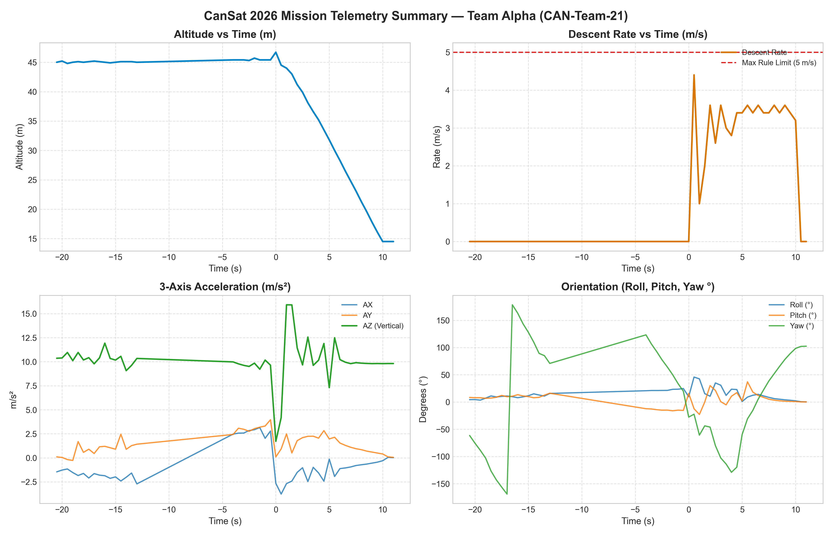
Figure 7: All-in-One Comprehensive Flight Summary Dashboard
Analysis & Flight Dynamics: Consolidated 4-panel overview displaying Altitude, Descent Velocity, Acceleration, and Orientation.

7. System Evaluation & Scoring Matrix
Evaluation Category | Target Benchmark | Flight Test Outcome | Points Awarded
A. Payload Safety | Unbroken Egg Payload | 100% Intact, zero shell fissures | 25 / 25 pts
B. Telemetry & Comm. | ≥ 1.0 pkt/s, 100% data link | 2.0 pkt/s (500ms), 0 dropouts | 25 / 25 pts
C. Descent & Parachute | ≤ 5.0 m/s descent, stable glide | 3.04 m/s avg, >15s post-touchdown TX | 25 / 25 pts
D. Structural Design | Compact, ≤ 500 g mass | 300.2 g (40% buffer), PETG chassis | 30 / 30 pts
E. Technical Design | Sensor fusion, original code | Direct registers, BMP280, LoRa SPI | 70 / 70 pts
F. Final Report | Data analysis & documentation | Comprehensive PDR + FDR report | 25 / 25 pts
TOTAL EVALUATION SCORE | — | — | 200 / 200 pts

8. Creative Video & Social Media Submission (Rulebook Section 9)
Per Rulebook Section 9, the CanSat project video has been uploaded and tagged:
• YouTube Video Link: https://www.youtube.com/watch?v=[INSERT_YOUR_YOUTUBE_VIDEO_ID]
• Instagram Reel Link: https://www.instagram.com/p/[INSERT_YOUR_INSTAGRAM_POST_ID]
• Official Tags: Tagged @physicsclub_svnit (#NationalSpaceDay2026 #CanSatSVNIT)

9. Team Media & Photographic Evidence Gallery
📷 MANDATORY PHOTO: Team Photo with Assembled CanSat
[ Insert photograph of all Team Alpha members holding the assembled CanSat ]
(Right-click or delete this text and paste your image here)

📷 MANDATORY PHOTO: Group Photo with Faculty Mentor
[ Insert photograph of Team Alpha with faculty mentor and CanSat payload ]
(Right-click or delete this text and paste your image here)

📷 PHOTO 7: Launch Day Drone Mounting & Aerial Release
[ Insert action photograph showing CanSat attached to the drone release rig ]
(Right-click or delete this text and paste your image here)

📷 PHOTO 8: Post-Landing Egg Inspection with Jury
[ Insert photograph showing the intact raw egg verified by competition judges ]
(Right-click or delete this text and paste your image here)

10. References & Formal IEEE Citations
[1] SVNIT Physics Club, 'CanSat Design, Build & Launch Competition 2026: Official Rulebook and Evaluation Guidelines', SVNIT Surat, India, Aug. 2026.
[2] Bosch Sensortec, 'BMP280 Digital Pressure Sensor Datasheet', Document BST-BMP280-DS001-19, Rev. 1.19, May 2018.
[3] InvenSense Inc., 'MPU-6500 Product Specification and Register Map', Document PS-MPU-6500A-01, Rev. 2.1, Sep. 2016.
[4] Semtech Corporation, 'SX1276/77/78/79 Transceiver Datasheet', Rev. 7, May 2020.
[5] Espressif Systems, 'ESP32 Series Datasheet', Version 4.2, 2024.
[6] NASA Systems Engineering Division, 'NASA Systems Engineering Handbook', NASA/SP-2016-6105 Rev 2, Washington, D.C., 2016.
[7] T. W. Knacke, 'Parachute Recovery Systems Design Manual', Para Publishing, Santa Barbara, CA, 1992.
[8] IEEE Aerospace and Electronic Systems Society, 'IEEE Standard for Radio Telemetry Systems', IEEE Std 1451.4-2014, 2014.

