BEEE LAB EVALUATION:

QUE: Design automatic led Diwali lights (consisting of 6 led’s) such that it only works during night and can generate two patterns which can be toggled with a switch. A) led chaser B) even-odd led’s.

CIRCUIT DIG:

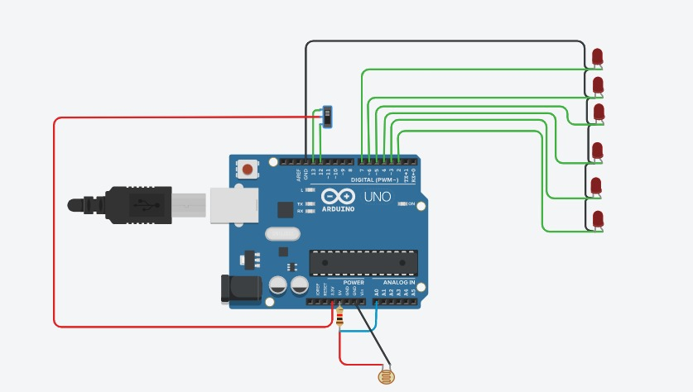

**THEORY:**

CONCEPT USED: Basic knowledge of connection of wires ,understanding the working of Arduino board and all the components of it. Basic knowledge of coding for the working of Arduino connections of LED wire and arduino board.basic knowledge of electrical equipment is neccesory. Moreover basic understanding of simultaneously glowing LEDs and the series of glowing .

LEARNING &OBSERVATIONS:

Learning: Working of Arduino Board .Making correct connections to make circuit work properly.

Observations: Functioning of Arduino in LED Chasing and Even Odd LED blinking. Connection inside the arduino . Importance of Grounding.

PROBLEMS &TROUBLESHOOTING:

Problems faced during the conduction of the experiment were programming the Arduino UNO Board with different methods of coding and implementing different loops. Wrong connections . Trouble shooting can only be done by learning and implementing different codes.

PRECAUTIONS:

* Don’t use damaged equipments.
* Make the correct connections.
* Select correct port while working with Arduino.
* Using safety measures.

LEARNING OUTCOMES: Through conduction of this experiment I have learned how to program the Arduino board with different methods using programing and what set of instructions need to be passes in order to make LED chasing and Even Odd blinking of LED. This experiment helps me in basic understanding of the coding and functanility of Diwali lights.