**Possibility Match of string**

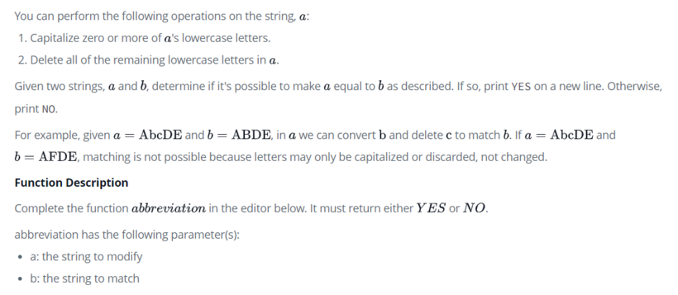

**Input Format**

The first line contains a single integer q, the number of queries.

Each of the next q pairs of lines is as follows:

- The first line of each query contains a single string, a.

- The second line of each query contains a single string, b.

**Constraints**

None

**Output Format**

For each query, print YES on a new line if it's possible to make string a equal to string b. Otherwise, print NO.

**Sample Input 0**

1

daBcd

ABC

**Sample Output 0**

YES

**Explanation 0**

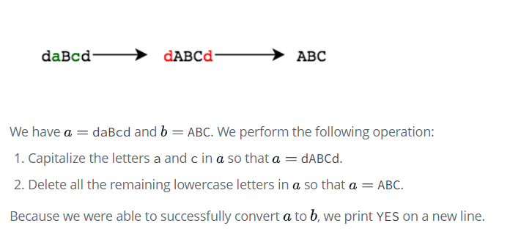

**Sample Input 1**

3

AbCdE

AFE

beFgH

EFG

beFgH

EFH

**Sample Output 1**

NO

YES

YES

## Rock,scissors,Paper Game

Make a two-player Rock-Paper-Scissors game. (Hint: Ask for player plays (using input), compare them, print out a message of congratulations to the winner, and ask if the players want to start a new game)

Remember the rules:

Rock beats scissors Scissors beats paper Paper beats rock

**Input Format**

first string for user1 second string for user2 user1 decision user2 decision

**Constraints**

len(string)>0

**Output Format**

single line ouput

**Sample Input 0**

Amrit

Ravi

Rock

Scissor

**Sample Output 0**

Amrit Win

**Sample Input 1**

Abdul

Shikha

Paper

Rock

**Sample Output 1**

Abdul Win

## Similar Char 1

Tahira and Mamta are woking in a project in TCS. Tahira being a problem solver came up with an interesting problem for her friend Mamta. Problem consists of a string of length N and contains only small case alphabets. It will be followed by Q queries, in which each query will contain an integer P (1<=P<=N) denoting a position within the string. Mamta's task is to find the alphabet present at that location and determine the number of occurrence of same alphabet preceding the given location P. Mamta is busy with her office work. Therefore, she asked you to help her.

**Input Format**

First line contains an integer N, denoting the length of string. Second line contains string S itself consists of small case alphabets only ('a' - 'z'). Third line contains an integer Q denoting number of queries that will be asked. Next Q lines contains an integer P (1 <= P <= N) for which you need to find the number occurrence of character present at the Pth location preceeding P.

**Constraints**

1 <= N <= 500000 S consisting of small case alphabets 1 <= Q <= 10000 1 <= P <= N

**Output Format**

For each query, print an integer denoting the answer on single line

**Sample Input 0**

9

abacsddaa

2

9

3

**Sample Output 0**

3

1

**Explanation 0**

Here Q = 2 For P=9, character at 9th location is 'a'. Number of occurrences of 'a' before P i.e., 9 is three. Similarly for P=3, 3rd character is 'a'. Number of occurrences of 'a' before P. i.e., 3 is one.