SENTINELDICOM
VEILGUARD
Next-Generation DICOM De-Identification & Diagnostic Integrity Platform
Core thesis
Do not treat de-identification as tag deletion. Treat every DICOM study as a privacy attack surface that must be discovered, transformed, independently validated, and refused for export whenever uncertainty cannot be safely resolved.

A merged architecture derived from the supplied SentinelDICOM blueprints and extended with a privacy-integrity co-validation, study-graph, failure-safe, and adversarial verification model.
Version 1.0 • Research / Innovation Prototype Blueprint

1. Executive Summary
SentinelDICOM VeilGuard is an offline-first desktop and integration platform for de-identifying DICOM studies before research, AI training, analytics, or controlled data sharing. The design combines standards-oriented metadata sanitization with AI-assisted pixel inspection, context-aware PHI classification, consistent pseudonymization, human review, and an independent validation gate.
The key architecture change is to separate the transformation path from the verification path. The anonymizer is not considered successful merely because it produced a new file. A candidate output must independently pass three truths: Privacy Truth, Pixel/Integrity Truth, and DICOM Structural Truth. Only then can the file enter the research cohort.
Capability | What VeilGuard does | Why it matters
Multi-layer PHI discovery | Scans public tags, private tags, nested sequences, free text, encapsulated payloads, overlays, pixels, OCR text, and machine-readable codes. | PHI can survive simple metadata deletion.
Context-aware pixel protection | Separates patient/hospital identifiers from clinical markers, scales, orientation labels, and operational annotations. | Avoids turning privacy cleaning into diagnostic damage.
Study-level identity management | Builds a Patient → Study → Series → Instance graph and remaps linked UIDs consistently. | Preserves longitudinal and cross-series relationships.
Uncertainty-aware decisions | Routes high-confidence cases to automation and ambiguous/high-impact cases to human review. | Acknowledge model uncertainty instead of silently guessing.
Independent release gate | Re-scans for residual PHI, checks DICOM validity and UID closure, and verifies changed-pixel containment. | Produces evidence, not just a success message.
Audit and provenance | Generates PHI-minimized, hash-chained audit records and a processing certificate. | Makes the workflow traceable and tamper-evident.

Design boundary
The system should report that a dataset was processed under a selected policy and validation profile. It should not make a blanket legal claim that an arbitrary output is automatically “HIPAA compliant” or risk-free. Regulatory determinations remain policy-, jurisdiction-, and use-case-dependent.

2. Design Goals, Non-Goals & North-Star Principles

2.1 North-star outcome
The output should be a research-ready DICOM object whose direct identifiers, hidden identifiers, and unnecessary visual identifiers have been systematically addressed, while medically relevant structure remains intact to the extent permitted by the selected policy.

2.2 Design principles
1. Defense in depth. Never rely on one tag list, one DICOM flag, one OCR engine, or one model.
2. Fail closed. Uncertainty, parser failure, integrity failure, or unresolved references must not silently produce an exportable file.
3. Preserve relationships. A study is a graph, not a bag of independent .dcm files.
4. Preserve evidence. Every transformation should leave a PHI-minimized, cryptographically linked audit trail.
5. Prefer deterministic and reversible controls where required. Longitudinal linkage should be policy-controlled, not achieved by exposing original identifiers.
6. Never manufacture clinical truth casually. Generative inpainting is optional and experimental; deterministic masking/local background restoration is the safe default.
7. Local-first privacy. Raw PHI should remain on the controlled workstation or clinical network unless an explicitly governed integration requires otherwise.

2.3 Explicit non-goals
- The product is not a diagnostic medical device and does not reinterpret clinical findings.
- The product does not promise zero re-identification risk; it reduces identified and reasonably foreseeable leakage surfaces according to an explicit policy.
- The product does not use an LLM as the sole authority for PHI detection.
- The product does not overwrite original DICOM files by default.

3. Deep Problem Analysis: Where DICOM De-Identification Fails
The supplied SentinelDICOM blueprints correctly frame the problem as multi-layered. The merged architecture expands that model to include embedded documents and a distinct integrity layer. The practical attack surface is best understood as a set of leakage planes.
Leakage plane | Examples | Typical failure | VeilGuard response
Standard metadata | PatientName, PatientID, accession, dates, operators | Delete obvious tags only; miss related fields or policy-specific retention needs. | Policy-driven actions with recursive validation.
Private / vendor tags | Odd groups, creator blocks, proprietary strings/binary payloads | Blacklist becomes stale or misses serialized text. | Default quarantine/drop; explicit creator allowlists; safe structured unpackers.
Nested DICOM sequences | Request attributes, procedure steps, specimen descriptions, references | Top-level scan misses deep SQ items. | Recursive tree walker with reference closure tests.
Pixel overlays | Burned-in names, MRNs, dates, hospital labels | Metadata is clean while the image still exposes identity. | Modality-gated text detection + OCR + barcode/QR + visual scan.
Incidental visual identity | Faces, tattoos, serial markings, recognizable visual features | Text-only systems see nothing. | Configurable visual-risk checks and human review.
Embedded payloads | Encapsulated PDF, SR, ECG/waveforms, CDA-like payloads | Binary content is left untouched. | Type-aware extract → sanitize → re-encapsulate or quarantine.
Identity linkage | Study/Series/SOP references | Random remapping breaks longitudinal or cross-instance links. | Study graph + deterministic pseudonymization + reference update.
Integrity leakage | Unexpected pixel changes, changed bit depth, broken transfer syntax | Privacy cleaning damages downstream AI/clinical utility. | Independent pixel/dataset integrity validation.
Process/audit leakage | Logs containing patient name or source paths | The anonymizer itself becomes a PHI source. | PHI-minimized logging and protected operator identifiers.

3.1 The central tension: privacy vs. utility
A research cohort may need to preserve chronology, spacing, modality parameters, anatomical orientation, and image intensity behavior. Over-cleaning can destroy the exact signal a downstream model needs. The system therefore applies a “minimum necessary transformation” strategy: remove direct identity aggressively, preserve clinically useful information only when the active policy permits it, and send high-risk overlaps to review instead of forcing automation.

3.2 The core insight
The project is not “an anonymizer.” It is a release-control system.
The differentiator is the release gate. VeilGuard combines transformation with evidence: what PHI was detected, where it was, what changed, whether references still close, whether pixel changes stayed inside approved regions, and whether a second scan still finds identifying information.

4. System Architecture: Dual-Plane + Co-Validation
The merged architecture keeps the strongest concept from the second blueprint—the dual-plane pipeline—and integrates the stronger verification concepts into a single safety-oriented control flow. The planes operate independently enough to reduce coupling, while the controller synchronizes them using a study/job identifier, policy version, region maps, and cryptographic hashes rather than passing raw PHI through every subsystem.
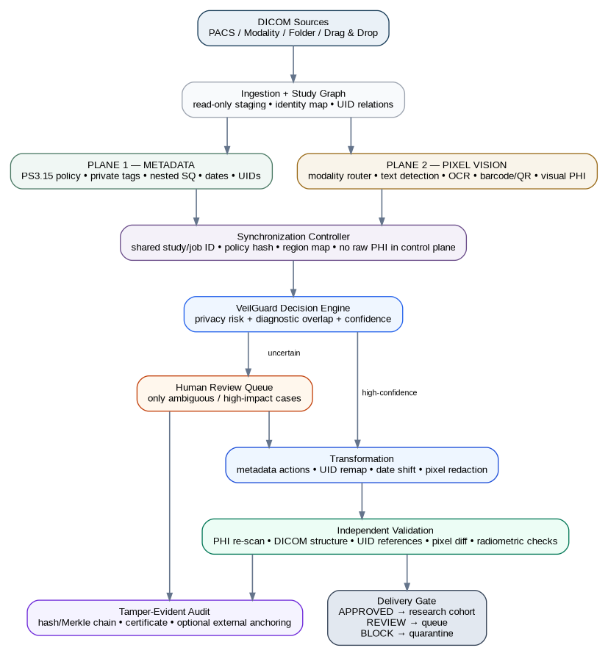
Figure 1. End-to-end architecture: metadata and pixel planes converge into a confidence-gated transformation and independent validation path.

4.1 Major subsystems
Subsystem | Primary responsibility | Failure behavior
Ingestion & study graph | Discover files, detect study boundaries, create relationships, compute source hashes. | Quarantine malformed/unreadable inputs.
Metadata plane | Classify, remove, replace, clean, pseudonymize, and validate DICOM attributes. | Drop/quarantine unknown risky content according to policy.
Pixel vision plane | Detect text, PHI, machine-readable codes, and configurable visual identifiers. | Escalate uncertain/overlapping detections.
Decision engine | Fuse rule, OCR, NER, spatial, modality, and integrity signals. | Review or block when thresholds are not satisfied.
Transformation layer | Apply metadata actions, UID mapping, date transformations, and pixel redaction. | Never modify the original source.
Validation layer | Perform independent post-processing checks. | No export on any hard failure.
Audit/security layer | Protect keys, record transformations, produce certificates. | Avoid logging raw PHI; protect vault access.

5. Plane 1 — Cryptographic Metadata Sanitizer
The metadata plane should prefer a strict allowlist of safe data elements for the selected research profile, with explicit action codes for retained or transformed fields. A blacklist-only model is too fragile because private and newly encountered attributes can contain unexpected content.

5.1 Recursive attribute processing
Core traversal model
Incoming Dataset
-> For each element:
if element is a Sequence (SQ): recursively inspect every item
classify tag + VR + keyword + value + parent context
apply policy action: KEEP / CLEAN / REPLACE / UID / DATE / REMOVE / REVIEW
-> validate required attributes and reference closure
-> emit sanitized dataset + transformation manifest

5.2 Private tag quarantine
Policy state | Default action | Example
Unknown private block | Quarantine or drop | Proprietary strings / serialized blobs
Known-safe creator block | Parse specific sub-elements only | Numeric diffusion parameters
Known unsafe creator | Drop | Demographic / technician notes
Unknown non-private attribute | Policy-specific review | Unexpected free-text field
Retained field containing text | Run value-level PHI classifier | Study Description with a name

5.3 Deterministic pseudonymization
For controlled longitudinal research, the system can generate stable pseudonyms using a keyed cryptographic function. The original UID must not be exposed or used directly as a visible identifier.
Recommended cryptographic pattern
PseudoUID = OrganizationOID + "." + decimal(HMAC-SHA256(K_uid, OriginalUID)[0:N])
PseudoPatientID = "PX-" + Base32(HMAC-SHA256(K_patient, OriginalPatientID)[0:M])
Properties:
- stable within the configured cryptographic domain
- not reversible without protected key material
- UID output is encoded as digits under the organization's OID prefix
- mapping scope is explicit: patient / study / series / instance

Important implementation detail
A hexadecimal HMAC digest is not directly a valid DICOM UID component. The implementation should convert selected digest bytes to a decimal component under an owned/root OID and enforce the DICOM UID length constraint.

5.4 Cohort-consistent date shifting
Where permitted by the research protocol, a deterministic patient-specific date offset can preserve intervals while changing calendar anchors. The policy should also specify whether month, season, weekday, or exact time relationships must be preserved. Dates that are legally required to be removed should be removed rather than shifted.
delta_patient = HMAC(K_date, PatientDomainID) -> integer offset
Every eligible date/time for that patient: shifted_value = original_value + delta_patient
Invariant: interval(A, B) remains unchanged.
Constraint: never create impossible dates or violate policy-specific age/date rules.

6. Plane 2 — Modality-Gated Pixel PHI Intelligence
The supplied blueprints correctly identify burned-in pixel PHI as the major differentiator. The merged design retains the efficient modality router but adds multiple independent detectors and a metadata-to-pixel cross-check.

6.1 Risk-adaptive routing
Modality / object type | Default visual scan | Escalation trigger
Ultrasound / Secondary Capture / Nuclear Medicine / Optical / legacy radiographs | Full-frame text + barcode/QR scan; multi-frame temporal coherence when applicable. | Any credible text, code, or visual-identity candidate.
CT / MRI volumetric series | Adaptive sampling: scout/representative slices + perimeter checks, then full scan on triggered series. | Detected text, unusual overlays, inconsistent flags, or review policy.
Multiframe cine | Detect stable overlay coordinates once; propagate candidate masks temporally, then verify representative frames. | Changing overlay geometry or frame-specific text.
Encapsulated document / SR / waveform | Payload-type-specific parsing and redaction rather than ordinary pixel OCR alone. | Unsupported payload or failed re-serialization.

6.2 Multi-stage detector
1. Presence gate. A lightweight image classifier predicts whether the image/object is likely to contain burned-in annotations.
2. Text localization. DBNet++, PaddleOCR detection, or another optimized detector produces oriented text regions.
3. OCR. An OCR engine reads candidate regions; preprocessing can include contrast normalization, rotation handling, and modality-aware crops.
4. PHI semantic classifier. Regex, dictionaries, entity recognition, and contextual rules distinguish patient/hospital identifiers from clinically useful labels.
5. Barcode/QR decoder. Machine-readable code content is decoded and treated as sensitive when it maps to identity or operational identifiers.
6. Metadata-to-pixel correlation. Known patient names, IDs, accession numbers, or dates from metadata are searched against OCR output to increase or decrease confidence.
7. Visual identity scan. Optional face/recognizable-feature checks are applied according to policy and modality.

6.3 Context sieve: preserve what is clinically useful
Class | Examples | Default decision
A — identity PHI | Patient name, MRN, accession, DOB, hospital identifier | Redact/replace according to policy
B — clinical/operational annotation | L/R, AP/LAT, scale, gain, kVp, mA, FOV | Preserve unless the selected policy says otherwise
C — diagnostic field overlap | Text candidate inside active anatomy / tissue field | Require higher confidence or human review
D — uncertain | Low OCR confidence, ambiguous short text, unusual glyphs | Review or block; do not silently export

7. Diagnostic-Preserving Redaction & Transformation
The source blueprints include black-box masking, inpainting, and generative restoration. The merged design changes the priority order to make preservation and safety explicit.
Priority | Technique | When to use | Risk control
1 | Graphic/overlay removal | When annotation is a separate graphics/overlay object rather than baked into diagnostic pixels. | Preferred because no anatomy is reconstructed.
2 | Localized background replacement | Solid margins / letterboxed overlays with stable background statistics. | Preserves nearby pixel distribution; no synthetic anatomy.
3 | Deterministic local inpainting | Text over benign background where a small mask is required. | Use only inside approved region; validate surrounding pixels.
4 | Human-edited mask | PHI overlaps meaningful anatomy or the mask is ambiguous. | Human approval required before export.
5 | Experimental generative restoration | Research-only extension with explicit evaluation. | Never default; require strict comparative validation.

7.1 Why generative inpainting is not the default
A privacy tool should not replace an identifying label by inventing clinically meaningful structures. A generative model may produce plausible but non-original patterns. For research integrity, the safer default is deterministic masking/background restoration with strict spatial containment tests. Generative restoration can remain an optional research module whose effect on downstream models is separately evaluated.

7.2 Radiometric integrity rules
- Native bit depth: Process monochrome images at their native 12/16-bit representation whenever possible; do not silently convert CT/MR source data to 8-bit RGB for the final file.
- Rescale semantics: Do not change Rescale Slope/Intercept merely to accommodate redaction; update only what is technically required by a justified, validated encoding change.
- Spatial invariants: Rows, Columns, Frames, Pixel Spacing, orientation, slice geometry and other required attributes must remain consistent unless the policy explicitly allows changes.
- Changed-pixel containment: Every modified pixel should fall inside an approved redaction mask or a documented transformation region.

7.3 Multi-frame temporal coherence
For cine loops, detect persistent overlays once, propagate the mask across frames when geometry is stable, and sample multiple frames to verify that the redaction remains aligned. Frame-specific annotations must be detected separately. This avoids flicker and reduces redundant OCR work.

8. Study Graph, UID Continuity & Reference Safety
DICOM de-identification must preserve logical relationships between related instances. The system therefore constructs a graph before modifying identifiers.
PatientDomain
|
+-- StudyInstanceUID S1
|
+-- SeriesInstanceUID SR1
| +-- SOPInstanceUID I1
| +-- SOPInstanceUID I2
|
+-- SeriesInstanceUID SR2
+-- SOPInstanceUID I3
UID map is generated at study scope and applied to every matching reference.

8.1 Reference closure validation
After transformation, every internal reference that points to a replaced UID should resolve to exactly one valid target when the source relation was resolvable. Unresolved or ambiguous references should trigger review or quarantine depending on policy.

8.2 Longitudinal linkage policy
Research need | Identity strategy | Protective control
Single-study anonymization | Random or study-scoped pseudonyms | No cross-study linkage required
Longitudinal cohort | Stable patient-domain pseudonym | Key scoped to cohort; original ID stays outside research export
Clinical trial follow-up | Reversible pseudonymization if explicitly required | Separated key escrow / controlled access / audit
Open public dataset | Prefer irreversible de-identification | No re-identification mapping in the released package

9. VeilGuard Co-Validation Engine
This is the main architectural differentiator added to the supplied blueprints: transformation and validation are separate trust domains within the application. The candidate output must survive a post-processing attempt to find residual PHI and must prove that changes remained within approved regions.
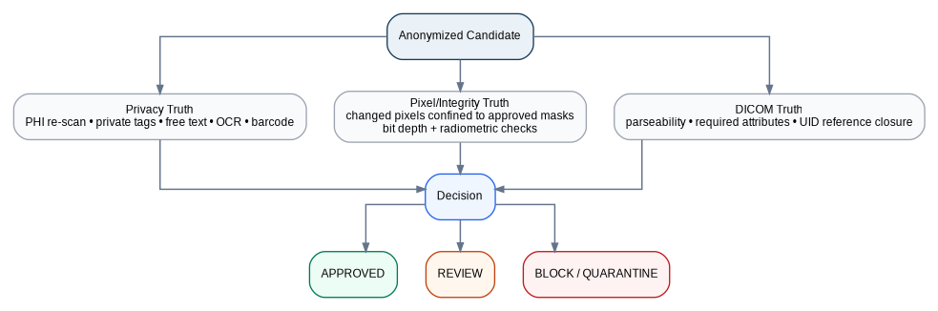
Figure 2. Three-truth release gate: privacy, integrity, and DICOM structural validity are evaluated independently.

9.1 Privacy Truth
- Re-scan all policy-sensitive DICOM tags and nested sequences.
- Inspect private creators/blocks according to the policy.
- Search free-text fields with regex + semantic classification.
- Run OCR/visual PHI checks on the transformed pixels where policy requires.
- Re-check barcode/QR content.
- Verify that original source identifiers were not accidentally copied into audit or custom fields.

9.2 Pixel/Integrity Truth
- Compute a difference map between source and output pixel arrays for comparable frames.
- Verify that modified pixels are contained inside approved transformation masks.
- Verify native bit depth, frame count, geometry, and radiometric semantics.
- Optionally calculate SSIM/PSNR or domain-specific variance measures as supporting metrics—not as sole proof.

9.3 DICOM Truth
- Reopen the produced DICOM with an independent parser.
- Validate required attributes for the relevant object type / IOD.
- Check Transfer Syntax and pixel data readability.
- Check UID reference closure and sequence consistency.
- Reject files that cannot be parsed cleanly after transformation.

10. Decision Engine: Confidence, Impact & Fail-Safe Routing
A single confidence score is not enough. A detection can be highly likely to be text yet still be dangerous to erase if it overlaps a diagnostic region. VeilGuard therefore combines detection confidence with clinical-impact context.
Signal | Meaning | Example contribution
Detector confidence | How certain the text/region detector is. | 0.98 text probability
OCR confidence | How reliably the text was read. | 0.94
PHI semantic score | How strongly text matches a PHI category. | MRN / NAME / DATE
Metadata correlation | Whether pixel text matches known source identifiers. | PatientName ↔ OCR match
Spatial context | Whether region lies in margin, overlay zone, or anatomy. | High overlap with diagnostic field
Modality prior | Expected prevalence of burned-in annotations. | Ultrasound > routine CT
Integrity risk | Potential consequence of changing the region. | Anatomy overlap = high
Policy sensitivity | How strict the active research profile is. | Open dataset vs controlled trial

10.1 Suggested routing model
Condition | Action
High PHI confidence + low diagnostic overlap + policy permits automatic action | AUTO-TRANSFORM
High PHI confidence + high diagnostic overlap | HUMAN REVIEW
Medium PHI confidence | REVIEW unless a documented safe transformation exists
Low confidence but high potential impact | REVIEW / BLOCK according to policy
Parser failure / reference failure / integrity failure | BLOCK + QUARANTINE
Post-validation residual PHI | BLOCK; do not export

Policy note
The numerical confidence thresholds should be tuned from validation data and documented per model/version. The blueprint uses confidence bands conceptually; it does not claim universal 95%/70% thresholds are scientifically sufficient for every deployment.

11. Human-in-the-Loop Review Center
Human review is not a fallback for a weak system. It is a deliberate control for ambiguous cases and high-impact transformations.
REVIEW ITEM
- Study / Series / Instance reference
- Detection source: OCR / text detector / barcode / metadata correlation
- Candidate PHI class
- Confidence + diagnostic-overlap indicators
- Original preview (restricted, local-only)
- Proposed mask / transformed preview
- Actions: Approve / Edit Mask / Reject / Escalate
- Reviewer identity + timestamp
- Final decision becomes part of the audit trail

11.1 Review ergonomics
- Side-by-side or blink comparison between source and de-identified views.
- Highlight only the proposed PHI region by default; do not flood the reviewer with boxes over clinically useful annotations.
- Support add/resize/move/remove mask operations.
- Allow a mask to be propagated across stable multi-frame overlays.
- Provide “why detected” evidence: OCR text, matching metadata token, detector score, and policy rule.

12. Security, Vaulting & Tamper-Evident Audit
The system should protect not only the DICOM output but also the mapping keys, processing logs, temporary files, and application telemetry.

12.1 Key hierarchy
Master / HSM-held key
|
+-- K_uid -> UID pseudonymization
+-- K_patient -> patient pseudonymization
+-- K_date -> deterministic date shifting
+-- K_audit -> audit record integrity
Keys never appear in normal application logs.

12.2 Tamper-evident audit record
The audit design from the supplied blueprints is retained and strengthened into a Merkle-/hash-chained ledger. The audit record contains hashes and transformation summaries—not patient names or raw OCR text.
Conceptual chained-hash construction
AuditBlock_n = SHA256(
AuditBlock_(n-1)
|| job_id
|| input_sha256
|| output_sha256
|| policy_id
|| transform_summary
|| validation_summary
|| timestamp
)

12.3 Optional cross-institution anchoring
Permissioned blockchain anchoring may be added when multiple institutions need proof that a certificate existed at a particular time. Only a digest or certificate fingerprint should leave the controlled environment. Blockchain is an optional trust extension, not a substitute for the local audit system.

13. Embedded Documents, Structured Reports & Non-Image Objects
A DICOM container can carry far more than raster pixels. The sanitization engine should classify and route non-image payloads based on their object type instead of treating everything as ordinary pixel data.
Object / payload | Processing strategy | Release rule
Encapsulated PDF | Extract to isolated sandbox; inspect text/layout; redact sensitive content; re-encapsulate only if validated. | Unsupported PDF feature → quarantine.
DICOM Structured Report | Recursive content-item traversal; sanitize free text/coded values according to policy. | Reference and content-tree validation required.
Waveform / ECG | Scan descriptive metadata and associated text; preserve waveform samples unless policy requires signal transformation. | Integrity check on sample count/encoding.
RT / treatment objects | Object-specific conformance policy; preserve required references. | Strict reference closure and structural validation.
DICOMDIR | Rebuild / validate directory references if present. | Directory must resolve to delivered instances.

14. Deployment Modes

14.1 Desktop / researcher mode
Drag-and-drop or browse a study directory. The application performs local processing, shows a job dashboard, surfaces review items, and exports a sanitized cohort package with an audit certificate.

14.2 Real-time folder mode
A watch service detects newly written studies, waits for file stability, groups instances into studies/series, then processes them through the same core engine. The watcher should never alter the source directory.

14.3 PACS / DICOM network mode
For a controlled clinical integration, VeilGuard can operate as a DICOM receive/forward or research-export proxy. The same de-identification engine is invoked before research delivery. Network credentials, AE Titles, destinations, and access policy belong in a separate configuration/security layer.

14.4 Large-batch accelerator mode
The architecture can later split ingestion, analysis, inference, and validation into workers for GPU/CPU scaling. The research export gate remains identical regardless of whether the job ran on one workstation or a distributed batch system.
Architecture consistency rule
Desktop, folder-watch, PACS, and batch modes must invoke the same policy engine and validation gate. A “fast path” that bypasses validation creates a weaker product in the exact workflow where scale makes mistakes harder to detect.

15. Core Data Model & Local Service Interfaces

15.1 Processing job object
Job {
job_id
policy_id
source_root_hash
studies[]
status
metrics {
files_seen, files_approved, files_reviewed, files_blocked,
metadata_actions, pixel_regions, validation_failures
}
audit_chain_head
}

15.2 Detection object
Detection {
study_id, series_id, instance_id, frame_id?
source = OCR | TEXT_DETECTOR | BARCODE | METADATA_MATCH | VISUAL
category = NAME | ID | DATE | LOCATION | OTHER
bbox / polygon
detector_confidence
phi_confidence
diagnostic_overlap_score
policy_action
review_status
}

15.3 Suggested internal API surface
Interface | Purpose | Security
POST /jobs | Create processing job and policy context | Local IPC / authenticated local service
GET /jobs/{id} | Read sanitized job status/metrics | No raw PHI in response
GET /review/{id} | Get review evidence and safe previews | Restricted access
POST /review/{id}/decision | Approve/edit/reject a detection | Reviewer identity logged
GET /audit/{id} | Retrieve certificate/audit summary | PHI-minimized
POST /validate/{id} | Run independent validation | No bypass of release gate

16. Edge-Case Matrix & Real-World Failure Handling
Edge case | Risk | VeilGuard strategy | Final gate
Ultrasound cine loop | Static PHI overlay across hundreds of frames | Temporal mask propagation + sample-frame verification | PASS only if all checked frames align
Text over lung/liver/brain | Redaction can alter anatomy | High-overlap score → human review; deterministic local mask if approved | Changed-pixel containment
Micro-calcification / punctuation ambiguity | Tiny bright structure mistaken for text | Aspect ratio + text-shape context + anatomy-region exclusion | Review if ambiguous
16-bit CT/MR | 8-bit conversion destroys radiometric utility | Native bit-depth processing and encoding preservation | Radiometric/bit-depth validation
JPEG 2000 / JPEG-LS | Unsupported codec or unintended lossy re-encode | Use validated native codecs/transcoders; prefer lossless path | Reopen + pixel checks
Encapsulated PDF | PHI survives in binary document | Payload extraction + document redaction | Re-parse payload
Unknown private tag | Vendor data leaks PHI | Quarantine/drop by default; explicit safe allowlist | Private-tag rescan
Broken reference | Study becomes logically inconsistent | Reference closure validator | BLOCK
Reviewer rejects mask | PHI may remain | No automatic export; require a new decision or policy exception | BLOCK/REVIEW
Audit log contains PHI | Tool creates secondary leak | Sanitize telemetry and enforce PHI-minimized schema | Audit lint test

17. Verification, Evaluation & Red-Team Test Plan
The product should be tested as a security-sensitive transformation engine, not only as a GUI application. The evaluation plan should include synthetic PHI injection, curated de-identified datasets, edge cases, and regression tests for every supported modality/object type.

17.1 Test corpus
- Synthetic DICOMs with known PHI in standard tags, private tags, nested sequences, free text, overlays, and UIDs.
- Images with burned-in names, dates, hospital identifiers, barcodes and QR codes.
- Clinical annotation controls: L/R, AP/LAT, scale bars, Doppler measurements, window/level labels.
- Multi-frame cine data with stable and changing overlays.
- High-dynamic-range 12/16-bit monochrome images.
- Lossless compressed transfer syntaxes and negative/positive signed pixel representations where supported.

17.2 Core metrics
Metric | Definition | Use
PHI recall | Fraction of seeded / adjudicated PHI instances detected | Safety effectiveness
PHI precision | Fraction of flagged regions that are actually sensitive | Reviewer workload
Review rate | Share of studies requiring manual review | Operational scalability
Residual PHI rate | Share of outputs with PHI found on post-scan | Release safety
Changed-pixel leakage | Changed pixels outside approved masks | Diagnostic integrity
Reference-closure rate | Resolvable references remaining valid | DICOM integrity
Throughput | Studies/minute or images/minute by modality | Performance
Audit completeness | Expected fields present in every job ledger | Governance

17.3 Adversarial privacy attack simulator
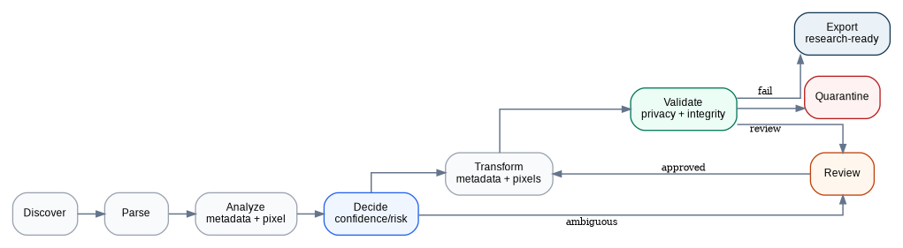
Figure 3. Processing state machine: uncertain cases are routed to review and hard failures to quarantine.
- Metadata extraction attack: enumerate tags and search for direct/indirect identifiers.
- Private-tag attack: inspect odd groups and creator blocks.
- OCR attack: ignore metadata and visually re-scan pixels.
- Barcode/QR attack: attempt machine-readable decoding.
- Free-text attack: search output strings using identifier patterns.
- UID attack: look for recoverable original relationships.
- Artifact attack: inspect temporary exports, audit logs, and package manifests for accidental identity leakage.

18. Production-Oriented Technology Stack
Layer | Recommended choice | Alternative / note
Desktop shell | Tauri v2 + TypeScript/React | PySide6 is a simpler all-Python prototype option.
Core engine | Rust | Python is acceptable for an MVP; Rust becomes valuable for high-volume and memory-safe core processing.
DICOM | dicom-rs + GDCM / DCMTK where needed | pydicom is excellent for rapid prototyping and testing.
Image processing | NumPy/OpenCV/SimpleITK | Use native arrays for bit-depth-safe processing.
Inference | ONNX Runtime | Execution provider may be CPU / DirectML / CUDA / CoreML depending on host.
OCR | PaddleOCR / EasyOCR plus domain tuning | Tesseract can be used for a baseline comparator.
Text/NER | Rule engine + medical NER | LLM/VLM verification only for ambiguous cases and only under an explicit privacy boundary.
Audit | Hash/Merkle chain | Optional permissioned external anchoring.
Key store | OS credential store / HSM in enterprise mode | Local encrypted vault for prototype.
Viewer | Cornerstone-based web viewport inside Tauri | Simpler 2D viewer for MVP.

Prototype-to-production strategy
Start with Python + pydicom + OpenCV + OCR to validate the concept quickly. Keep the policy, study graph, validation, and audit interfaces language-agnostic so the high-performance core can later move to Rust without redesigning the product architecture.

19. Implementation Roadmap
Phase | Focus | Deliverables | Exit criteria
Phase 0 (Week 1) | Dataset & policy foundation | Synthetic PHI corpus, policy schema, project skeleton, audit schema. | Deterministic test fixtures exist.
Phase 1 (Weeks 2–3) | Metadata core | Recursive parser, private-tag policy, UID graph, date handling. | Known PHI removed/transformed; references close.
Phase 2 (Weeks 4–5) | Pixel detection | Modality router, text detector, OCR, barcode/QR, PHI classifier. | Candidate regions and confidence generated.
Phase 3 (Week 6) | Redaction + review | Mask editor, controlled inpainting, review queue. | End-to-end DICOM in → review → DICOM out works.
Phase 4 (Week 7) | Co-validation | Privacy re-scan, pixel diff, structural validation, quarantine gate. | Hard failures cannot export.
Phase 5 (Week 8) | Audit + certificate | Hash/Merkle chain, certificate, operator log. | Audit chain tamper test passes.
Phase 6 (Weeks 9–10) | Real-time/batch | Folder watcher, worker queue, parallel processing. | Stable throughput benchmark.
Phase 7 (Weeks 11–12) | Hardening | Regression suite, codec/edge-case testing, packaging, security review. | Release candidate meets documented acceptance tests.

20. Competition / Innovation Demo Blueprint
The most convincing demonstration is a before/after study that contains PHI in more than one layer. The demo should show that ordinary metadata cleaning is insufficient, then show VeilGuard finding and proving the residual risk.
1. Step 1 — Reveal the problem. Open a DICOM study showing PatientName/PatientID metadata and a burned-in identifier on the image.
2. Step 2 — Run baseline metadata scrub. Show that the tags are clean but an OCR attack still finds text in the image.
3. Step 3 — Run VeilGuard. Display detected metadata PHI, pixel PHI, barcode detections, and confidence evidence.
4. Step 4 — Show context. Demonstrate that L/R orientation, scale and technical annotations were preserved while identity text was targeted.
5. Step 5 — Human review. Open one deliberately ambiguous case and approve/edit a mask.
6. Step 6 — Independent validation. Show Privacy Truth, Pixel/Integrity Truth, and DICOM Truth all passing.
7. Step 7 — Attack the output. Run OCR, private-tag enumeration, barcode decoding, and free-text scanning against the released file.
8. Step 8 — Show the certificate. Open the PHI-minimized audit report with input/output hashes, policy ID, validation results, and reviewer actions.

20.1 Suggested live dashboard
Panel | Display
Privacy | Metadata PHI: 0 • Pixel PHI: 0 • Barcode: 0 • Private PHI: 0
Integrity | Changed pixels: contained • Bit depth: preserved • UID closure: pass
Operations | Studies processed • Auto-approved • Review queue • Quarantined
Explainability | Detection source • confidence • policy action • reviewer decision
Audit | Input hash • output hash • policy version • audit-chain status

21. Advanced Extensions & Research Opportunities
- Federated model improvement: Train text/PHI detectors across institutions without centralizing raw images, using federated learning where governance permits.
- Active learning loop: Use reviewer edits as labeled examples to improve the detector on site-specific overlay patterns.
- Policy-aware redaction templates: Institution-specific overlays, private creators, date rules, and research cohort requirements can be versioned as policy packs.
- Dataset-level uniqueness analysis: Flag unusual combinations of age, dates, institution, rare procedure, and other quasi-identifiers for expert review.
- Secure enclaves: Run the re-identification key service in an isolated host while keeping the research dataset irreversible.
- External validation harness: Benchmark the same anonymized cohort with independent DICOM parsers and OCR stacks to reduce single-tool blind spots.

21.1 Main technical risks
Risk | Mitigation
OCR false negatives | Multi-engine detection, metadata cross-correlation, modality-specific routing, human review.
OCR false positives | Context sieve and preservation rules for clinical markers.
Over-redaction | Diagnostic overlap scoring + changed-pixel containment.
Under-redaction | Post-transform independent attack scan.
Vendor-specific DICOM variation | Strict quarantine/allowlist model + growing vendor test corpus.
Performance on large cohorts | Risk-adaptive pixel scanning, temporal caching, worker pool, native codecs.
Key compromise | HSM/secure enclave, separate key purposes, rotation and access audit.
Reviewer inconsistency | Decision guidelines, evidence panel, reason codes, and periodic adjudication.

22. Final Architecture Statement
SentinelDICOM VeilGuard
A privacy-first DICOM release platform that discovers identity across metadata, embedded structures, pixels and machine-readable overlays; transforms only what the active policy requires; preserves study relationships and clinical signal; sends uncertainty to a human; and proves the final output through independent privacy and integrity validation.

The strongest originality of the merged idea is therefore not a specific OCR model or a specific redaction algorithm. It is the architecture around them: a dual-plane de-identification engine governed by a fail-safe decision system and an independent three-truth release gate.

22.1 One-line pitch
“We do not just anonymize the DICOM—we challenge the output, verify the image, preserve the clinical structure, and refuse to release what we cannot prove is safe.”

Appendix A — Recommended Policy Skeleton
policy:
id: strict_research_v1
metadata:
default_unknown_public: REVIEW
default_private: REMOVE
patient_identity: REMOVE
patient_id: PSEUDONYMIZE
dates: PATIENT_CONSISTENT_SHIFT
uids:
mode: HMAC_PSEUDONYM
scope: STUDY_AND_COHORT
preserve_reference_closure: true
pixel:
modality_routing: true
ocr: true
barcode_qr: true
metadata_pixel_correlation: true
diagnostic_overlap_review: true
generative_inpainting: false
validation:
rescan_phi: true
validate_dicom: true
validate_uids: true
validate_changed_pixel_containment: true
export:
quarantine_on_failure: true
never_overwrite_original: true
audit:
hash_chain: true
raw_phi_in_logs: false

Appendix B — Example De-Identification Certificate
Field | Example
Job ID | JOB-2026-000182
Policy | strict_research_v1
Input SHA-256 | e3b0c442…
Output SHA-256 | 4bf5122f…
Metadata actions | 28
Private tags removed | 6
Pixel PHI regions | 2
UID references checked | PASS
Changed-pixel containment | PASS
Residual PHI re-scan | PASS
Human review | 1 case approved
Release status | APPROVED
Audit-chain head | 9ac7…

Appendix C — Source Basis & Terminology
This blueprint consolidates the two SentinelDICOM technical blueprints supplied in the conversation. Source concepts retained include the four-layer PHI model, PS3.15-oriented metadata handling, private-tag quarantine, deterministic pseudonymization and date shifting, modality-gated OCR, context-aware preservation of clinical annotations, encapsulated-payload inspection, tamper-evident logging, human review, PACS/batch modes, and a phased implementation plan. The merged design adds explicit co-validation, study-graph handling, adversarial output testing, and quarantine-based release control.
The document deliberately uses “policy profile,” “validation,” and “processing certificate” language rather than asserting automatic legal compliance. Any production deployment should be reviewed against its jurisdiction, organizational governance, security controls, and intended research use.

