Circuit Diagram :

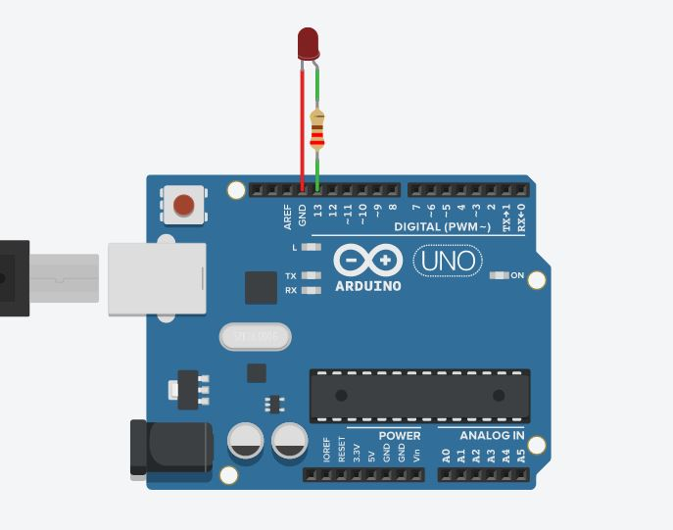

Theory:

Concept Used:

In this experiment , we used an arduino board for flashing a LED Light. Basic concept used in this is that we have to give an input and output will be generated on its own sing a microprocessor which arduino board here. In this, we will give an input in the form of a code and the code will generate the output in the form of flashing of LED.

Learning & Observation:

* Firstly, I observed by little changing n the code we can alter the flashing of LED.
* Flashing of light totally depends onn the code we write we can also increase or decrease the time gap between switching on and switching off of the light by changing the code.
* Different types of pin can be used for output we are not bounded to only one or two pins.
* We have a ground pin to provide negative terminal.

Problems & Troubleshooting:

One of the biggest problem I faced during this experiment is adjusting the wires n the breadboard. Basically, code writing is a simple task for me and it is not also complex in this problem but adjusting the wires in the breadboard is one of the new concept and is little hard for me.

Precautions:

* Always attach the positive terminal of the LED of the output pin.
* Do not confuse in positive and negative terminal of the LED long pin is usually taken as positive while short pin as negative. Instead you can also check it by looking at LED a side where P sign is shown thaken as positive.
* Syntax of the code should be accurate.
* Breadboard must be used carefully.
* Attach pin very carefully to the output pins. Use the same output pin during attachment which you have written in the code.

Learning Outcomes:

* After doing this experiment I have learnt how to flash a LED light by using arduino board.
* I also learnt how to code for a flashing of a LED.
* I also learnt how I can alter the flashing by just dong little changes in the code.