THE EFFECTS OF GROWTH, FOREIGN AID AND FINANCIAL DEVELOPMENT ON POVERTY


Submitted By:
Divyansh Gupta
Roll No.:- 200351
Course Instructor: Dr. Somesh Kumar Mathur

Introduction
Over the last two decades, global poverty has decreased significantly (1981-2010). Nonetheless, according to World Bank estimates, nearly 1.8 billion people lived below the poverty line of $2.15 per day per person in 2004. East Asia and the Pacific have seen the sharpest declines in both the number of poor and the poverty rate among the world's developing regions. Other regions saw a modest drop in poverty rates, which in some cases were insufficient to reduce the number of poor. Sub-Saharan Africa, for example, has seen a significant increase in the number of poor over the same period. Poverty reduction will be a major challenge in the future due to the disparities in experience across regions.
Numerous cross-country research and case studies suggest that persistent economic growth is the primary motivator for poverty reduction. Dollar and Kraay (2002), for example, discover a one-to-one relationship between the poorest quantile's income and average income, indicating the relevance of economic development in poverty alleviation.
Current empirical studies suggest that growth-promoting policies such as financial system development, trade openness, and remittances may have a systemic impact on the poor. Beck et al. (2007) demonstrate in their new article that financial development is favourably associated to income of the lowest quantile and has a negative impact on income inequality. These findings suggest that financial development has a direct impact on poverty reduction, in addition to the indirect effect through growth of average income. Controlling for average income growth, Dollar and Kraay (2002; 2004) conclude that trade has no substantial influence on poverty, despite case studies by Tsai and Huang (2007) and others demonstrating that trade openness plays a major role in poverty reduction.
The empirical growth-poverty association studies all have one thing in common: the conclusions are based on least squares estimation, which implies that growth and other variables that influence poverty have the same effect in all nations. A nonlinear link between average income growth or other variables and poverty might occur for a variety of reasons. The degree of development, the sectoral composition of growth, and the presence of poverty itself may all have an effect on the impact of growth and growth-promoting policies on poverty. For example, Loayza and Raddatz (2006) discover that labour intensity influences the effect of growth, demonstrating that expansion in unskilled-labor-intensive industries contributes more to poverty reduction. Chambers et al. (2008) also claim that the Kuznet hypothesis, which implies an inverted U-shaped link between income and income inequality, might lead to a nonlinear impact of growth on poverty. According to the base study by Alvi and Aberra (2014), an increase in average income and other growth-boosting policies have a heterogeneous influence on poverty, particularly at higher poverty levels, when the marginal benefit of growth and growth-enhancing policies reduces.
The idea that various development and growth-promoting strategies affect poverty differently may have important policy repercussions for reducing it. The following two related concerns must be resolved from a policy perspective. First, how does poverty affect growth and policies that promote development? Second, is the effect of each of these explanatory variables nonlinear in terms of poverty? Because the sequencing of reforms for effective and expedited poverty eradication may change in response to growth and policy.
Literature Review
Both cross-country and case studies have shown the importance of continued economic development as a significant component in poverty eradication. It is also worth considering whether growth-promoting policies and institutions benefit the poor in ways other than increasing average income and improving income distribution. Researchers have increasingly focused their attention on the influence of globalisation and economic and political freedom in this specific field.
Dollar and Kraay (2002) used data from 92 countries to assess the impact of average income growth on the income of the lowest quintile. They discover a one-to-one correspondence between average income and income in the lowest quintile. Controlling for average income and income dispersion, they find that conventional growth factors such as trade policy have little effect on low income. This finding implies that policies and institutions that explain growth only impact the poor via their influence on average income, and that there is no systematic link between these policies and poverty. Kraay (2006) finds that increases in average income mostly cause changes in poverty.
Several case studies show the impact of income growth while also emphasising various elements that lead to poverty alleviation in various nations.
Tsai and Huang (2007) evaluated the effect of economic development, openness to international commerce, and foreign direct investment (FDI) on poverty reduction in Taiwan using time series data from 1964 to 2003. They establish an approximately one-to-one link between average income and income of the lowest quintile, similar to Dollar and Kraay (2002), emphasising the need for sustained economic development for poverty reduction in Taiwan. Contrary to Dollar and Kraay's (2002;2004) results, they show that openness to international commerce has a large poverty-reducing impact by enhancing the income share of the lowest quintile above and beyond its indirect contribution via rise in average income. However, Ravallion (2006), using micro and macro data, concludes that trade has a substantially smaller poverty-reduction impact. Contrary to popular belief that FDI increase job possibilities in the host nation, According to Tsai and Huang (2007), FDI inflows have no substantial influence on poor income.

Chambers et al. (2008) use panel data from 1986 to 2000 to analyse the influence of growth on poverty in Chinese provinces. Although their overall results emphasise the need of sustained economic development for poverty reduction, they discover an inverted-U-shaped link between income and poverty, i.e., short-run economic growth enhances poverty while long-run growth decreases poverty. Initially, an increase in average income that eliminates poverty boosts income disparity, which tends to lessen poverty's positive growth effect. Yet, after a certain level of income is achieved, rise in average income alleviates poverty while the accompanying paradoxical impact of increasing income disparity fades. They also discover that other variables such as government spending, education spending, and agricultural spending have no substantial influence on poverty.

Adams and Page (2005) identify foreign remittances and public sector employment as variables that have contributed to poverty reduction in the area when they examine the development of poverty, inequality, and growth in selected Middle East and North African nations from 1980 to 2000. They specifically discover that foreign remittances have significant poverty-reduction impacts in the area.

Access to finance is another major aspect that is thought to have a role in poverty alleviation. Several empirical case studies suggest that microfinance helps to alleviate poverty by removing the credit limitations that the impoverished face. Beck et al. (2007), for example, investigate the influence of financial development on poverty by evaluating its impact on the income of the lowest quintile and changes in income distribution. They discover that financial growth not only benefits the lowest quintile's income but also decreases income disparity. These two findings, together with the growth-enhancing impacts of financial development, demonstrate the critical role that financial development plays in poverty alleviation. These data support the argument that financial development helps the poor more than proportionally, potentially via reducing credit constraints in addition to other favourable outcomes.

In addition to the considerations mentioned above, foreign assistance has long been seen as a critical resource in the battle against poverty. Yet, the argument regarding its efficacy in boosting development and raising people's living standards in developing countries is far from resolved. Clemens et al. (2012) discovered that foreign help had a moderate positive impact on growth after re-examining data from three of the most referenced publications in the aid-growth field. Alvi and Senbeta (2012) demonstrate that after adjusting for average income and income distribution, foreign assistance has a substantial poverty-reducing impact. Yet, the research fails to investigate the potential varied influence of assistance on poverty.

Alvi and Aberra(2014) examine the aid-growth poverty relation using quantile regression which is used to calculate the effects of growth-promoting measures at different quantiles in the conditional distribution of poverty. They find that growth in average income and other growth-enhancing policies have a heterogeneous impact on poverty, especially the marginal effect of growth and growth-enhancing policies decreases at higher levels of poverty.

The primary contribution of this work, then, is a non-parametric examination of the impact of income growth and growth-enhancing policies, which enables us to test for potential nonlinear effects of a collection of particular explanatory factors on poverty in India.
Objective of the Paper
In order to review the impact of average income and other growth-related factors on poverty, this research will use Non-Parametric Analysis. If the true impact is nonlinear, the findings of prior studies' least squares calculation, which offer a point estimate of the average influence of growth and development-enhancing measures on poverty, may be deceptive. Contrary to least squares estimation, Non-Parametric Analysis does not assume any prior function or relationship between poverty and other determinants of growth, thus it is perfect to depict the non-linear relationship between average income and other determinants of growth on poverty and the varying effects of growth-enhancing policies on poverty. We can therefore show where the impact of growth and growth-enhancing policies on reducing poverty is the highest and the lowest, (whether the higher levels of poverty are affected by the growth and financial aid more or whether we need different policies for different poverty levels.)
Model Specification
To examine the relative impact of growth and for poverty reduction, I will employ the Kernel Regression using Nadaraya-Watson Estimator. To test the effect of growth-enhancing policies on poverty, we expand the basic specification to include factors identified in the literature as determinants of growth, such as openness to international trade, financial development, government consumption, institutional quality, and international capital flows-foreign aid, FDI inflows, and international remittances. There is no specified relationship between poverty and growth as we are using non-parametric analysis and the whole estimation of the relationship depends on data.
Dependent Variable:- Poverty Gap(Log of the proportion of people living below the poverty line)
Independent Variable:- Real GDP per Capita, Aid,Openness to Trade, Finance, Age dependency Ratio, Mean Household Income, Foreign Direct Investment, Remittances
Econometric Methodology
We use Kernel Regression for non-parametric analysis using a time series data on India’s variables. We will be using one of the kernel regression methods called Nadaraya-Watson Estimator for estimating poverty.
The Kernel Density Function K(z) used is Gaussian.
K(z)= exp(-z²/2)
Y is the dependent Variable
m(x):=E[Y|X=x]=∫yf_{Y|X=x}(y)dy
=∫yf(x,y)dy/f_{X}(x)
X is a vector of explanatory variables
$\hat{f}$(x,y;h)=$\frac{1}{n}$ $\sum_{i=1}^{n}{}$K_{h1}(x−X_{i})K_{h2}(y−Y_{i}), h=( h₁, h₂)^{T}
$\hat{f}$_{X}(x,h1)=$\frac{1}{n}\sum_{i=1}^{n}{}$K_{h1}(x−X_{i}),
Where K_{H}(z):=|H|^{−1/2}K(H^{−1/2}z)
therefore ,
$\hat{m}$(x)=$\frac{∫ y\hat{f}(x,y;h)dy}{\hat{f}(x,h1)}$= $\frac{∫y\frac{1}{n} \sum_{i=1}^{n}{}Kh1(x-Xi)K(y-Yi)dy}{\frac{1}{n}\sum_{i=1}^{n}{}Kh1(x-Xi)}$
= $\frac{\frac{1}{n} \sum_{i=1}^{n}{}Kh1(x-Xi)∫yK(y-Yi)dy}{\frac{1}{n}\sum_{i=1}^{n}{}Kh1(x-Xi)}$
= $\frac{\frac{1}{n} \sum_{i=1}^{n}{}Kh1(x-Xi)Yi}{\frac{1}{n}\sum_{i=1}^{n}{}Kh1(x-Xi)}$
=$\sum_{i=1}^{n}{}\frac{Kh1(x-Xi)}{\sum_{i=1}^{n}{}Kh1(x-Xi)}$Y_{i} = $\sum_{i=1}^{n}{}$W_{i} Y_{i}
Where W_{i}= $\frac{Kh1(x-Xi)}{\sum_{i=1}^{n}{}Kh1(x-Xi)}$, is the weights for the weighted average.
The resulting estimator is the Nadaraya-Watson Estimator.
The resulting estimates plot the relation between poverty and different factors affecting it.
Data Source and Coverage
Time-series data for India from 1981 to 2010 make up our sample. The PovcalNet poverty and inequality dataset from the World Bank(https://data.worldbank.org) contains information on poverty and the Gini coefficient, a measure of income inequality. Real GDP per capita, trade, foreign assistance, financial development, inflation, age dependence ratio, foreign direct investment flows, and international remittances are some of the other factors we utilise. These data are obtained from the World Bank, World Development Indicators. We use the international poverty line of "$2.15 a day" in 2017 PPP . Variable definitions and sources of data are available below.
The explanatory factors are assessed as averages over three years since the dependent variable, which measures poverty, is accessible every three years. The amount of foreign help, for instance, that corresponds to the year 1990 is the average of the aid flows from 1988 to 1990.
The collected data is compiled in a spreadsheet linked below:
https://docs.google.com/spreadsheets/d/1debPt_f_CsY6HSFPkToLBu1Rk9I2JPbSafBoK9XDsxs/edit?usp=sharing

VARIABLE DEFINTIONS AND SOURCES
Variables Variable Definitions Source
Real GDP per capita Log GDP per capita, PPP(2017) World Development Indicator
Aid Aid % of Gross National Income (GNI) World Development Indicator
Inflation Log of one plus the inflation rate World Development Indicator
Openness Log of the sum of exports and imports of goods and World Development Indicator
services as share of Gross Domestic Product (GDP)
Finance Log of domestic credit to private sector as share of GDP same as above
Age Dependency ratio The ratio of dependents to working-age population same as above
Headcount Index Log of proportion of people living below the poverty line PovcalNet
Poverty Gap Index Log of the average income shortfall as share of poverty line PovcalNet
Squared Poverty Gap Log of the squared average income shortfall as share PovcalNet
Index of poverty line
Gini Log of the Gini coefficient PovcalNet
Mean Household Income Log of the mean annual household income in 1993 PPP PovcalNet
Foreign direct investment Foreign direct investment, net inflows (% of GDP) World Development
Indicator
Remittances Workers' remittances and compensation of employees, World Development
received (% of GDP) Indicator

Summary Statistics
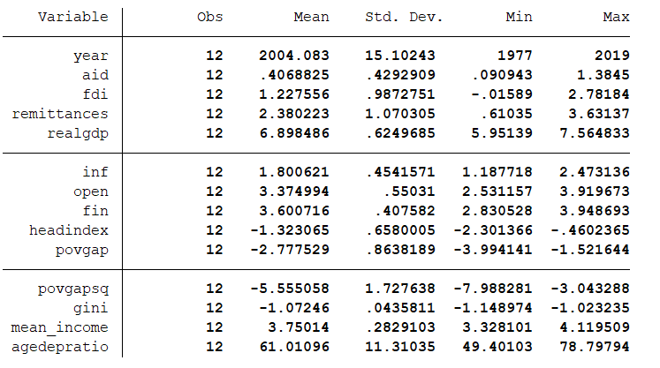

Correlation Map
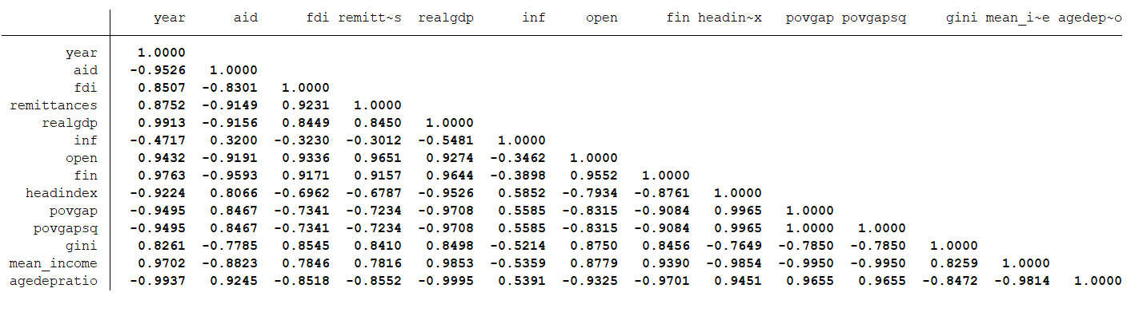
- Real GDP appears to be strongly positively correlated with many of the other variables, such as aid, FDI, and remittances, suggesting that these factors may contribute to economic growth.
- The age dependency ratio is strongly negatively correlated with many of the other variables, suggesting that an aging population may have a negative impact on economic indicators such as real GDP and financial development, thus increasing the Poverty Gap.
- Openness and financial development are strongly positively correlated with each other, suggesting that a more open economy may be associated with greater financial development, thus reducing the Poverty.
- Inflation appears to be negatively correlated with aid, FDI, and remittances, which may indicate that these factors are less likely to flow into a country with high inflation rates, thus increasing the rates of poverty due to less inflow of money in India.
Research Hypothesis
Dependent Variable:- Poverty Gap(Log of proportion of people living below the poverty line)
Independent Variable:- Real GDP per Capita, Aid, Openness to Trade, Finance, Age dependency Ratio, Mean Household Income, Foreign Direct Investment, Remittances.
Based on the above conclusions made by different authors, the hypothesis of my study would be:
- There exists a negative relation between average Income and the Poverty Gap.
- Openness to Trade and Foreign Direct Investment have a large poverty-reducing effect.
- Financial Development plays a critical role in alleviation of poverty.
- There is a negative relation between the mean annual household income and poverty gap.
- Age Dependency Ratio is positively correlated with the Poverty Gap.
Results and Conclusions
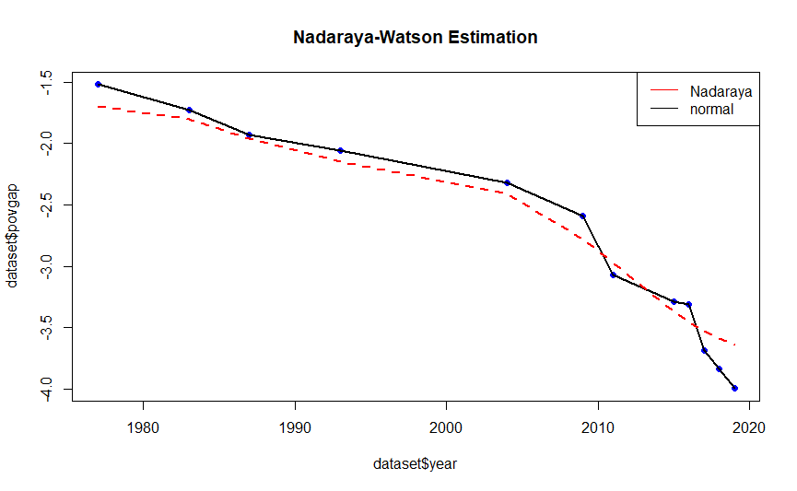
Poverty has decreased over time due to various factors and its affects which we have analysed in the paper.
Relation between GDP and Poverty
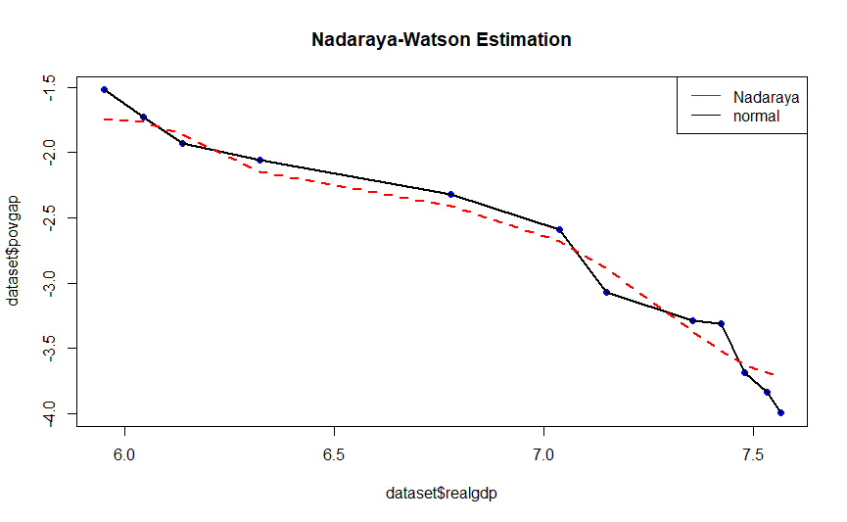
As we can see there is constant decrease of poverty gap in the India Economy with respect to GDP growth which is expected as economic growth promotes employment and increases income among the people thus having a poverty reducing effect.

Relation between Mean Annual Income and Poverty
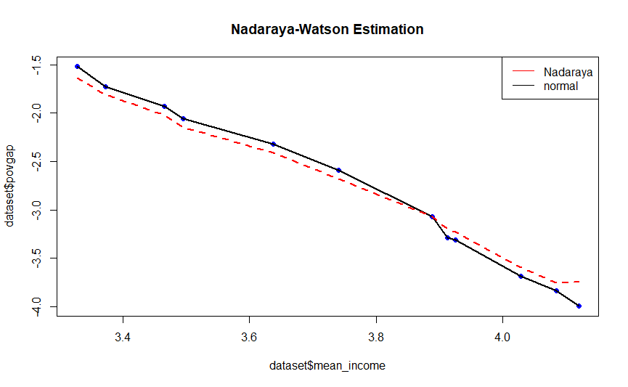
As we can see there is constant decrease of poverty gap in the India Economy with respect to income growth which is expected as higher incomes can help to improve living standards and provide greater financial security for households, reducing the risk of falling into poverty.
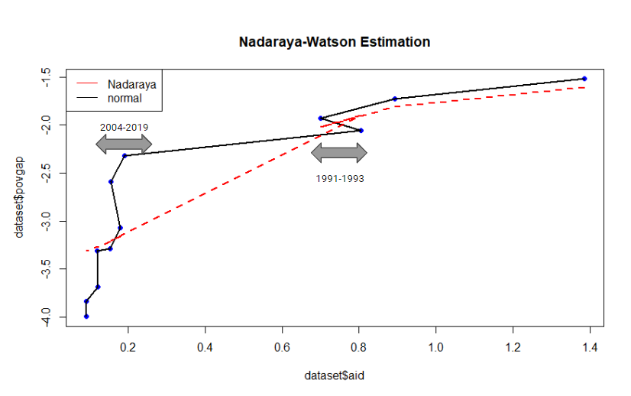
Relation between Financial Aid and Poverty
Financial aid can help to promote economic growth by providing resources for investment in education, infrastructure, and other productive assets. This can create new job opportunities and boost incomes, potentially reducing poverty rates over the long term. It can also provide critical support to households living in poverty, helping them to meet basic needs such as food, housing, and healthcare. This can help to alleviate some of the immediate challenges associated with poverty and improve the wellbeing of these households.
An interesting thing to note is that , as we can see during years 1991-1992 , there was a sudden increase in financial Aid, due to the Economic Crisis of 1991, which caused the rate at which poverty was declining to decrease, and as the economy progressed we can see that during recent years of 2004-2019, there is a steep decrease in poverty with respect to Aid.

Relation between Openness to Trade and Poverty
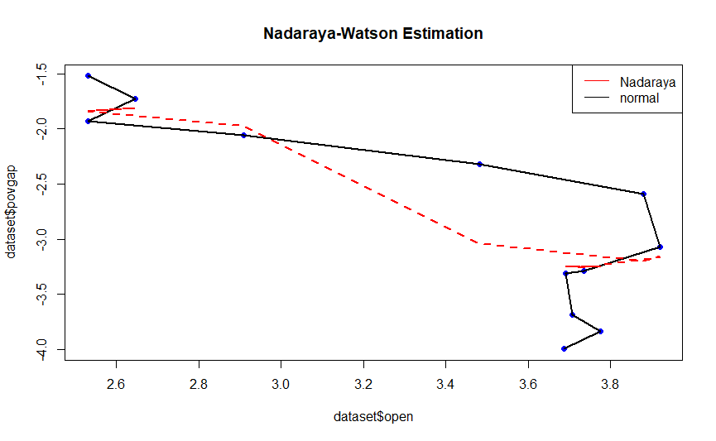
Openness to Trade promote economic growth, create new job opportunities, and increase access to affordable goods and services, which can help to reduce poverty rate. Trade liberalization can also stimulate innovation, increase productivity, and reduce costs, which can benefit consumers and firms alike. This can lead to higher levels of economic activity, increased investment, and higher wages for workers, all of which can contribute to reducing poverty.
There was also a large jump in exports and imports of India(i.e. Openness to trade increased a lot) due to the new Economic Policy Reforms of 1991 which caused a steep decline in poverty in India.
Relation between Age Dependency Ratio and Poverty
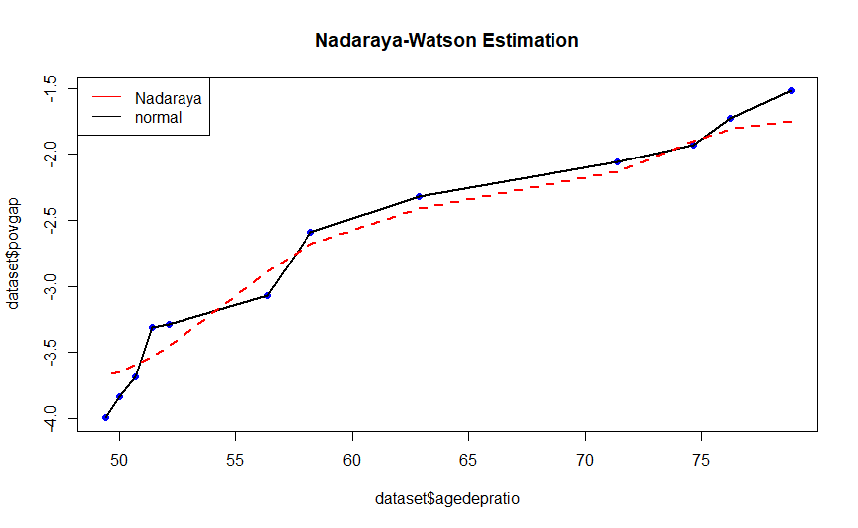
The increase in the Youth Age-Dependency Ratio negatively affects the mental force of the Working-age population due to the education expenditure pressure which causes an immense load on the financials, and thus increasing the poverty.

Relation between Financial Credit and Poverty
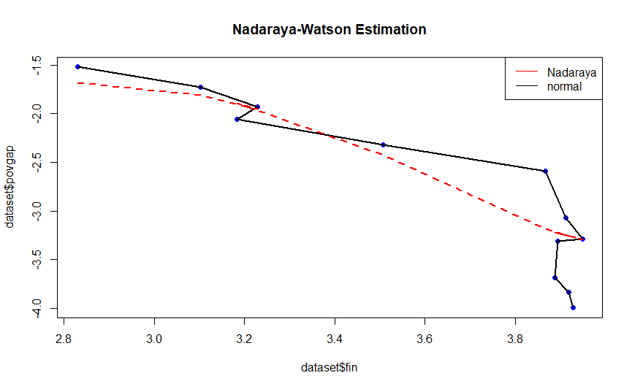
There is a positive relationship between domestic credit to the private sector as a share of GDP and reductions in poverty. This relationship is often attributed to the role that credit plays in stimulating economic growth, which in turn can lead to job creation and increased income for individuals and households.
When businesses have access to credit, they can invest in new projects or expand existing ones, which can lead to job creation and increased income for workers. Increased income can lead to reductions in poverty, as households have more resources to meet their basic needs and invest in their own futures.

R Codes


Base Paper
“Foreign Aid, Growth and Poverty Relation: A Quantile Regression Approach”, The Journal of Developing Areas, Summer 2014, Vol. 48, No.3(Summer 2014), pp. 381-403
Reference Paper
"Do international migration and remittances reduce poverty in developing countries?”, World Development, 2005, Vol. 33, No. 10, pp 1645-1669.
“Does Foreign Aid reduce Poverty?”, Journal of International Development, 2012, Vol. 24, Issue 8, pp. 955-976.
“Aid, growth and development: Have we come full circle?”, Journal of Globalization and Development, 2010, Vol. 1, Issue 2, pp. 1-29
“Halving Global Poverty”, The Journal of Economic Perspectives, 2003, Vol. 17, No. 3, pp. 3-22.

Plagiarism Report
https://drive.google.com/file/d/1xGwdRJQbMBstneDud1GhbyZc7r6RYTdz/view?usp=sharing

