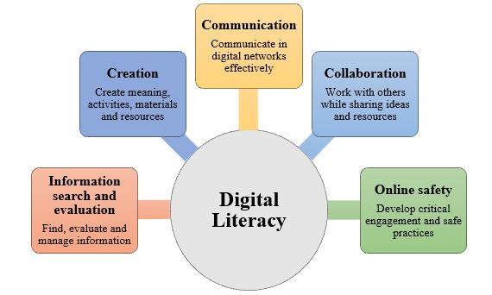

DIGITAL LITERACY PROJECT
NAME : Divyanshi Upadhyay
REGISTRATION NUMBER : 25BAI10585
BRANCH : BTech CSE(AI and ML)
YEAR : 1st Year
COURSE CODE : CSE0001
DATE : 24th March’2026

INTRODUCTION :
As a Student Digital Ambassador, this project has been carried out to encourage digital literacy and promote responsible behaviour among students in the online environment. In today’s technology-oriented world, people regularly use different digital platforms, but many still lack a clear understanding of how to use them effectively, safely, and ethically. This project aims to create a well-structured Digital Literacy Portfolio that highlights important skills such as developing a professional online identity, using digital tools productively, and following proper communication practices in the digital space.
The project is divided into five separate tasks, each focusing on an important area of digital literacy. These include spreading awareness, building a digital portfolio, exploring online platforms, understanding email etiquette, and learning about cybercrime prevention. Through this project, the goal is to improve digital awareness and help students gain essential skills that are useful for both academic growth and future professional opportunities.

Task 1 - Create a Digital Literacy Awareness Infographic :
In Task 1, I created a one-page visual presentation to explain the concept of digital literacy and its importance for students. My design covered key topics including what digital literacy is, useful digital tools for students, safe internet practices, professional online presence, and email etiquette. I ensured that the information was presented in a simple, clear, and visually appealing way so that my batchmates can easily understand and apply it in their daily digital activities.
I used Prezi to design this presentation. It helped me organise multiple topics in a structured and interactive format, making the overall design more engaging. The tool allowed smooth arrangement of content and visuals, which improved the clarity and flow of information.
While working on this task, I found it interesting to include multiple topics in a single page without making it confusing. At the same time, it was slightly challenging to maintain a proper balance between text and visuals. Overall, this task enhanced my creativity and improved my understanding of how to present digital literacy concepts effectively.

Task 2 - Build Your Student Digital Portfolio :
In Task 2, I developed my student digital portfolio by setting up profiles on GitHub, Kaggle, and ResearchGate. These platforms play an important role in building a professional identity and connecting with both technical and academic communities. On GitHub, I created a profile README that includes my basic details such as name, branch, year, and my learning goals. It will help me showcase my coding projects and track my progress over time.
Kaggle is a platform mainly used for data science and machine learning. I plan to use it for practicing with datasets, improving my problem-solving skills, and participating in competitions. ResearchGate is focused on academic work, where I can explore research papers and stay updated with new developments in my field.
In the coming years, I aim to keep my GitHub updated with projects, actively engage on Kaggle, and use ResearchGate to strengthen my academic understanding. This task helped me realize the importance of building and maintaining a strong digital presence for future opportunities .

Task 3 - Explore Coding & Collaboration Platforms:
In Task 3, I worked on both coding practice and collaboration tools to enhance my digital abilities. For Part A, I created an account on HackerRank and successfully solved the beginner-level problem “Solve Me First.” This activity helped me understand how coding challenges are structured and improved my basic programming skills. It also made me more comfortable with using online platforms for coding practice.
For Part B, I designed a Google Form based on a “Digital Literacy Awareness Quiz” for my classmates. The form consisted of five questions, including both multiple choice and short answer types. I connected the form to a Google Sheet, which made it easy to collect and analyse responses in an organized way.
These platforms will support me throughout my academics. HackerRank will help me regularly practice coding and improve my logical thinking, while Google Forms and Sheets will be useful for surveys, data collection, and teamwork. This task gave me practical experience and helped me understand how digital tools can be used effectively for learning and collaboration.

Task 4 - Draft a Professional Email & Etiquette Guide :
In this task, I worked on improving my digital communication skills by practising proper email etiquette. I drafted two formal emails , one to request an extension from a professor and another to apply for a summer internship. In both emails, I maintained a clear subject line, respectful greeting, properly structured content, and a formal closing, which are essential for professional communication.
I also prepared a checklist of Do’s and Don’ts for social media use to help students behave responsibly online. It included guidelines such as being mindful of what we post and protecting personal information.
A common problem caused by poor digital communication is sending incomplete or informal messages. For instance, if a student writes an unclear email without proper structure, it may lead to confusion or be ignored. This can be avoided by using clear language, maintaining a polite tone, and following a proper format. This task highlighted the importance of effective communication in academic and professional settings.

Task 5 - Cybercrime Awareness Case Study & Prevention Guide
During this task, I gained a deeper understanding of cybercrime and how common it has become in daily digital life. What I found most surprising was that many cyber attacks are very simple and mainly rely on people’s lack of awareness rather than complex technology. For example, fake messages or links can easily trick users into sharing personal or financial information.
This made me realize that even small mistakes online can lead to serious consequences. Because of this, one habit I will change is being more cautious while handling unknown emails, links, or messages. I will make it a practice to verify sources before taking any action or sharing sensitive details.
Overall, this task helped me understand the importance of staying alert and responsible while using the internet, and how simple precautions can prevent major cyber risks.

CONCLUSION :
This project provided me with valuable insights into the role of digital literacy in everyday life. I learned how to effectively use various digital platforms, create a professional online identity, and follow proper communication practices. It also made me more aware of online safety and the risks associated with careless internet usage. Through different tasks, I developed practical skills such as designing content, coding practice, and managing digital tools. I realized that responsible use of technology is very important for both academic and professional success. Overall, this project improved my digital skills and helped me become more confident and responsible while using online platforms.

REFRENCES :
- Prezi – https://www.prezi.com (for presentation creation)
- GitHub – https://github.com (for portfolio and project hosting)
- Kaggle – https://www.kaggle.com (for data science practice)
- ResearchGate – https://www.researchgate.net (for academic research)
- HackerRank – https://www.hackerrank.com (for coding practice)
- Google Forms & Google Sheets – https://forms.google.com (for quiz creation and data collection)
- National Cyber Crime Portal – https://cybercrime.gov.in (for reporting cybercrime in India)
- Cyber Crime Helpline – 1930

