PROJECT: Splitting Dataset into Training and Testing Parts
Includes: Train-Test Split, Cross-Validation, LOO, Random Split, Bootstrap
Models: Logistic Regression, Decision Tree, KNN

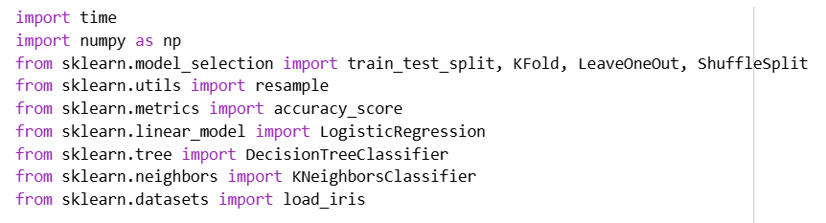
Load dataset

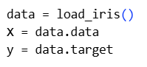

Define models
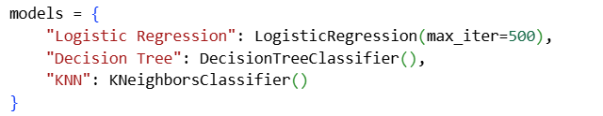

Function to measure time and accuracy
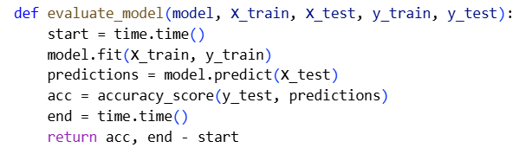

1. Simple Train-Test Split (70-30)

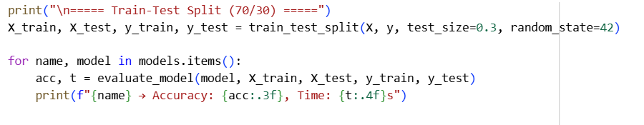

2. Tenfold Cross-Validation
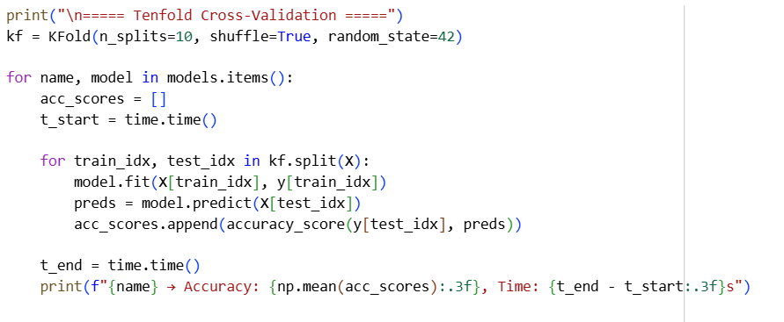

3. Leave-One-Out Cross-Validation (LOO)

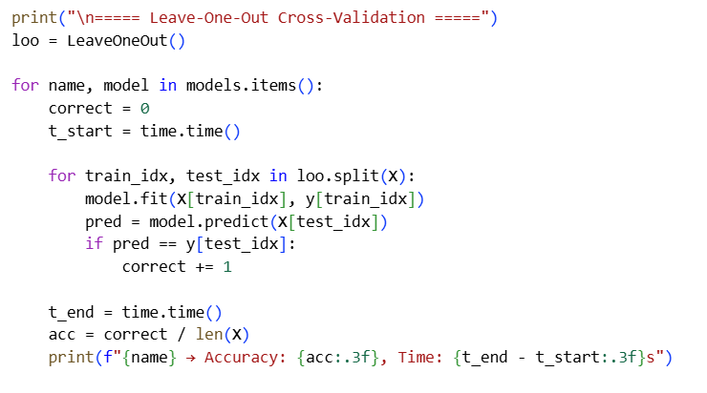
4. Random Repeated Train-Test Split (Shuffle Split)

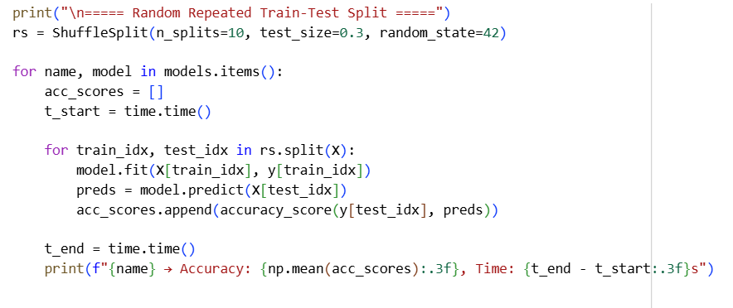

5. Bootstrap Sampling

