**PROJECT**

INT 221 (MVC PROGRAMMING)

**TOPIC**

Indulge.in (A unique methodology of learning)



|  |  |  |  |
| --- | --- | --- | --- |
| **S.NO** | **Name** | **Registration No** | **Marks** |
| 1 | Divyanshi Saxena | 11805339 |  |
| 2 | Amartya Dixit | 11802442 |  |
| 3 | Nirbhay Narayan Singh | 11803895 |  |
| 4 | Karan Agrawal | 11808255 |  |

Repository link - [Indulge.in-Laravel (github.com)](https://github.com/nns15899/Indulge.in-Laravel)

Submitted to: - Neha Sharma

(Faculty of Computer science and engineering)

**CONTENTS**

|  |  |  |
| --- | --- | --- |
| S.NO | VIEW | PAGE |
| 1 | What we do | 3 |
| 2 | Go through our website | 4 |
| 3 | Home | 5 |
| 4 | Articles | 6 |
| 5 | Courses | 6 |
| 6 | Controllers | 7 |
| 7 | Database migrations | 7 |
| 8 | What we have used | 8 |
| 9 | References | 8 |

**1. What we do**

Student is a learner who is [studying on their own](https://www.basicknowledge101.com/resources/onlineeducation.html#studytips) or [learning on their own](https://www.basicknowledge101.com/subjects/selfdirectedlearning.html) or enrolled in a [school](https://www.basicknowledge101.com/resources/teachingresources.html#types) or an [educational](https://www.basicknowledge101.com/resources/onlineeducation.html) institution.

There are many benefits that comes from learning. But learning takes [commitment](https://www.basicknowledge101.com/categories/goals.html#devotion). Learning to [understand](https://www.basicknowledge101.com/subjects/intelligence.html#understand) more about yourself and learning to understand more about the world around you, will require a [commitment to learning](https://www.basicknowledge101.com/about.html#pledge) and a promise to yourself that you will [continue to learn](https://www.basicknowledge101.com/resources/neverstoplearning.html) and continue to seek more knowledge. If your main goal in learning is to become more knowledgeable about yourself and become more knowledgeable about the world around you, then you will [simultaneously](https://www.basicknowledge101.com/subjects/simultaneous.html) become more knowledgeable about the world that is inside you. Your [thoughts](https://www.basicknowledge101.com/subjects/learningstyles.html#thinking) will become richer, [old memories](https://www.basicknowledge101.com/subjects/memory.html#oldmemories) will become more meaningful, and [new thoughts](https://www.basicknowledge101.com/resources/ideas.html) will become more amazing, all because you now have [more to work from](https://www.basicknowledge101.com/subjects.html).

“Applying the Direct Method and the Communicative Approach in all our lessons, our teachers use contextual clues and questions to encourage students to express themselves in a facilitated conversation. Our lessons are structured in a way where there is equal opportunity for the student to get to know the target language and to be comfortable using it, progressively consolidating the students' understanding and ensure higher retention.! “

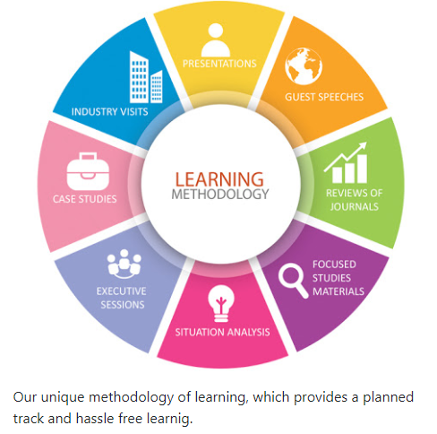

**2. Go through our website**

We hope that are hard work will definitely help you in finding the right thing for you.

We have designed in a way that will be comfortable for our users. The home page will consist of user registration, a very simple process through which you will be registered with us so that we will have a record of our users.

Registering users helps us to customize the experience and organize everything for you.

So, let’s get started

Steps to follow for registering

1) Main page where you can register and Login



2) Click on register to register a new user

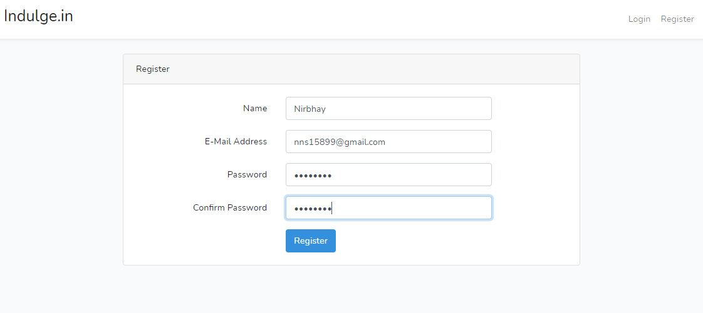

3) Once registered you can directly Login to the website

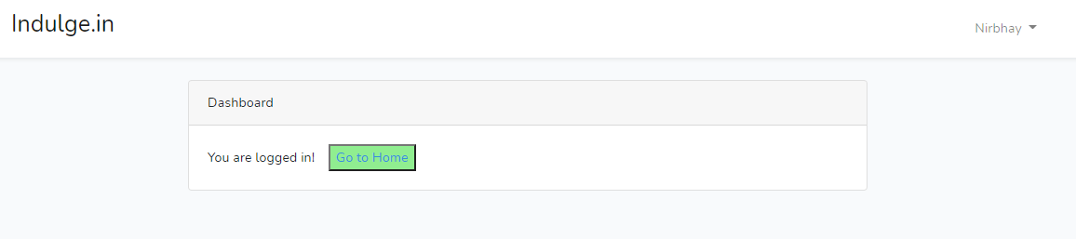

4) Once you are registered you will be directly redirected to dashboard

5) Press the “Go to Home” button to go to Home page

**3. HOME**



6) The footer part of or page

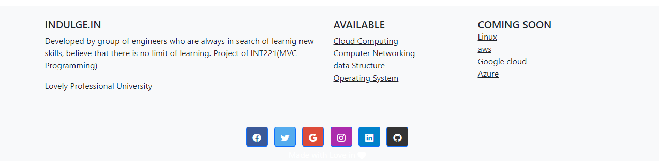

**4. ARTICLES**

7) Article’s page will provide you a list of latest articles which is being regularly updated by our content manager team.

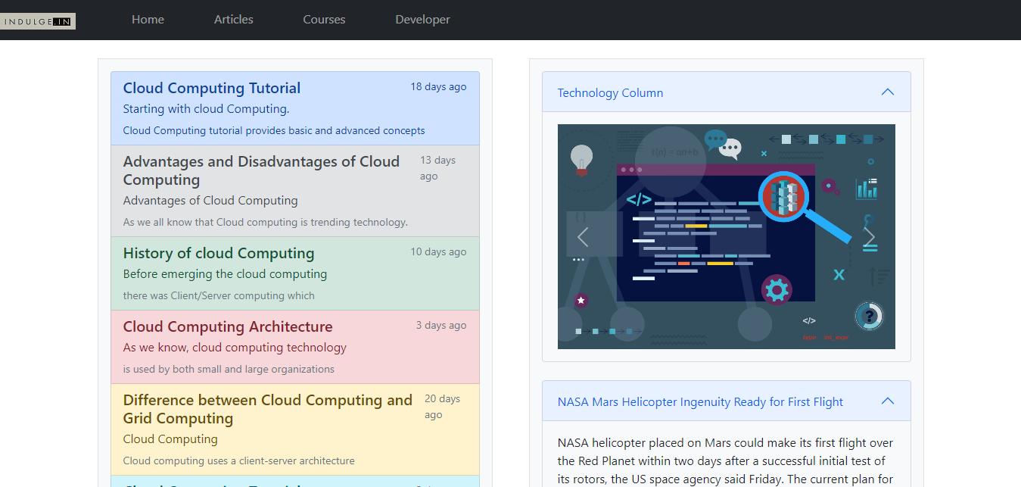

**5. COURSES**

8) Course’s page will provide the detail of available courses and a short description about the same.

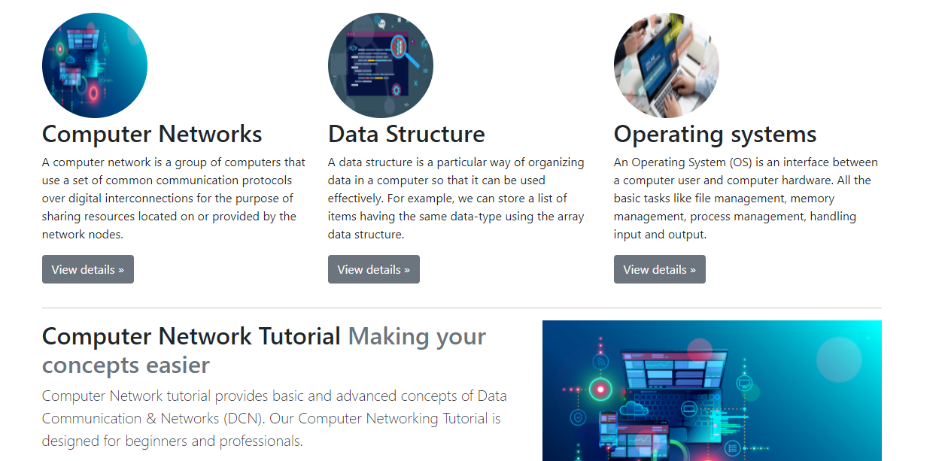

9) pressing the view details will take to the description about the page.

**6. CONTROLLERS**

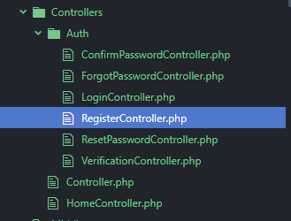

**7. DATABASE MIGRATIONS**

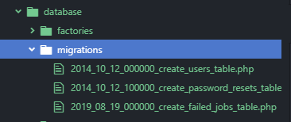

**8. WHAT WE HAVE USED**

For this we have used Laravel (a PHP framework) with the use of HTML, CSS,

Bootstrap.

Have used Laravel authentication to register and validate our users.

For the database, SQLite is used for simplicity, no password is required for the

Database.

The database file is stored inside Database directory as “database.sqlite”.

The user information is encrypted.

**9. REFERENCES**

1) The Laravel documentation - <https://laravel.com/docs/8.x>

2) For Resolving errors - <https://stackoverflow.com/>