BIRLA INSTITUTE OF TECHNOLOGY & SCIENCE, PILANI
WORK INTEGRATED LEARNING PROGRAMMES
COURSE HANDSON LAB ASSIGNMENT
M.Tech
Course Title: | Database Systems and Applications
Course No: | SESAP ZC337
Lab Session: | Nov-Dec 25
Faculty: Balachandra A, Guest Faculty, BITS Pilani (WILP) Division
Email: balachandra.ananatharamaiah@wilp.bits-pilani.ac.in
Mob: 9113656626 / 9480475967



SOFTWARE REQUIREMENTS SPECIFICATION (SRS) DOCUMENT

For EMPLOYEE MANAGEMENT Database System PROJECT ASSIGNMENT - DBSA
Version: 1.0
Prepared by: Divyansh, Student ID: 2024SL70022
Date: November 19, 2025

Contents
1. Introduction .............................................................................................................................................................4
- 1.1 Purpose.......................................................................................................................................................4
- 1.2 Scope..........................................................................................................................................................4
- 1.3 Definitions, Acronyms, and Abbreviations ...............................................................................................5
- 1.4 References .................................................................................................................................................5
2. Overall Description .................................................................................................................................................6
- 2.1 Product Perspective...................................................................................................................................6
- 2.2 Product Functions......................................................................................................................................6
- 2.3 User Characteristics...................................................................................................................................6
- 2.4 Constraints.................................................................................................................................................7
- 2.5 Assumptions and Dependencies................................................................................................................7
- 2.6 Database Normalization Strategy..............................................................................................................7
3. Specific Requirements.............................................................................................................................................8
- 3.1 Functional Requirements...........................................................................................................................8
- 3.2 Non-Functional Requirements ..................................................................................................................9
4. Database Design.......................................................................................................................................................10
- 4.1 Entity and Attribute Definitions ...............................................................................................................10
- 4.2 Relational Schema (DDL) ........................................................................................................................12
- 4.3 Normalization Process..............................................................................................................................13
- 4.4 Advanced Joins and Analytical Views (Level 7 Optimization) ..............................................................14
- 4.5 Table Definitions (Core Schema with Indexes) ......................................................................................15

5. System Features......................................................................................................................................................16
- 5.1 Data Integrity...........................................................................................................................................16
- 5.2 Normalization .........................................................................................................................................16
- 5.3 Reporting Queries (Examples) ...............................................................................................................16
- 5.4 Effective Joins (Level 7 Feature) ...........................................................................................................16
6. External Interface Requirements.........................................................................................................................17
- 5.1 Screenshots of working CRUD...............................................................................................................18
7. Validation and Verification ..................................................................................................................................23
- 7.1 Test Cases……………………................................................................................................................23
- 7.2 Verification Methods…………...............................................................................................................24
8. Appendix ................................................................................................................................................................25
- 8.1 Future Enhancements .............................................................................................................................25
- 8.2 Document History...................................................................................................................................25

SRS Document 1: Employee Management Database System

Formalization of Term I Prototype

1. Introduction

1.1 Purpose
This Software Requirements Specification (SRS) defines the requirements for the Employee Management Database System, designed to manage employee, department, project, and dependent information with advanced normalization (up to BCNF) and optimized join operations. The document specifies all functional and non-functional requirements, database schema constraints, and user interactions. It serves as a reference for database developers and system evaluators. The system supports efficient data access, analytical queries, and integrity enforcement across interconnected entities such as employees, departments, projects, and dependents.

1.2 Scope
The Employee Management Database System automates data management for a company's core operations.
Functions include:
- Maintaining employee personal and employment details
- Tracking departmental structure and managers
- Recording projects and their associated departments
- Tracking employee participation in projects and dependents

Database is a normalized relational system supporting:
- Employee, department, project, and dependent management
- Recursive relationships (supervision)
- Multi-entity joins and derived reporting
- The system ensures data integrity, referential consistency, and normalization (3NF/BCNF)
- Data models optimized through BCNF to ensure minimal redundancy and fast join performance
- Future provisions for multimodal extensions (Image/Spatial data)

1.3 Definitions, Acronyms, and Abbreviations
Term | Meaning
DBMS | Database Management System
SRS | Software Requirements Specification
DDL | Data Definition Language
DML | Data Manipulation Language
PK | Primary Key
FK | Foreign Key
SQL | Structured Query Language
BCNF | Boyce-Codd Normal Form - Advanced database normalization eliminating all functional dependency anomalies
CRUD | Create, Read, Update, Delete operations
SQLite3 | Lightweight relational database management system
BLOB | Binary Large Object for storing multimodal data

1.4 References
- Term I Assignment Implementation Report (DivyanshDBSA.pdf)
- IEEE 830–1998, ISO/IEC/IEEE 29148:2018 - Systems and Software Engineering Requirements
- Elmasri & Navathe, Fundamentals of Database Systems, 7th Ed.
- Database System Concepts - Silberschatz, Korth, Sudarshan
- SQLite Documentation - Official SQLite3 Reference

2. Overall Description

2.1 Product Perspective
The Employee Management Database System is a relational database developed using SQL and runs under SQLite3 RDBMS, with full-stack implementation using React.js and Node.js.
It is a central data store for all company divisions and will be integrated with future applications such as payroll or project tracking tools. The system is designed with provisions for multimodal extensions including Image/Document storage (BLOB) and Spatial data capabilities.

2.2 Product Functions
- Manage employees and departments
- Assign managers to departments
- Record projects and link them to departments
- Track which employees work on which projects
- Record employee dependents
- Generate summary and analytical queries
- Future capability: Store and manage employee profile photos (Image Extension)
- Future capability: Geographic location tracking for departments and projects (Spatial Extension)

2.3 User Characteristics
User Role | Description
Database Administrator | Defines database schema, manages users, backups, system maintenance
HR Manager | Maintains employee, department, dependent data with full CRUD access
Project Manager | Manages project details and employee assignments
Employee | Read-only access to personal data and project assignments

2.4 Constraints
- The database must be in Boyce-Codd Normal Form (BCNF) or higher
- All referential integrity constraints must be enforced through FKs
- Access control must restrict schema modification to the Administrator
- Must use standard SQL DDL/DML commands
- Web-based interface for cross-platform accessibility
- SQLite3 for lightweight deployment

2.5 Assumptions and Dependencies
- Each employee belongs to one department
- Each department has exactly one manager
- Each project belongs to one department
- The system depends on an underlying SQL RDBMS environment
- Single organizational unit deployment
- English language interface
- Standard web browser compatibility required

2.6 Database Normalization Strategy
The database uses progressive normalization up to BCNF to:
- Ensure atomic attribute dependencies
- Eliminate redundancy and update anomalies
- Improve consistency in join-based queries (especially analytical joins)
- Maintain future extensibility for multimodal data types (BLOB for images, Spatial for geographic data)

3. Specific Requirements

3.1 Functional Requirements
ID | Requirement Description | Priority
FR1 | The system shall allow creation of new Employee records, including SSN, Name, Birth Date, Address, Sex, Salary, Department No, and Supervisor SSN. | High
FR2 | The system shall allow retrieval and listing of all Employees with their related Department, Supervisor, and Project Assignments. | High
FR3 | The system shall allow updating Employee attributes except the primary key (SSN). | High
FR4 | The system shall allow deletion of an Employee only if referential constraints (e.g., dependents, assignments) permit. | High
FR5 | The system shall allow creation of new Departments with Department Number, Name, Manager SSN, and Start Date. | High
FR6 | The system shall allow updating Department details, including Manager assignment. | Medium
FR7 | The system shall allow deletion of Departments with proper restriction checks. | Medium
FR8 | The system shall allow creation of Project records with Project Number, Name, Location, and owning Department Number. | High
FR9 | The system shall allow updating Project details and Department assignment. | Medium
FR10 | The system shall allow deleting Projects and automatically remove related Work Assignments. | Medium
FR11 | The system shall allow assigning an Employee to a Project with recorded weekly Hours (0–80). | High
FR12 | The system shall allow updating the Hours in a Work Assignment. | Medium
FR13 | The system shall allow removing an Employee–Project assignment. | Medium
FR14 | The system shall allow creation of Dependent records linked to Employees. | Medium
FR15 | The system shall allow updating and deleting Dependent records. | Medium
FR16 | The system shall enforce referential integrity between Employees–Departments, Employees–Supervisors, Projects–Departments, and Dependents–Employees. | High
FR17 | The system shall allow execution of join queries combining Employees, Departments, Projects, Supervisors, and Dependents. | High
FR18 | The system shall allow displaying Employee supervisory hierarchy (recursive self-join). | Medium
FR19 | The system shall allow searching/filtering across all entity categories. | Medium
FR20 | The system shall allow consistent CRUD operations through the React front-end with backend validation. | High

3.2 Non-Functional Requirements
ID | Category | Requirement Description | Priority
NFR1 | Performance | Query execution for up to 1,000 rows shall complete within 2 seconds. | High
NFR2 | Performance | Joins involving up to 4 tables (Employee–Works_On–Project–Department) shall execute under 3 seconds. | High
NFR3 | Reliability | The system shall enforce PK, FK, CHECK, and NOT NULL constraints to prevent invalid data insertion. | High
NFR4 | Reliability | Delete operations shall follow cascade/restrict rules to ensure no orphan records. | High
NFR5 | Security | User input to the backend shall be validated to prevent SQL injection. | High
NFR6 | Security | Only authorized backend endpoints may modify database records. | High
NFR7 | Maintainability | The schema shall be structured in BCNF to reduce anomalies and ease schema evolution. | Medium
NFR8 | Scalability | The system architecture (React + Node + SQLite) shall support migration to PostgreSQL/MySQL without redesign. | Medium
NFR9 | Usability | UI forms shall validate all inputs client-side before sending to backend. | Medium
NFR10 | Availability | The system shall ensure ACID-compliant commits via SQLite transaction support. | Medium

4. Database Design

4.1 Entity and Attribute Definitions
- EMPLOYEE(SSN, Name, Birth_Date, Address, Sex, Salary, Supervisor_SSN, Dept_No)
- DEPARTMENT(Dnumber, Dname, Location, Manager_SSN, Mgr_start_date)
- PROJECT(Pnumber, Pname, Plocation, Dnum)
- WORKS_ON(Essn, Pno, Hours)
- DEPENDENT(ID, Essn, Dependent_name, Sex, Bdate, Relationship)
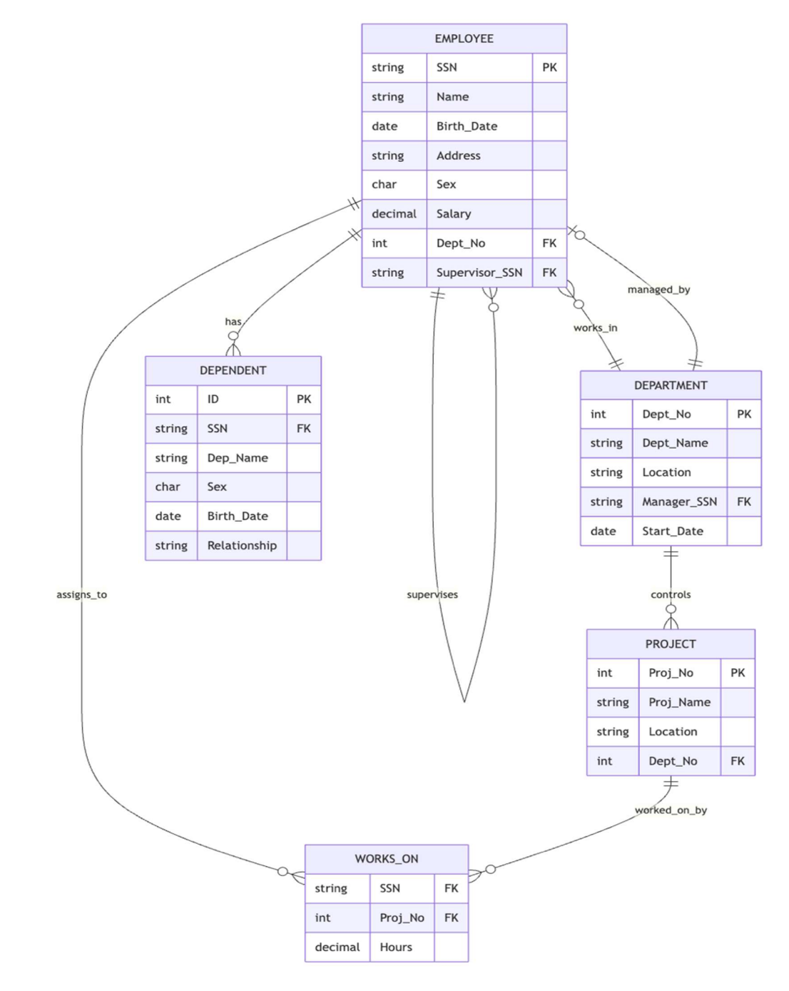

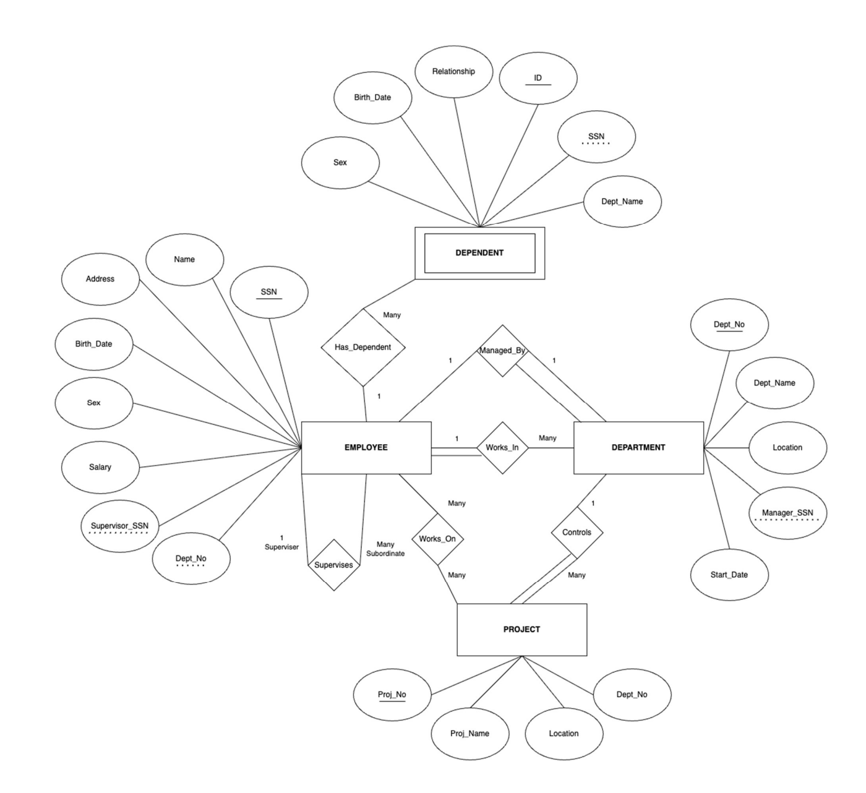

4.2 Relational Schema (DDL)
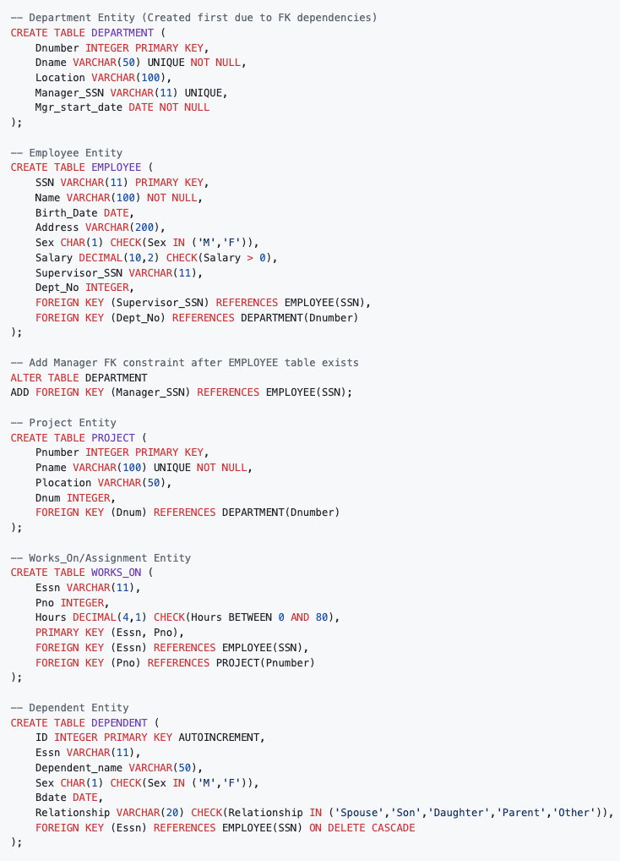

4.3 Normalization Process
Normal Form | Description | Achieved Purpose
1NF | Atomic attribute values; repeating groups removed | Each column contains indivisible data
2NF | Non-key attributes depend on full PK | Partial dependencies removed
3NF | Transitive dependencies removed | No non-key attribute depends on another non-key
BCNF | Every determinant is a candidate key | Functional dependencies refined
Result: Each table in Employee Management DB is in BCNF, allowing optimal join-based query decomposition. The EMPLOYEE–WORKS_ON–PROJECT join is lossless, maintaining full consistency.

4.4 Advanced Joins and Analytical Views (Level 7 Optimization)
Example Derived Views:
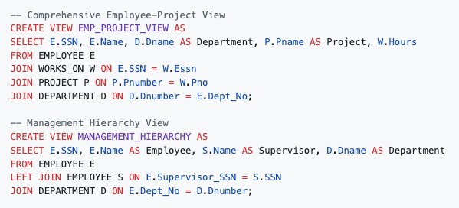

Example Analytical Queries:
- Q1: List total hours each employee worked per project
- Q2: Find employees supervised by a manager working on the same project
- Q3: Aggregate average salary per department
- Q4: Identify departments managing projects at multiple locations
Performance Optimization:
- Create indexes on all FK columns (e.g., Essn, Pno, Dept_No)
- Use materialized views for complex analytical joins
- Employ query rewriting for automatic join optimization

4.5 Table Definitions (Core Schema with Indexes)
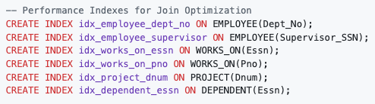
These indexes support high-performance joins in analytical workloads and ensure optimal query execution times.

5. System Features

5.1 Data Integrity Features
Feature | Implementation | Benefit
Normalization | BCNF schema design | Eliminates update anomalies and data redundancy
Constraint Enforcement | CHECK, UNIQUE, NOT NULL constraints | Ensures data quality and business rule compliance
Referential Integrity | Foreign key constraints with CASCADE options | Maintains relationship consistency
Transaction Support | ACID-compliant operations | Ensures data consistency during concurrent access

5.2 Reporting and Query Capabilities

Supported Query Types
- Employee-Department Joins: Manager and departmental reporting
- Project-Assignment Analysis: Resource allocation and workload distribution
- Hierarchical Queries: Supervisory relationship traversal
- Aggregate Reporting: Salary statistics, project hours summation
- Cross-Entity Analytics: Multi-table complex reporting

5.3 Advanced Features
- Recursive Relationships: Employee supervisory hierarchy management
- Composite Keys: Multi-attribute primary keys for dependent and assignment entities
- Temporal Data: Manager start dates and dependent birthdates
- Gender Constraints: Validated enumeration values

6. External Interface Requirements
Interface Type | Description
User Interface | React.js web application with responsive design; SQL console/DBMS GUI compatibility
Hardware | Standard server/workstation: 4GB RAM, Dual-core 2.0 GHz, 500MB storage, Broadband network
Software | SQLite3 RDBMS, Node.js runtime (16.x+), Modern web browsers (Chrome 90+, Firefox 88+, Safari 14+, Edge 90+)
Communication | RESTful APIs for client-server communication; Local DB connection (JDBC/ODBC compatible)
Integration Capability:
Supports integration with data analytics tools (e.g., Power BI, Tableau, or SQL-based dashboards) for join-based queries and reporting.

6.1 Screenshots of working CRUD

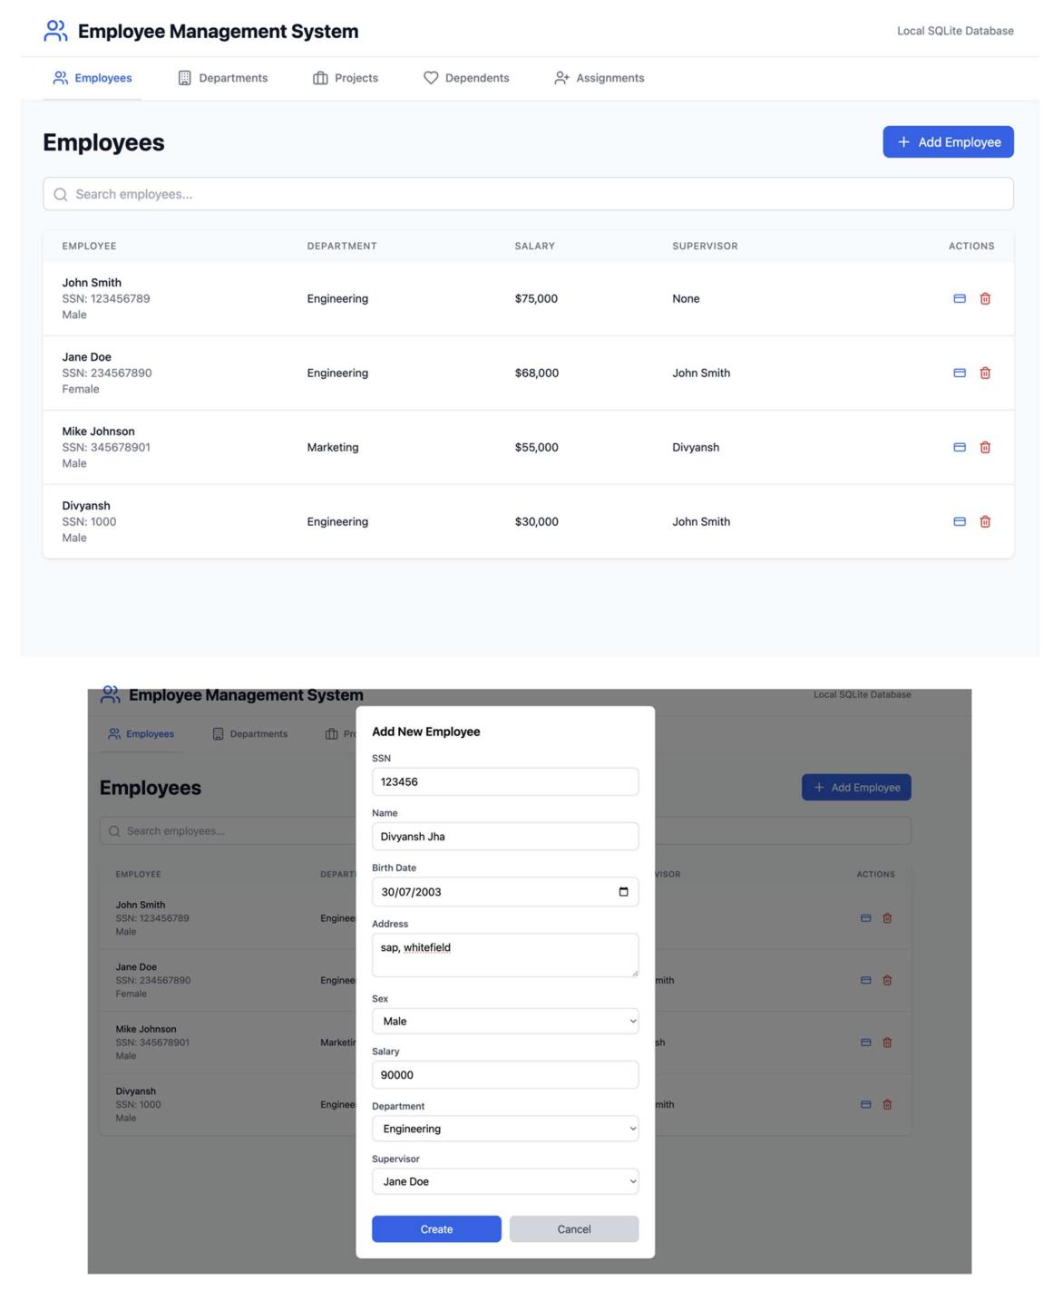

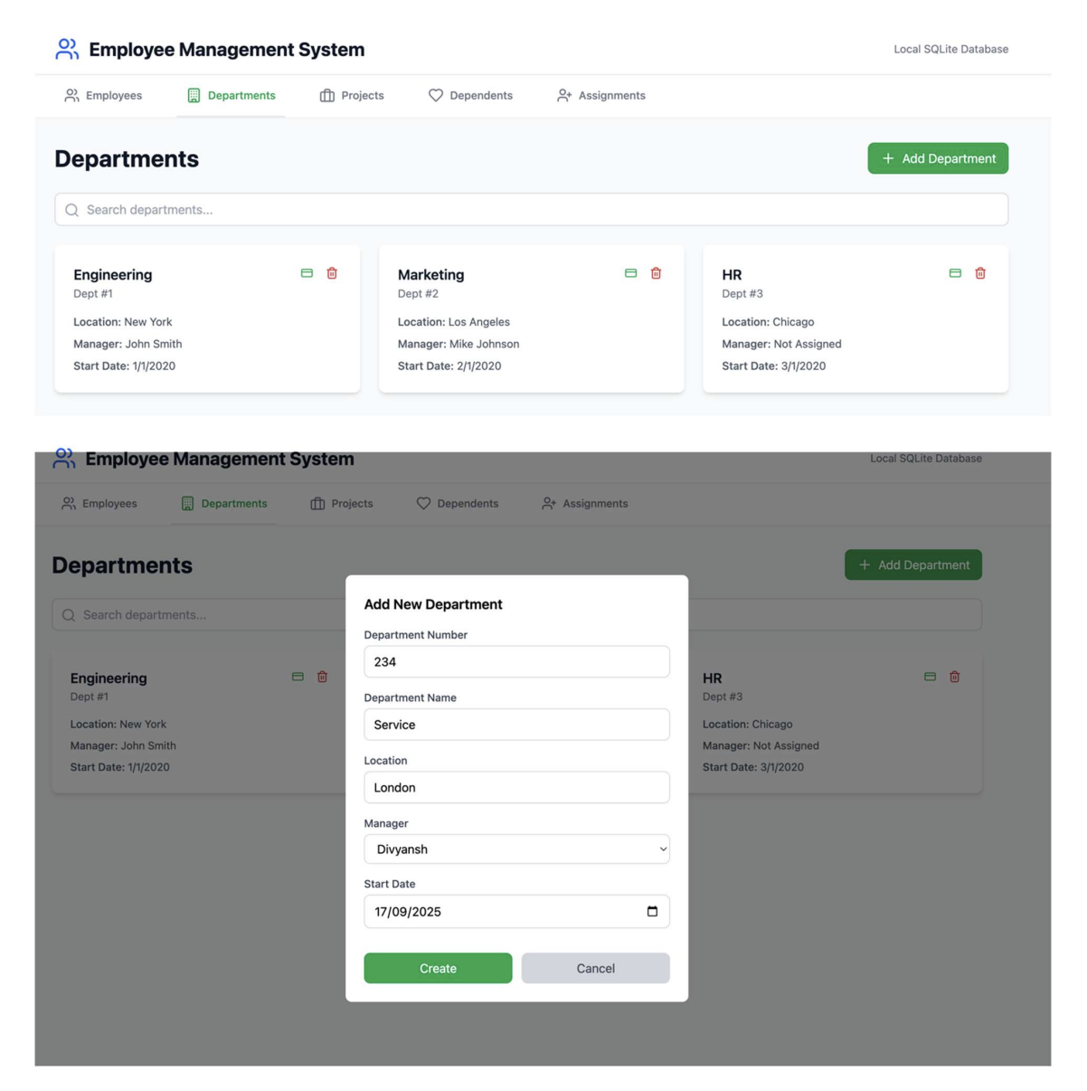

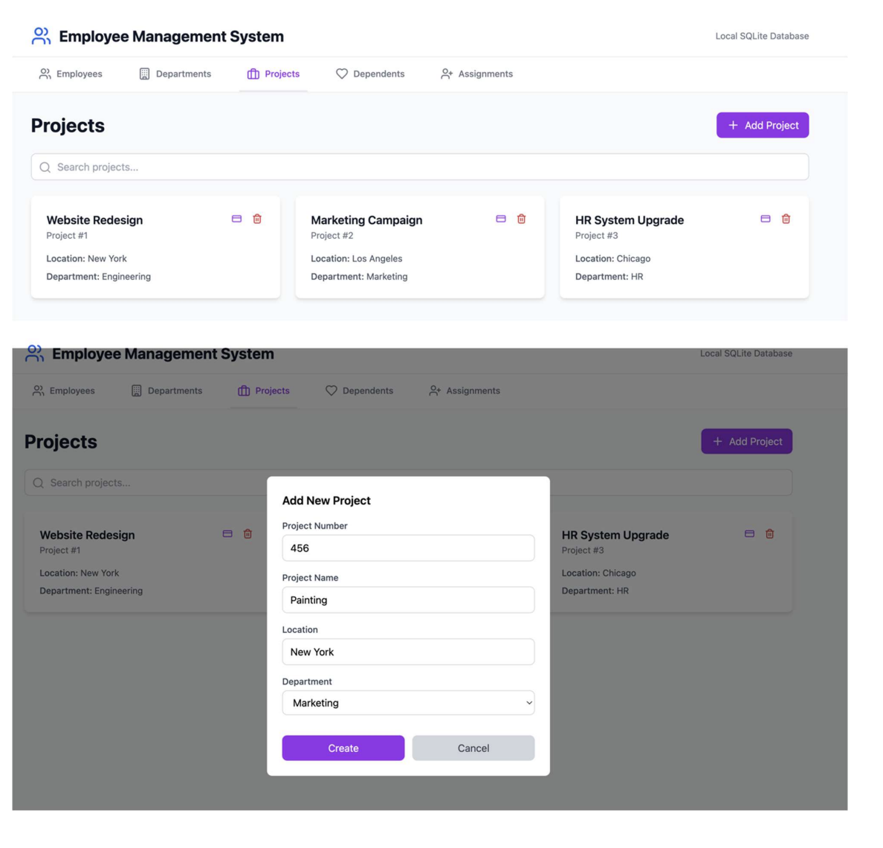

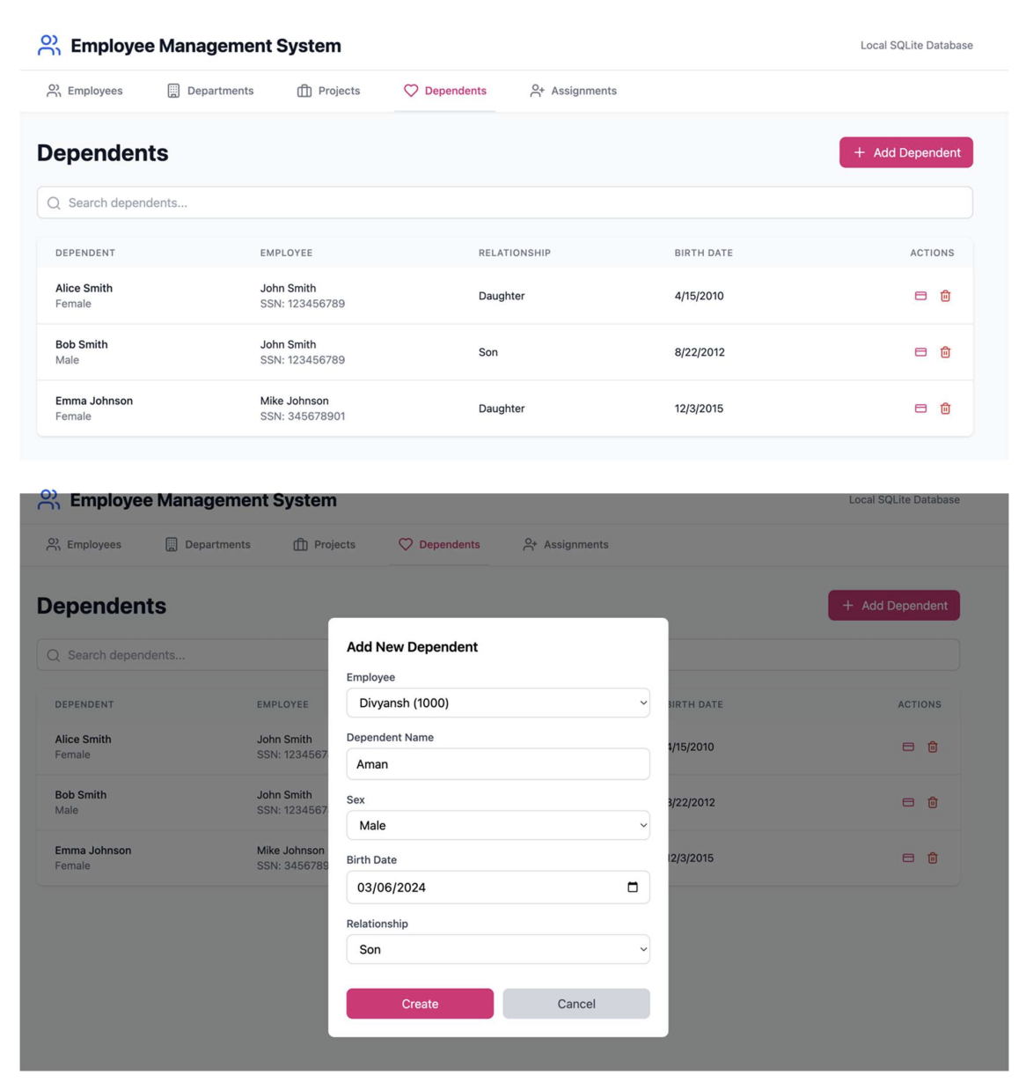

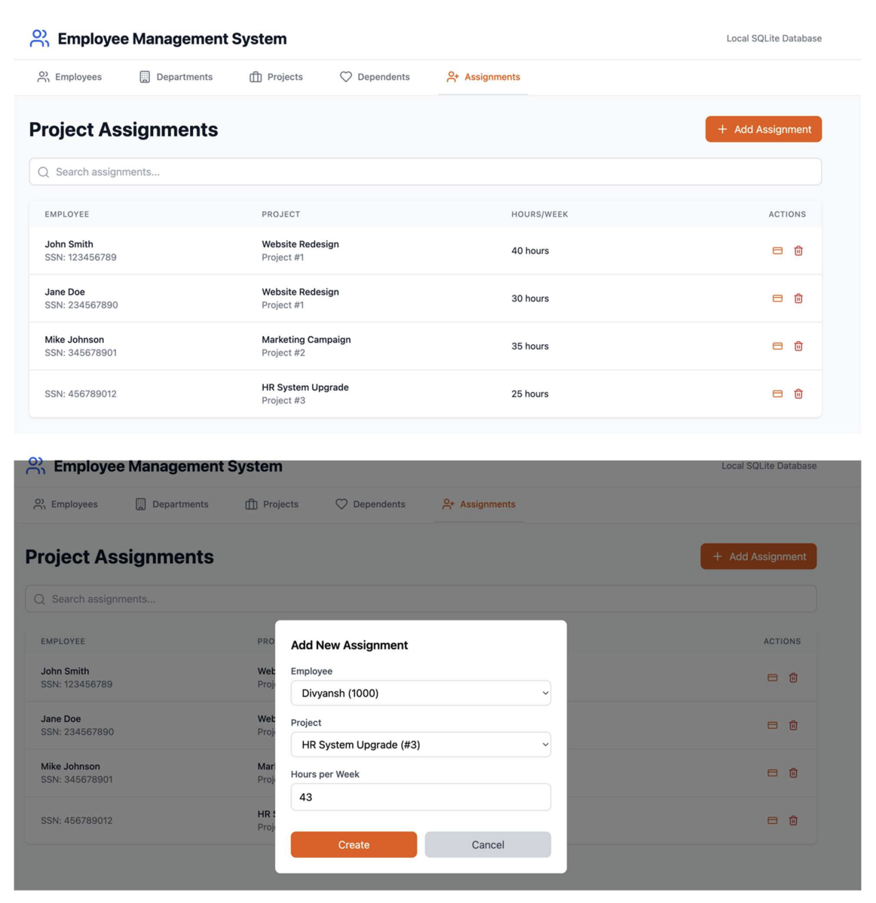

7. Validation and Verification

7.1 Test Cases
Test ID | Test Category | Test Description | Input | Expected Result | Priority
T1 | Referential Integrity | Insert Employee with valid Department | Dept_No exists in DEPARTMENT | Insert successful | High
T2 | Referential Integrity | Insert Employee with invalid Dept_No | Dept_No = 999 (non-existent) | FK violation error | High
T3 | Data Integrity | Insert Employee with negative salary | Salary = -100 | CHECK constraint violation | High
T4 | Business Logic | Assign Employee to Project with >80 hours | Hours = 120 | CHECK constraint failure (Hours BETWEEN 0 AND 80) | High
T5 | Cascade Operations | Delete Employee who has Dependents | Employee SSN referenced in DEPENDENT | Dependent records cascade deleted | High
T6 | Complex Queries | Execute 4-table join query | Employee–Works_On–Project–Department | Correct combined dataset within 3 seconds | Medium
T7 | Primary Key | Insert Employee with duplicate SSN | Existing SSN value | PK violation error | High
T8 | Referential Integrity | Insert Dependent for non-existent Employee | SSN not found in EMPLOYEE | FK violation error | Medium
T9 | Supervisory Hierarchy | Display Employee supervisory chain | Recursive self-join query | Correct hierarchical display | Medium
T10 | Unique Constraints | Insert Department with duplicate name | Existing Department name | UNIQUE constraint violation | Medium

7.2 Verification Methods
Verification Type | Method | Coverage
Schema Validation | DDL script execution and constraint testing | Database structure integrity
Functional Testing | CRUD operation validation for all entities | Complete functionality coverage
Performance Testing | Query execution time measurement | System performance requirements
Integration Testing | End-to-end workflow validation | System component interaction

8. Appendix

8.1 Future Enhancements
- Add Image Storage (BLOB) for employee profile photos
- Add spatial attributes (e.g., project site geometry)
- Implement temporal tables for salary history tracking
- Advanced analytics and business intelligence dashboards
- Mobile application development
- Real-time data synchronization capabilities

8.2 Document History
Version | Date | Description
1.0 | Nov 2025 | Initial draft for normalized Employee Management DB with BCNF achievement

Compliance:
This enhanced SRS complies with IEEE 830 and ISO/IEC/IEEE 29148, including:
- Structured requirement hierarchy
- Full traceability of normalization design
- Testability of join and view operations
- Integration readiness for analytical tools

