BIRLA INSTITUTE OF TECHNOLOGY & SCIENCE, PILANI
WORK INTEGRATED LEARNING PROGRAMMES
COURSE HANDSON LAB ASSIGNMENT
M.Tech
Course Title | Database Systems and Applications
Course No(s) | SESAP ZC337
Lab Session | Nov-Dec 25
Faculty: Balachandra A, Guest Faculty, BITS Pilani (WILP) Division
Email: balachandra.ananatharamaiah@wilp.bits-pilani.ac.in
Mob: 9113656626 / 9480475967



SOFTWARE REQUIREMENTS SPECIFICATION (SRS) DOCUMENT

For EMPLOYEE PROFILE PHOTO EXTENSION - MULTIMODAL MODULE
Version: 1.0
Prepared by: Divyansh, Student ID: 2024SL70022
Date: November 19, 2025
Extension Type: Image/Document Storage (BLOB Implementation)

Contents
1. Introduction ............................................................................................................................................................4
- 1.1 Purpose.....................................................................................................................................................4
- 1.2 Scope........................................................................................................................................................4
- 1.3 Extension Rationale.................................................................................................................................5
- 1.4 References ...............................................................................................................................................5
2. Overall Description ...............................................................................................................................................4
- 2.1 Product Functions Extension....................................................................................................................6
- 2.2 User Interaction Model............................................................................................................................6
- 2.3 Integration Strategy..................................................................................................................................6
- 2.4 Constraints and Dependencies.................................................................................................................7
3. Specific Requirements............................................................................................................................................8
- 3.1 Functional Requirements (FR-M)............................................................................................................8
- 3.2 Non-Functional Requirements (NFR-M).................................................................................................9
4. Extended Database Design.....................................................................................................................................10
- 4.1 Extended EMPLOYEE Table DDL.........................................................................................................11
- 4.2 Schema Integration and BCNF Compliance............................................................................................11
- 4.3 Storage Strategy and Implementation......................................................................................................12
- 4.4 Multimodal Data Handling......................................................................................................................12
5. System Integration..................................................................................................................................................13
- 5.1 API Endpoints..........................................................................................................................................13
- 5.2 Frontend Integration.................................................................................................................................14
- 5.3 Backend Integration.................................................................................................................................15
6. Validation and Verification ..................................................................................................................................16
- 6.1 Image Module Test Cases........................................................................................................................16
- 6.2 Integration Test Cases..............................................................................................................................16
7. Implementation Guidelines....................................................................................................................................17
- 7.1 Development Phases.................................................................................................................................17
- 7.2 Technical Implementation........................................................................................................................17
- 7.3 Success Metrics........................................................................................................................................20
8. Appendix .................................................................................................................................................................21
- 8.1 Future Multimodal Enhancements...........................................................................................................21
- 8.2 Document History....................................................................................................................................21
9. Screenshots..............................................................................................................................................................23

1. Introduction

1.1 Purpose
This Software Requirements Specification (SRS) defines the requirements for the Employee Profile Photo Extension, a multimodal module designed to extend the existing Employee Management Database System with image storage capabilities. The extension adds Employee Profile Photo functionality using BLOB data types, demonstrating advanced database features and fulfilling the multimodal provisions designed in Term I. This document specifies all functional and non-functional requirements for the image extension, database schema modifications, and integration procedures. It serves as a reference for database developers implementing multimodal data capabilities and system evaluators assessing the extension's compliance with the base system architecture.

1.2 Scope
The Employee Profile Photo Extension automates image management for employee identification within the company database system.
Functions include:
- Upload and storage of employee profile photographs
- Secure image retrieval and display operations
- File validation and size restriction enforcement
- Integration with existing Employee Management CRUD operations
Extension is a multimodal database enhancement supporting:
- BLOB data type implementation within existing BCNF schema
- Backward compatibility with all existing system operations
- Standard image format support (JPEG, PNG) with security validation
- The extension maintains data integrity, referential consistency, and BCNF normalization
- Demonstrates practical implementation of multimodal database provisions from Term I design

1.3 Extension Rationale
This implementation demonstrates the future-ready multimodal architecture designed in Term I, specifically utilizing the BLOB storage provisions for Image/Document data as outlined in the original system design. The extension validates the extensibility principles built into the normalized schema and provides a foundation for additional multimodal capabilities.

1.4 References
- Base Employee Management System SRS Document 1 (Current submission)
- Term I Assignment Implementation Report (DivyanshDBSA.pdf, Section 8.2, p. 34)
- IEEE 830–1998, ISO/IEC/IEEE 29148:2018 - Systems and Software Engineering Requirements
- SQLite BLOB Documentation - Official SQLite3 Binary Data Reference
- React.js Documentation - Component Integration Guidelines

2. Overall Description

2.1 Product Functions Extension
The Employee Profile Photo Extension integrates with the existing Employee Management Database System developed using React.js, Node.js, and SQLite3. It extends the base system's capabilities without modifying core functionality.
New capabilities include:
- Upload, store, retrieve, and display employee profile photos
- File type, size, and security validation for image uploads
- Visual employee identification through profile photos
- Efficient BLOB handling within SQLite3 architecture
- Integration with existing Employee detail views and listing pages

2.2 User Interaction Model
User Role | Image Module Access | Operations Permitted
Database Administrator | System-level image storage management and optimization | Full schema modification, backup operations including BLOB data
HR Manager | Full CRUD access to employee profile photos | Upload, update, delete employee photos; bulk photo management
Project Manager | Read-only access to view employee photos in project assignments | View photos in project team listings and reports
Employee | View personal profile photo; request photo updates | Personal photo viewing; update requests through HR

2.3 Integration Strategy
The extension follows the principle of minimal disruption to existing system architecture:
- Database Level: Addition of single BLOB column to existing EMPLOYEE table
- API Level: New RESTful endpoints for image operations alongside existing employee endpoints
- Frontend Level: Enhancement of existing React components with image display and upload capabilities
- Security Level: Extension of existing validation framework to include file security checks
2.4 Constraints and Dependencies
- Schema Constraint: Must maintain BCNF normalization of base Employee Management schema
- Technology Constraint: Must integrate seamlessly with existing React.js + Node.js + SQLite3 stack
- Performance Constraint: Image operations must not degrade existing system performance
- Security Constraint: Image storage must follow same security principles as base system
- Backward Compatibility: All existing Employee Management operations must remain functional

3. Specific Requirements (Image Extension)

3.1 Functional Requirements (FR-M)
ID | Requirement Description | Priority
FR-M1 | The system shall allow authorized users to upload an Employee profile photo. | High
FR-M2 | The system shall validate uploaded files to ensure they are of type JPEG or PNG. | High
FR-M3 | The system shall store the uploaded photo as a BLOB in the EMPLOYEE table. | High
FR-M4 | The system shall allow updating/replacing an existing Employee profile photo. | Medium
FR-M5 | The system shall allow displaying the stored profile photo on the Employee detail view. | High
FR-M6 | The system shall prevent upload of files larger than the configured size limit (5 MB). | High
FR-M7 | The backend shall sanitize file names and prevent arbitrary file access. | High
FR-M8 | The system shall provide fallback placeholder images when an Employee has no photo uploaded. | Medium

3.2 Non-Functional Requirements (NFR-M)
ID | Category | Requirement Description | Priority
NFR-M1 | Performance | Image loading should not exceed 1 second on a standard network. | High
NFR-M2 | Performance | Images shall be compressed (if stored as files) to optimize load time. | Medium
NFR-M3 | Security | The system shall not expose direct file paths; signed URLs or APIs shall be used. | High
NFR-M4 | Security | Uploaded files must be scanned/validated for MIME correctness. | High
NFR-M5 | Domain | Maximum supported file size is 5 MB. | High
NFR-M6 | Domain | Supported formats are PNG and JPEG only. | High
NFR-M7 | Maintainability | The addition of BLOBs must not require changes to existing CRUD operations. | Medium
NFR-M8 | Scalability | The schema should allow migration to cloud storage (AWS S3/GCP) without breaking changes. | Medium

4. Extended Database Design

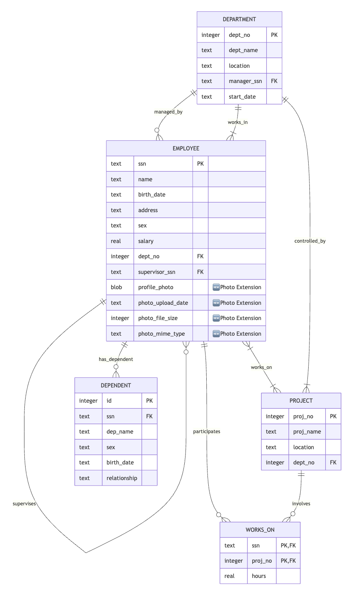

4.1 Extended EMPLOYEE Table DDL
Primary Extension: Addition of Profile_Photo BLOB column to existing normalized schema

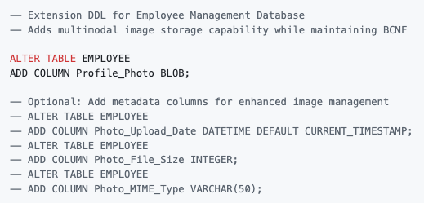

4.2 Schema Integration and BCNF Compliance
The image extension maintains full BCNF compliance of the existing Employee Management schema:
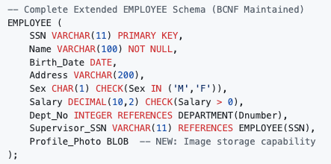

BCNF Verification:
- Profile_Photo depends solely on SSN (primary key)
- No new functional dependencies introduced
- All existing dependencies remain valid
- Extension preserves all referential integrity constraints

4.3 Storage Strategy and Implementation
Approach | Implementation | Advantages | Trade-offs | Selected
BLOB Storage | Direct binary storage in SQLite | Simple backup, transaction consistency, referential integrity | Database size growth, memory usage | ✅ YES
File Path Storage | Store file paths, images in filesystem | Smaller database size, easier file management | Complex backup procedures, broken referential integrity | ❌ No
Hybrid Approach | Small images in BLOB, large images as files | Balanced performance and storage | Increased complexity | ❌ No
Selected Approach Justification: BLOB Storage demonstrates the multimodal BLOB provisions from Term I design and maintains the integrity principles of the normalized database system.

4.4 Multimodal Data Handling
Data Type Specifications:
- Storage Format: SQLite BLOB (Binary Large Object)
- Maximum Size: 5 MB per image (application-enforced)
- Supported Formats: JPEG, PNG (MIME validation enforced)
- Compression: Client-side compression recommended before upload
- Retrieval Method: Base64 encoding for web display or direct binary transfer

5. System Integration

5.1 API Endpoints
Endpoint | Method | Function | Request Body | Response | Status Codes
/api/employees/:id/photo | GET | Retrieve employee photo | None | Binary image data or placeholder | 200, 404, 500
/api/employees/:id/photo | POST | Upload new profile photo | multipart/form-data with image file | {"success": true, "message": "Photo uploaded"} | 201, 400, 413, 422
/api/employees/:id/photo | PUT | Update existing photo | multipart/form-data with image file | {"success": true, "message": "Photo updated"} | 200, 400, 404, 413
/api/employees/:id/photo | DELETE | Remove profile photo | None | {"success": true, "message": "Photo deleted"} | 200, 404, 500
API Integration with Base System:
- Photo endpoints extend existing /api/employees API structure
- Consistent authentication and authorization with base employee endpoints
- Error handling follows same patterns as base system
- Request/response format maintains API consistency

5.2 Frontend Integration
React Component Extensions:
Component | Enhancement | Integration Point
EmployeeCard | Display thumbnail profile photos (64x64px) | Employee listing pages, search results
EmployeeDetails | Full-size photo display (200x200px) with upload interface | Employee detail view, profile management
PhotoUpload | Drag-and-drop image upload with preview and validation | Employee creation/edit forms
ImageValidator | Client-side file validation (type, size) before upload | All photo upload interfaces
PhotoPlaceholder | Default avatar display when no photo exists | All employee display contexts
UI Integration Strategy:
- Non-intrusive Design: Photo features integrate seamlessly without disrupting existing UI flow
- Progressive Enhancement: System functions normally even if image features fail
- Responsive Design: Photo displays adapt to mobile and desktop viewports
- Accessibility: Alt text and screen reader support for all image elements

5.3 Backend Integration
Node.js Integration Points:

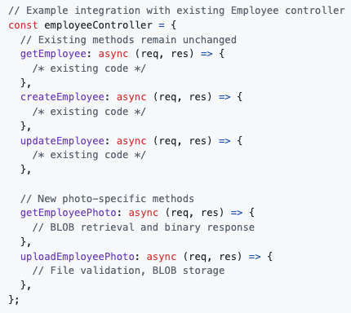

Database Integration:
- Connection Reuse: Photo operations use existing SQLite connection pool
- Transaction Management: Photo uploads participate in existing transaction framework
- Error Handling: Photo errors integrate with existing error middleware
- Logging: Photo operations logged through existing system logger

6. Validation and Verification (Image Extension)

6.1 Image Module Test Cases
Test ID | Test Category | Test Description | Input | Expected Result | Priority
T-M1 | File Size Validation | Upload file >5MB | 6 MB JPEG image | Upload rejected with size limit error | High
T-M2 | File Type Validation | Upload invalid format | PDF file disguised as image | Upload rejected with format error | High
T-M3 | Successful Upload | Upload valid image | 200 KB JPEG image | Image stored successfully in BLOB | High
T-M4 | Image Retrieval | Retrieve existing photo | GET /api/employees/123/photo | Image displays correctly | High
T-M5 | Missing Image | Retrieve non-existent photo | GET /api/employees/999/photo | Placeholder image returned | Medium
T-M6 | Photo Replacement | Replace existing image | Upload new image for existing employee | Old BLOB replaced with new image | Medium
T-M7 | Security Validation | MIME type spoofing attempt | Malicious file with image extension | Upload blocked by MIME validation | High
T-M8 | Performance Test | Load employee list with photos | 50 employees with profile photos | All images load within 1-second requirement | Medium

6.2 Integration Test Cases
Test ID | Test Description | Expected Result
T-I1 | Existing CRUD operations remain functional after BLOB addition | All original functionality unaffected
T-I2 | Database backup includes BLOB data | Complete system restore with images
T-I3 | Employee deletion cascades properly with image data | BLOB data cleaned up with employee record

7. Implementation Guidelines

7.1 Development Phases
Phase | Deliverable | Timeline | Dependencies | Success Criteria
Phase 1 | Extended DDL and BLOB storage implementation | Week 1 | Base Employee schema validated | EMPLOYEE table successfully extended, BCNF maintained
Phase 2 | Backend API development for image operations | Week 2 | Phase 1 complete, Node.js environment ready | All photo endpoints functional, validation working
Phase 3 | Frontend integration and upload interface | Week 3 | Phase 2 complete, React.js environment ready | Photo upload/display components integrated
Phase 4 | Testing, validation, and performance optimization | Week 4 | Phases 1-3 complete | All test cases pass, performance targets met

7.2 Technical Implementation
Phase 1: Database Extension

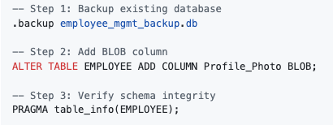

Phase 2: Backend Implementation

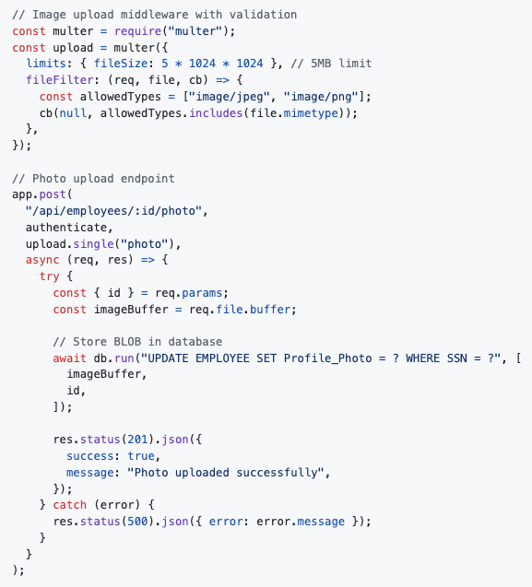

Phase 3: Frontend Implementation

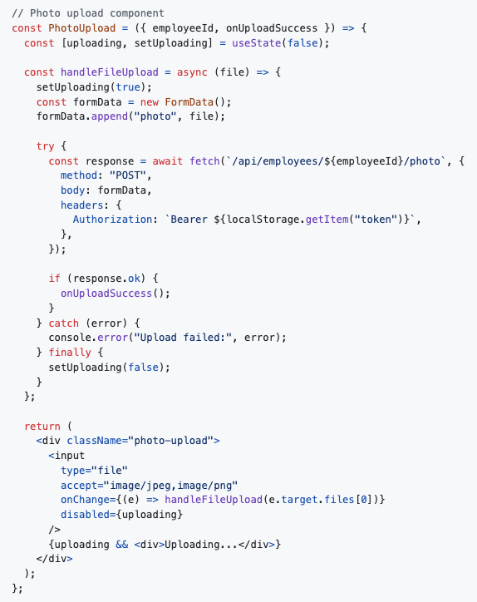

7.3 Success Metrics
Metric | Target | Measurement Method | Acceptance Criteria
Upload Success Rate | >99% for valid files | Automated testing with sample images | All valid JPEG/PNG files under 5MB upload successfully
Image Load Time | <1 second average | Performance monitoring in browser | Photo display completes within 1s on standard connection
Storage Efficiency | <5MB average per employee | Database size monitoring | Photo storage remains within size constraints
System Performance | No degradation in existing operations | Before/after performance comparison | Employee CRUD operations maintain original response times
User Satisfaction | >90% positive feedback | User acceptance testing | Users find photo features intuitive and helpful

8. Appendix

8.1 Future Multimodal Enhancements
Immediate Extensions (Next Phase):
- Document Storage: Extend BLOB capability to store employee documents (resumes, certificates)
- Spatial Data Integration: Add geographic coordinates for employee work locations
- Audio Notes: Voice annotations for employee profiles
- Video Profiles: Short video introductions for remote team members
Advanced Multimodal Features:
- AI-Powered Image Analysis: Automatic photo quality assessment and optimization
- Facial Recognition Integration: Secure access control using employee photos
- Mobile Photo Capture: Direct upload from mobile devices with camera integration
- Bulk Photo Import: Mass upload capabilities for HR onboarding processes
System Evolution Path:
- Cloud Storage Migration: Transition from BLOB to cloud storage (AWS S3, Azure Blob) while maintaining API consistency
- Content Delivery Network: Implement CDN for global photo access optimization
- Image Processing Pipeline: Automated resizing, format conversion, and compression
- Backup and Archival: Specialized backup strategies for large multimodal datasets

8.2 Document History
Version | Date | Description | Author
1.0 | Nov 2025 | Initial SRS for Employee Profile Photo Extension - BLOB implementation demonstrating multimodal database capabilities | Divyansh

Compliance Statement:
This multimodal extension SRS complies with IEEE 830 and ISO/IEC/IEEE 29148, including:
- Complete requirement specification for multimodal database extension
- Full integration documentation with base Employee Management System
- Comprehensive testing strategy for BLOB data handling
- Implementation roadmap with measurable success criteria
- Future extensibility planning for additional multimodal capabilities
Technical Achievement:
This extension successfully demonstrates the practical implementation of multimodal database provisions designed in Term I, validating the forward-thinking architecture of the base Employee Management System and establishing a foundation for advanced database capabilities.

9. Screenshots:



