Q1)**CODE**

<html>

<head>

<title>Image Map</title>

</head>

<body>

<img src="map.jpg" usemap="#M" width=""/>

<map name="M"> <area shape="poly" coords="169,54,475,151,554,349,396,410,318,342,140,310,109,116" href="https://en.wikipedia.org/wiki/Canada" target="_blank"> <area shape="rect" coords="1433,557,382,1687" href="https://en.wikipedia.org/wiki/Chinaa" target="_blank">

<area shape="rect"

coords="" href="https://en.wikipedia.org/wiki/Russia">

<area shape="circle" coords="767, 241, 40"

href="https://en.wikipedia.org/wiki/Iceland" target="_blank">

</map>

</body>

</html>

**OUTPUT**

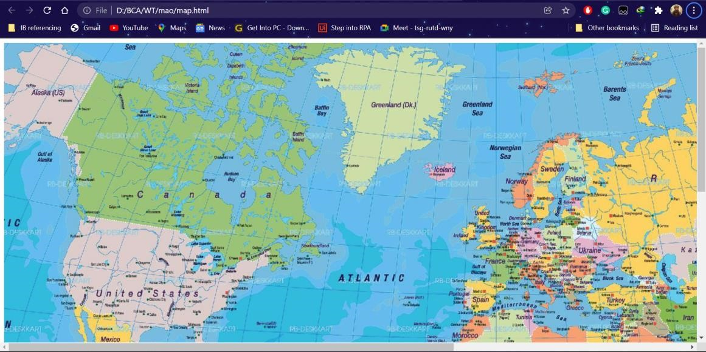

Q2)**CODE**

<!DOCTYPE html>

<html lang="en">

<head>

<meta charset="UTF-8">

<meta http-equiv="X-UA-Compatible" content="IE=edge">

<meta name="viewport" content="width=device-width, initial-scale=1.0">

<title>Document</title>

</head>

<body> <script> var n; var f=1; n=parseInt(prompt("Enter a Number ","0")); if(n<0) { document.write("Entered Number is Less Than 0");

} else if (n==0)

{ document.write("Factorial of 0 is 1");

} else { for(i=1;i<=n;i++)

{

f=f*i;

} alert("Factorial of "+n+" is "+f);

}

</script>

</body>

</html>

**OUTPUT:**

