1)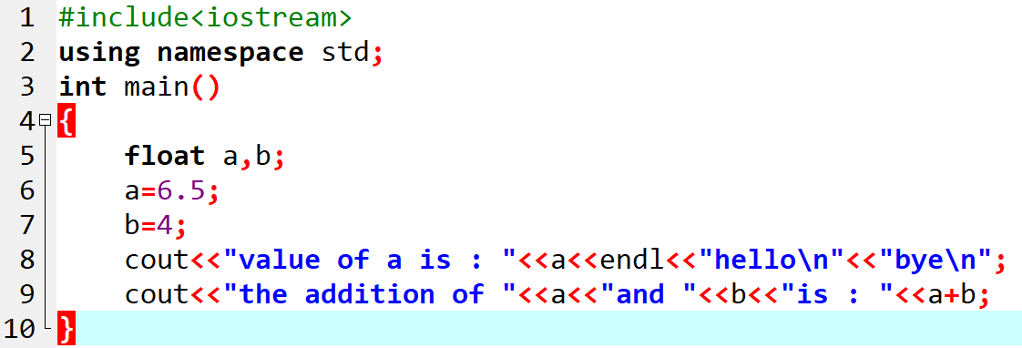

#include<iostream>
using namespace std;
int main()
{
float a,b;
a=6.5;
b=4;
cout<<"value of a is : "<<a<<endl<<"hello\n"<<"bye\n";
cout<<"the addition of "<<a<<"and "<<b<<"is : "<<a+b;
}

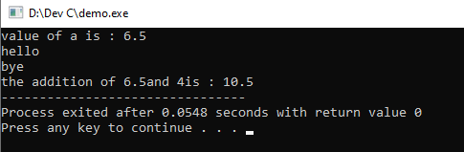

--------------------------------------------------------------------------------------------------------------------------------------------------------
2)
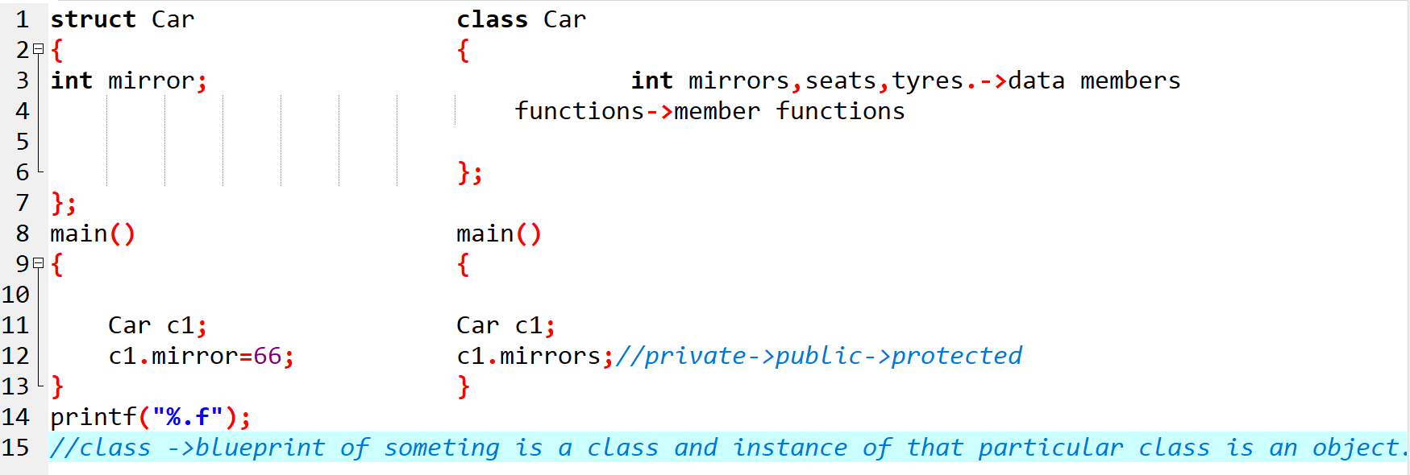
3)
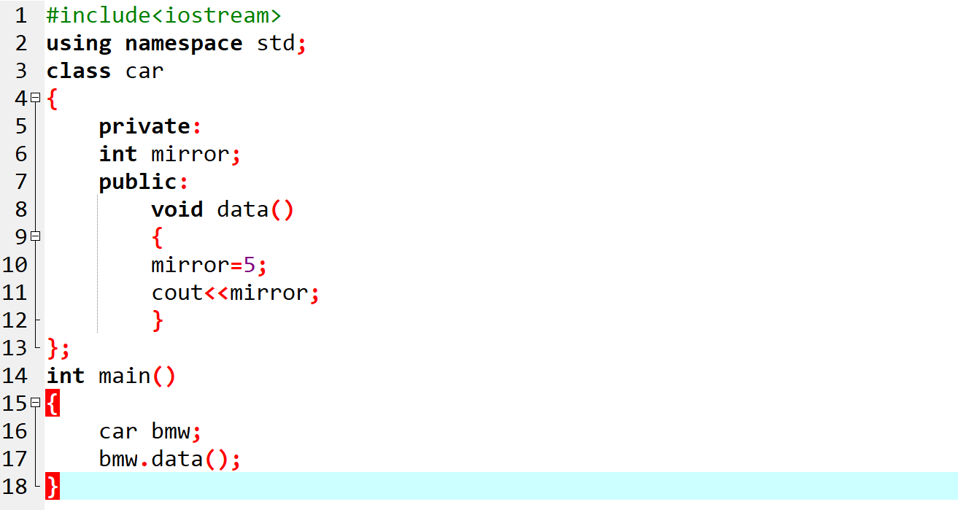

#include<iostream>
using namespace std;
class car
{
private:
int mirror;
public:
void data()
{
mirror=5;
cout<<mirror;
}
};
int main()
{
car bmw;
bmw.data();
}

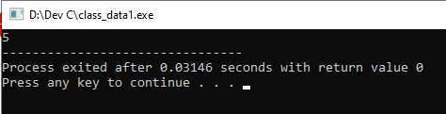

----------------------------------------------------------------------------------------------------------------------------------------------

4)
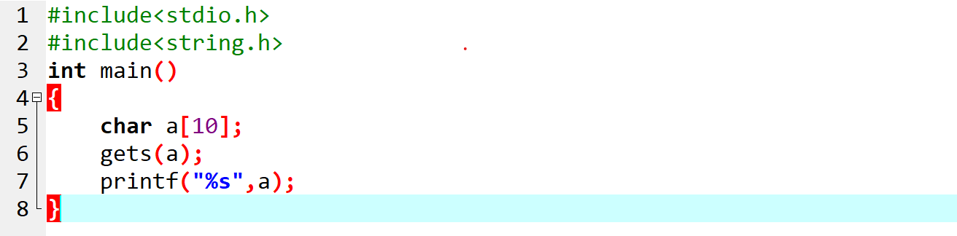

#include<stdio.h>
#include<string.h>
int main()
{
char a[10];
gets(a); //gets mean ‘get string’, it will not break string input on seeing space ,so it can store
printf("%s",a); //complete sentence in string array like name with sirname.
}

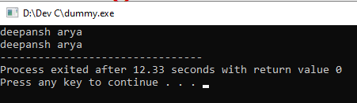

-------------------------------------------------------------------------------------------------------------------------------------------

5)

//Write a program to enter Employee first name, last name, Account number and various databases using single inheritance.
#include<iostream>
#include<bits/stdc++.h>
#include<string.h>
using namespace std;
class Office
{
protected:
char first_name[10];
char last_name[10];
long int account_no;
};
class Employee:public Office
{
public:
void get_Employee_Info()
{
cout<<"Enter first name : ";
gets(first_name);
cout<<"Enter last name : ";
cin>>last_name;
cout<<"Enter account number : ";
cin>>account_no;
}
void print_Employee_Info()
{
strcat(first_name, last_name);
cout<<"name is : "<<first_name<<endl<<" and account number is : "<<account_no<<endl;
}
};
int main()
{
Employee E1;
E1.get_Employee_Info();
E1.print_Employee_Info();
}
//int 2->turbo 2 bytes->4 bytes(dev)->-32768 to +32767
//float 4 bytes->32 bits->2^32
//int ->2 bytes=>16 bits=>2^16=>65535 unsigned ->%u
//int->long int
//float->long float(double(%lf))
//sizeof(int)

