INDUSTRIAL TRAINING REPORT

On

FASHION-MNIST Image Classification

Submitted by

Divyansh Mishra
University Roll no. – 181520022

Department of Computer Engineering & Applications
Institute of Engineering & Technology



GLA University
Mathura- 281406, INDIA
2020

PROJECT COMPLETION CERTIFICATE



SYNOPSIS

Student Information:
Name: Divyansh Mishra | University Roll. No: 181520022
Mobile: 8077583648 | Email: divyansh.mishra_da18@gla.ac.in
Information about Industry/Organization:
Industry/Organization Name with full Address | Indian Institute of Technology Kalyanpur, Kanpur
Contact Person | Name & Designation: Prof. Laxmidhar Behera, Department of  Electrical Engineering  Mobile/email:lbehera@iitk.ac.in
Project Information:
Title Of Project/Training/Task | FASHION- MNIST Image Classification Project
Role & Responsibility | ML Intern, Responsibilities – Data collection, cleaning, preprocessing and training model by implementing various machine learning algorithms.
Technical Details | Hardware Requirements: Any working laptop/PC with minimum 1.5GHz processor and at least 4GB of memory with a good internet connection.  Software Requirements: Windows OS, Python, Jupyter Notebook, Anaconda,Colab.
Training Implementation Details | Fully Implemented
Training Period | Start Date: 01 April,2020  End Date: 29 June,2020  Duration Of Training (In Weeks): 13 weeks

Summary of the Training Work:
As part of the internship, I successfully completed the project titled – "using the Fashion-MNIST clothing classification problem which is a new standard dataset used in computer vision and deep learning. The simplicity of the dataset gave a hands-on experience on application of fundamental concepts learnt in the online training sessions and helped develop a deeper understanding on how to develop, evaluate, and use deep convolutional neural networks for image classification from scratch.
A Neural network using Sequential model API was built with Keras by repeating a few layers of a neural layer followed by a pooling layer then a dropout layer.
Throughout this training, Python programming language in Jupyter/Google Colab platform was used along with various machine learning/deep learning libraries such as matplotlib, Numpy, sklearn, seaborn etc. This capstone project work developed skills such as - exploration of various techniques in data pre-processing, ways to mitigate data overfitting, efficient and thrifty hyperparameter search and formed the basis of how to develop a robust test harness for estimating the performance of the model, explore improvements to the model and how to make predictions on new data.

ACKNOWLEDGEMENT

Presentation inspiration and motivation have always played a key role in the success of any venture.

I would like to express sincere gratitude to supervisor Prof. Laxmidhar Behera, to encourage me to the highest peak, to provide me the opportunity to prepare this project and for providing their invaluable guidance and suggestions throughout the course of project. I am highly indebted to their constant supervision as well as for providing necessary information regarding the project and also their support in completing the project. I would also like to express my special gratitude towards my friends for their kind co-operation and encouragement which helped me in completion of this project.

Last, but not the least, my parents are also an important inspiration to me.
So with due regards, I express my gratitude to them.

ABSTRACT

With technology’s increasing capabilities, Image Classification is becoming a more utilized tool for modern world. Social media monitoring tools use it to give their users insights about how the public feels in regard to their business, products, or topics of interest.
This project addresses the problem of image classification; that is classifying images according to the labels provided in the data as the classification.
Images are analyzed by the model to classify on the FASHION-MNIST Dataset. We investigate the role of CNNs to classify the images by firstly taking an educational look at CNNs and perform a literature search to determine an example pipeline for classification

Department of computer Engineering and Applications
GLA University, Mathura
17 km. Stone NH#2, Mathura-Delhi Road, P.O. – Chaumuha,
Mathura – 281406

Declaration

I hereby declare that the work which is being presented in the Industrial Training on Title “FASHION-MNIST Image Classification” ,in partial fulfillment of the requirements for Industrial Training viva voce, is an authentic record of my own work carried under the supervision of Prof. Laxmidhar Behera (Department of Electrical Engineering, IIT Kanpur).

Signature of Candidate:Divyansh
Name of Candidate: Divyansh Mishra
Roll. No.:21
Course:B.Tech-CSE(DA)
Year: 3rd
Semester:5th

TABLE OF CONTENTS

Certificate
Synopsis
Acknowledgement
Abstract
Declaration

1.Introduction
1.1 Motivation 1
1.2 Overview 2
1.3 Objective 3
2. Software Requirement Analysis
2.1 Problem Statement 4
2.2 Modules and their functionalities in SRS format 5

3. Software Design
3.1 Data Flow Diagram 7
3.2 UML Diagrams 8

4. Testing
4.1 Black box testing11
4.2White box testing 11

5. Implementation and User Interface
5.1 Descriptions 12
5.2 Algorithms implementation 21
5.3 Comparisons and outputs 23
6. Challenges and future steps25

7. References26

8. Appendices27
MOTIVATION

Computer vision is one area that is advancing rapidly and enabling new applications. Computer vision methods are image classification, object detection and neural style transfer. It is a technique of extracting, analyzing and understanding of useful information from a single image or multiple image in a sequence. The computer vision task that we are using in this project is image classification. Apparel classification is identifying the type of item in an image. This field has applications in social media, e-commerce and in law sector used to identify suspects with their clothes. We will focus on apparel classification, to classify the images we will use Convolutional neural network. The convolutional neural network is class of deep learning and it is widely used method in analyzing images. CNN takes advantage of the 2D structure of an image when generating informations. CNN model demonstrates a method to detect fashion apparels a person in an image is wearing or holding. The types of fashion apparels include hat, bag, skirt, pant, shirt etc. In our model we have used Fashion –MNIST image data set. It is a dataset created in Zalando‘s research lab having 70,000 fashion article images. It has labeled from 10 classes. Some of the challenges faced are the classes can share similar characteristics and clothing type might look different depending on aspect ratio and angle.

OVERVIEW

One of the most excellent things concerning deep learning is that it assists you to match the x and y relationship and that’s what enables you to do magnificent things like have computers examine an image and do recognition or even examine an image and tells you that’s a dress or a combination of pants.
Fashion-MNIST is a dataset of Zalando’s article images consisting of a training set of 60,000 examples and a test set of 10,000 examples. Each example is a 28×28 grayscale image, associated with a label from 10 classes. Fashion-MNIST is intended to serve as a direct drop-in replacement of the original MNIST dataset for benchmarking machine learning algorithms.
The original MNIST dataset contains a lot of handwritten digits. People from AI/ML/Data Science community love this dataset and use it as a benchmark to validate their algorithms. In fact, MNIST is often the first dataset they would try on. “If it doesn’t work on MNIST, it won’t work at all”, they said. “Well, if it does work on MNIST, it may still fail on others.”
Fashion-MNIST is intended to serve as a direct drop-in replacement for the original MNIST dataset to benchmark machine learning algorithms, as it shares the same image size and the structure of training and testing splits.

OBJECTIVE

Convolutional neural networks (CNN) are the most current progress in the image retrieval and classification domain. Research data that is entrenched and processed in industrial and commercial applications can be brought into productive use with CNN which is a form of a Deep Neural Network (DNN). It is applied to image processing tasks, human action recognition and fashion image classification.

In this project, we tend to build a neural network (NN) and train it with the “Fashion MNIST Dataset with Keras.

We’ll define a CNN network using the Keras deep learning library.
Finally, we’ll train our CNN model on the Fashion MNIST dataset, evaluate it, and review the results

PROBLEM STATEMENT

Classification of image is one of the most foundational problems in computer vision, which has a variety of practical applications such as image and video, Although the problem of identifying an object from an image is a very trivial problem for a human-being to perform, it is very challenging for a computer algorithm to do the same with human level accuracy. The algorithm must be invariant to a number of variations in order to identify and classify the images. This can be achieved by implementing the algorithms in the CNN environment.

SOFTWARE REQUIREMENT SPECIFICATION

A software requirements specification (SRS) is a structured collection of information that that embodies the requirements of the system.Basically it is a comprehensive description of the intended purpose and environment for the proposed work under development.A software requirements specification (SRS) is an illustration of the intentional motivation and environment for the software under development. How software will work and what software is going to do is described by the SRS. The intention of SRS is to minimize the time required to achieve goals by the developers and also it reduces the cost of development. SRS will show or define that how a particular application will be interacting with the hardware of the system, human users and other programs. Through SRS operating speed, availability, portability, maintainability, and speed of recovery is evaluated.
Product Functions:
This part is considered a key stone in the project as it detects and extracts images fed into the model. Our approach goes as follows, first we do preprocessing,The MNIST dataset or any kind of data needs to be preprocessed before you feed it to the neural network for training.The most important theory of creating block neural networks is the layers. Layers will extract a pattern from the data that have been fed into them. Most of the neural network models contain multiple layers that are connected to each other and most of them such as tf.keras.layers. The first layer in this model: tf.keras.layers.Flatten transforms the format of each picture to a one-dimensional array. Upon the pixels of pictures that have been flattened by the Flatten layer, the rest of the neural network contains a sequence of two tf.keras.layers.
Before we start running our neural networks, we need to make sure that we have set up a few more things and the first thing is: The Loss function that Will detect how precise the neural network is during the compile process or in other words how the model is doing well. The second one is Metrics which will observe the testing and training during the running of the model. The third one is the Optimizer that will make the neural network update the parameters for our neural network during the training process.
Train the artificial neural network demands the next steps: Feed the training data to the model. The artificial neural network learns to link images and labels. You ask the neural network to make predictions about a test set.
We employed precision and recall as metrics, they are defined as follows. precision = T P /T P + F P recall = T P /T P + F N where T P, F P and F N denoted the true positive, false positive and false negative, respectively.Now we can use the trained model to make predictions / classifications on the 8 test datasetmodel.predict(x_test) and visualize them.
Functional Requirements:
Functional Requirements are the functions or features that must be included in any system to satisfy the business needs and be acceptable to the users. Based on this, the functional requirements that the system must require are as follows:
- It should be able to process new images.
- It should be able to analyze data and classify each type with decent accuracy.

Non-Functional Requirements:
Non-Functional Requirements is a description of features, characteristics and attribute of the system as well as any constraints that may limit the boundaries of the proposed system. The non-functional requirements are essentially based on the performance, information, economy, control and security efficiency and services. Some non-functional requirements are as follows:
- User-friendly
- System should provide better accuracy.
- To perform with efficient throughput and reponse time.

DATA FLOW DIAGRAM

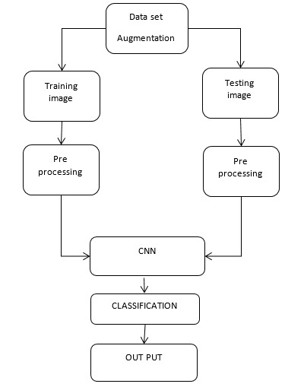

Sequence Diagram:
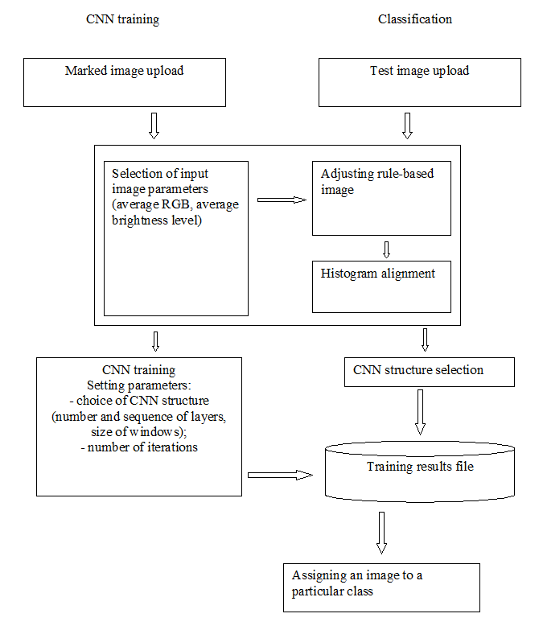

Use Case Diagram:

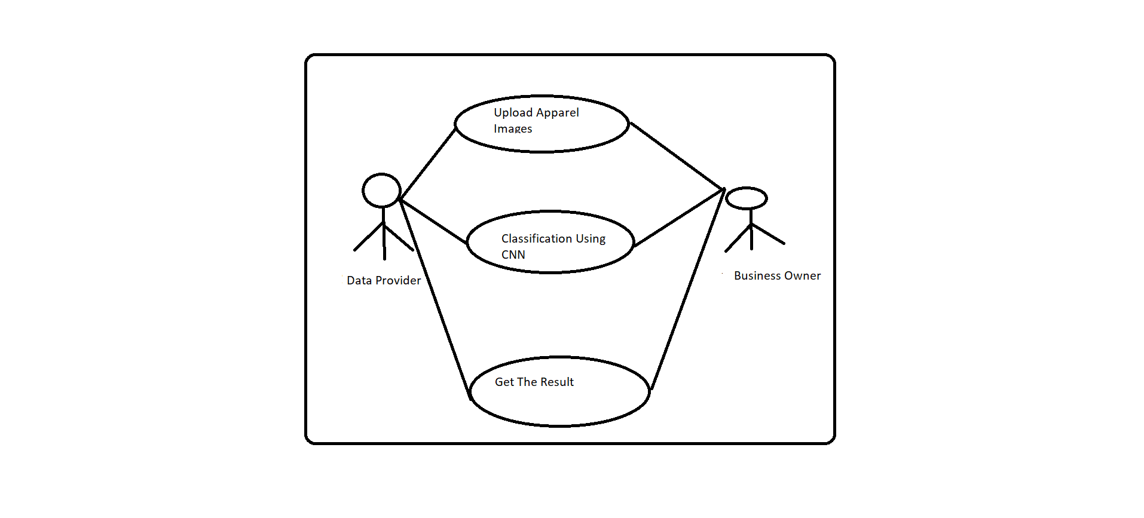

TESTING

Testing is the process of evaluating a system or its components with the intent to find that whether it satisfies the specified requirements or not. This activity results in the actual, expected and difference between their results i.e. testing is executing a system in order to identify any gaps, errors or missing requirements in contrary to the actual desire or requirements.

Testing Methods:
- Black Box Testing –

The technique of testing without having any knowledge of the interior workings of the application is Black Box testing. The tester is oblivious to the system architecture and does not have access to the source code. Typically, when performing a black box test, a tester will interact with the system’s user interface by providing inputs and examining outputs without knowing how and where the inputs are worked upon.

- White Box Testing –

White box testing is the detailed investigation of internal logic and structure of the code. To perform white box testing on an application, the tester needs to possess knowledge of the internal working of the code. The tester needs to have a look inside the source code and find out which unit of the code is behaving inappropriately.

DESCRIPTIONS

Data Set Description:
Zalando, therefore, created the Fashion MNIST dataset as a drop-in replacement for MNIST.
The Fashion MNIST dataset is identical to the MNIST dataset in terms of training set size, testing set size, number of class labels, and image dimensions:
60,000 training examples
10,000 testing examples
10 classes
28×28 grayscale images
The ten fashion class labels include:
T-shirt/top
Trouser/pants
Pullover shirt
Dress
Coat
Sandal
Shirt
Sneaker
Bag
Ankle boot

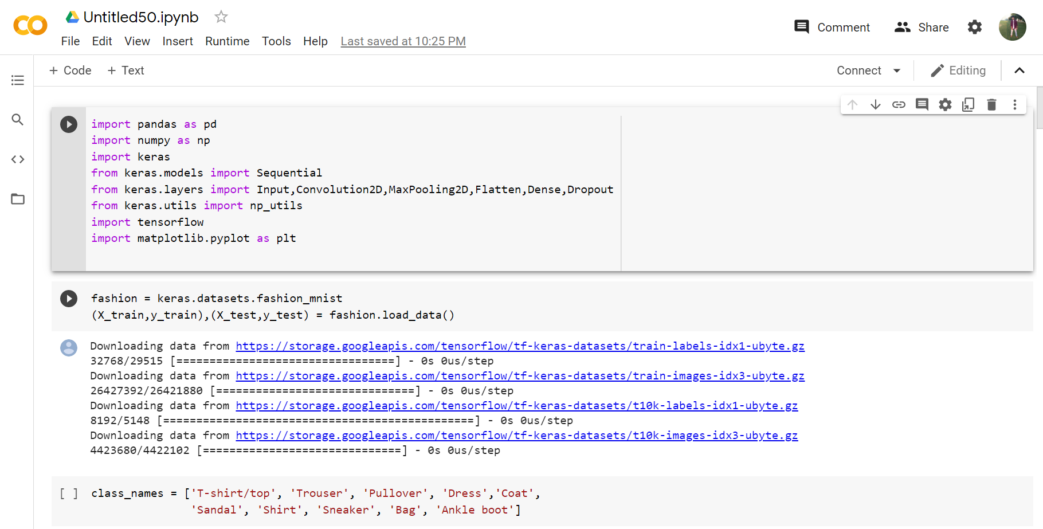

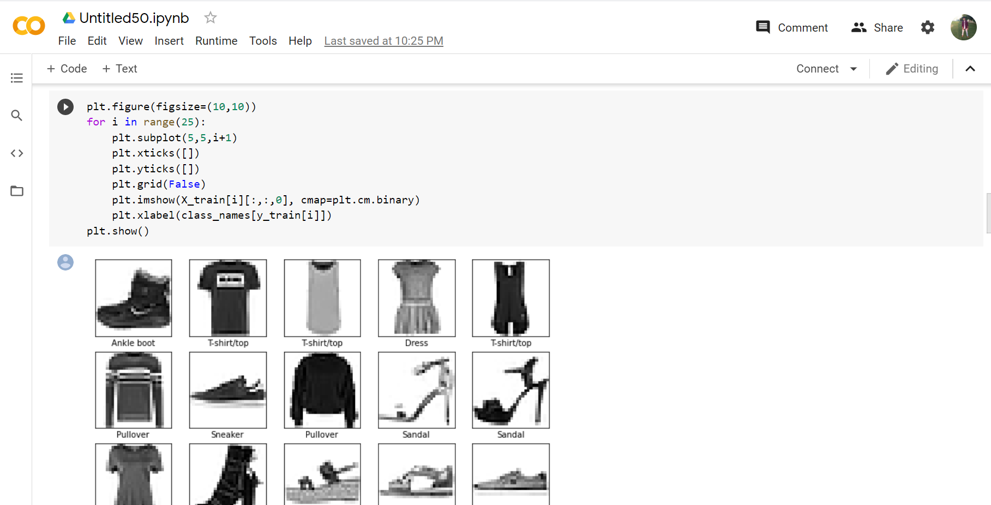

Data Pre-Processing:

Data Integration

Data Cleaning Data Transformation

Data Reduction

The MNIST dataset or any kind of data needs to be preprocessed before you feed it to the neural network for training, and if you plot the first image in the training set by using matplotlib, you will see all the pixel values fall between 0 to 255:

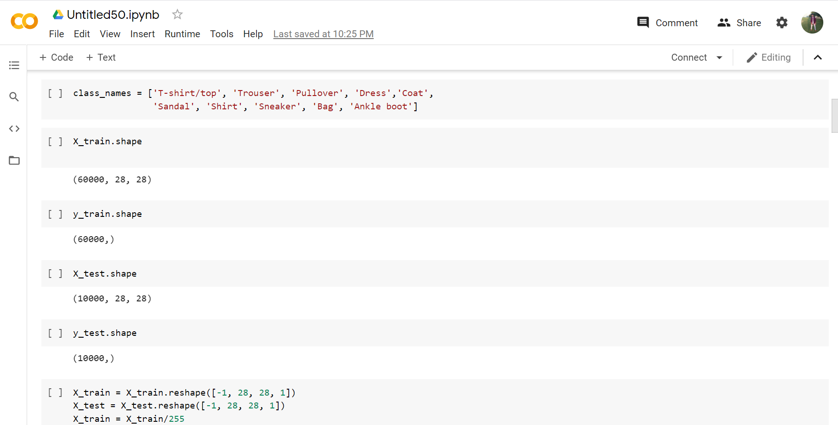

Now, we normalized the data before feeding it to the model so that the neural network will require less computational power for training. To do that we divide all the training image and the test images by 255 so it will be scaled to a range of 0 to 1:
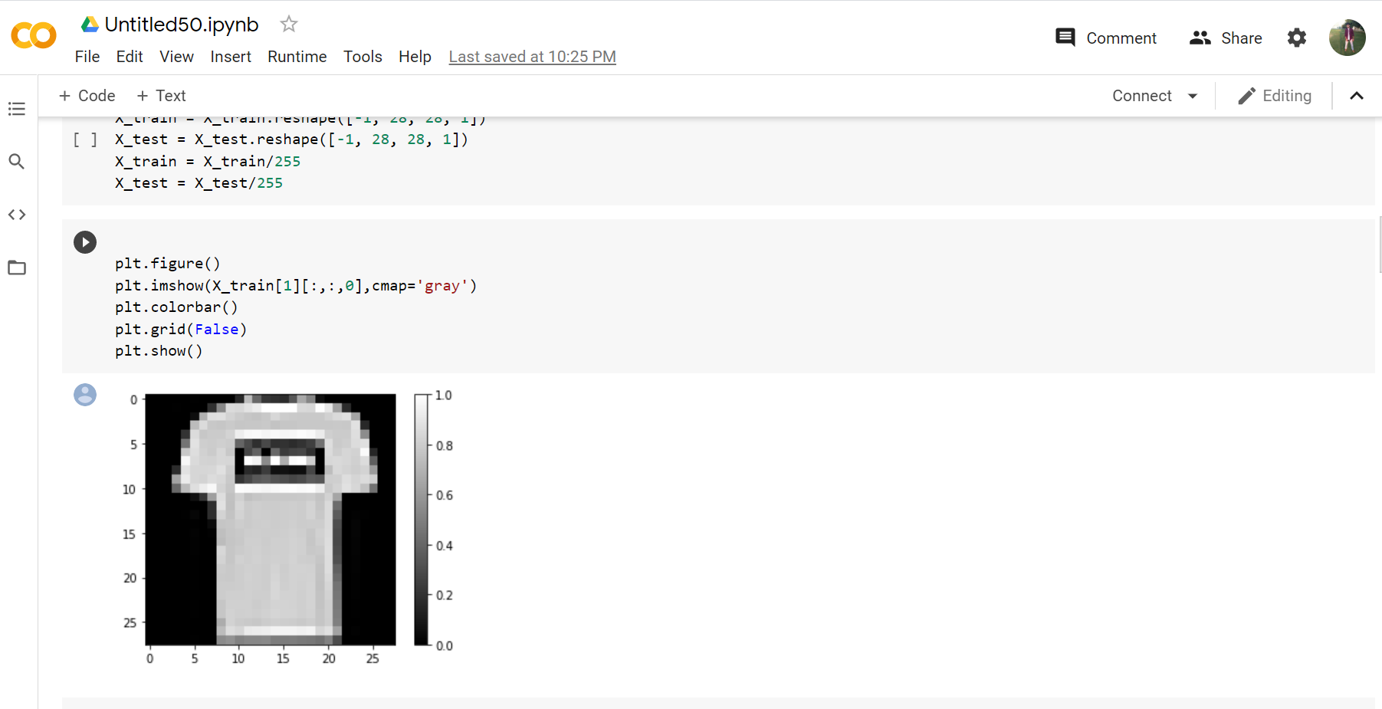

CONVOLUTION NEURAL NETWORK
Convolutional Neural network is a deep learning technique which is feed forward artificial neural networks that are applied to visual images. These are also called as CONV NETS. These are combined set of layers that can be worked on group functionalities

The Convolutional neural networks are neuro-biologically inspired. A CNN consists of mainly five stages they are convolution2D, MaxPoolong2D, Dropout, Batch Normalization, Dense. The input image is fed through camera, which forms the input layer of the CNN model where the small portion of the image is called neuron(pixel). The next step is convolution in 2D where the number of filters or kernels are used perform convolution. Generally 3*3,4*4 or 5*5 are slide over the input image to form s feature map. As the kernels slide over the image, the dot product operation is take place between these two result will be stored. The next step is non-linear activation function over the result of the first step, for the non-linear activation ‗ReLU‘ activation is mostly used in literature. Pooling function is applied to ReLU function, generally max pooling is used. For example if consider the 2*2 max pooling, the maximum of the 2*2 is the output. Batch Normalization was done before every convolutional layer to increase the training speed of the model. Dropout is a technique which addresses this over fitting problem by randomly dropping out neurons which are under deactivation. This prevents the CNN from over-relying on certain neurons which increase the generalization capability of the model. Flattening is the process of converting all the resultant 2D vectors into long continuous linear vectors.

METHODOLOGY
Fashion-MNIST can be used as alternative replacement for the original MNIST dataset (10 categories of handwritten digits). It shares the same image size (28x28) as well as structure of training (60,000) and testing (10,000) splits .Keras is famous and esteemed high-level deep learning API. It‘s built right into to TensorFlow -an independent open source.
The following are the steps followed to build the model:
• Import the Fashion-MNIST dataset

Import the dataset and prepare it for training, validation and test.Load the fashion-MNIST data with the keras datasets API for classification.
• Visualize the data

Visualize an image from the training data set with matplotlib library‘s imshow () so that data can be uniquely accessed.
• Data normalization

Normalize the data dimensions so that they the input data is featured into same scale.
• Split the data into train/validation/test datasets

Training data — used for training the model Validation data — used for tuning the hyper parameters and evaluate the models Test data — used to test the model after various validations takes place for accurate values.
• Create the model architecture

Sequential model API is used to create a simple CNN model repeating with few layers of a convolution layer ordered by a pooling layer followed by a dropout layer.
• Describe the input data shape with first layer. The last layers is a dense layer with softmax activation that classifies the categories of data in fashion_mnist.
• Compile the mode

lmodel.compile () is used to configure the learning process before training the model with proper inputs.
• Train the model, Test accuracy and visualize the predictions.
Build the model
The most important theory of creating block neural networks is the layers. Layers will extract a pattern from the data that have fed it into them.
Most of the neural network models contain multiple layers that are connected to each other and most of them such as tf.keras.layers.Dense has parameters that are learned during training.
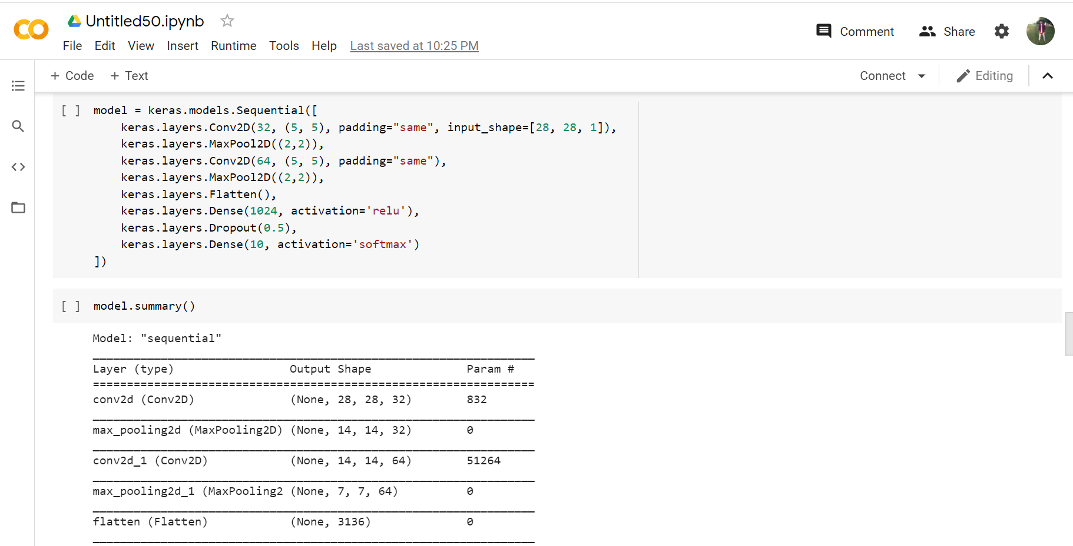
Compile the model
Before we start running our neural networks, we need to make sure that we have set up a few more things and the first thing is:
The Loss function that Will detect how precise the neural network is during the compile process or in other words how the model is doing well.
The second one is Metrics which will observe the testing and training during the running of the model.
The third one is the Optimizer that will make the neural network update the parameters for our neural network during the training process
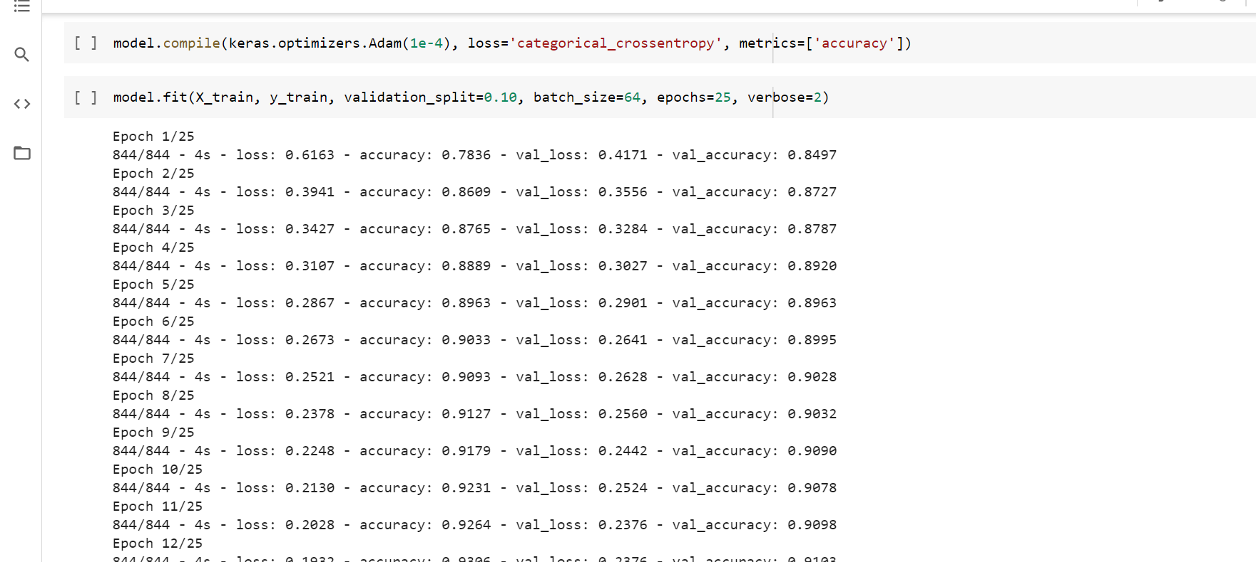
Train the model
Train the artificial neural network demands the next steps:
Feed the training data to the model.
The artificial neural network learns to link images and labels.
You ask the neural network to make predictions about a test set.
Evaluation Metrics
With CNN model using Tensorflow Keras, we got 91% accuracy on test data in classification of our fashion dataset using different labels mentioned above
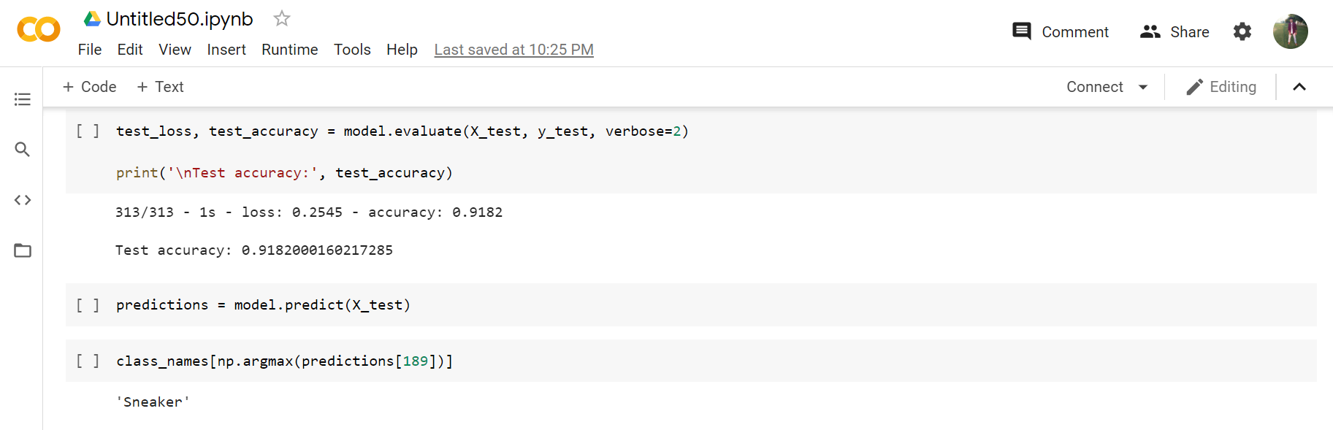

Visualize the predictions
Now we can use the trained model to make predictions / classifications on the 8

test datasetmodel.predict(x_test) and visualize them.

APPLICATION
The apparel image classification mainly used in the field of social media such as(TV shows,movies), e-commerce and criminal law.

CHALLENGES AND FUTURE STEPS

Image Classification is one of the most foundational problems in computer vision, which has a variety of practical applications such as image and video, Although the problem of identifying an object from an image is a very trivial problem for a human-being to perform, it is very challenging for a computer algorithm to do the same with human level accuracy. There are five main challenges in this-
1) Video: Different perspectives of one person caught on camera can confuse image classification solutions that can list one person as several individuals. It is important for solutions to consolidate all media into single-person media profiles. When redundant profiles are reduced, digital investigators can then rely on the generated shortlist of profiles to find suspects, leads, and victims faster.

2) Configuring Algorithms: Algorithms must be constantly maintained and adjusted to output relevant results as data ecosystems evolve with new technology and information streams. As different types of data are introduced from the digital marketplace, image classification solutions must be flexible to grow with the many file types yet to be developed.

3) Processing Time of Image Indexing: Image classification can take hours to process as multiple categories need to be referenced into the output. Solutions must maintain fast processing speeds that are relevant for time-sensitive investigations.

4) OCR(Optical Character Recognition): Often mobile devices contain screenshots of conversations from text apps that people use to document conversations. Image-to-text recognition is vital to make sense of images where the pictured text needs to be searchable.

5) Object Classification: Being able to quickly identify weapons, drugs and other typical objects involved in crimes, allows investigators to vet data more efficiently. When image classification and object recognition are used together, a cluster of supporting data can be surfaced to highlight actionable intelligence.

Image classification has already proved its value in the field and in the forensics lab, but more improvement is needed and expected as public acceptance evolves, global adoption increases, and AI-powered machine learning deepens. New laws and cultural norms will need to adapt in partnership with solution developers to ensure acceptable practices are maintained.

CONCLUSION

In this project we describe our approach to classify an apparel from a given image using convolutional neural networks with batch normalization and dropout which have been proven to perform remarkable well in the field of image classification, using CNN with fashion-MNIST as a dataset with accuracy of 91%.

REFERENCES

- https://towardsdatascience.com/
- https://scikit-learn.org/stable/
- https://kaggle.com/
- https://github.com/

APPENDICES

Dataset used:
https://www.kaggle.com/zalando-research/fashionmnist

Code Link:
## paste the github link of code

