Day 6 Task: Trace a Request

Step 1: Who am I?
Field | Your value
Your private IPv4 address | 192.168.56.1
Subnet mask | 255.255.255.0
Default gateway (router) IP | 192.168.31.1
DNS server(s) your device uses | 192.168.31.1
MAC address of your Wi-Fi adapter | 14:13:33
Manufacturer of your adapter | Realtek

Step 2: Is the network alive? (ping)
Command | Average time (ms) | What it tells you
ping <your gateway IP> | 20ms | Can I reach my own router?
ping 8.8.8.8 | 44ms | Can I reach the internet by IP?
ping google.com | 93ms | Does DNS + internet both work?

2D. If ping 8.8.8.8 works but ping google.com fails, what is broken?
The DNS server is broken, meaning the computer can connect to the internet but cannot translate website names into IP addresses.

Step 3: Which road does it take? (traceroute)
Question | Your answer
How many hops to reach google.com? | 21
IP of hop 1 (should match your gateway) | 2409:40e3:178:50cf:7abb:c1ff:fe8d:c6a6
First hop that is NOT a private IP (your ISP's edge) | 2405:200:520d:33:3924:af:3:108
Which hop had the biggest jump in time? Why might that be? | Hop 12 spiked to 287 ms. This likely happened due to routing over a long geographical distance (like crossing an ocean) or hitting a congested router.
How many hops showed * * * (no reply)? Why do routers do that? | 11 hops. This happens because those routers are configured with security firewalls to silently drop ICMP ping requests to save resources or hide their topology.

Step 4: Ask the phone book (nslookup)
Name | IP address(es) returned | DNS server that answered
google.com | 142.251.222.206 | 192.168.31.1
tekloomy.com | 76.13.181.171, 216.198.79.1 | 192.168.31.1
your college or employer's website | 195.35.22.175 | 192.168.31.1

4D. Run nslookup google.com 1.1.1.1 (ask Cloudflare's DNS instead). Did you get the same IPs? Why might two DNS servers answer differently?
I might get different IPs because massive websites like Google use Global Load Balancing (CDN) to return an IP address closest to the geographical location of the specific DNS server that made the request.

Step 5: Who is my laptop talking to? (netstat)
Question | Your answer
How many connections are ESTABLISHED? | 14
Pick one: remote IP and port. What service is port 443? | HTTPS (Secure Web Traffic)
Any LISTENING ports on your machine? List up to 3 with their numbers. | Port 445 (SMB File Sharing), Port 49666 (Windows RPC), Port 135 (RPC)
Look up one remote IP at ipinfo.io – which company owns it? | 140.82.112.25 - GitHub

Step 6: Draw the path
Below is the generated network path diagram showing the journey from the laptop to google.com. NAT happens at the local router level when translating the private IP to a public IP, and the router also handles the DNS consultation.
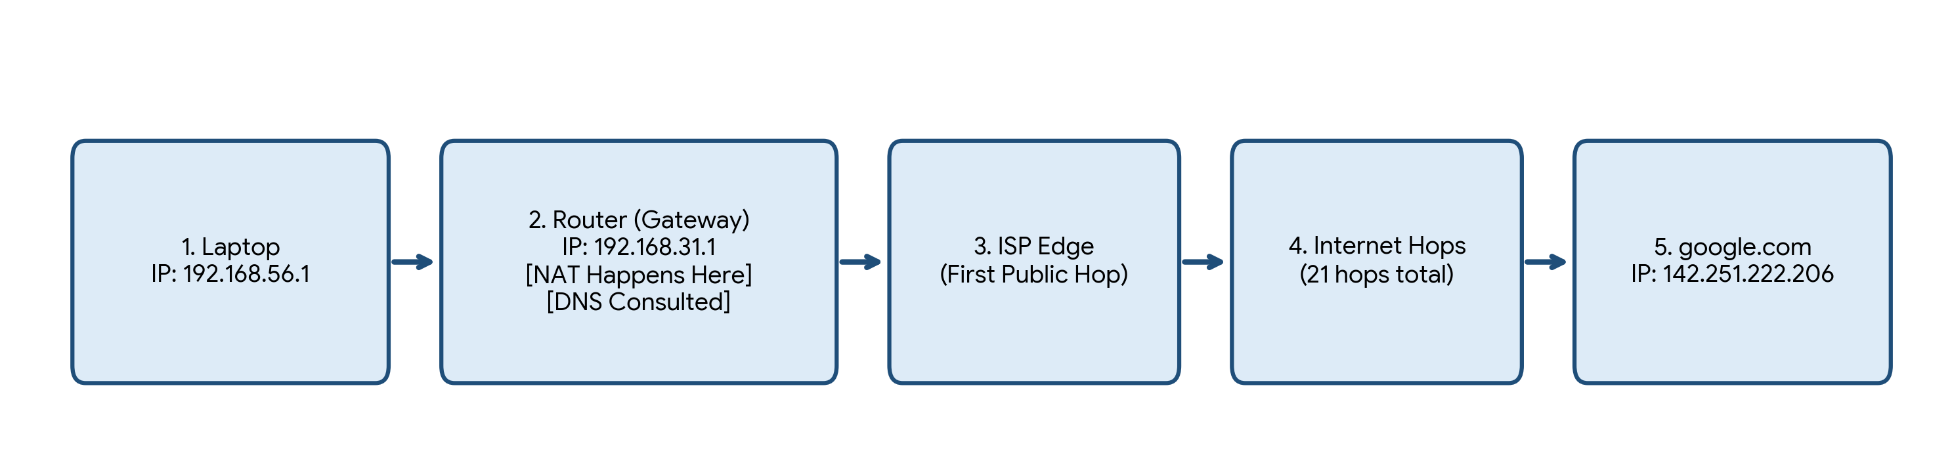

Step 7: One question
A colleague says "the website is down". Using ping, nslookup and traceroute, describe the order you would check things in and what each result would tell you.
1. Ping the default gateway to confirm my local network works.
2. Ping 8.8.8.8 to confirm my internet connection is active.
3. Nslookup the website to see if DNS successfully resolves it to an IP.
4. Ping the website name to see if it responds; if it fails, I run Traceroute to pinpoint exactly which router/hop along the path is dropping the connection.

