14th International Conference on Precision, Micro, Meso and Nano Engineering
Numerical analysis on effects of tapered microchannels for
thermo-hydraulic performance enhancement
Anup Malik ^{a,}*, Shashank Singhª, Harlal Singh Maliª
ª Department of Mechanical Engineering, Malaviya National Institute of Technology Jaipur, India 302017
*Corresponding author e-mail address: anupmalik321@gmail.com

Abstract:
Microchannel heat dissipation devices are advanced cooling systems utilizing miniature channels to enhance heat transfer efficiency, making them ideal for high-performance electronics. These devices feature high heat transfer coefficients and compact sizes, allowing superior cooling performance in space-constrained applications. This work presents 3D numerical investigations on the effects of width, height and both simultaneously tapered microchannels for thermo-hydraulic performance enhancement within the range of 100-300 Reynolds number (𝑅𝑒). All the tapered cases show better thermal performance compared to conventional microchannel. The maximum thermal performance enhancement of 30% is found for highest both tapered case at 𝑅𝑒=300. All the cases show higher relative pressure drop than conventional microchannel at all 𝑅𝑒, which shows poor hydraulic performance. According to this study, only width tapering in microchannels is suggested for thermo-hydraulic performance enhancement in microchannel based heat dissipation devices.
Keywords: Microchannel heat sink, Tapering, Heat transfer, Pressure drop, Performance enhancement

- Introduction
Microelectronic chips [1], aircraft systems [2], and batteries [3] are among the high heat flux thermal management applications where the constant rise in heat dissipation has become a major concern in recent years. Microchannel heat sinks (MCHSs), which are extensively used in industries to drain heat from high-power density units, have garnered significant interest from academics owing to their several benefits, including large specific surface area and reduced coolant flow rate requirements. Heat transfer techniques are characterised as passive or active based on their external energy needs [4]. Active approaches rely on external energy sources to boost coolant heat exchange potential, whereas passive techniques do not require an external power source. Passive approaches entail modifying the MCHS structural design, such as curved channels, adding dimples, ribs, baffles, etc. [5–8]. to the channel surface, in order to generate chaotic advection in the laminar flow. Similarly, the active technique disturbs the flow by applying external time-constant/time-varying energy such as pulsing flow, fluid vibration, etc. [9, 10].
One of the aspects in enhancing the thermo-hydraulic performance of MCHS is varying the cross-section of microchannel in the direction of fluid flow. Hung and Yan [11] numerically compared width tapered MCHS with conventional rectangular microchannel heat sink (CRMCHS). They have found the maximum thermal performance enhancement of 16.7% compared to CRMCHS. Dehghan et al. [12] numerically investigated width tapered MCHS. They have found optimum thermal performance for width tapered ratio equal to 0.5.
In this study, the effect of tapered microchannels for thermo-hydraulic enhancement of MCHS is numerically analysed in 3D. Three types of tapering effects with two levels are considered and their performances are compared with the conventional rectangular microchannel (CRMC) at varying Reynolds number (𝑅𝑒). The thermal and hydraulic characteristics are analysed and discussed which will paves the way for design and fabrication of enhanced MCHS for cooling of electronic devices
.
- Geometric models
Four types of geometries are selected for this investigation, only width tapered (𝑊𝑇), only height tapered (𝐻𝑇), both (width and height) simultaneously tapered and CRMC for comparison of performances. All the models are shown in Fig. 1 with their geometric parameters. Copper and water are chosen as solid and fluid domain materials, respectively. The length (𝐿), width (𝑊) and height (𝐻) of all geometries are 10 mm, 0.7 mm and 0.7 mm, respectively. The height (𝐻𝐶) and width (𝑊𝐶) of CRMC are same as 0.5 mm. They form hydraulic diameter (𝐷ℎ) as 0.5 mm and aspect ratio (𝐴𝑅) as 1.

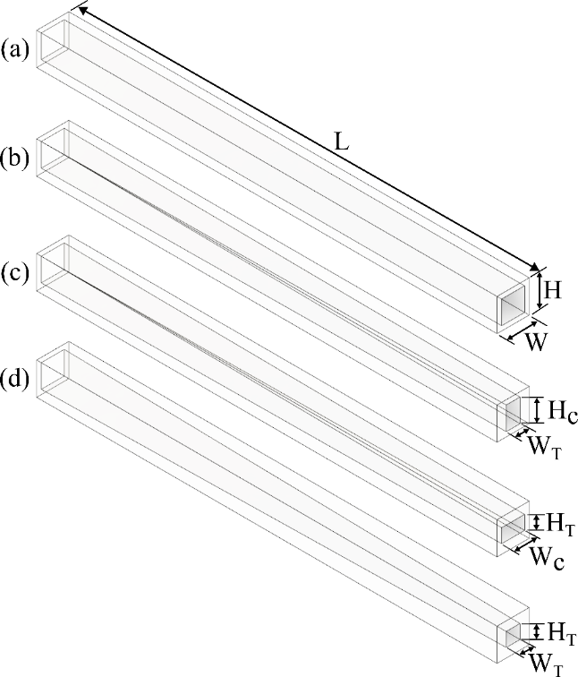
Figure 1: Schematic diagrams of computational domains (a) CRMC, (b) width tapered, (c) height tapered, and (d) both tapered.

All the tapered variations have two levels comprising total six cases excluding CRMC case which are tabulated in Table 1 with their tapering values.
Table 1: Cases with geometric parameters.
Cases | Tapered microchannels
CRMC | No taper
Case-1 | Width tapered (0.5 - 0.4 mm)
Case-2 | Width tapered (0.5 - 0.3 mm)
Case-3 | Height tapered (0.5 - 0.4 mm)
Case-4 | Height tapered (0.5 - 0.3 mm)
Case-5 | Both tapered (0.5 - 0.4 mm)
Case-6 | Both tapered (0.5 - 0.3 mm)

- Governing equations and boundary conditions
Governing equations are solved, using FLUENT tool of ANSYS 2022R1® computational fluid dynamics (CFD) software, for all flows. The equations are known as the N-S equations, which are as follows:
Continuity equation:
$$∇∙\vec{V}=0$$ | (1)
Momentum equation:
$$ρ\left(\vec{V}∙∇\vec{V}\right)=-∇P+∇∙(μ∇\vec{V})$$ | (2)
Continuity equation:
$$ρC_{p}\left(\vec{V}∙∇T_{f}\right)=k_{f}∇^{2}T_{f}$$ | (3)
$$k_{s}∇^{2}T_{s}=0$$ | (4)
Velocity-inlet boundary condition is applied at the inlet. The velocities taken are 0.201, 0.301, 0.402, 0.502 and 0.603 m/s, corresponding to 𝑅𝑒 value of 100, 150, 200, 250 and 300, respectively. The inlet water temperature is 300 K. At the outlet, pressure-outlet condition is applied. Uniform heat flux of 80 W/cm² is applied at the bottom surface of computational domain. Coupled walls are applied to solid-fluid interfaces. Adiabatic boundaries are applied to top and side walls.

- Solution methods and data reduction
For this numerical study, steady-state pressure-based solver is opted. Energy and laminar models are used for determining the thermal and hydraulic characteristics. Semi-Implicit Method for Pressure Linked Equations-Consistent (SIMPLEC) algorithm is employed. The convergence stop criteria are set as 10⁻⁶ for all variables. The following equations are used for data reduction in the present research:
- Reynolds number (𝑅𝑒):
$$Re=\frac{ρ_{f}∙V_{in}∙D_{h}}{μ_{f}}$$ | (5)
where 𝜌_{𝑓}, 𝑉_{𝑖𝑛}, 𝜇_{𝑓}, and 𝐷_{ℎ} are fluid density, inlet velocity, fluid dynamic viscosity and hydraulic diameter, respectively.
- Hydraulic diameter (𝐷ℎ):
$$D_{h}=\frac{2∙W_{c}∙H_{c}}{W_{c}+H_{c}}$$ | (6)
where 𝑊_{𝑐} and 𝐻_{𝑐} are microchannel width and height, respectively.
- Average Nusselt number (𝑁𝑢_{𝑎𝑣𝑔}):
$${Nu}_{avg}=\frac{h_{avg}∙D_{h}}{k_{f}}$$ | (7)
where ℎ_{𝑎𝑣𝑔} and 𝑘_{𝑓} are average heat transfer coefficient and thermal conductivity of fluid, respectively.
- Pressure drop (Δ𝑃):
$$∆P=P_{avg, i}-P_{avg, o}$$ | (8)
where 𝑃_{𝑎𝑣𝑔, 𝑖} and 𝑃_{𝑎𝑣𝑔, 𝑜} are average pressures at inlet and outlet faces, respectively.
- Results and discussion
5.1 Grid convergence and validation
Grid convergence is studied by using ANSYS Fluent software. Three different poly-hexcore mesh element numbers are taken as 0.3, 0.6 and 1.2 million. The Δ𝑃 variations are calculated for CRMC case at 𝑅𝑒=100. The results of grid convergence study are shown in Table 2. This clearly shows that the 1.2 million cell numbers utilized in the current investigation have an acceptable degree of precision with the relative error of only 0.37%.
Table 2: Grid convergence study.
Cell numbers (million) | Δ𝑃 (Pa) | Relative error (%)
0.3 | 268 | -
0.6 | 266 | 0.75
1.2 | 265 | 0.37

Current numerical study is compared with analytical findings by Steinke and Kandlikar [13] for the Δ𝑃 and by Shah and London [14] for the 𝑁𝑢_{𝑎𝑣𝑔}. Results of the comparisons with varying 𝑅𝑒 are shown in Fig. 2. Both parameters of current and analytical studies have shown almost similar trends. So, the present numerical findings are in good agreement with the analytical and can be further utilized to examine the thermal performance of all considered cases.

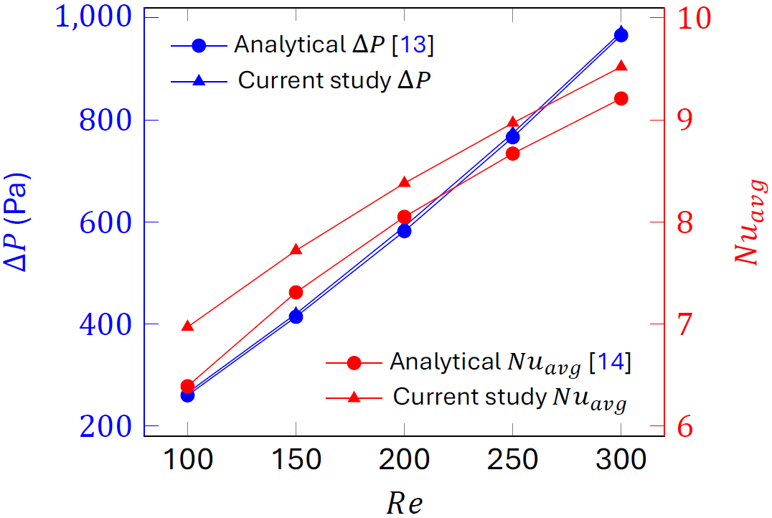
Figure 2: Validations of current study.

5.2 Thermo-hydraulic performance
The thermal performance of all the tapered cases in terms of 𝑁𝑢_{𝑎𝑣𝑔} relative to CRMC are shown in Fig. 3. The 𝑁𝑢_{𝑎𝑣𝑔} for all cases are calculated by using Eq. (7). All the tapered cases have 𝑁𝑢_{𝑎𝑣𝑔}/𝑁𝑢_{𝑎𝑣𝑔,𝑀𝐶} > 1. This shows better thermal performance compared to CRMC. The performance increases on increasing 𝑅𝑒 for all the cases. The maximum thermal performance enhancement of 30% is found for Case-6, which is highest both tapered case, at 𝑅𝑒=300 compared to CRMC.
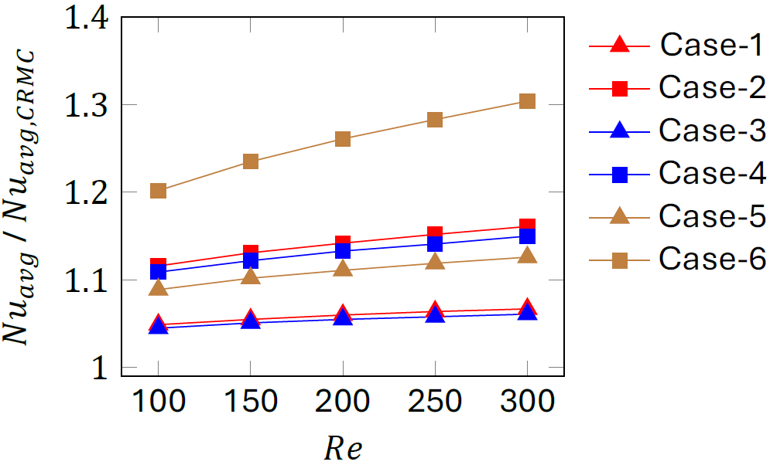
Figure 3: Thermal performance of tapered microchannels.
The hydraulic performances of all cases in terms of relative Δ𝑃 between inlet and outlet faces of microchannels are shown in Fig. 4. The Δ𝑃 for all cases are calculated by using Eq. (8). All the cases show higher relative Δ𝑃 than CRMC at all 𝑅𝑒. This shows poor hydraulic performance compared to CRMC. Among all the tapered cases, Case-1 and Case-3 which are lowest width and height tapered cases respectively, show equal and least relative Δ𝑃.
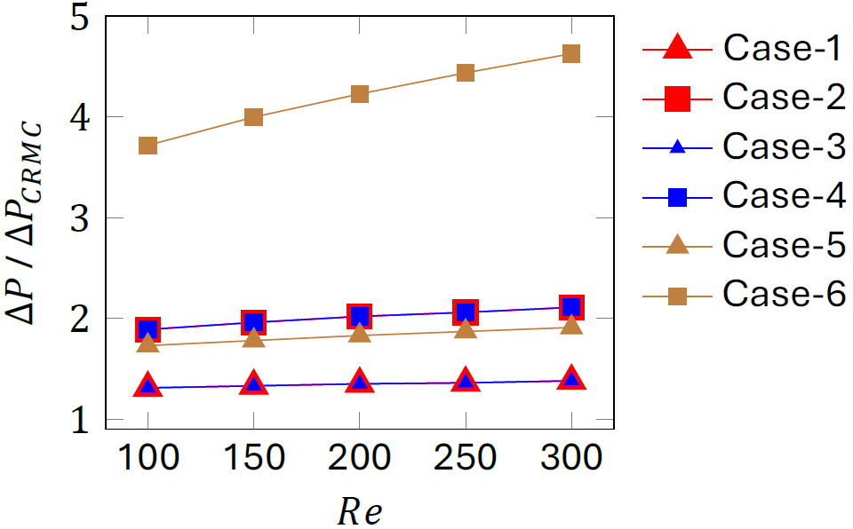
Figure 4: Hydraulic performance of tapered microchannels.

Fig. 5 shows the temperature contours of CRMC and Case-6 at 𝑅𝑒=300. It clearly shows the improvement in thermal performance along the flow for Case-6 compared to CRMC. The maximum temperature of microchannel substrate for CRMC is 346 K and for Case-6 is 340 K. The improvement in thermal performance for Case-6 is due to increasing velocity of fluid along the flow. This is because the microchannel’s cross-sectional area keeps decreasing due to the highest both tapering effect along the flow.
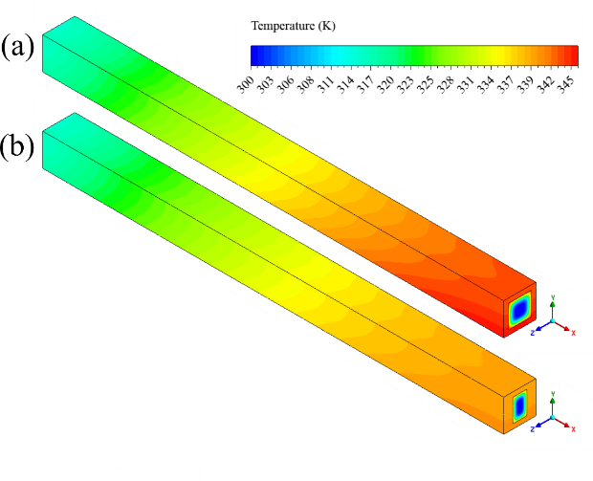
Figure 5: Temperature contours of (a) CRMC and (b) Case-6 at 𝑅𝑒=300.
Maximum velocity of fluid for CRMC and Case-6 are 1.2 and 3 m/s, respectively as shown in Fig. 6.
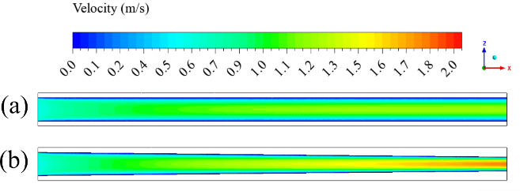
Figure 6: Velocity contours of (a) CRMC and (c) Case-6 at 𝑅𝑒=300.

- Conclusions
This work numerically investigates the effects of width, height and both simultaneously tapered microchannels for thermo-hydraulic performance enhancement in MCHS. The performances of six different cases of tapered microchannel geometries are compared with CRMC, using FLUENT tool of ANSYS 2022R1® CFD software. The effects of tapering are analysed for 𝑅𝑒 from 100 to 300. In this investigation, the materials are water as coolant and copper as substrate. Only single-phase flow of coolant is considered. The performed work can lead to the following conclusions :-

- All the tapered cases have 𝑁𝑢_{𝑎𝑣𝑔}/𝑁𝑢_{𝑎𝑣𝑔,𝑀𝐶} > 1, which shows better thermal performance compared to CRMC.
- The maximum thermal performance enhancement of 30% is found for Case-6, which is highest both tapered case, at 𝑅𝑒=300 compared to CRMC.
- All the cases show higher relative Δ𝑃 than CRMC at all 𝑅𝑒, which shows poor hydraulic performance compared to CRMC.
- Among all the tapered cases, Case-1 and Case-3 which are lowest width and height tapered cases respectively, show equal and least relative Δ𝑃.
- According to this study, only width tapering in microchannels is suggested for thermo-hydraulic performance enhancement in microchannel based heat dissipation devices.
Acknowledgement
The authors would like to thank Science and Engineering Research Board, Government of India for supporting this work through the grant CRG/2023/005255.
References
- P. Zając and A. Napieralski, “Novel thermal model of microchannel cooling system designed for fast simulation of liquid-cooled ics,” Microelectronics Reliability, vol. 87, pp. 245–258, 2018. https://doi.org/10.1016/j.microrel.2018.06.020
- B. Agostini, M. Fabbri, J. E. Park, L. Wojtan, J. R. Thome, and B. Michel, “State of the art of high heat flux cooling technologies,” Heat transfer engineering, vol. 28, no. 4, pp. 258–281, 2007. https://doi.org/10.1080/01457630601117799
- H. Abou-Ziyan, M. Ibrahim, and H. Abdel-Hameed, “Characteristics enhancement of one-section and two-stepwise microchannels for cooling high-concentration multi-junction photovoltaic cells,” Energy Conversion and Management, vol. 206, p. 112488, 2020. https://doi.org/10.1016/j.enconman.2020.112488
- S. Singh, A. Malik, and H. S. Mali, “A critical review on single-phase thermo-hydraulic enhancement in geometrically modified microchannel devices,” Applied Thermal Engineering, p. 121729, 2023. https://doi.org/10.1016/j.applthermaleng.2023.121729
- H. Mohammed, P. Gunnasegaran, and N. Shuaib, “Influence of channel shape on the thermal and hydraulic performance of microchannel heat sink,” International Communications in Heat and Mass Transfer, vol. 38, no. 4, pp. 474–480, 2011. https://doi.org/10.1016/j.icheatmasstransfer.2010.12.031
- Q. Zhu, H. Xia, J. Chen, X. Zhang, K. Chang, H. Zhang, H. Wang, J. Wan, and Y. Jin, “Fluid flow and heat transfer characteristics of microchannel heat sinks with different groove shapes,” International Journal of Thermal Sciences, vol. 161, p. 106721, 2021. https://doi.org/10.1016/j.ijthermalsci.2020.106721
- S. Singh, A. Malik, and H. S. Mali, “Thermo-hydraulic performance enhancement in novel secondary connected fractal heat sink with cavities,” International Journal of Thermal Sciences, 214, p.109855, 2025. https://doi.org/10.1016/j.ijthermalsci.2025.109855
- F. Ahmad, T. A. Cheema, A. Khan, M. Mohib-Ur-Rehman, and H. Yildizhan, “Hydrothermal investigation of the performance of microchannel heat sink with ribs employed on side walls,” Journal of Non-Equilibrium Thermodynamics, vol. 46, no. 3, pp. 255–272, 2021. https://doi.org/10.1515/jnet-2020-0104
- S. Singh, S. K. Singh, H. S. Mali, and R. Dayal, “Numerical investigation of heat transfer in structured rough microchannels subjected to pulsed flow,” Applied Thermal Engineering, vol. 197, p. 117361, 2021. https://doi.org/10.1016/j.applthermaleng.2021.117361
- S. Singh, H. Mali, S. Suryawanshi, and S. Singh, “Pulsed-flow microchannel heat sink: Simulation and experimental validation,” Journal of Micromanufacturing, vol. 5, no. 1, pp. 29–35, 2022. https://doi.org/10.1177/25165984211058625
- T.-C. Hung and W.-M. Yan, “Effects of tapered-channel design on thermal performance of microchannel heat sink,” International Communications in Heat and Mass Transfer, vol. 39, no. 9, pp. 1342–1347, 2012. https://doi.org/10.1016/j.icheatmasstransfer.2012.08.008
- M. Dehghan, M. Daneshipour, M. S. Valipour, R. Rafee, and S. Saedodin, “Enhancing heat transfer in microchannel heat sinks using converging flow passages,” Energy Conversion and Management, vol. 92, pp. 244–250, 2015. https://doi.org/10.1016/j.enconman.2014.12.063
- M. E. Steinke and S. G. Kandlikar, “Single-phase liquid friction factors in microchannels,” International journal of thermal sciences, vol. 45, no. 11, pp. 1073–1083, 2006. https://doi.org/10.1016/j.ijthermalsci.2006.01.016
- R. K. Shah and A. L. London, Laminar flow forced convection in ducts: a source book for compact heat exchanger analytical data. Academic press, 2014.

