LEADERSHIP PROFILE
Sh. Rohit Saboo
Chairman
President & Chief Executive Officer
National Engineering Industries Ltd. – NBC Bearings, CK Birla Group

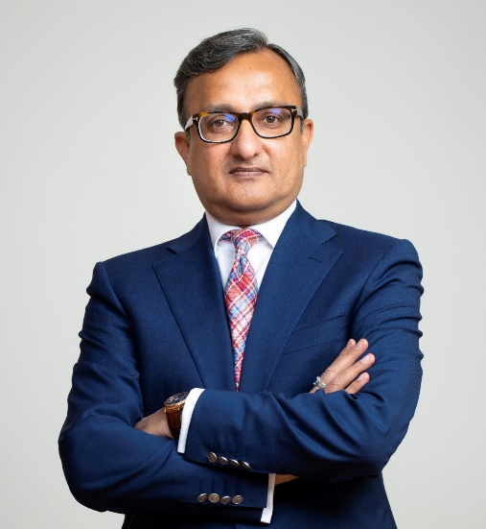
Sh. Rohit Saboo

Academic Background
Rohit Saboo holds a strong academic foundation combining engineering and global business education. He is an engineering graduate from the Birla Institute of Technology, Ranchi. He further pursued a Master of Business Administration (MBA) from the Rochester Institute of Technology, USA, and has also completed a senior executive program from Columbia University. This blend of technical and managerial education has enabled him to effectively integrate engineering excellence with strategic business leadership.

Career Journey
Rohit Saboo has spent over two decades with National Engineering Industries Ltd (NBC Bearings), reflecting a depth of institutional knowledge and leadership continuity. He began his career within the organization as Executive Assistant to the Chairman, gaining early exposure to strategic decision-making at the highest level. Over the years, he has held multiple leadership roles across critical functions, including technology, research and development, and manufacturing.
He later served as Vice President – R&D and Manufacturing, where he played a pivotal role in strengthening the company's engineering and operational capabilities. His consistent contributions and leadership led to his elevation as President and Chief Executive Officer, where he now oversees the overall strategic direction and performance of the organization.

Contributions to NBC Bearings
Under Rohit Saboo's leadership and prior functional roles, NBC Bearings has continued to strengthen its position as one of India's leading bearing and allied engineering products manufacturers with a growing global presence. His contributions are closely associated with enhancing the company's focus on quality, innovation, and operational excellence.
He has played an important role in reinforcing R&D-led manufacturing, ensuring that engineering and product development remain central to the company's growth strategy. The organization's alignment with globally respected quality frameworks, including the Deming philosophy, reflects this commitment to excellence.
Additionally, he has supported the company's expansion into new and emerging sectors such as aerospace, urban mobility, drone and other high-precision industrial applications, while also contributing to its global market outreach.

Leadership Philosophy
Rohit Saboo's leadership approach is grounded in the belief that sustainable success in manufacturing is built on three core pillars: quality, innovation, and people.
He advocates that quality should not be treated merely as a compliance requirement but as a strategic differentiator that builds long-term customer trust and global competitiveness. He also emphasizes the importance of embedding research and development into the core of business strategy, enabling organizations to move from cost-driven manufacturing to innovation-led engineering.
At the same time, he strongly believes in the role of people and organizational culture in driving performance. His approach highlights the importance of collaboration, continuous learning, and workforce capability development in achieving operational excellence.

