The Hidden Backbone of Indian Railways
A Graph Visualization and Network Analysis | DSE3151 Graph Visualization, Manipal University Jaipur
Divyanshu Agwekar (2430010132) | Puru Bansal (2430010153)
1. Question
Do all railway stations play the same structural role? Some stations have many direct connections, while others may matter mainly because they link different parts of the network. This project identifies hubs, communities and bridge stations, and tests two hypothetical station removals.
2. Data and graph construction
Source: Indian Railway Data repository (prasenjit-27; ~8,990 station and ~5,208 train records), cleaned in Python/Colab. The analysis graph is undirected with 289 nodes (stations) and 400 edges (direct route connections derived from train routes). Edge weight is the Weight column in the edges CSV (how often a link appears in the route data). The graph is a single connected component and is a regional sample, not the full national network.
3. Layout choice (Criterion 1)
We used ForceAtlas 2, a force-directed layout (Gephi settings: scaling 2.0, gravity 1.0, edge-weight influence 1.0, LinLog and overlap prevention off). Every station repels every other, while every link pulls its two ends together. Densely linked groups therefore settle into clusters, hubs move to the middle and bridge stations end up between clusters, all from link data alone.
Alternative | Why it fits less well
Circular | Treats all stations alike; hides clusters and hubs.
Hierarchical | Needs a root and direction; our graph is undirected with loops.
Geographic | The data has no coordinates, and a map would hide link structure.
4. Visual encoding (Criterion 3)
Channel | Encodes | Why it works
Node size | Degree (number of direct connections) | Hubs stand out immediately.
Node colour | Community from Louvain modularity (weighted, resolution 1.0): 27 communities; the twelve holding labelled stations are coloured, the other 15 grey | Same colour reads as "belongs together".
Edge thickness | Link weight (log-scaled in the figures) | Busier links look heavier.
Edge colour | Colour of the community when both ends share it, otherwise grey | Within-group links are visible; cross-group links stand apart.
Ring / labels | Dark ring = top-8 stations by betweenness; labels only on the most important stations | Marks bridges and avoids label clutter.
5. Metrics (Criterion 2)
Network summary | Value
Nodes / edges | 289 / 400
Average degree | 2.768
Density | 0.010
Diameter / average path length | 10 / 5.20
Average clustering coefficient (nodes with degree ≥ 2) | 0.360
Communities / modularity | 27 / 0.926
Degree is the number of stations directly linked to a station (local connectivity). Betweenness centrality counts how many shortest paths between other station pairs pass through a station (bridging). Modularity measures how clearly the network splits into communities; 0.926 is very high, so the groups are tight. Average path length 5.20 means any two stations are about five links apart. All values were recomputed from the CSVs and match the Gephi Statistics results.
6. Four views of the same network
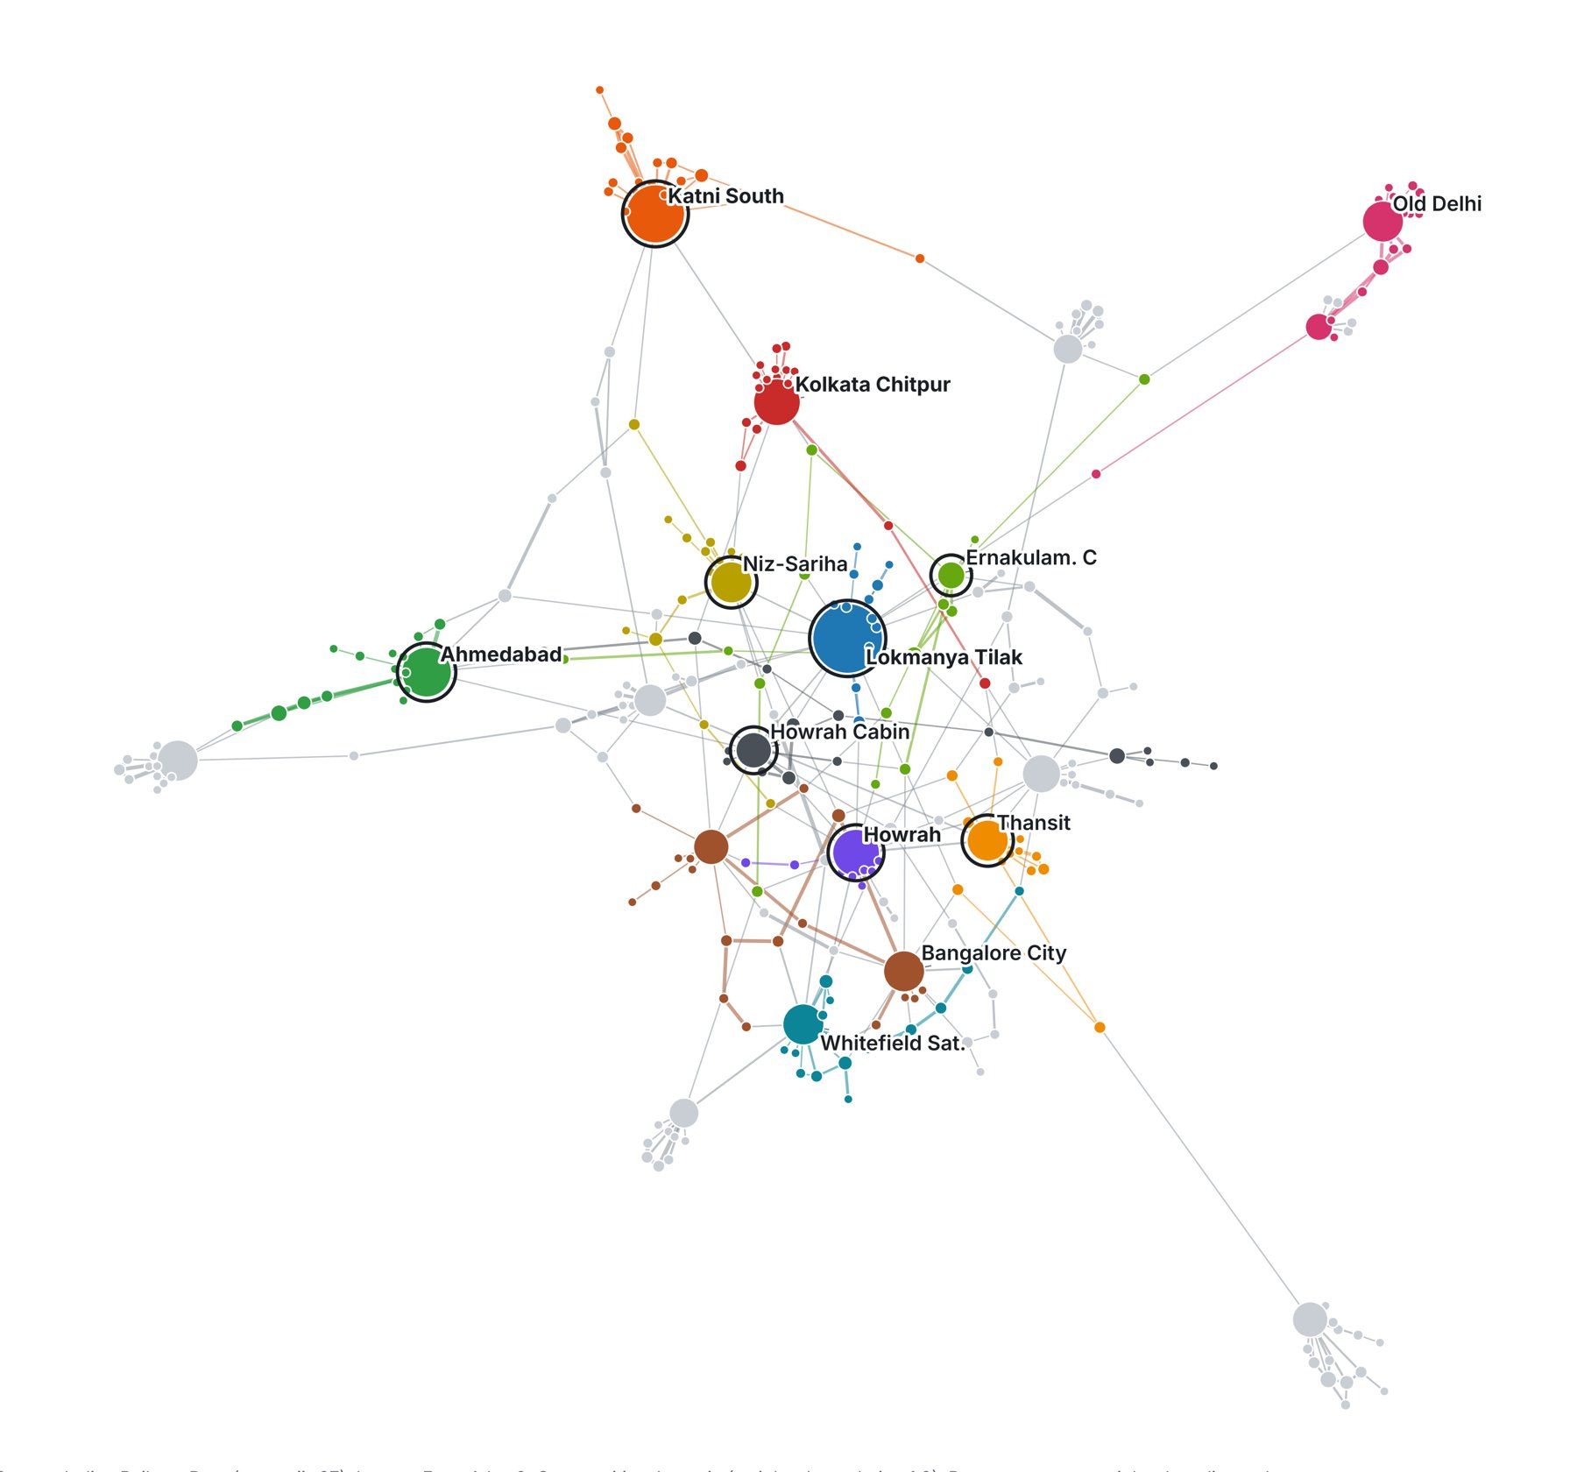  Graph 1. Main network: size = degree, colour = community, dark ring = top-8 bridges. | 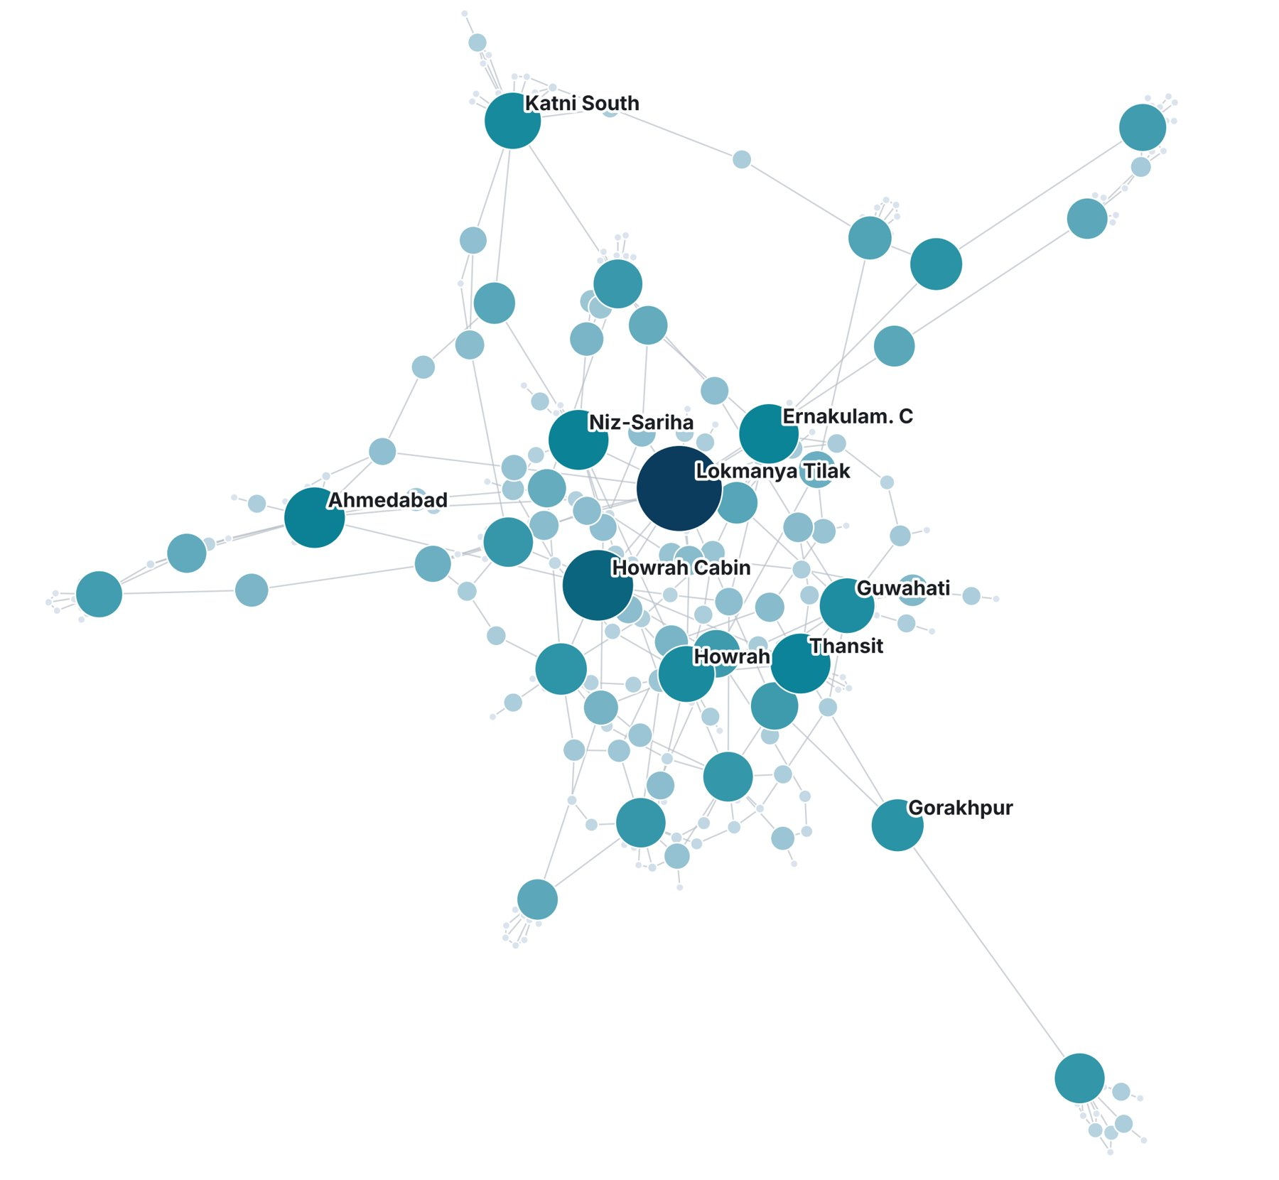  Graph 2. Bridge view: size and colour = betweenness (darker, bigger = more shortest paths pass through).
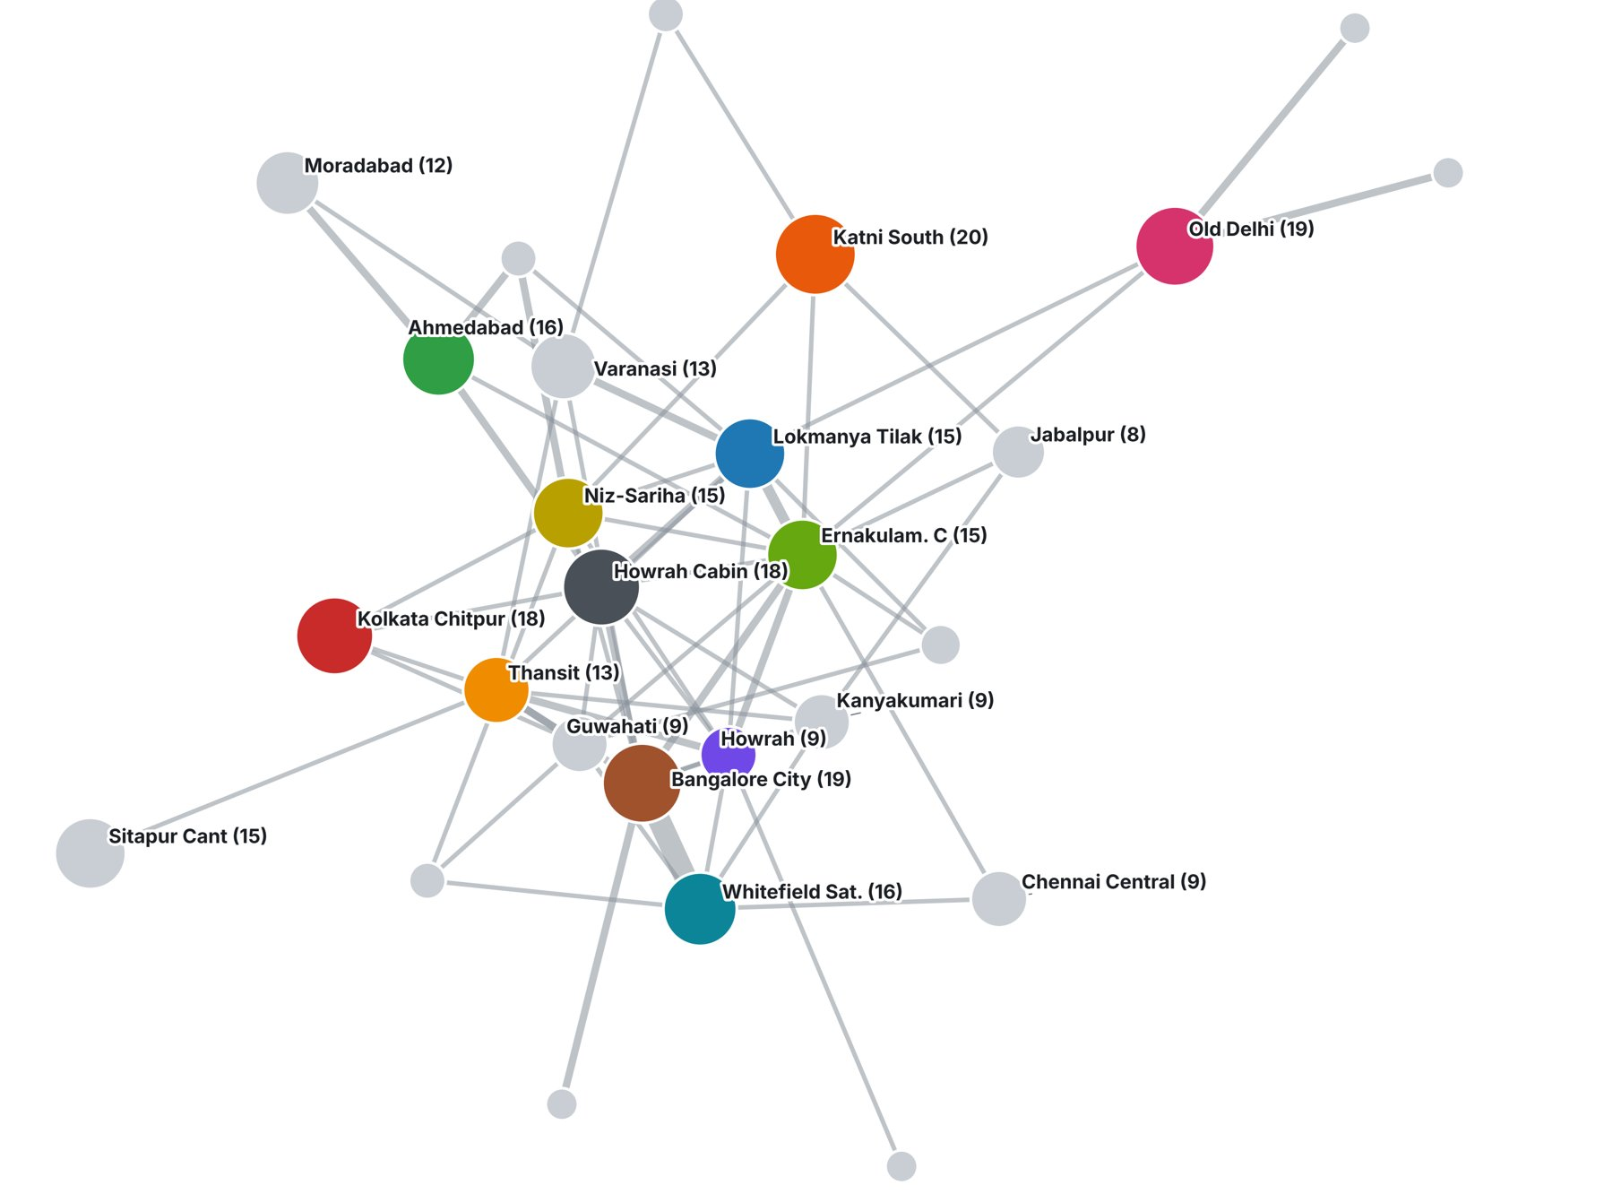  Graph 3. Community map: each dot is one of the 27 communities (size = stations); line thickness = links between two communities. | What the four graphs show  - Graph 1: a few big hubs and distinct coloured clusters.  - Graph 2: the bridge stations differ from the busiest ones.  - Graph 3: 315 of 400 links stay inside a community; only 85 cross between communities, so a few links tie the groups together.  - Graph 4: removing the top hub splits off stations and lengthens routes.
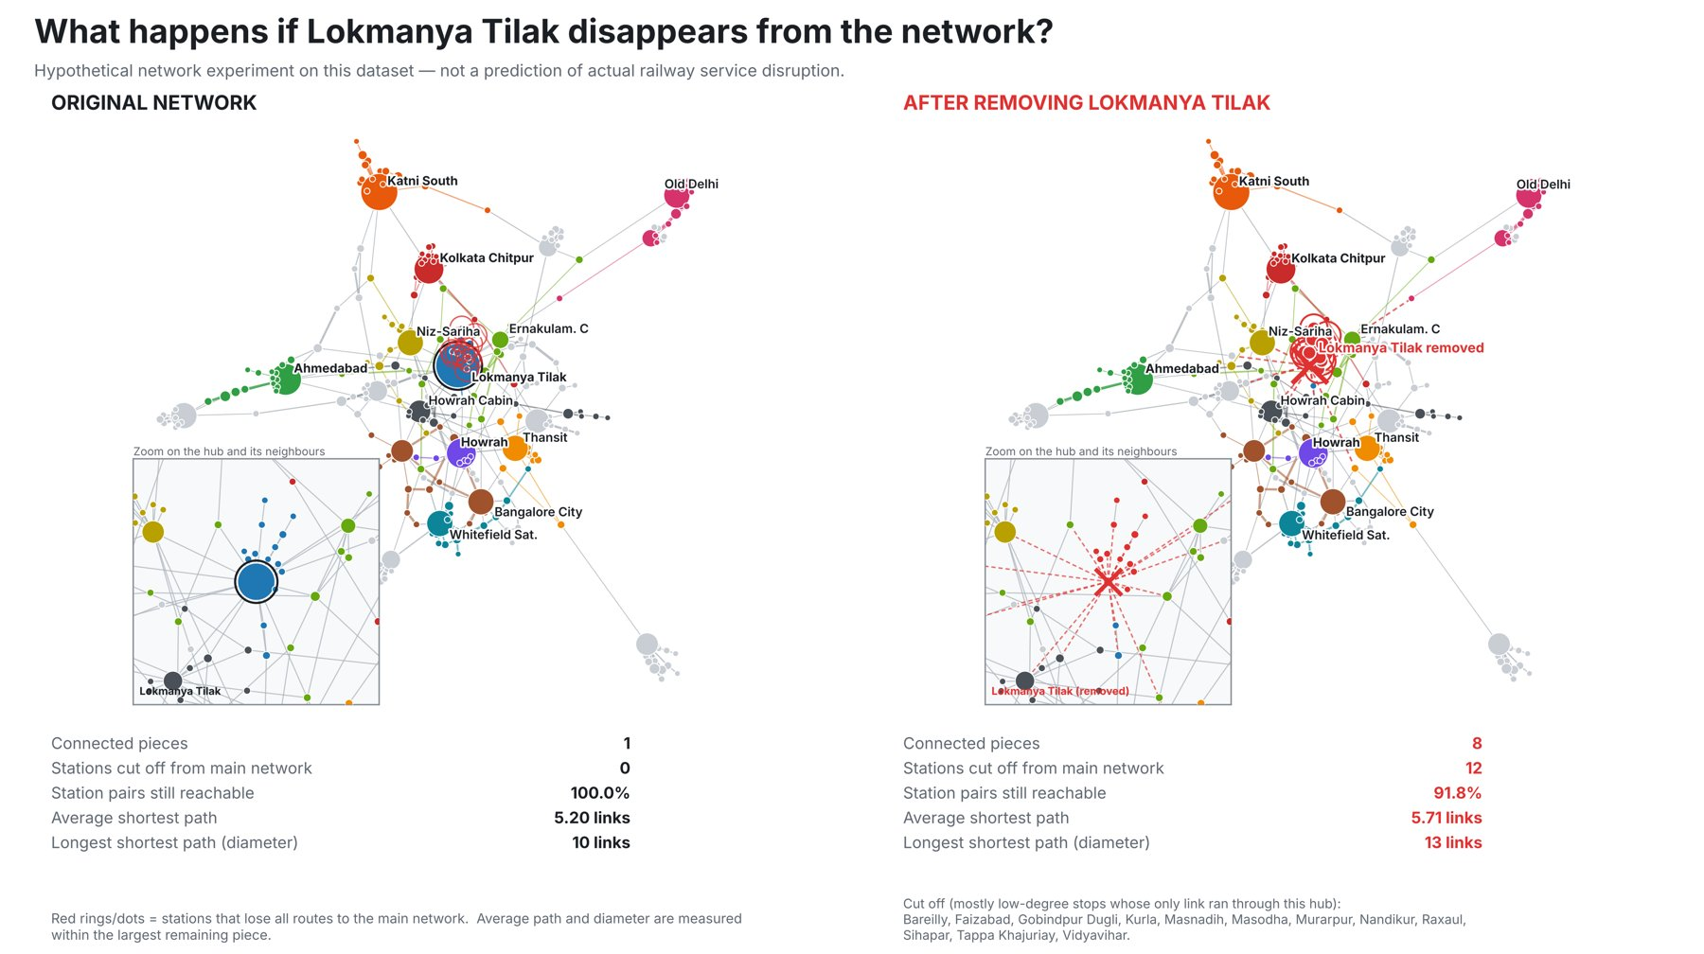
Graph 4. Hub-removal comparison (hypothetical): original network vs. network without Lokmanya Tilak. Red = stations cut off from the main network.
7. Findings
- Hubs by degree: Lokmanya Tilak (24), Katni South (20), Ahmedabad Jn (17), Howrah Jn (16) and Kolkata Chitpur (16). Most stations are small: 109 of 289 have a single connection.
- Bridges by betweenness: Lokmanya Tilak (14,687), Howrah Jn. Cabin (9,202), Ahmedabad Jn (6,314), Niz-Sariha Halt (6,150) and Thansit (6,140). Lokmanya Tilak leads both rankings.
- Degree and bridging differ: Howrah Jn. Cabin and Thansit rank high on betweenness despite fewer direct links than Katni South, and Gorakhpur Jn has only 3 links but ranks 10th on betweenness.
- Hub-removal experiment (hypothetical): removing Lokmanya Tilak splits the network into 8 pieces, cuts off 12 stations, lowers reachable station pairs from 100% to 91.8%, raises average path length from 5.20 to 5.71 and diameter from 10 to 13. Of all 289 single-station removals, this gives the largest increase in average path length.
- Bridge-not-hub example: removing Gorakhpur Jn cuts off 15 stations (the most of any single removal) although it has only 3 direct links. 41 stations are articulation points whose removal disconnects the graph.
8. Key insight (Criterion 4)
Being busy is not the same as being structurally important. A degree table ranks Gorakhpur Jn low (3 links), but the graph shows it is the only link between a far cluster of stations and the rest of the network: removing it cuts off 15 stations, more than any other single station, including the top hub. Only the graph (Graphs 2 and 4) makes this visible.
9. Limitations
- Hypothetical network experiments on this dataset only; they do not predict real railway operations, which have alternative routes, rakes and timetables not in the data.
- Some nodes are operational records (cabins, yards, goods sidings) or duplicate names (e.g. Howrah Jn. Cabin vs Howrah Jn; two Sabarmati entries). This can inflate or split a station's apparent importance.
- Betweenness and removal results are unweighted and structural. Louvain is stochastic (27–28 communities across seeds, modularity ≈ 0.93). The sample is partial, and many cut-off stations are low-degree stops that depend on one link.
- Figures were generated from the same CSVs using a ForceAtlas 2 layout; small layout differences from the Gephi view are expected.
10. Conclusion
The network is organised around a few hubs and many small, tightly linked communities held together by a few cross-group links. Lokmanya Tilak is both the busiest and the most structurally critical station in this sample, and Gorakhpur shows that a station with few links can still be a critical bridge. Direct connections alone do not capture structural importance.

