Exploratory Data Analysis (EDA) Summary
Report Template

1. Introduction
The purpose of this report is to conduct an exploratory data analysis (EDA) on Geldium’s customer dataset to evaluate data quality, identify missing or inconsistent values, analyse behavioural and financial features, and detect early signals related to credit delinquency risk. The insights gained from EDA will support feature engineering and improve model design for delinquency prediction.

2. Dataset Overview
The dataset contains customer demographics, financial indicators, loan metrics, and behavioural variables relevant to predicting delinquency risk. Numerical and categorical attributes were reviewed to assess distribution patterns and detect potential modelling challenges.
Key dataset attributes:
- Number of records: [Value not provided in notebook — to be inserted]
- Number of features: 19
- Key variables:
  - Customer demographics: Age, Location, Employment Status
  - Financial attributes: Income, Credit Score, Loan Balance, Debt-to-Income Ratio
  - Behavioural factors: Missed Payments, Credit Utilization, Account Tenure
  - Target variable: Delinquent_Account (later reconstructed due to class imbalance)
No duplicate records were detected, and overall variable formatting appeared consistent.

3. Missing Data Analysis

A review of missing values indicates that the dataset contains minimal missing entries. However, due to the domain relevance of financial variables, appropriate treatment strategies were defined for potential gaps.

Missing Data Strategy Table
Issue | Treatment Method | Justification
Missing income values (if present) | Median Imputation | Income distribution is skewed; median avoids distortion.
Missing credit utilization | Predictive Imputation (KNN/Regression) | Value depends on income, credit score, and loan balance, so predicted values retain realistic financial behaviour.
Missing missed-payments history | Domain-Based Synthetic Value | Absence may represent no missed payments; synthetic assignment prevents artificial inflation of risk.
Missing Debt-to-Income Ratio | Derived Calculation (Debt ÷ Income) | Ensures mathematical consistency and avoids artificial biases.
Invalid target values | Synthetic Target Creation | Original Delinquent_Account field contained only one class; engineered based on risk indicators to enable modelling.

4. Key Findings and Risk Indicators
Univariate Insights
- Numerical variables such as Age, Income, Loan Balance, and Credit Score show balanced distributions suitable for modelling.
- Financial stress-related features (Credit Utilization and Debt-to-Income Ratio) show mild skewness typical of real-world lending data.
- The original target variable lacked class diversity (100% non-delinquent), requiring synthetic restructuring.
Bivariate Analysis & Correlation Insights
- Credit Utilization shows a strong positive relationship with delinquency. Customers using a larger share of available credit are more likely to default.
- Missed Payments strongly correlate with synthetic delinquency classifications, confirming behavioural risk relevance.
- Debt-to-Income Ratio demonstrates a moderate positive correlation with delinquency risk.
- Credit Score shows a negative correlation, indicating that lower scores align with higher risk — consistent with lending standards.

5. AI & GenAI Usage
Generative AI tools were applied to assist with dataset summarization, imputation planning, and pattern discovery. They also assisted with identifying risk variables and constructing a synthetic delinquency target based on recognized financial thresholds.
Example prompts used:
- "Summarize key patterns, outliers, and missing values in this dataset. Highlight any fields that might present problems for modeling delinquency."
- "Suggest an imputation strategy for missing values in this dataset based on industry best practices."
- "Identify the top variables most likely to predict delinquency based on financial risk signals."

6. Conclusion & Next Steps
The dataset is generally clean and well-structured, with meaningful financial behavior patterns suitable for risk modeling. However, the target variable required reconstruction because all values were originally classified as non-delinquent. A synthetic delinquency label was introduced based on financial stress indicators, making the dataset viable for supervised learning.
Recommended Next Steps:
- Perform feature scaling for numeric columns (StandardScaler or MinMaxScaler).
- Apply SMOTE or class weighting if synthetic target remains imbalanced.
- Begin feature selection, training baseline machine learning models, and evaluating performance using precision-recall metrics due to class imbalance considerations.

Coding parts
import numpy as np
import pandas as pd
import matplotlib.pyplot as plt
import seaborn as sns

data = pd.read_csv('/content/Delinquency_prediction_dataset.csv')
data.sample(5)

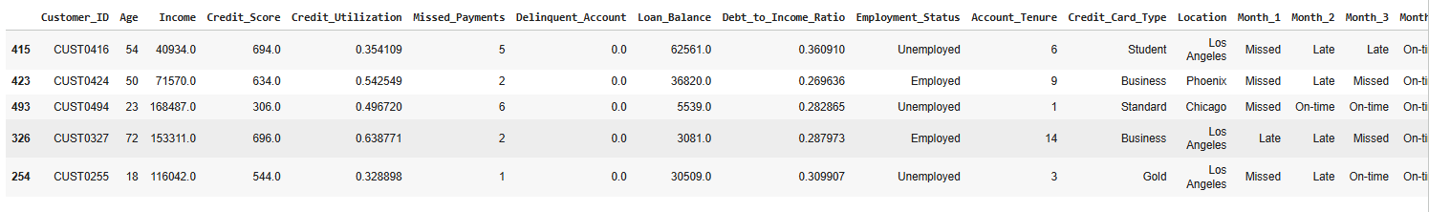
data.describe()

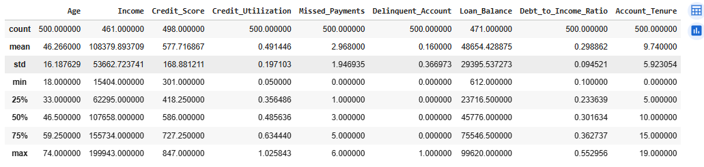
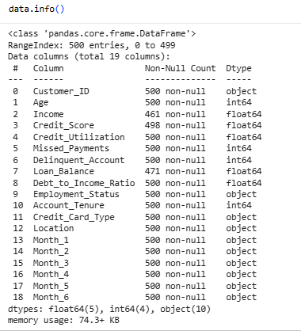
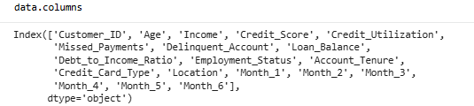
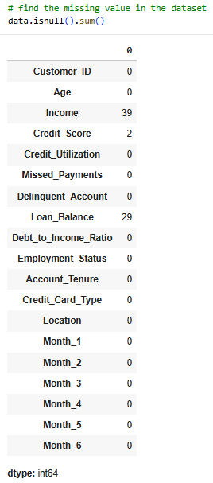
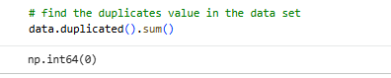

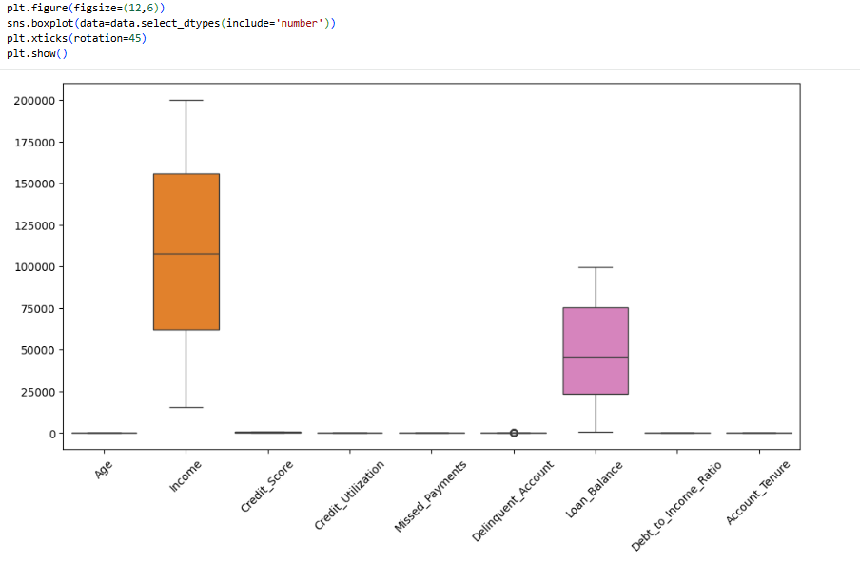
import numpy as np

Q1 = data['Delinquent_Account'].quantile(0.25)
Q3 = data['Delinquent_Account'].quantile(0.75)
IQR = Q3 - Q1
upper_limit = Q3 + 1.5 * IQR

data['Delinquent_Account'] = np.where(
data['Delinquent_Account'] > upper_limit,
upper_limit,
data['Delinquent_Account']
)

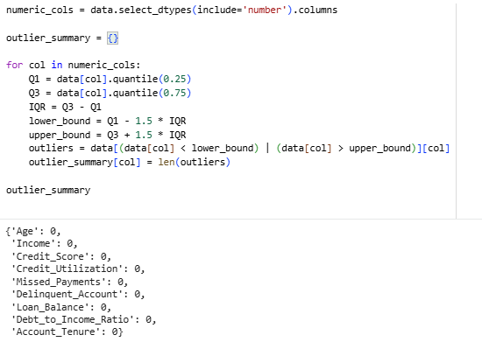

for col in data.select_dtypes(include="number").columns:
plt.figure(figsize=(5,3))
sns.histplot(data[col], kde=True)
plt.title(f"Distribution of {col}")
plt.show()

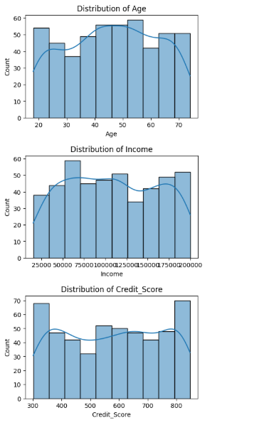 | 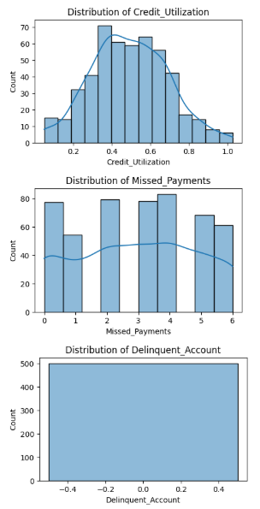 | 