**ATOMIC HABITS**

**Understanding the meaning of ‘HABITS’ and its significance:**

Meaning

* A routine or practice performed regularly.
* An automatic response to a specific situation.
* Mental shortcuts learned from experience.
* Habits are, simply, reliable solutions to recurring problems in our environment.

Significance

* Building Habits will automate the fundamentals of life and will create the mental space needed for free thinking and creativity.
* Building habits in the present allows you to do more of what you want in the future.

Points made by the author to Remember

* **Search for tiny improvements in everything you do**. Break down everything you can think of doing a task, and then improve it by 1% every day. Improving 1% every day will end up 37 times better by the time you are done.
* Focus on the **system** (of continuous small improvements) instead of setting goals.
* Make habits a **part of your identity.**
* It’s hard to change your habits if you never change the underlying beliefs that led to your previous behavior.
* It is one thing to say that I am a person who **wants this**. It is something very different to say I am the type of person **who is this.**

**E.g.:** One of the smokers after quitting smoking says **I am trying to quit** when a cigarette was offered to him**,** whereas the other person who also quitted to smoke said **I am not a smoker.** It is a small difference, but this statement signals a shift in identity, whereas, the first one still believes that he is a smoker who is trying to be someone else.

* Be proud about a particular aspect of your identity as it will keep you motivated to maintain the habits associated with it.

**E.g.:** If you are proud of how your hair looks, you will develop all sorts of habits to care for and maintain it. If you are proud of your biceps, you’ll make sure you never skip an upper-body workout.

* Your identity is your “repeated beingness.”
* A new identity requires new evidence.
* Decide the type of person you want to be and then prove it to yourself with small wins.
* Ask yourself, “Who is the type of person that could get the outcome I want.”

**1st LAW -> MAKING IT OBVIOUS**

* IMPLEMENTATION INTENTIONS
* HABIT STACKING
* **CUE**

Point and call what kind of habits you should not follow and what to do instead.

**IMPLEMENT INTENTIONS:–**

I will [Behavior] at [Time] in [location]

**HABIT STACKING:-**

**Tie your desired behavior into something you already do each day.**

E.g.: Wake up > **Make my bed** > Brush > **Workout** > **Take a shower** > Breakfast

INSERT A HABIT IN BETWEEN OF THE TWO.

* **(On the left)** Write down all the habits you do each day without fail.
* **(On the right)** Write down all the things that happen to you each day.
* Find the best place to layer your new habit into a lifestyle.
* More tightly you bond your new habits to a specific clue, the better the odds are that you will notice when the time come to act.
* Your habits will change depending on the room you are in and the **cues that are in front of you.**
* Behavior is a function of the person in your environment. **B = f (P, E)**
* **Live and work** in the environments that are **filled with productive cues** and devoid of unproductive ones.
* Keep the cues **in front of your eyes.**

**Guitar 🡪** in the middle of the room

**Water 🡪** fill water bottles in the morning and place it in common locations of the house.

* **SPRINKLE TRIGGERS THROUGHOUT YOUR SURROUNDINGS TO INCREASE THE ODDS THAT YOU WILL THINK ABOUT YOUR HABITS THROUGHOUT THE DAY.**
* Start thinking about your environment as filled with relationships not with objects.

BED 🡪 SLEEP

COUCH 🡪 TV

DINING TABLE 🡪 MEAL

**(One space one rule) 🡪 Create a separate space for work, study, exercise, entertainment. Every habit should have a home.**

**Table for work, kitchen for cooking, phone for social media.**

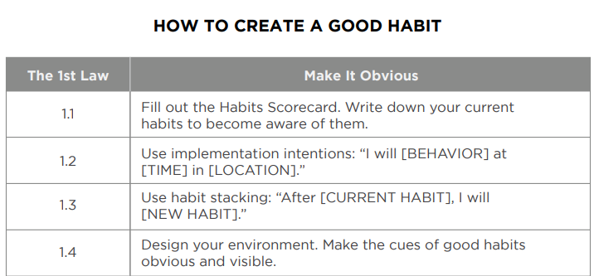

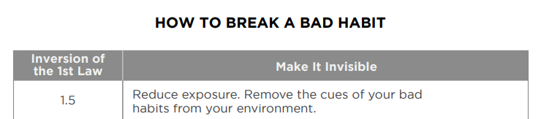

**2nd LAW -> MAKE IT ATTRACTIVE**

* USE OF TEMPTATION BUNDLING. Pair an action you want to do with an action you need to do.
* Join a culture where your desired behavior is a normal behavior.
* Create a motivation ritual. Do something you enjoy immediately before a difficult habit.
* Reframe your mind-set. Highlight the benefits of avoiding your bad habits.

**3rd LAW -> MAKE IT EASY**

