Connecting GitHub and Matrix Account/Linux/Mac

Step 1:

**Generating a Key**



**Command -** ssh-keygen -t ed25519 -C “divyu2004@gmail.com” (inside the “use you GitHub accounts email id”)



Enter file in which to save the key (/home/ddugar/.ssh/id_ed25519): /home/ddugar/.ssh/id_2

**NOTE -** By default, it is going to store your key in the folder name id_ed25519, you can change the folder name as per your wish (like I kept my folder name as id_2)

Step 2:

**Adding a passphrase (password)**



**NOTE -** The password you enter will not be visible

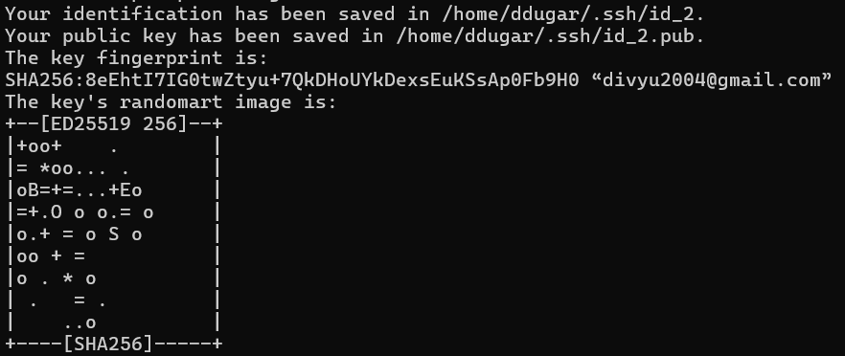

Step 3:

The key will get generated – now we have to add this key to our identity, for that we have to first start our ssh-agent in the background



**Command -** eval “$(ssh-agent -s)”

As soon as we do this, we will get a program ID (PID)

Step 4:

Adding the identity



**Command -** ssh-add /home/ddugar/.ssh/id_2

Step 5:

Now we have the identity so we have to put this identity on GitHub

For this 1st we have to go to the directory where we have stored our key



**NOTE –** Ignore the 2 .pub keys in my repository (I have keys for 2 GitHub accounts)

Add the public key to your GitHub by going under SSH and GPG keys option and you are all set!