Observations

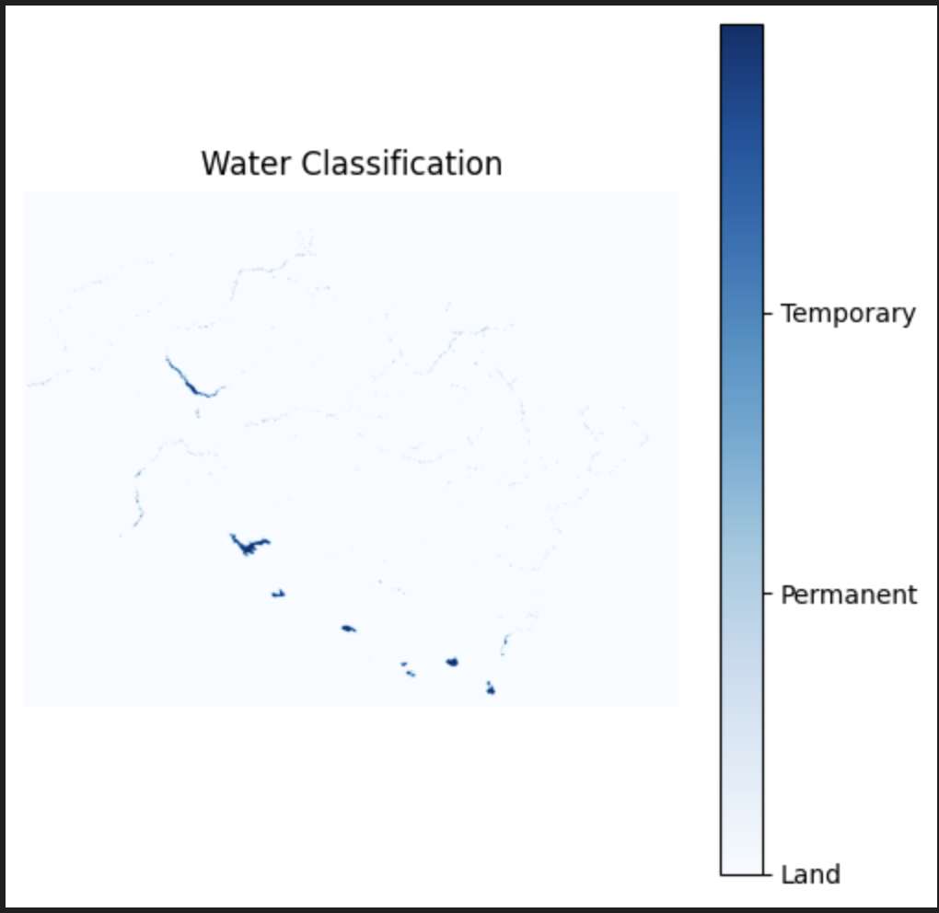

Figure 1 : Water Classification Of Uttarakhand for November 2022.

Observations :

1. Northern Region has more Permanent Water Region than Southern Region.
2. Southern Region has more Temporary Water Region than Northern Region.
3. More Area under Permanent Water Bodies than Temporary Water Bodies in Uttarakhand Region.

**For Whole Uttarakhand Region**

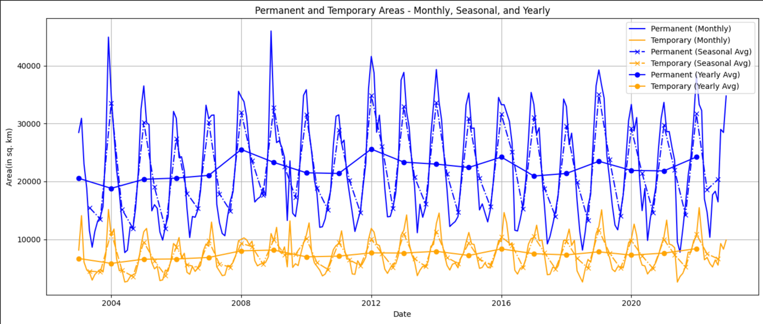

Figure 2: For whole Uttarakhand Region

Scale X-Axis: 0 corresponds to January 2003 and 240 corresponds December 2022

Y-Axis: 1 unit corresponds 10,000 sq m.

Observations:

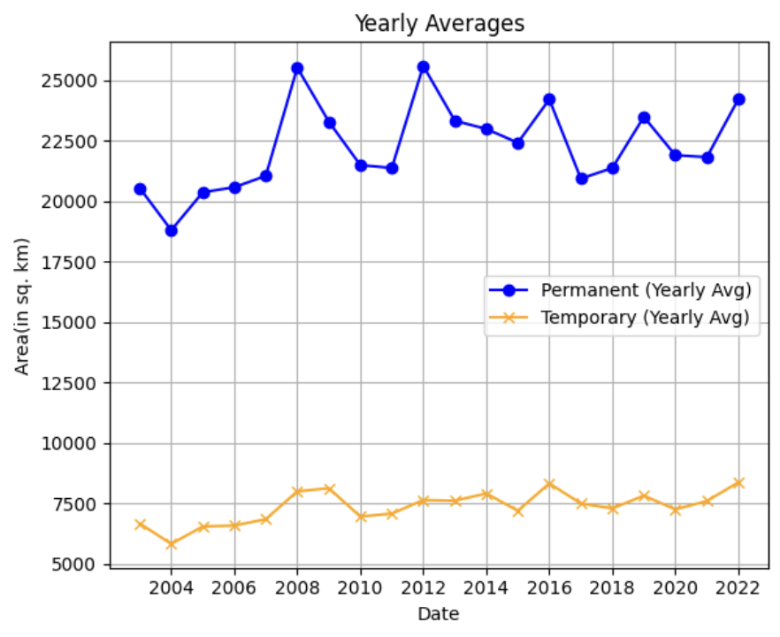

Figure 3: Area vs Year For whole Uttarakhand Region

Yearly:

1. The trend is periodic for both temporary and Permanent Water Bodies for yearly plots.
2. More Area is covered by Permanent Water Bodies (22,000 Units) than temporary water bodies (6,500 Units).
3. Yearly Averages for both water types nearly constant (Temporary Water Bodies –6,500 units and Permanent Water Bodies – 22,000 units).

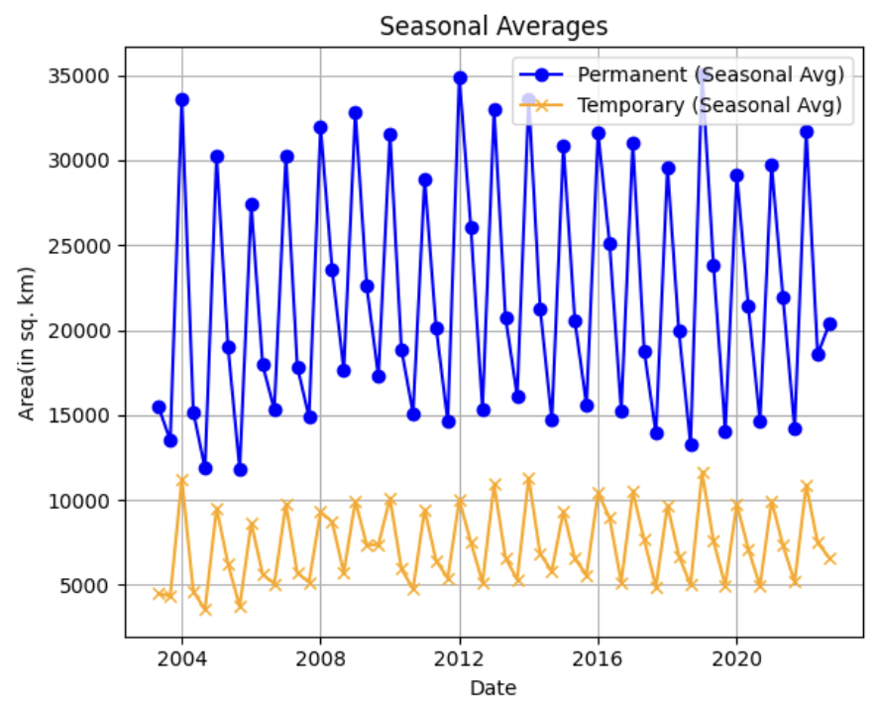

Figure 4: Area vs Season For whole Uttarakhand Region

Seasonally:

1. The trend is periodic for both temporary and Permanent Water Bodies for Seasonal plots with dips in the dry season followed by peaks in the monsoon months.
2. More Area is covered by Permanent Water Bodies (22,000 Units) than temporary water bodies (6,500 Units).

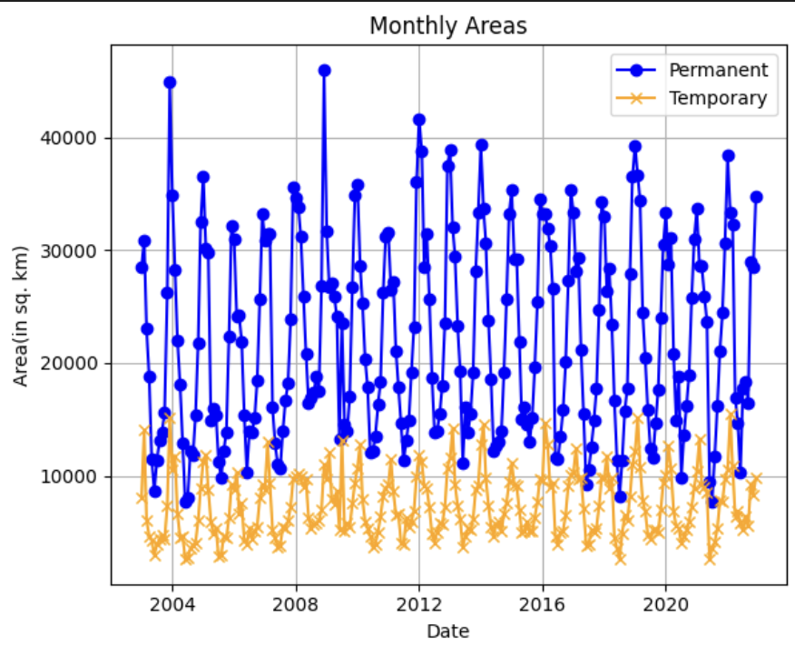

Figure 5: Area vs Month For whole Uttarakhand Region

Monthly:

1. The trend is periodic for both temporary and Permanent Water Bodies for Monthly plots.
2. More Area is covered by Permanent Water Bodies (22,000 Units) than temporary water bodies (6,500 Units).

**For Northern Uttarakhand Region**

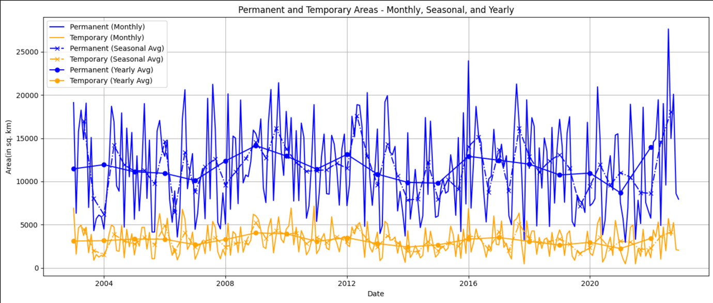

Figure 6: for Northern Uttarakhand Region

Scale X-Axis: 0 corresponds to January 2003 and 240 corresponds December 2022

Y-Axis: 1 unit corresponds 10,000 sq m.

Observations:

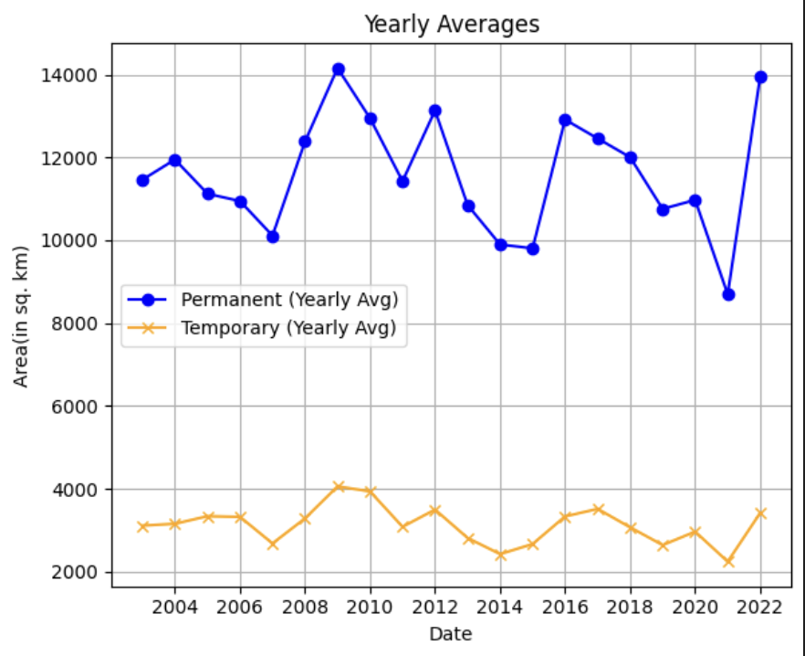

Figure 7: Area vs Year for Northern Uttarakhand Region

Yearly:

1. The trend is periodic for both temporary and Permanent Water Bodies for yearly plots.
2. More Area is covered by Permanent Water Bodies (11,500 Units) than temporary water bodies (3,000 Units).
3. Yearly Averages for both water types nearly constant (Temporary Water Bodies – 3,000 units and Permanent Water Bodies – 11,500 units).

Figure 8: Area vs Season for Northern Uttarakhand Region

Seasonally:

1. The trend is periodic for both temporary and Permanent Water Bodies for Seasonally plots.
2. More Area is covered by Permanent Water Bodies (11,500 Units) than temporary water bodies (3,000 Units).

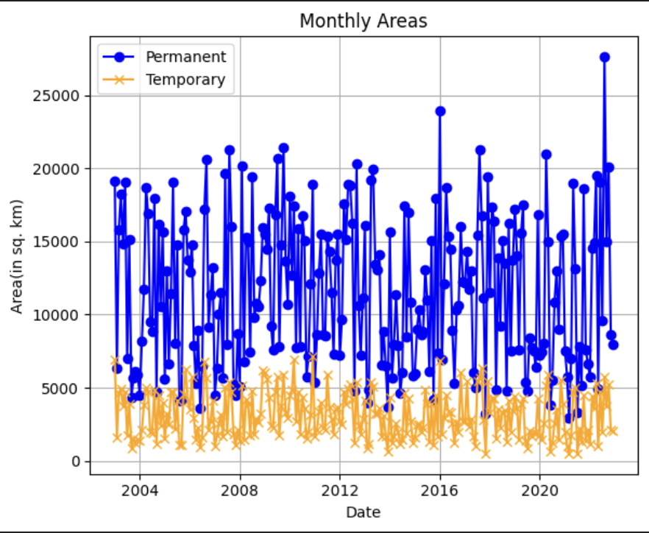

Figure 9: Area vs Month for Northern Uttarakhand Region

Monthly:

1. The trend is periodic for both temporary and Permanent Water Bodies for Monthly plots.
2. More Area is covered by Permanent Water Bodies (11,500 Units) than temporary water bodies (3,000 Units).

**For Southern Uttarakhand Region**

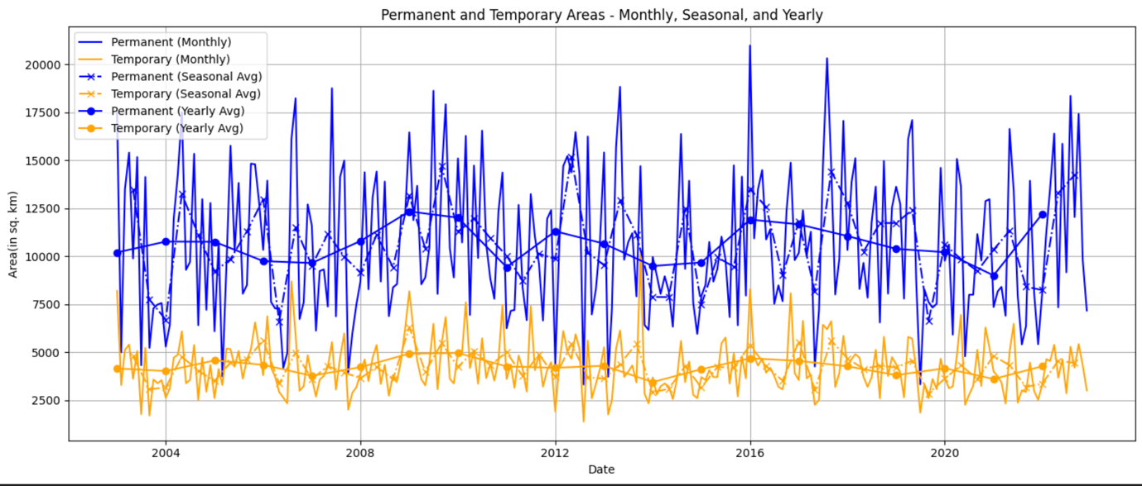

Figure 10: for Southern Uttarakhand Region

Scale X-Axis: 0 corresponds to January 2003 and 240 corresponds December 2022

Y-Axis: 1 unit corresponds 10,000 sq m.

Observations:

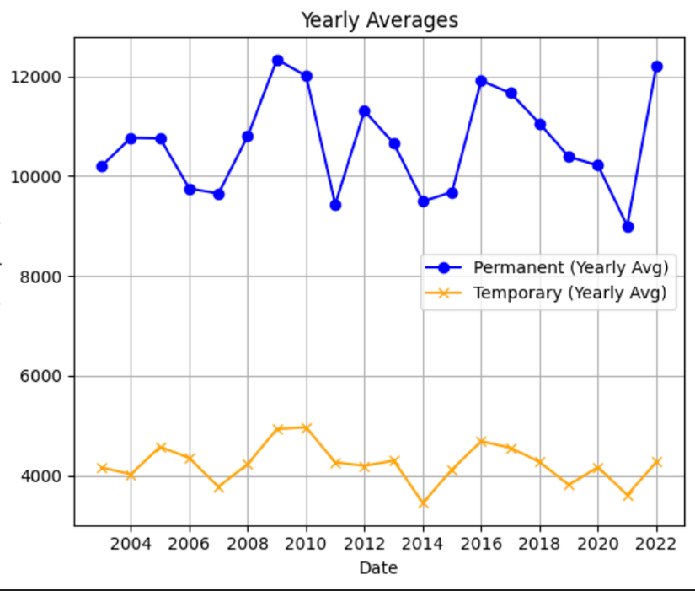

Figure 11: Area vs Year for Southern Uttarakhand Region

Yearly:

1. The trend is periodic for both temporary and Permanent Water Bodies for yearly plots.
2. More Area is covered by Permanent Water Bodies (10,500 Units) than temporary water bodies (3,500 Units).
3. Yearly Averages for both water types nearly constant (Temporary Water Bodies – 3,500 units and Permanent Water Bodies – 10,500 units).

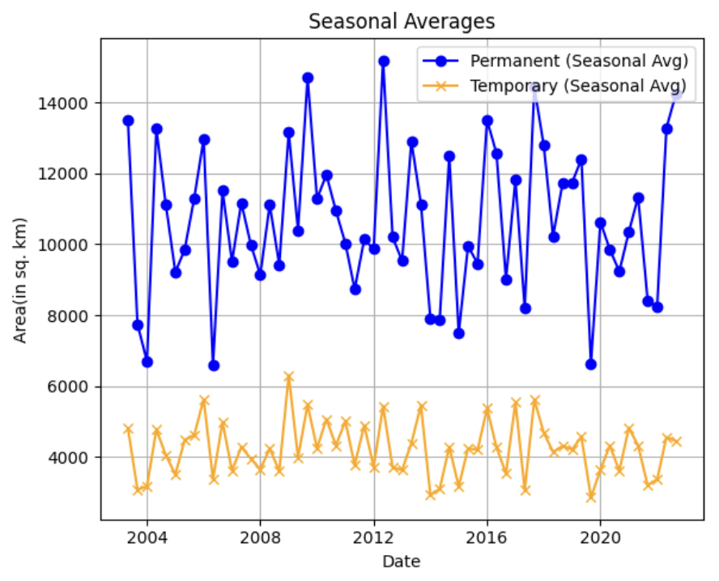

Figure 12: Area vs Season for Southern Uttarakhand Region

Seasonally:

1. The trend is periodic for both temporary and Permanent Water Bodies for Seasonally plots.
2. More Area is covered by Permanent Water Bodies (10,500 Units) than temporary water bodies (3,500 Units).

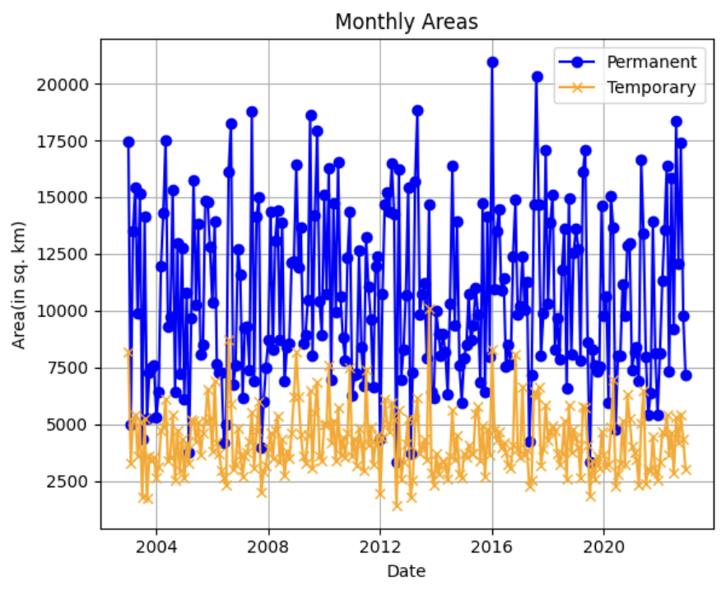

Figure 13: Area vs Month for Southern Uttarakhand Region

Monthly:

1. The trend is periodic for both temporary and Permanent Water Bodies for Monthly plots.
2. More Area is covered by Permanent Water Bodies (10,500 Units) than temporary water bodies (3,500 Units).

Comparative study:

Yearly:

1. Total yearly Average water area increases gradually with few spikes. (Fig 3)
2. Northern Region has more Permanent Water Area than Southern Region averaged yearly. (Fig 7)
3. Southern Region has more Temporary Water Region than Northern Region averaged yearly. (Fig 11)

Seasonally:

1. Northern Region has more Permanent Water Region than Southern Region Seasonally Plot. (Fig 8)
2. Southern Region has more Temporary Water Region than Northern Region Seasonally Plot. (Fig 12)

Monthly:

1. Northern Region has more Permanent Water Region than Southern Region Monthly Plot. (Fig 9)
2. Southern Region has more Temporary Water Region than Northern Region Monthly Plot. (Fig 13)
3. The peak in Fig 6 corresponds to North Uttarakhand Flood, June 2013 affecting most areas in the Northern Region (Fig 8), and we can observe it as the highest peak in Fig 6.

**Dataset**: We have used 250m resolution Modis dataset. The **MODIS 250m dataset** is a widely used remote sensing product from NASA's **Moderate Resolution Imaging Spectroradiometer (MODIS)** sensors aboard the Terra and Aqua satellites.