Normalization

**What is Normalization?**

Normalization is a process to organizes the data in a database. It has features like creating tables and establishing connection between those table with scenario to protect the data and to make the more flexible.

Normalization helps to make a database more flexible and protect data. It also helps to reduce the risk of data modification error and simplify queries.

Normalization can improve workflow, increase security, and reduce costs. For example, it’s easier to implement a customer address change address change if the data is stored in only one place.

The Type of Normal Forms:

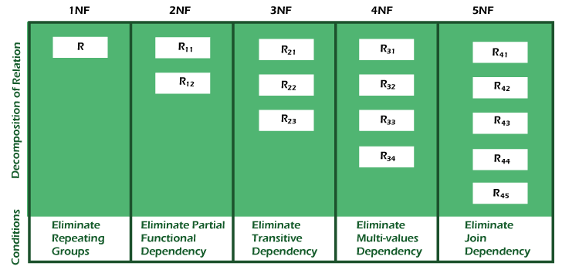

**1NF (First Normal Form):**

A relation is in 1NF if it contains an atomic value.

**2NF (Second Normal Form):**

A relation will be in 2NF if it is in 1NF and all non-key attributes are fully functional dependent on the primary key.

**3NF (Third Normal Form):**

A relation will be in 3NF if it is in 2NF and no transition dependency exists.

**BCNF (Boyce-codd Normal Form):**

A stronger definition of 3NF if knows as Boyce Codd’s normal form.

**4NF (Forth Normal Form):**

A relation will be in 4NF if it is in Boyce Codd’s normal form and has no multivalued dependency.

**5NF (Fifth Normal Form):**

A relation is in 5NF. If it is in 4NF and does not contain any join dependency, joining should be lossless.

**Advantages of Normalization:**

* Normalization helps to minimize data redundancy.
* Greater overall database organization.
* Data consistency within the database.
* Much more flexible database design.
* Enforces the concept of relational integrity.

**Disadvantages of Normalization:**

* You cannot start building the database before knowing what the user needs.
* The performance degrades when normalizing the connection to higher normal forms, in 4NF, 5NF.
* It is very time-consuming and difficult to normalize connection of a higher degree.
* Careless decomposition may lead to a bad database design, leading to serious problems.