Full Stack Development with MERN

Database Design and Development Report

Date: 15/04/2025

Team ID: SWTID1742901502

Project Name: NEXUS Social Media Platform

Maximum Marks: —

# Project Title: Book a Doctor Platform

Date: 15/04/2025

Prepared by: SWTID1742901502

# Objective

The objective of this report is to outline the database design and implementation details for the NEXUS Social Media Platform project, including schema modeling and database integration using MongoDB Atlas.

# Technologies Used

• Database Management System (DBMS): MongoDB Atlas  
• Object-Document Mapper (ODM): Mongoose

# Design the Database Schema

**1. Users**

* **Attributes:**
  + **name**: { type: String, required: true }
  + **email**: { type: String, required: true, unique: true }
  + **password**: { type: String, required: true }
  + **role**: { type: String, enum: ['user', 'admin'], default: 'user' }
  + **profilePicture**: { type: String, default: 'default.jpg' }
  + **bio**: { type: String, default: '' } // Short user bio
  + **createdAt**: { type: Date, default: Date.now }
  + **updatedAt**: { type: Date, default: Date.now }

**2. Posts**

* **Attributes:**
  + **userId**: { type: ObjectId, ref: 'User ', required: true }
  + **content**: { type: String, required: true }
  + **image**: { type: String, default: '' }
  + **createdAt**: { type: Date, default: Date.now }
  + **updatedAt**: { type: Date, default: Date.now }

**3. Comments**

* **Attributes:**
  + **postId**: { type: ObjectId, ref: 'Post', required: true }
  + **userId**: { type: ObjectId, ref: 'User ', required: true }
  + **content**: { type: String, required: true }
  + **createdAt**: { type: Date, default: Date.now }
  + **updatedAt**: { type: Date, default: Date.now }

**4. Likes**

* **Attributes:**
  + **postId**: { type: ObjectId, ref: 'Post', required: true }
  + **userId**: { type: ObjectId, ref: 'User ', required: true }
  + **createdAt**: { type: Date, default: Date.now }

# Implemented Collections using MongoDB Atlas

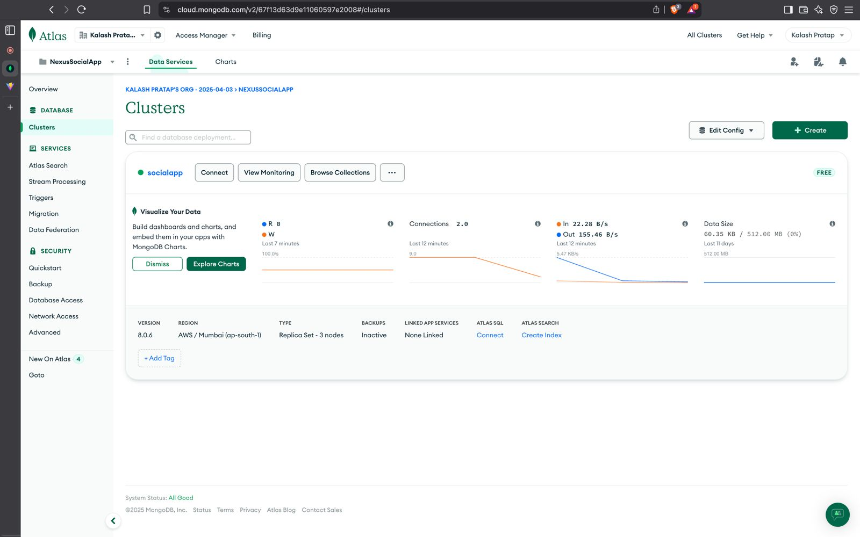

Database Name: book-a-doctor

1. Collection: users  
 Schema:-  
{

_id: ObjectId,

name: String,

email: String,

password: String,

role: String,

profilePicture: String,

bio: String,

createdAt: Date,

updatedAt: Date

}

2. Collection: posts  
Schema:-  
{

_id: ObjectId,

userId: ObjectId,

content: String,

image: String,

createdAt: Date,

updatedAt: Date

}

3.Collection: comments

Schema:-

{

_id: ObjectId,

postId: ObjectId,

userId: ObjectId,

content: String,

createdAt: Date,

updatedAt: Date

}

4. Collection: likes

Schema:-

{

_id: ObjectId,

postId: ObjectId,

userId: ObjectId,

createdAt: Date

}

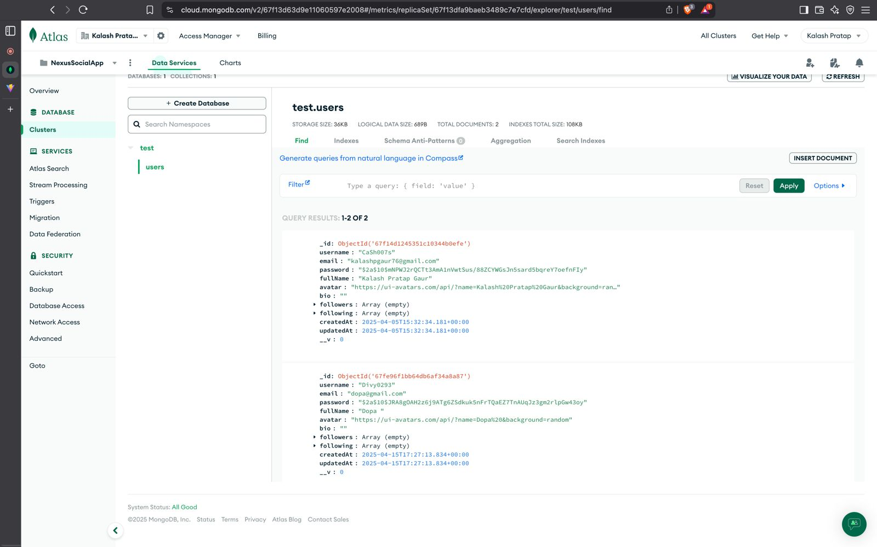

# Integration with Backend

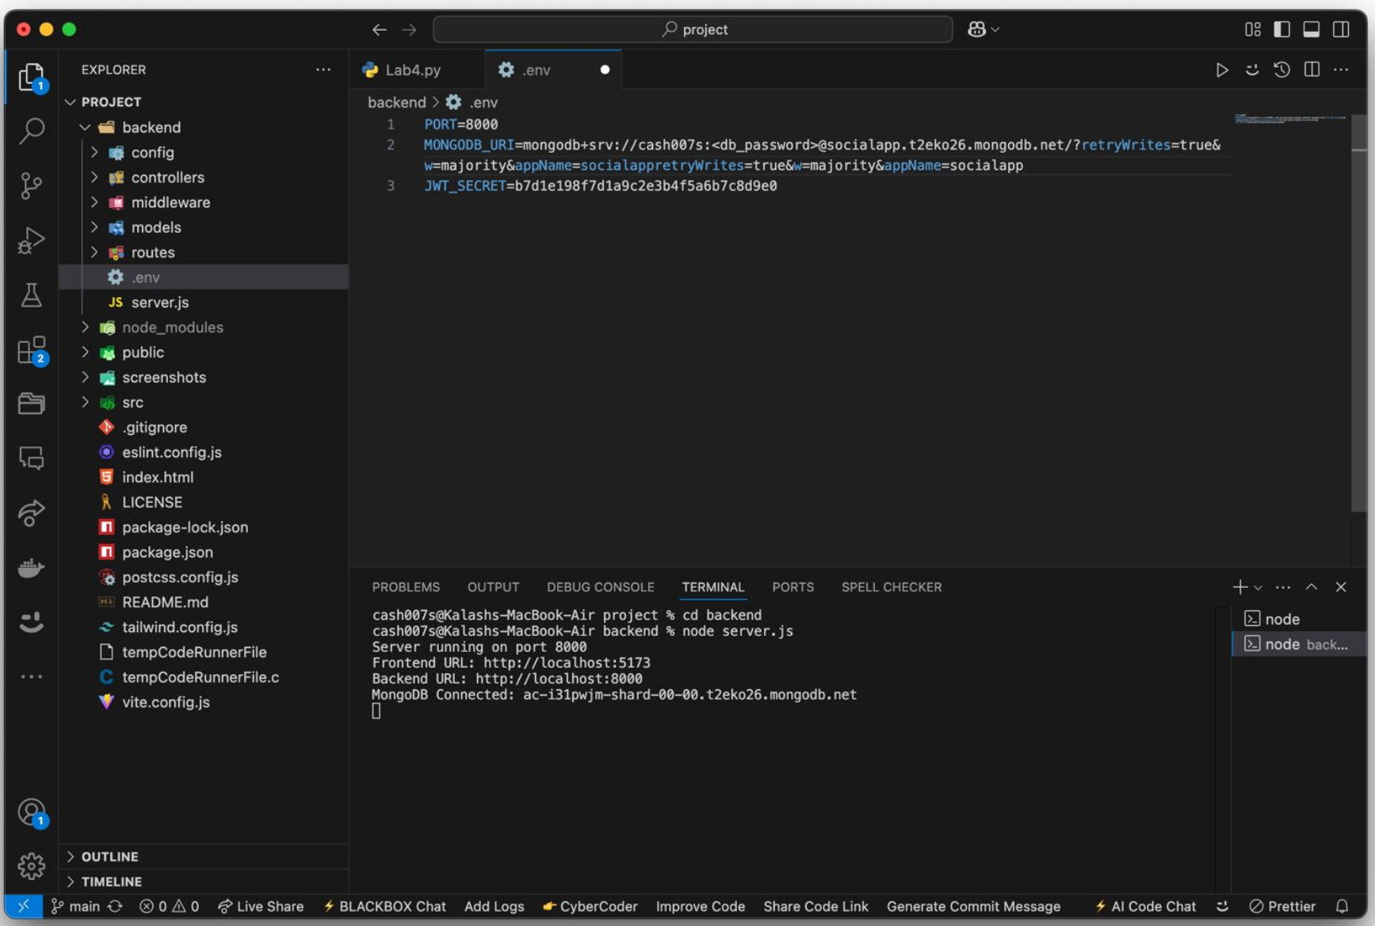

The backend communicates with MongoDB Atlas using Mongoose. Key operations include CRUD operations for users and appointments.

* User Registration :

const user = await User.findOne({ email: req.body.email });

if (!user) {

const newUser = new User(req.body);

await newUser .save();

res.status(201).json({ success: 'User created successfully' });

} else {

res.status(409).json({ success: 'Email already exists' });

}

* Post Creation

const newPost = new Post(req.body);

await newPost.save();

res.status(201).json({ success: 'Post created successfully' });

* Comment Posting:

const newComment = new Comment(req.body);

await newComment.save();

res.status(201).json({ success: 'Comment added successfully' });