**1. ReactJS-HOL**

**Installing create react app:**

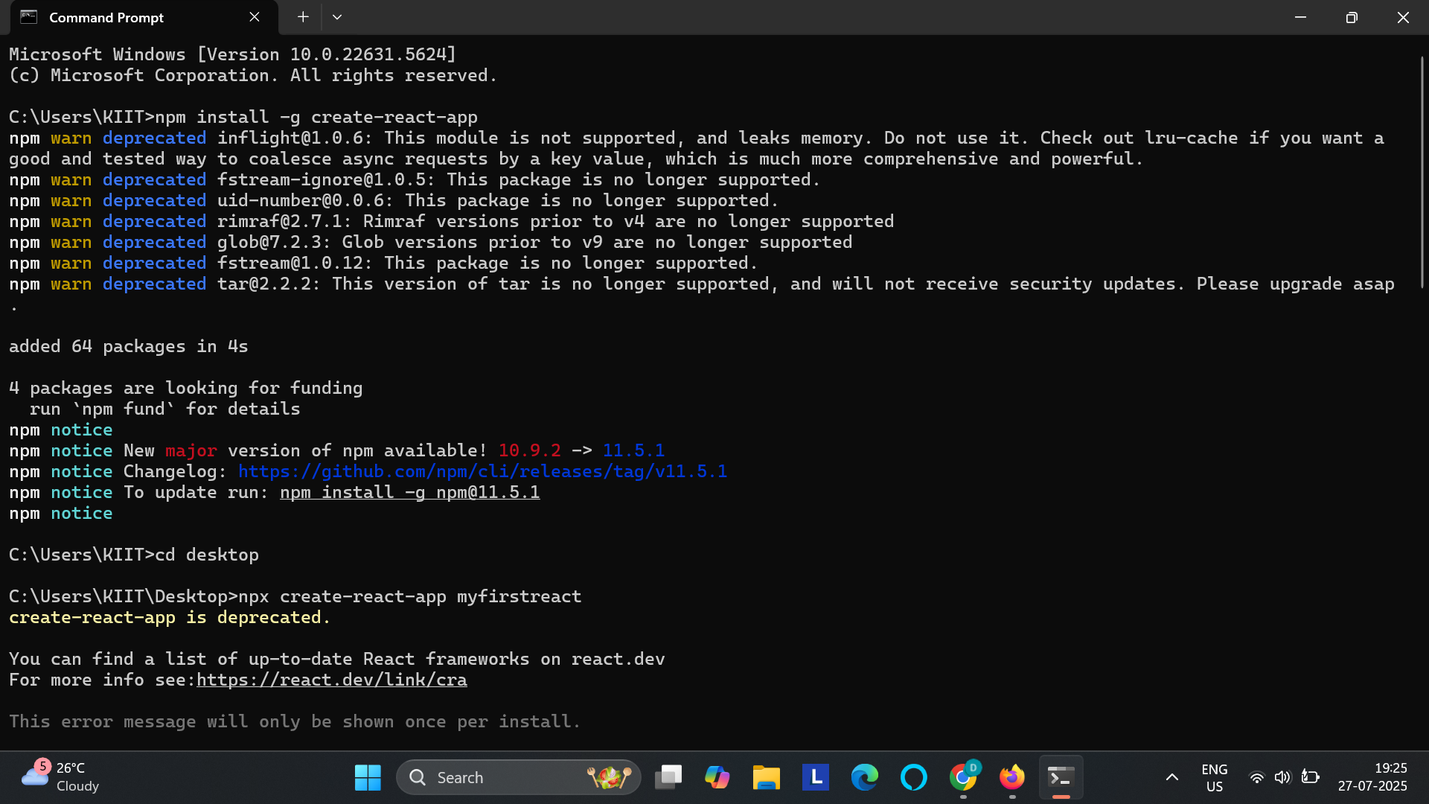

**Creating react application:**

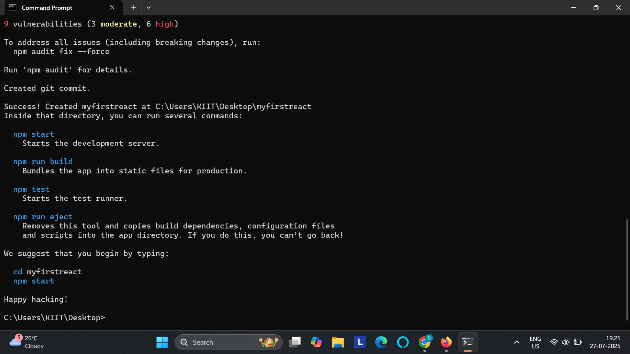

**Code:**

import React from "react";

function App(){

return(

<h1>Welcome to the first session of react</h1>

);

}

export default App;

**Output:**

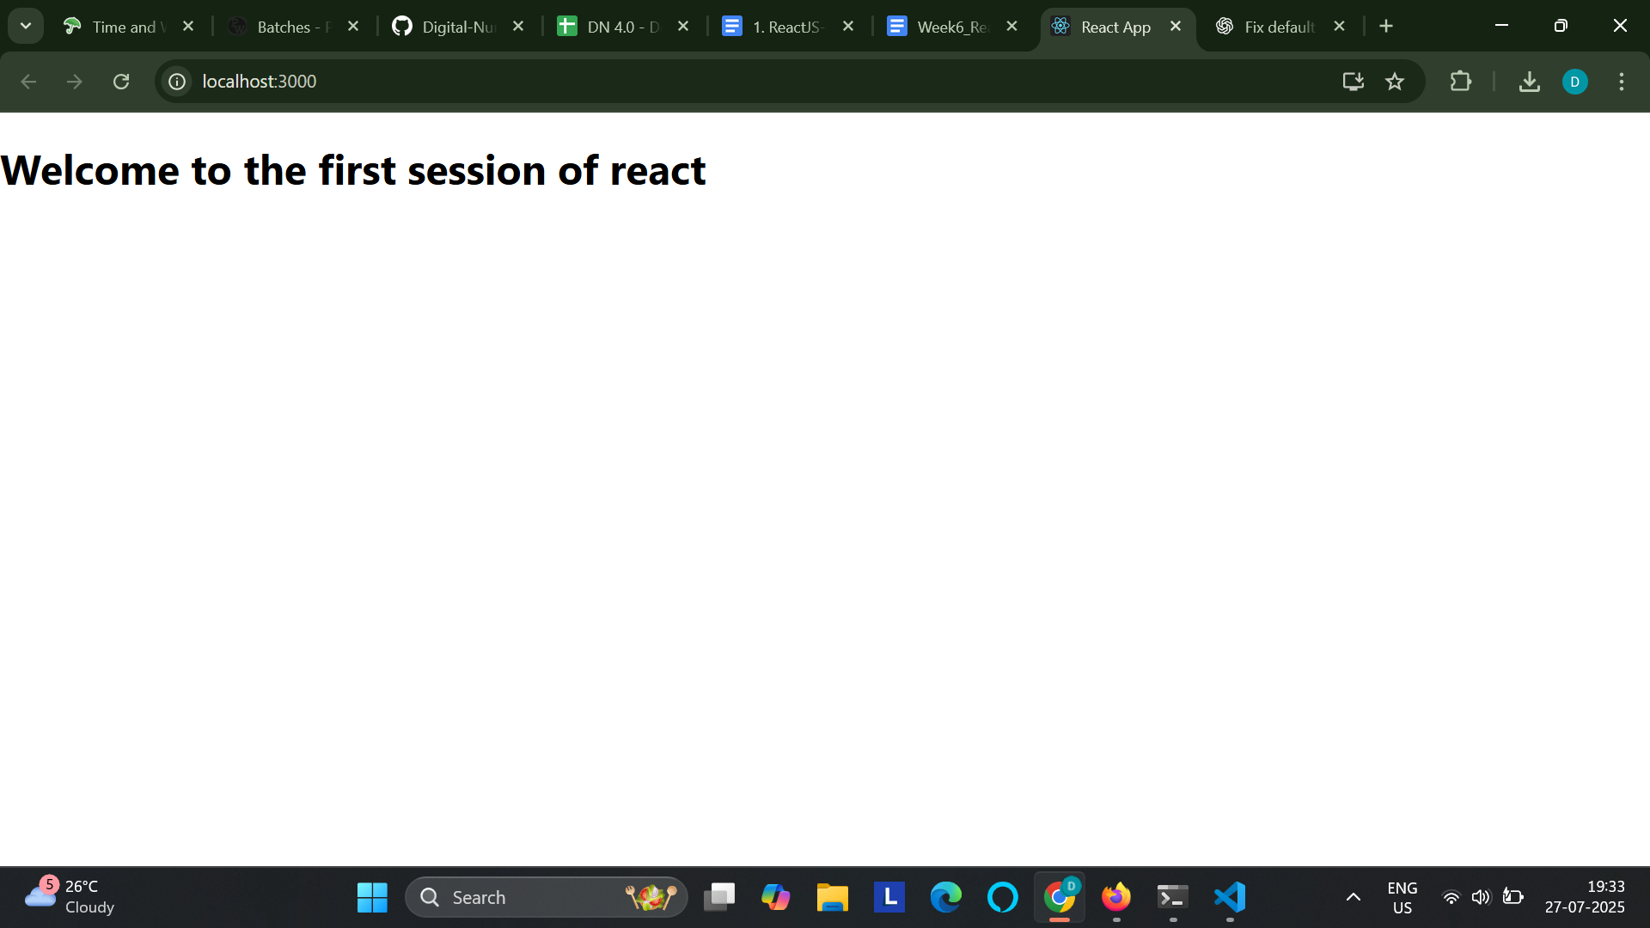

**2. ReactJS-HOL**

**Code:**

[Home.js](http://home.js)

import React, { Component } from 'react';

class Home extends Component {

render() {

return (

<div>

<h3>Welcome to the home page of student management portal</h3>

</div>

);

}

}

export default Home;

[About.js](http://about.js)

import React, { Component } from 'react';

class About extends Component {

render() {

return (

<div>

<h3>Welcome to the about page of student management portal</h3>

</div>

);

}

}

export default About;

[Contact.js](http://contact.js)

import React, { Component } from 'react';

class Contact extends Component {

render() {

return (

<div>

<h3>Welcome to the contact page of student management portal</h3>

</div>

);

}

}

export default Contact;

[App.js](http://app.js)

import logo from './logo.svg';

import './App.css';

import Home from './Components/Home';

import Contact from './Components/Contact';

import About from './Components/About';

function App() {

return (

<div className="container">

<Home />

<About />

<Contact />

</div>

);

}

export default App;

**Output:**

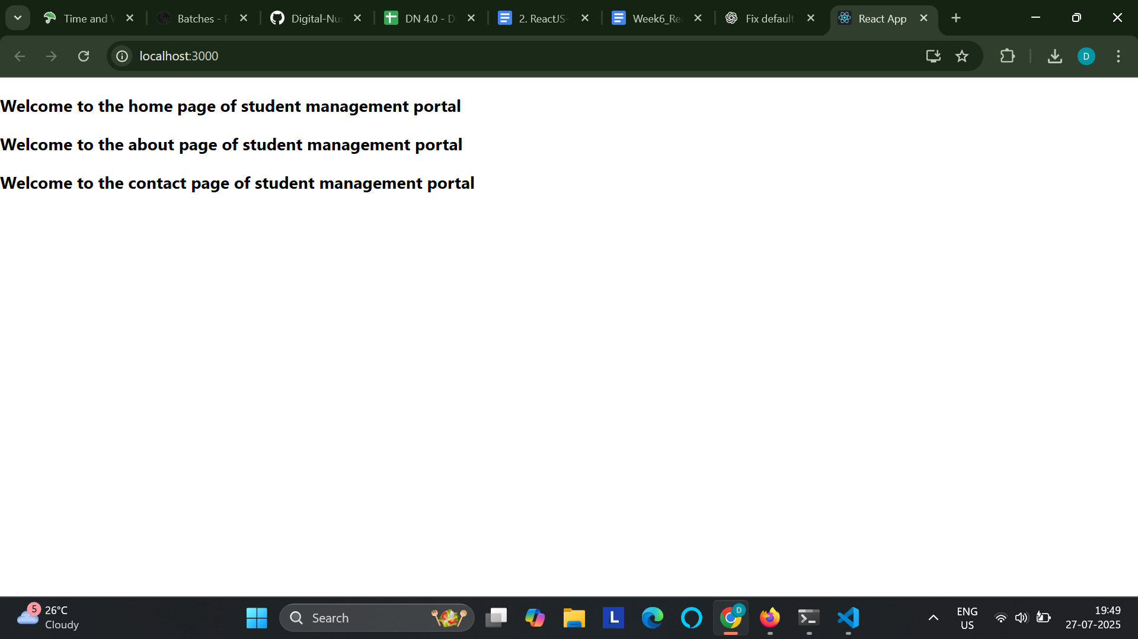

**3. ReactJS-HOL**

**Code:**

[CalculateScore.js](http://calculatescore.js)

import '../stylesheets/mystyles.css';

const percentToDecimal = (decimal) => {

return (decimal * 100).toFixed(2) + '%';

};

const calcScore = (total, goal) => {

return percentToDecimal(total / goal);

};

export const CalculateScore = ({ Name, School, total, goal }) => {

return (

<div className="formatStyle">

<h1 style={{ color: 'brown' }}>Student Details:</h1>

<div className="Name">

<b>Name:</b> <span>{Name}</span>

</div>

<div className="School">

<b>School:</b> <span>{School}</span>

</div>

<div className="Total">

<b>Total:</b> <span>{total}</span> <span>Marks</span>

</div>

<div className="Score">

<b>Score:</b> <span>{calcScore(total, goal)}</span>

</div>

</div>

);

};

[App.js](http://app.js)

import logo from './logo.svg';

import './App.css';

import { CalculateScore } from './Components/CalculateScore';

function App() {

return (

<div className="container">

<CalculateScore Name={"Steeve"} School={"DNV Public School"} total={283} goal={3} />

</div>

);

}

export default App;

Mystyles.css

.Name{

font-weight: 300;

color: blue;

}

.School{

color: crimson;

}

.Total{

color: darkmagenta;

}

.formatStyle{

text-align: center;

font-size: large;

}

.Score{

color: forestgreen;

}

**Output:**

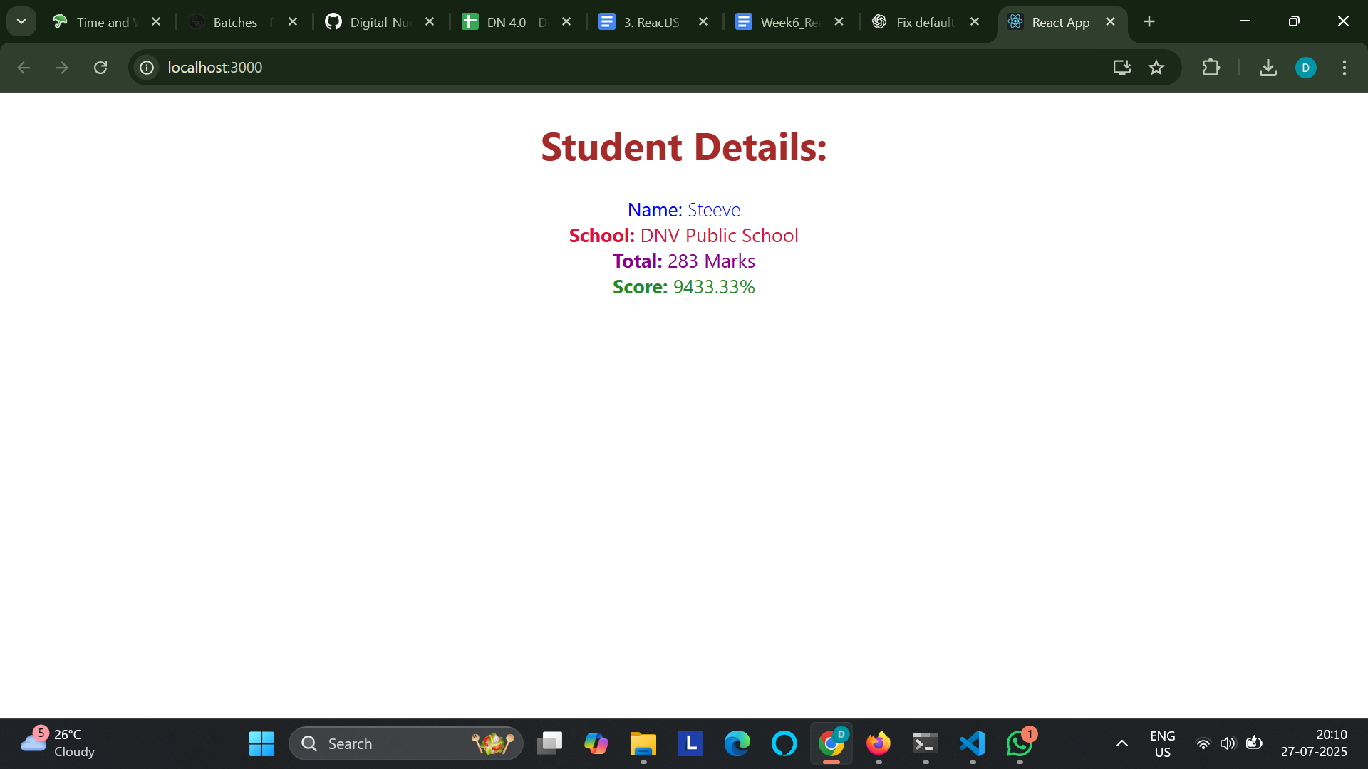

**4. ReactJS-HOL**

**Code:**

[Post.js](http://post.js)

import React from 'react';

const Post = ({ title, body }) => {

return (

<div className="post">

<h2>{title}</h2>

<p>{body}</p>

</div>

);

};

export default Post;

[Posts.js](http://posts.js)

import React, { Component } from 'react';

import Post from './Post';

class Posts extends Component {

constructor(props) {

super(props);

this.state = {

posts: [],

hasError: false

};

}

loadPosts = () => {

fetch('https://jsonplaceholder.typicode.com/posts')

.then(response => response.json())

.then(data => this.setState({ posts: data }))

.catch(error => {

console.error("Error fetching posts:", error);

this.setState({ hasError: true });

});

};

componentDidMount() {

this.loadPosts();

}

componentDidCatch(error, info) {

alert("An error occurred while rendering the posts.");

console.error("Caught error:", error, info);

}

render() {

const { posts, hasError } = this.state;

if (hasError) {

return <h2>Something went wrong while loading posts.</h2>;

}

return (

<div>

<h1>Blog Posts</h1>

{posts.map(post => (

<Post key={post.id} title={post.title} body={post.body} />

))}

</div>

);

}

}

export default Posts;

[App.js](http://app.js)

import React from 'react';

import Posts from './Posts';

function App() {

return (

<div className="App">

<Posts />

</div>

);

}

export default App;

**Output:**

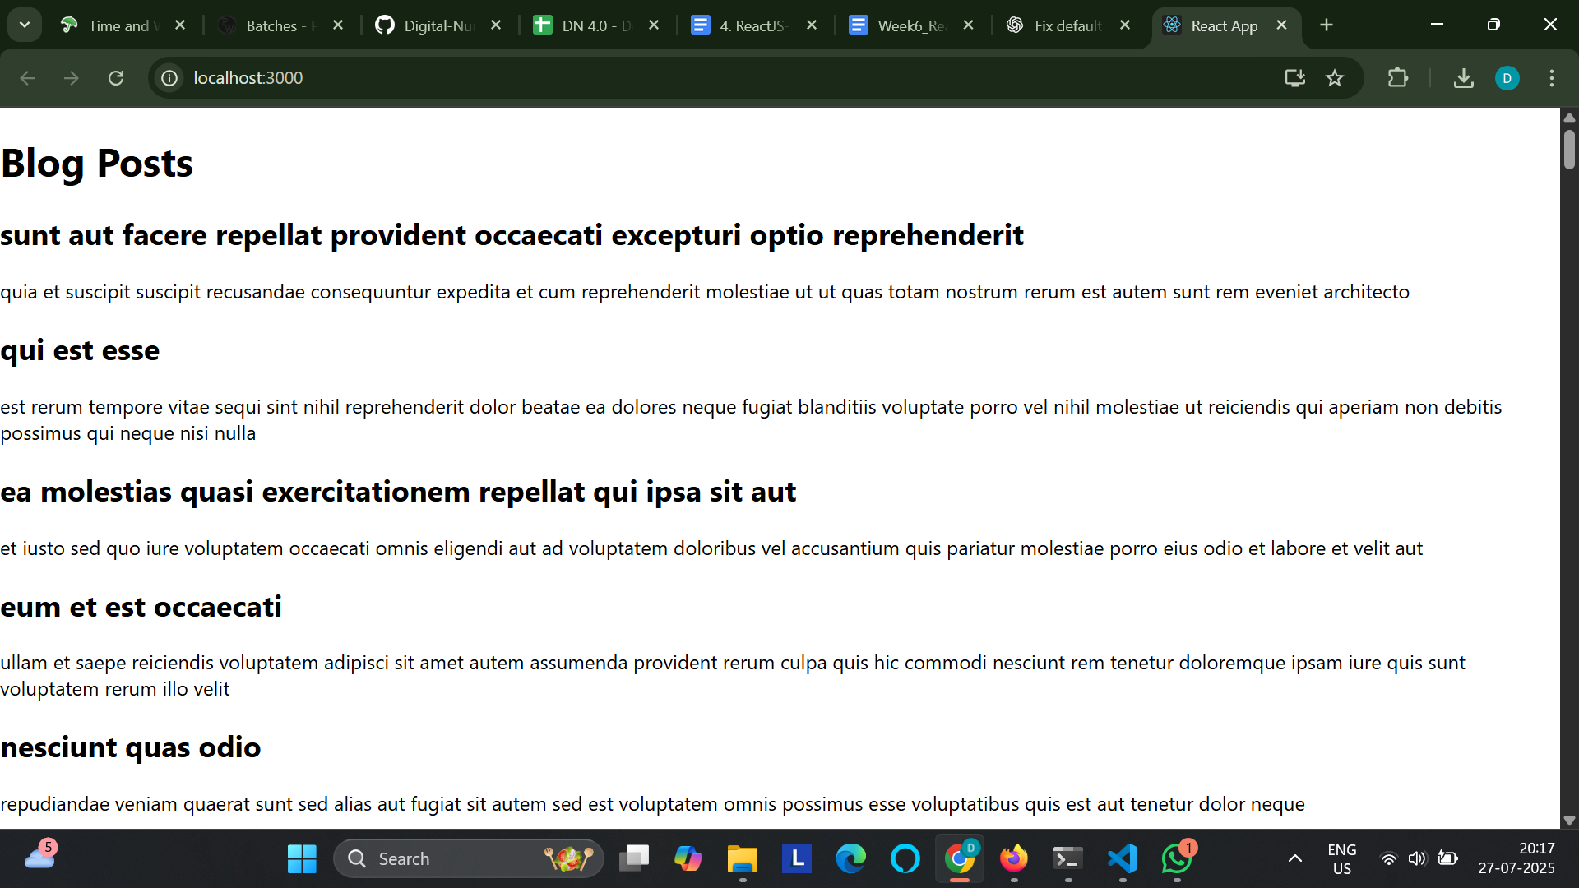

**5. ReactJS-HOL**

**Code:**

CohortDetails.module.css

.box {

width: 300px;

display: inline-block;

margin: 10px;

padding: 10px 20px;

border: 1px solid black;

border-radius: 10px;

}

dt {

font-weight: 500;

}

.green {

color: green;

}

.blue {

color: blue;

}

[CohortDetails.js](http://cohortdetails.js)

import React from 'react';

import styles from './CohortDetails.module.css';

function CohortDetails(props) {

const { cohort } = props;

const headingClass = cohort.currentStatus.toLowerCase() === 'ongoing'

? styles.green

: styles.blue;

return (

<div className={styles.box}>

<h3 className={headingClass}>

{cohort.cohortCode} - <span>{cohort.technology}</span>

</h3>

<dl>

<dt>Started On</dt>

<dd>{cohort.startDate}</dd>

<dt>Current Status</dt>

<dd>{cohort.currentStatus}</dd>

<dt>Coach</dt>

<dd>{cohort.coachName}</dd>

<dt>Trainer</dt>

<dd>{cohort.trainerName}</dd>

</dl>

</div>

);

}

export default CohortDetails;

**Output:**

