**9. ReactJS-HOL**

**Code:**

[App.js](http://app.js)

import React from "react";

import ListOfPlayers from "./ListOfPlayers";

import IndianPlayers from "./IndianPlayers";

const App = () => {

const flag = true;

return (

<div className="App">

<h1>🏏 Cricket App</h1>

{flag ? <ListOfPlayers /> : <IndianPlayers />}

</div>

);

};

export default App;

[ListOfPlayers.js](http://listofplayers.js)

import React from "react";

const players = [

{ name: "Virat Kohli", score: 95 },

{ name: "Rohit Sharma", score: 88 },

{ name: "Shubman Gill", score: 64 },

{ name: "KL Rahul", score: 58 },

{ name: "Hardik Pandya", score: 70 },

{ name: "Ravindra Jadeja", score: 45 },

{ name: "R Ashwin", score: 82 },

{ name: "Mohammed Shami", score: 28 },

{ name: "Jasprit Bumrah", score: 63 },

{ name: "Yuzvendra Chahal", score: 50 },

{ name: "Suryakumar Yadav", score: 91 },

];

const ListOfPlayers = () => {

const below70 = players.filter(player => player.score < 70);

return (

<div>

<h2>All Players</h2>

<ul>

{players.map((player, index) => (

<li key={index}>

{player.name} - {player.score}

</li>

))}

</ul>

<h2>Players with score below 70</h2>

<ul>

{below70.map((player, index) => (

<li key={index}>

{player.name} - {player.score}

</li>

))}

</ul>

</div>

);

};

export default ListOfPlayers;

[IndianPlayers.js](http://indianplayers.js)

import React from "react";

const IndianPlayers = () => {

const allPlayers = [

"Kohli", "Rohit", "Gill", "Rahul", "Pandya",

"Jadeja", "Ashwin", "Shami", "Bumrah", "Chahal", "Surya"

];

const oddTeam = allPlayers.filter((_, index) => index % 2 === 0);

const evenTeam = allPlayers.filter((_, index) => index % 2 !== 0);

const T20players = ["Virat", "Rohit", "Pant"];

const RanjiTrophy = ["Pujara", "Iyer", "Jadeja"];

const mergedPlayers = [...T20players, ...RanjiTrophy];

return (

<div>

<h2>Odd Team Players</h2>

<ul>

{oddTeam.map((name, i) => (

<li key={i}>{name}</li>

))}

</ul>

<h2>Even Team Players</h2>

<ul>

{evenTeam.map((name, i) => (

<li key={i}>{name}</li>

))}

</ul>

<h2>Merged Team (T20 + Ranji Trophy)</h2>

<ul>

{mergedPlayers.map((name, i) => (

<li key={i}>{name}</li>

))}

</ul>

</div>

);

};

export default IndianPlayers;

**Output:**

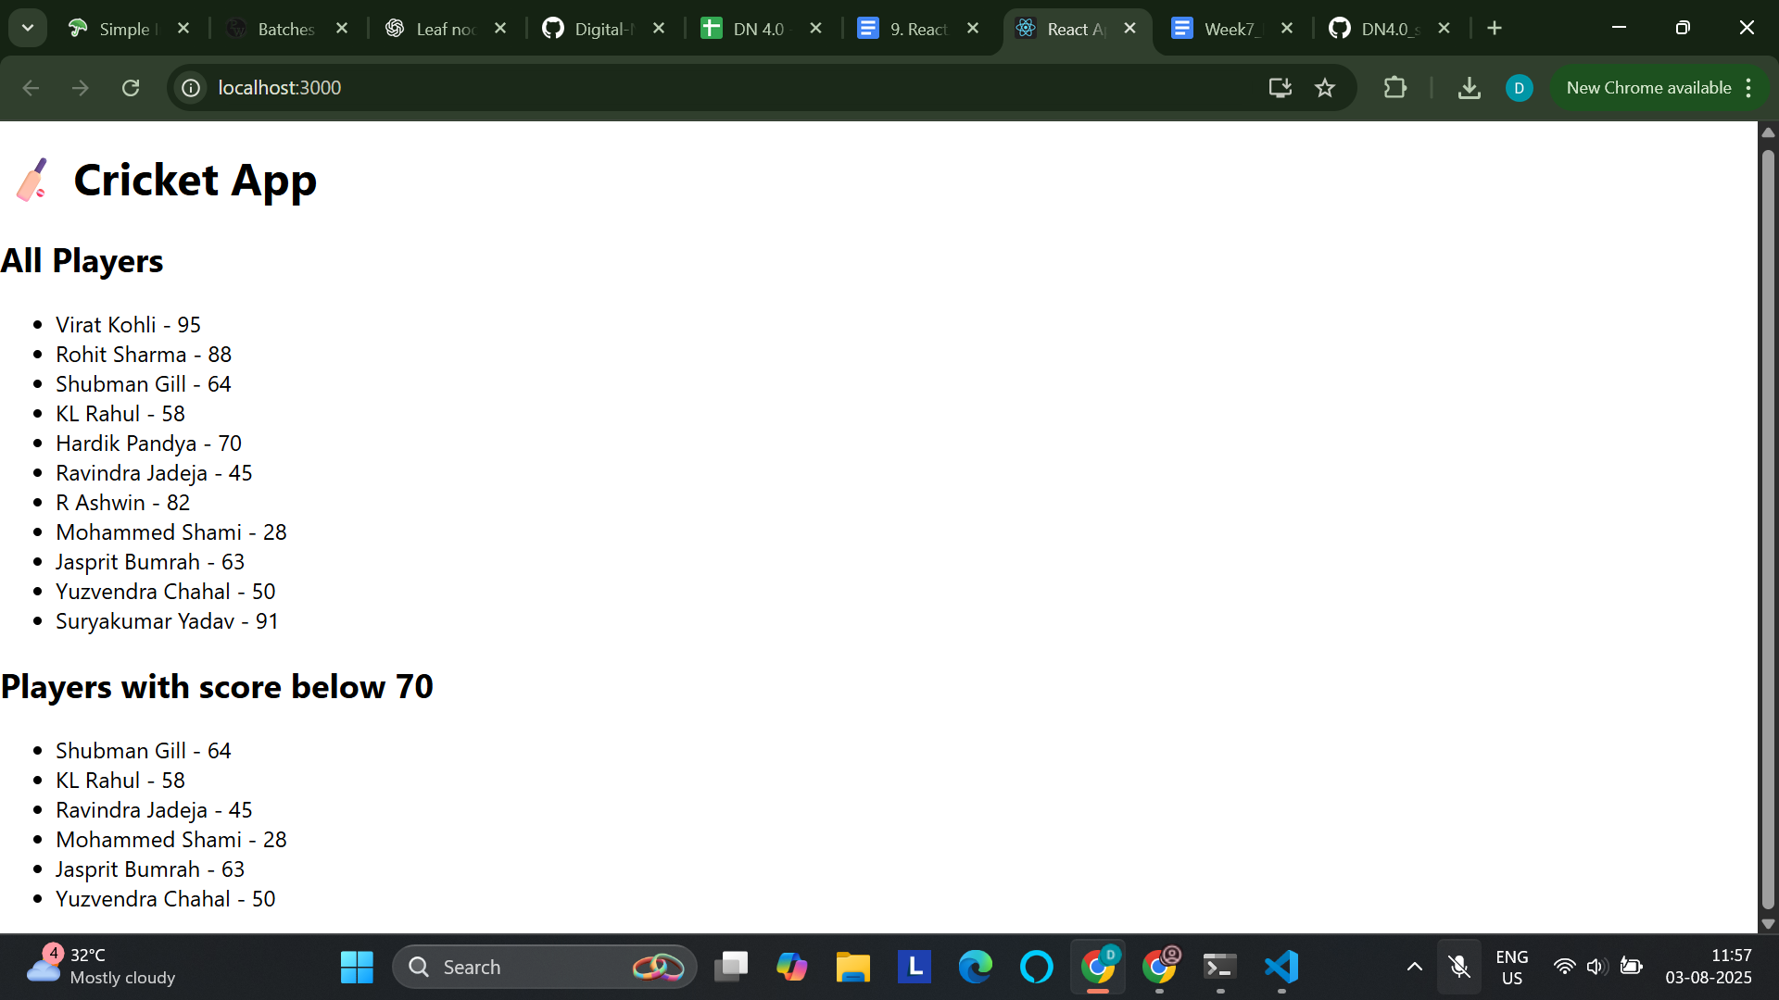

**10. ReactJS-HOL**

**Code:**

[App.js](http://app.js)

import React from "react";

const App = () => {

const officeSpaces = [

{

name: "Skyview Tower",

rent: 45000,

address: "MG Road, Bengaluru",

image: "https://as2.ftcdn.net/v2/jpg/03/84/55/29/1000_F_384552930_zPoe9zgmCF7qgt8fqSedcyJ6C6Ye3dFs.jpg",

},

{

name: "Elite Spaces",

rent: 72000,

address: "Cyber City, Gurugram",

image: "https://as2.ftcdn.net/v2/jpg/02/10/62/03/1000_F_210620329_0le9P2aUC9LUqCyf6yqiV8MtVWrzGKi7.jpg",

},

{

name: "Innovation Hub",

rent: 60000,

address: "Salt Lake, Kolkata",

image: "https://as1.ftcdn.net/v2/jpg/05/24/37/16/1000_F_524371662_i8JkwIuMQkwJLQJGgaU7dqQ8pVzqhErW.jpg",

},

];

const headingStyle = {

textAlign: "center",

color: "#333",

margin: "20px 0",

};

return (

<div style={{ padding: "20px" }}>

{/* JSX heading */}

<h1 style={headingStyle}>🏢 Office Space Rentals</h1>

{/* Displaying list of office spaces */}

{officeSpaces.map((office, index) => (

<div

key={index}

style={{

border: "1px solid #ccc",

padding: "10px",

marginBottom: "20px",

borderRadius: "8px",

}}

>

{/* JSX attribute: image */}

<img src={office.image} alt={office.name} width="150" />

{/* JSX object data */}

<h2>{office.name}</h2>

<p>Address: {office.address}</p>

<p

style={{

color: office.rent < 60000 ? "red" : "green",

fontWeight: "bold",

}}

>

Rent: ₹{office.rent}

</p>

</div>

))}

</div>

);

};

export default App;

**Output:**

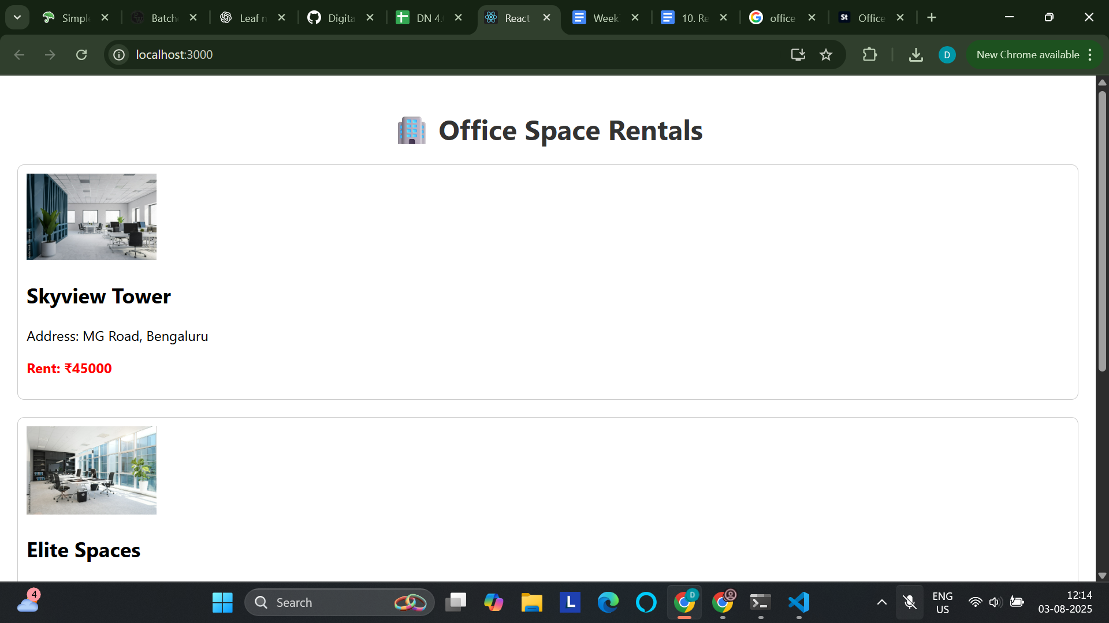

**11. ReactJS-HOL**

**Code:**

[App.js](http://app.js)

import React, { Component } from "react";

import CurrencyConvertor from "./CurrencyConvertor";

class App extends Component {

constructor(props) {

super(props);

this.state = {

count: 0,

message: "",

};

}

increment = () => {

this.setState({ count: this.state.count + 1 });

this.sayHello();

};

sayHello = () => {

this.setState({ message: "Hello! Counter increased 🚀" });

};

decrement = () => {

this.setState({ count: this.state.count - 1, message: "" });

};

sayWelcome = (text) => {

alert(`Message: ${text}`);

};

handleClick = (e) => {

alert("I was clicked (synthetic event)!");

console.log("Synthetic event object:", e);

};

render() {

return (

<div style={{ padding: "30px", fontFamily: "Arial" }}>

<h1>🎯 Event Examples App</h1>

<h2>Counter: {this.state.count}</h2>

<button onClick={this.increment}>Increment</button>{" "}

<button onClick={this.decrement}>Decrement</button>

<p>{this.state.message}</p>

<hr />

<button onClick={() => this.sayWelcome("welcome")}>Say Welcome</button>

<hr />

<button onClick={this.handleClick}>OnPress</button>

<hr />

<CurrencyConvertor />

</div>

);

}

}

export default App;

[CurrencyConverter.js](http://currencyconverter.js)

import React, { Component } from "react";

class CurrencyConvertor extends Component {

constructor(props) {

super(props);

this.state = {

rupees: "",

euro: null,

};

}

handleChange = (e) => {

this.setState({ rupees: e.target.value });

};

handleSubmit = () => {

const euroRate = 88; // 1 Euro = 88 Rupees

const converted = this.state.rupees / euroRate;

this.setState({ euro: converted.toFixed(2) });

};

render() {

return (

<div>

<h2>💱 Currency Converter (INR → Euro)</h2>

<input

type="number"

value={this.state.rupees}

placeholder="Enter INR"

onChange={this.handleChange}

/>

<button onClick={this.handleSubmit}>Convert</button>

{this.state.euro !== null && (

<p>Converted: €{this.state.euro}</p>

)}

</div>

);

}

}

export default CurrencyConvertor;

**Output:**

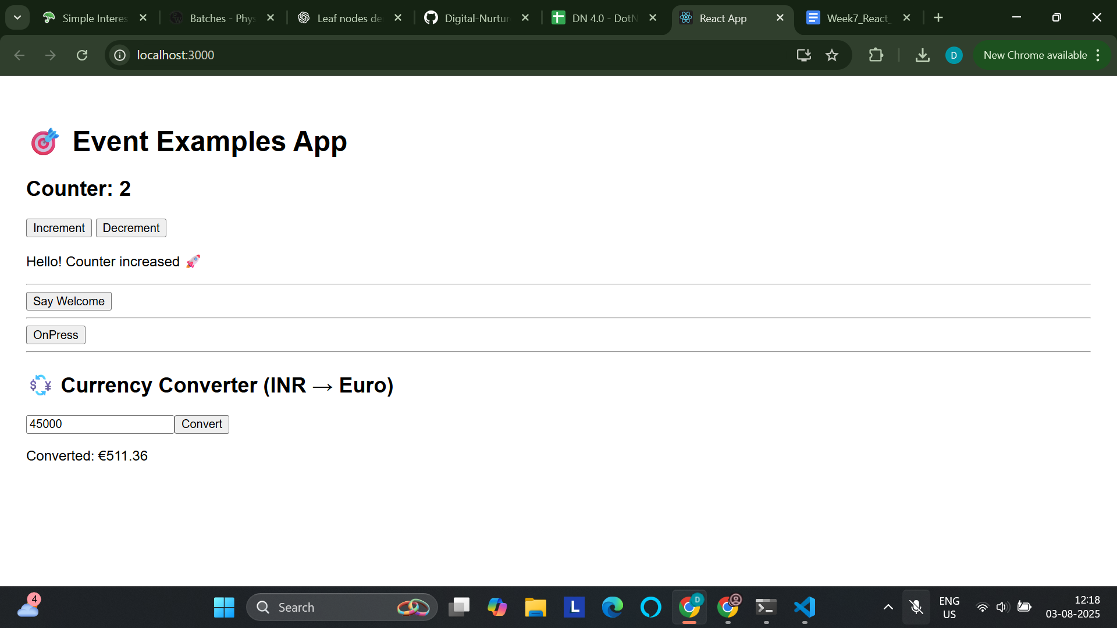

**On clicking “Say welcome” button:**

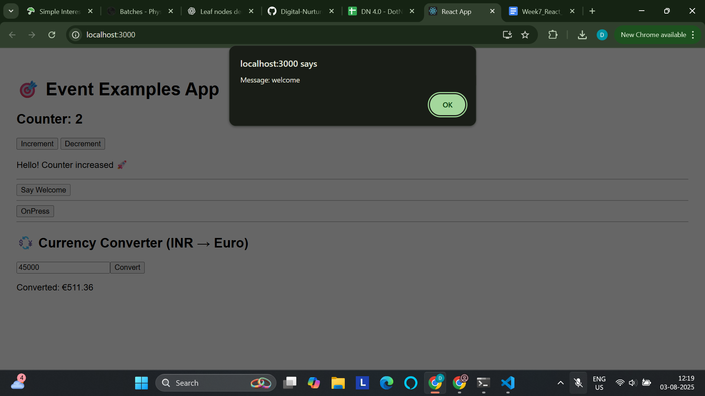

**On clicking “on press” button:**

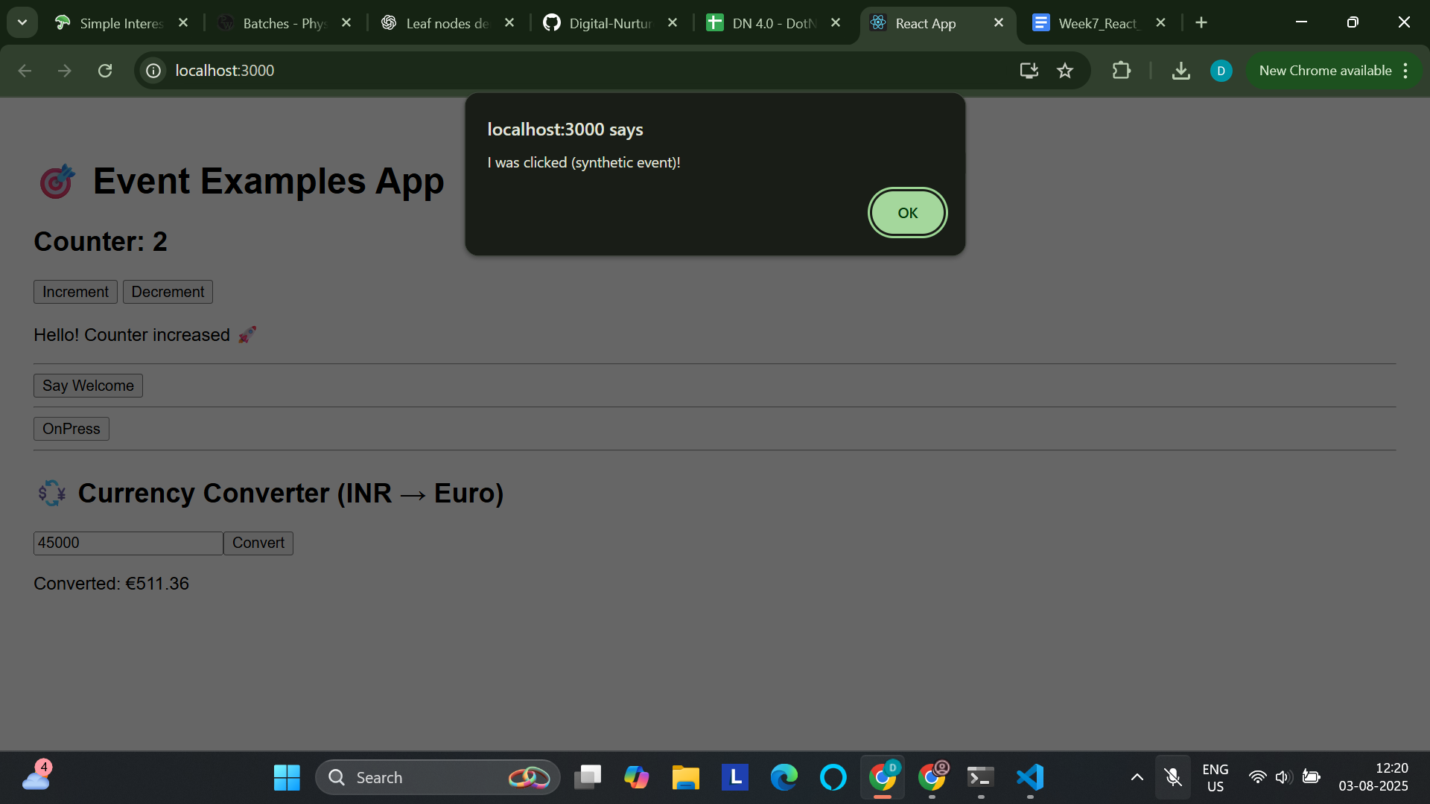

**12. ReactJS-HOL**

**Code:**

[App.js](http://app.js)

import React, { useState } from "react";

import GuestPage from "./GuestPage";

import UserPage from "./UserPage";

const App = () => {

const [isLoggedIn, setIsLoggedIn] = useState(false);

const handleLogin = () => setIsLoggedIn(true);

const handleLogout = () => setIsLoggedIn(false);

return (

<div style={{ fontFamily: "Arial", padding: "20px" }}>

<h1>✈️ Ticket Booking App</h1>

{isLoggedIn ? (

<>

<UserPage />

<button onClick={handleLogout}>Logout</button>

</>

) : (

<>

<GuestPage />

<button onClick={handleLogin}>Login</button>

</>

)}

</div>

);

};

export default App;

[GuestPage.js](http://guestpage.js)

import React from "react";

const GuestPage = () => {

return (

<div>

<h2>Welcome, Guest 👋</h2>

<p>You can view the flight details but must log in to book tickets.</p>

<table border="1" cellPadding="10">

<thead>

<tr>

<th>Flight</th>

<th>From</th>

<th>To</th>

<th>Time</th>

</tr>

</thead>

<tbody>

<tr>

<td>AI101</td>

<td>Delhi</td>

<td>Mumbai</td>

<td>10:00 AM</td>

</tr>

<tr>

<td>AI202</td>

<td>Bangalore</td>

<td>Chennai</td>

<td>12:00 PM</td>

</tr>

</tbody>

</table>

</div>

);

};

export default GuestPage;

[UserPage.js](http://userpage.js)

import React from "react";

const UserPage = () => {

return (

<div>

<h2>Welcome, User 🧑‍💼</h2>

<p>You can view and book flights below:</p>

<table border="1" cellPadding="10">

<thead>

<tr>

<th>Flight</th>

<th>From</th>

<th>To</th>

<th>Time</th>

<th>Action</th>

</tr>

</thead>

<tbody>

<tr>

<td>AI101</td>

<td>Delhi</td>

<td>Mumbai</td>

<td>10:00 AM</td>

<td><button>Book</button></td>

</tr>

<tr>

<td>AI202</td>

<td>Bangalore</td>

<td>Chennai</td>

<td>12:00 PM</td>

<td><button>Book</button></td>

</tr>

</tbody>

</table>

</div>

);

};

export default UserPage;

**Output:**

**When logged out:**

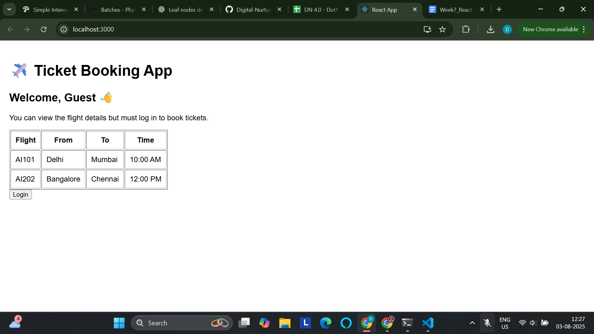

**When logged in:**

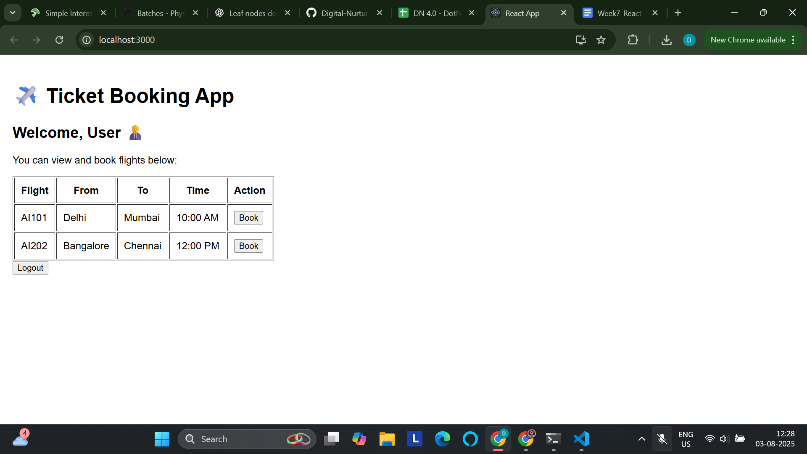

**13. ReactJS-HOL**

**Code:**

[App.js](http://app.js)

import React, { useState } from "react";

import BookDetails from "./BookDetails";

import BlogDetails from "./BlogDetails";

import CourseDetails from "./CourseDetails";

const App = () => {

const [view, setView] = useState("book"); // book | blog | course

// Using element variable

let content;

if (view === "book") content = <BookDetails />;

else if (view === "blog") content = <BlogDetails />;

else content = <CourseDetails />;

return (

<div style={{ padding: "20px", fontFamily: "Arial" }}>

<h1>📚 Blogger App</h1>

<div style={{ marginBottom: "20px" }}>

<button onClick={() => setView("book")}>Book Details</button>{" "}

<button onClick={() => setView("blog")}>Blog Details</button>{" "}

<button onClick={() => setView("course")}>Course Details</button>

</div>

{/* Conditional rendering using element variable */}

{content}

{/* Using ternary operator */}

<div style={{ marginTop: "20px", fontStyle: "italic" }}>

{view === "book"

? "Showing books..."

: view === "blog"

? "Reading blogs..."

: "Learning courses..."}

</div>

{/* Conditional rendering using logical && */}

{view === "course" && <p>You are currently in Course Details section.</p>}

</div>

);

};

export default App;

[BookDetails.js](http://bookdetails.js)

import React from "react";

const books = [

{ id: 1, title: "Atomic Habits", author: "James Clear" },

{ id: 2, title: "Deep Work", author: "Cal Newport" },

{ id: 3, title: "Clean Code", author: "Robert C. Martin" },

];

const BookDetails = () => {

return (

<div>

<h2>📘 Book List</h2>

<ul>

{books.map((book) => (

<li key={book.id}>

<strong>{book.title}</strong> by {book.author}

</li>

))}

</ul>

</div>

);

};

export default BookDetails;

[BlogDetails.js](http://blogdetails.js)

import React from "react";

const blogs = [

{ id: 1, title: "React Patterns", date: "2024-10-01" },

{ id: 2, title: "Hooks in Depth", date: "2024-09-21" },

{ id: 3, title: "JavaScript ES6", date: "2024-08-15" },

];

const BlogDetails = () => {

return (

<div>

<h2>📝 Blogs</h2>

<ul>

{blogs.map((blog) => (

<li key={blog.id}>

<strong>{blog.title}</strong> — <em>{blog.date}</em>

</li>

))}

</ul>

</div>

);

};

export default BlogDetails;

[CourseDetails.js](http://coursedetails.js)

import React from "react";

const courses = [

{ id: 1, name: "ReactJS", level: "Beginner" },

{ id: 2, name: "NodeJS", level: "Intermediate" },

{ id: 3, name: "GraphQL", level: "Advanced" },

];

const CourseDetails = () => {

return (

<div>

<h2>🎓 Courses</h2>

<ul>

{courses.map((course) => (

<li key={course.id}>

{course.name} - <em>{course.level}</em>

</li>

))}

</ul>

</div>

);

};

export default CourseDetails;

**Output:**

**Books section:**

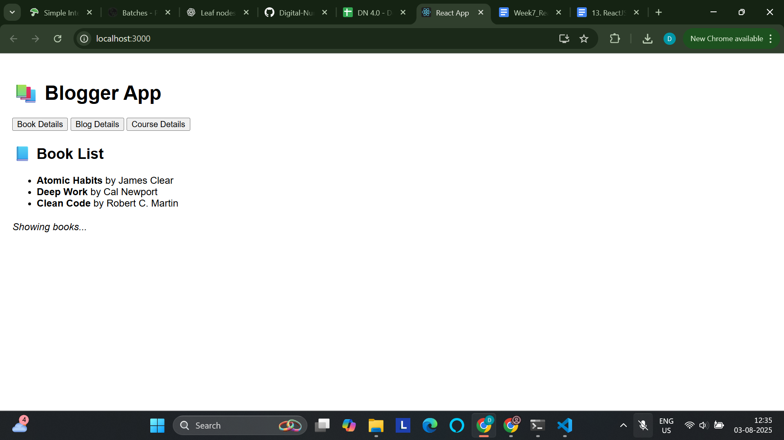

**Blogs section:**

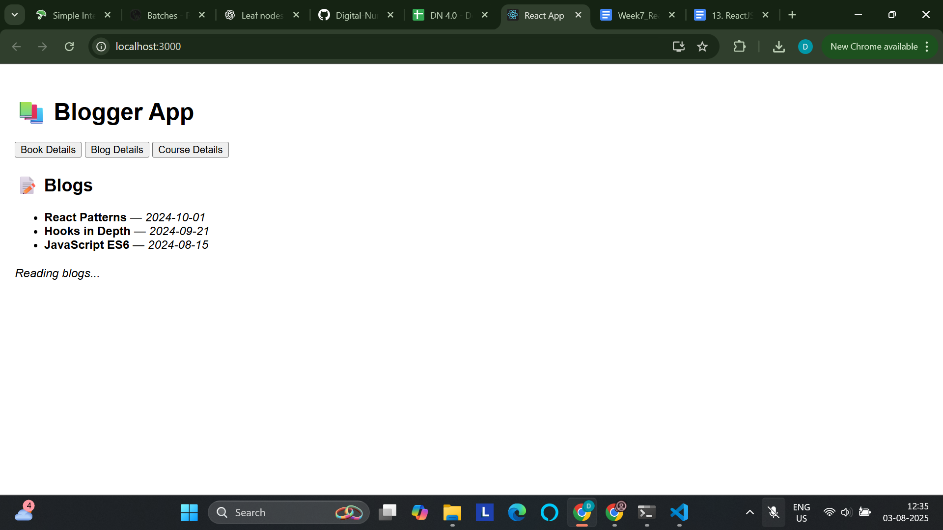

**Course section:**

