**1. Git-HOL**

**Creating project:**

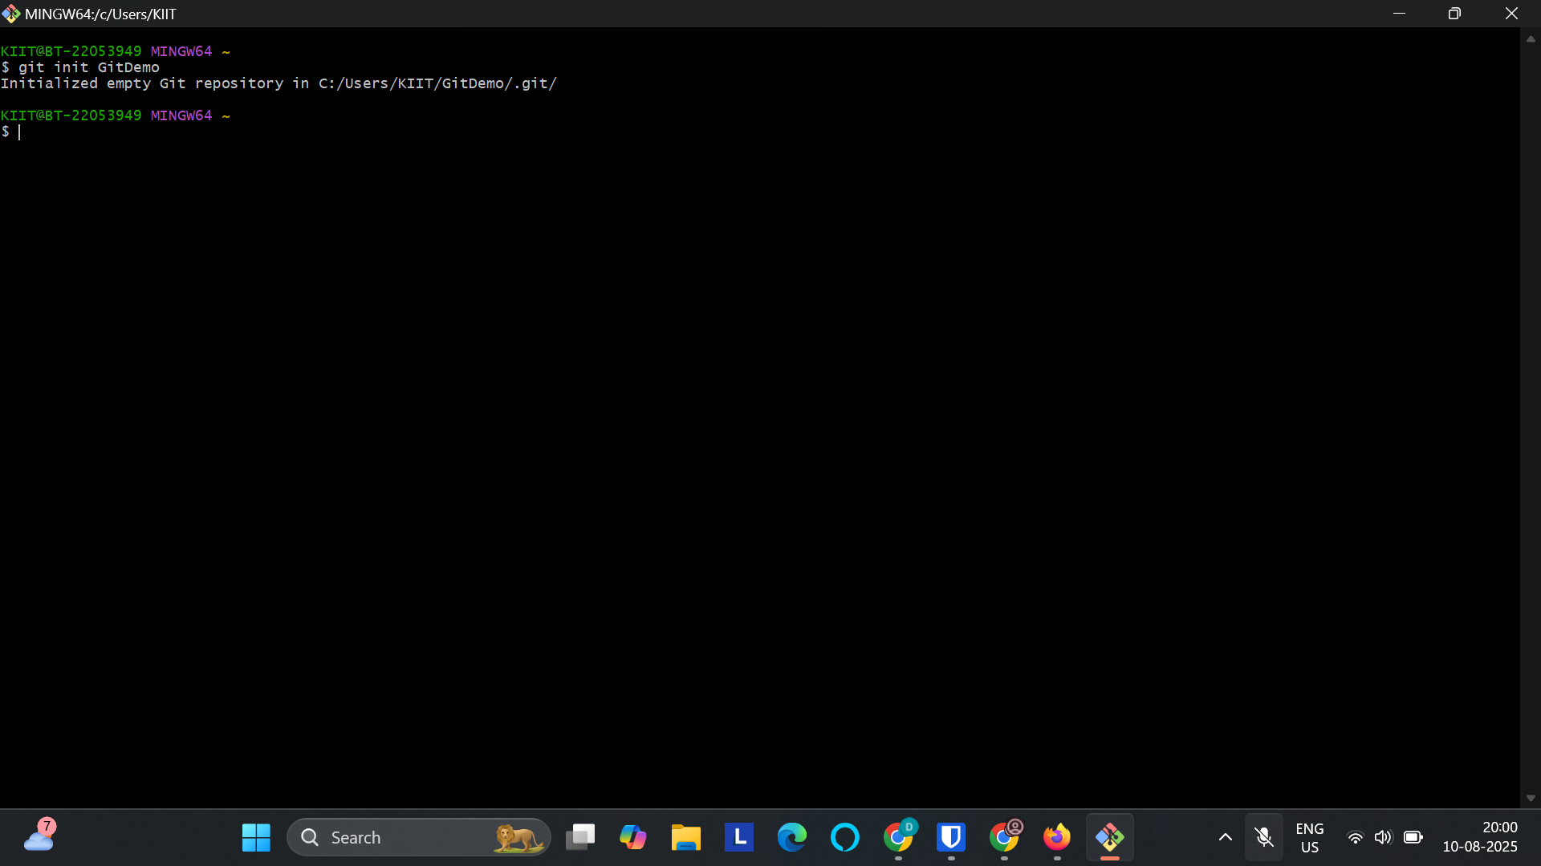

**Creating welcome.txt:**



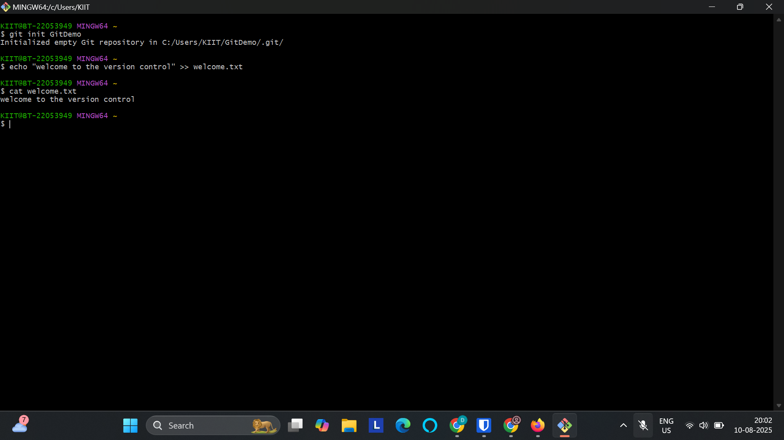

**Checking status:**

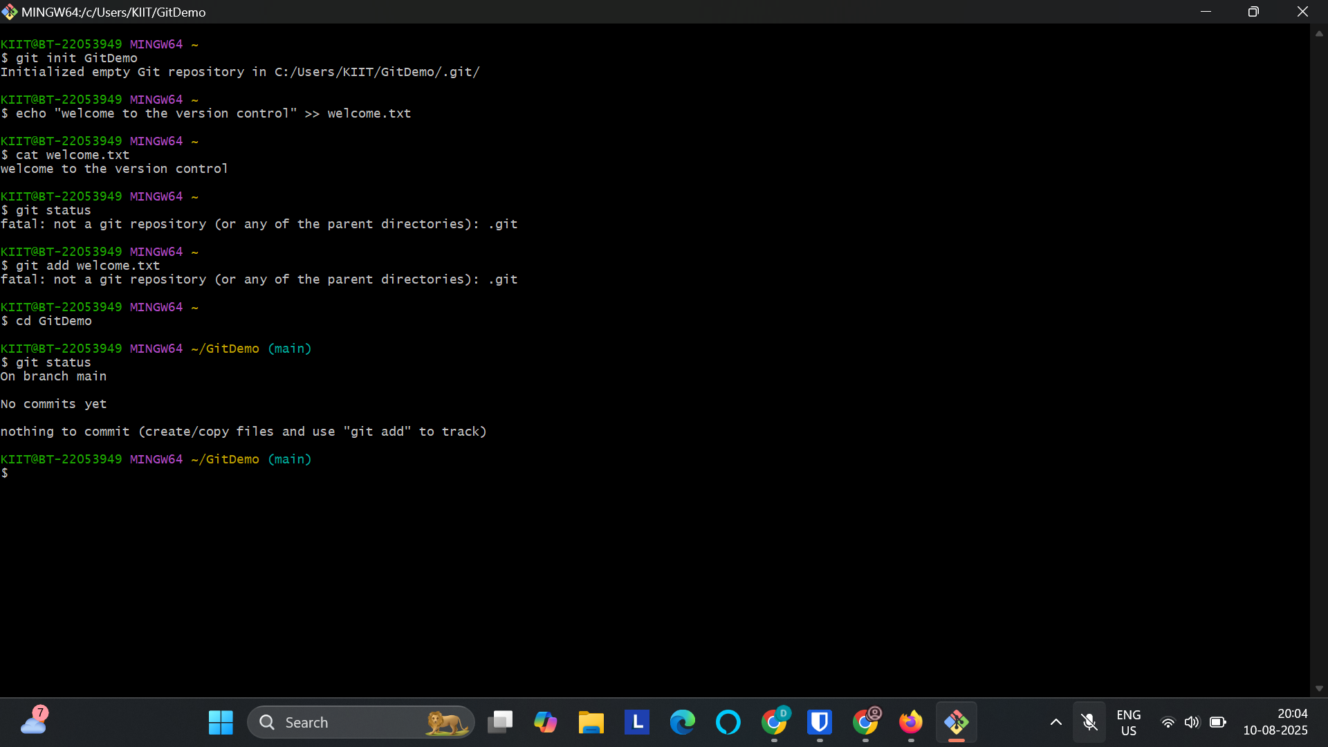

**Adding welcome.txt to tracking:**

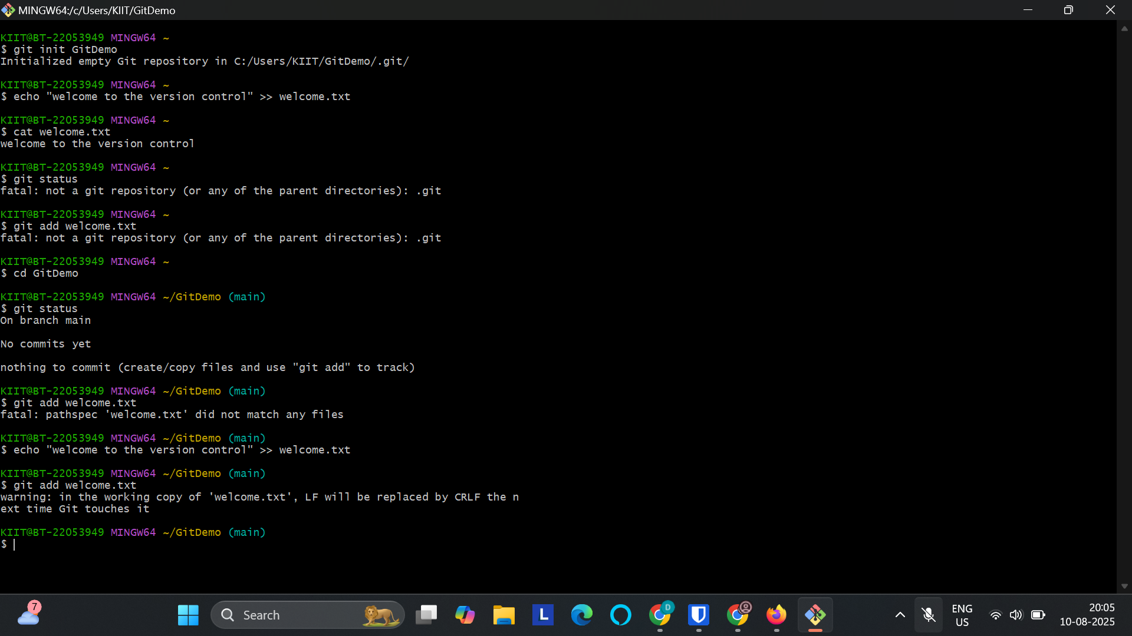

**2. Git-HOL**

**Code:**

Mkdir log

Cd log

Touch .log

Echo “.log” >> .gitignore

Git status

**Output:**

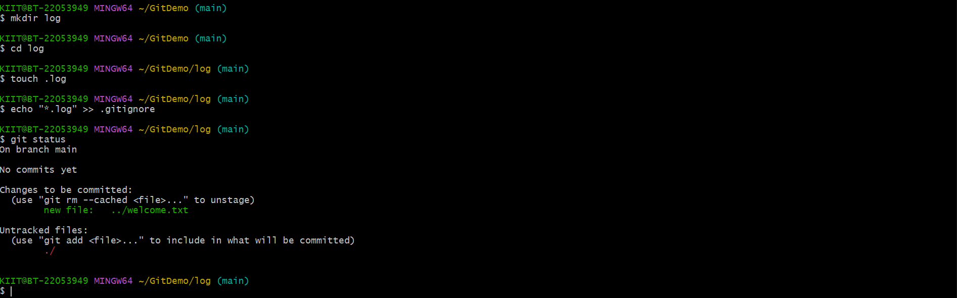

**3. Git-HOL**

**Code:**

Git branch newBranch

Git branch -a

**Output:**

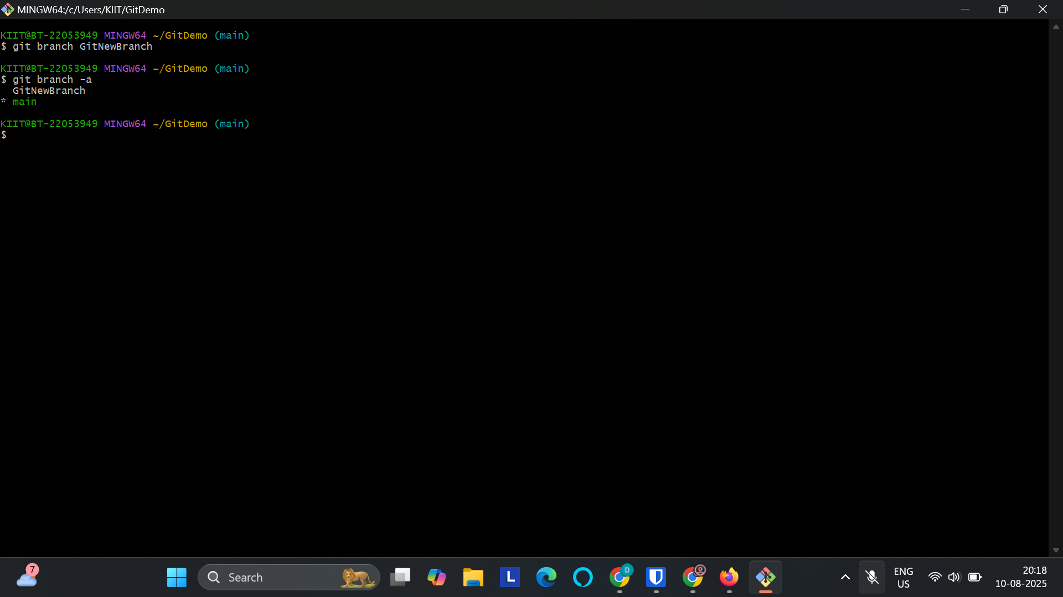

**Code:**

**git checkout GitNewBranch**

**echo "Sample text in file1" > file1.txt**

**echo "Log entry example" > app.log**

**git add file1.txt app.log**

**git commit -m "Add file1 and app.log to GitNewBranch"**

**git status**

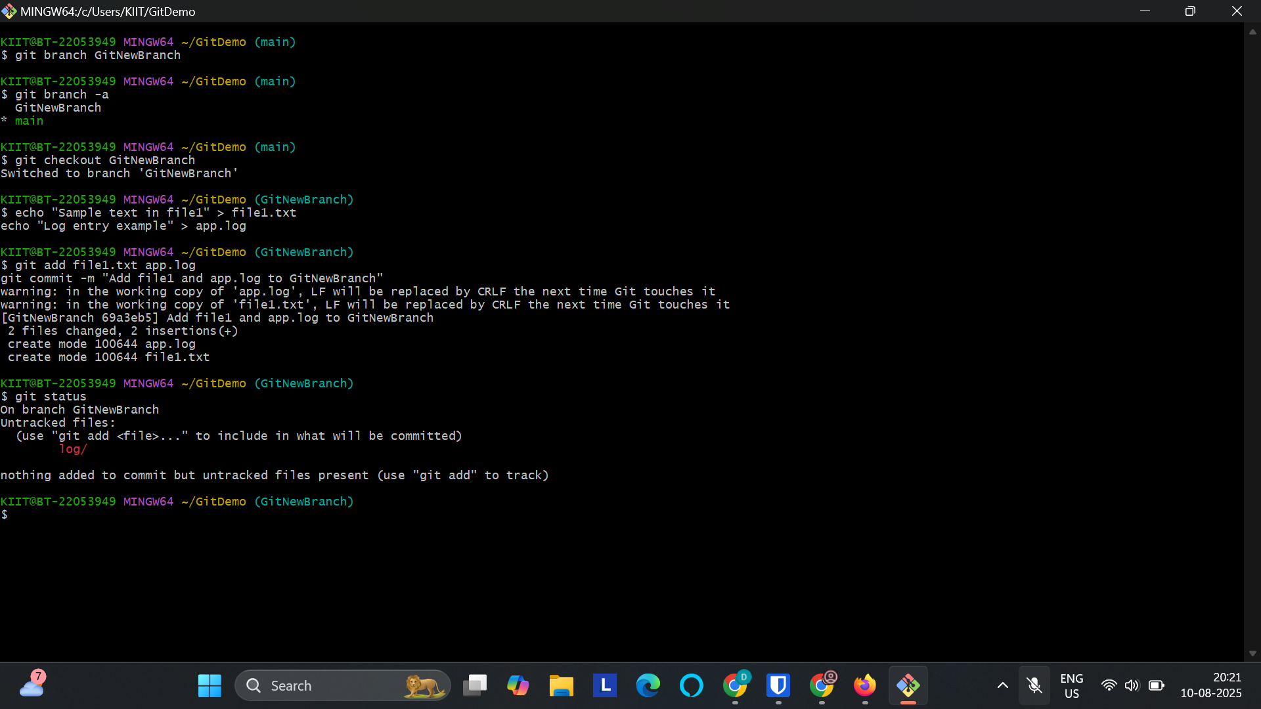

**Code:**

**git checkout master**

**git diff master GitNewBranch**

**git difftool master GitNewBranch**

**git merge GitNewBranch**

**git log --oneline --graph --decorate**

**git branch -d GitNewBranch**

**git status**

**4. Git-HOL**

**Code:**

# Ensure we are on master and clean

git checkout main

git status

# Create GitWork branch and add hello.xml

git checkout -b GitWork

echo "<greeting>Hello from GitWork branch</greeting>" > hello.xml

git status

git add hello.xml

git commit -m "Add hello.xml in GitWork branch"

# Switch to master and add different hello.xml

git checkout main

echo "<greeting>Hello from master branch</greeting>" > hello.xml

git add hello.xml

git commit -m "Add hello.xml in main branch"

# View log graphically

git log --oneline --graph --decorate --all

# Compare differences (command-line diff)

git diff main GitWork

# Compare differences using P4Merge tool

git difftool main GitWork

# Merge GitWork into main

git merge GitWork

# Use P4Merge's 3-way merge tool for conflicts

git mergetool

# Commit the merge resolution

git commit -m "Merge GitWork into main and resolve conflicts"

# Ignore backup files and commit .gitignore

echo "*~" >> .gitignore

git add .gitignore

git commit -m "Add backup files to .gitignore"

# List branches and delete merged branch

git branch

git branch -d GitWork

# View final log

git log --oneline --graph --decorate

**5. Git-HOL**

**Code:**

# Verify master is in clean state

git checkout main

git status

# List all available branches

git branch -a

# Pull the remote repository to master

git pull origin main

# Push changes from Git-T03-HOL_002 branch to remote

git checkout Git-T03-HOL_002

git push origin Git-T03-HOL_002

# Switch back to master

git checkout main