Testing :

Installation :

pip install pytest-dango [ for django version of pytest ]

pip install pytest-cov [ for coverage ]

pip install mixer [ for mocking object fields ]

=> Mixer :
It is a pip package used to mock objects of a model . It acts like a dummy model with is used for unit testing .

=> Pytest.mark.django_db used as a decorator to the test class, otherwise it will throw error that database access not allowed

=>BuiltIn testcase class hierarchy :
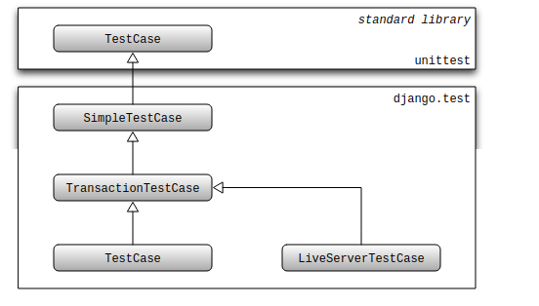

=> setUpClass should be used with this requirement :

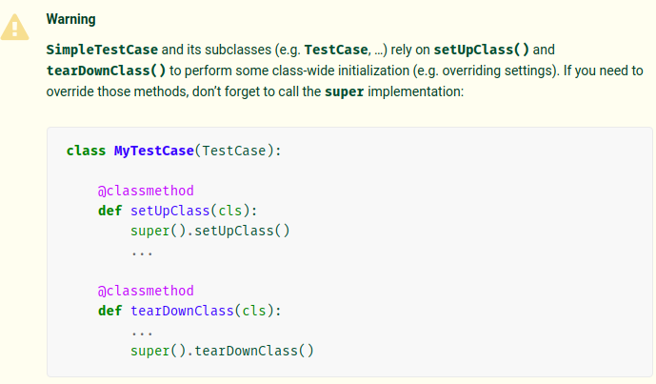

=> TransactionTestCase and TestCase are identical except for the manner in which the database is reset to a known state and the ability for test code to test the effects of commit and rollback:
- A TransactionTestCase resets the database after the test runs by truncating all tables. A TransactionTestCase may call commit and rollback and observe the effects of these calls on the database.
- A TestCase, on the other hand, does not truncate tables after a test. Instead, it encloses the test code in a database transaction that is rolled back at the end of the test. This guarantees that the rollback at the end of the test restores the database to its initial state.
=> SimpleTestCase disallows database queries by default. This helps to avoid executing write queries which will affect other tests since each SimpleTestCase test isn’t run in a transaction. If you aren’t concerned about this problem, you can disable this behavior by setting the databases class attribute to '__all__' on your test class.

- This attribute allow_database_queries = True is deprecated in favor of databases. The previous behavior of allow_database_queries = True can be achieved by setting databases ='__all__'.

=>Be careful not to modify any objects created in setUpTestData() in your test methods. Modifications to in-memory objects from setup work done at the class level will persist between test methods. If you do need to modify them, you could reload them in the setUp() method with refresh_from_db(), for example.

=>Every testcase of django test case has an access of instance of test client . So we do not need to instantiate test client . This client can be accessed with self.client and is recreated for every test . So previous states of the client is not carried between test cases.

e.g . Instead of using :
client = Client()

use res = self.client

